Camp 36 - Walworth Castle, Walworth, County Durham

Prisoner of War Camps (1939 – 1948) - Project report by Roger J.C. Thomas - English Heritage 2003
OS NGR | Sheet | No. | Name & Location | County | Cond’n | Type 1945 | Comments
NZ 2316 1884 | 93 | 36 | Walworth Castle, Walworth | County Durham | 4 |  | Nissen huts dispersed under trees to east of castle

Location: About 7.5 km NW of Darlington.  Before the camp: Walworth Castle site dates from the 11th C – the castle was completed c.1600. Passed through various families.  POW Camp: The castle and grounds were used as a pow camp for 200 men including Italian and German officers. Some huts were found to the east of the castle in woodland. Guards have been recorded as Durham Light Infantry and the Pioneer Corps.  May 1946 – Walworth Castle was recorded as a pow hostel administered by Stadium Camp 662, Catterick (see 631).  After the camp: Became a girls’ boarding school and then a hotel. | 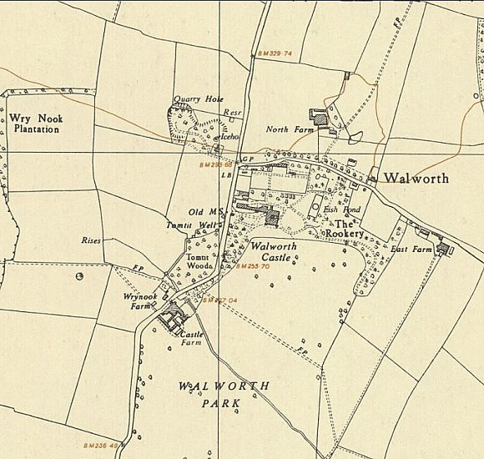
 | Ordnance Survey 1954

