Camp 607 Hutted Camp, Ickleton Grange, Ickleton, Essex

Included in the 1945 ICRC Camp List – Labour Camp. 607. Hutted Camp, Ickleton Grange, Saffron Walden, Essex.

Prisoner of War Camps (1939 – 1948) - Project report by Roger J.C. Thomas - English Heritage 2003
OS NGR | Sheet | No. | Name & Location | County | Cond’n | Type 1945 | Comments
TL 4528 4291 | 154 | 607 | Hutted Camp, Ickleton Grange, Ickleton | Essex (Cambridgeshire) | 3 |  | Site situated in woodland.

Location: 1949 aerial photo of area; Aerial Photo | Historic England  Before the camp:  Pow Camp: Italian and later German pows.  Early 1945 – Camp list; “Italian Working Company, 607, Hutted camp, Ickleton Grange, Ickleton, Nr.Saffron Walden, Essex.”  After the camp:  Further Information:  Research carried out - http://www.ickleton.org.uk/ipsgallery/images/d1398.pdf  Pictures and further info - http://www.ickleton.org.uk/ipsgallery2/index.php...  Facebook link and info - https://www.facebook.com/TheIckletonSociety | 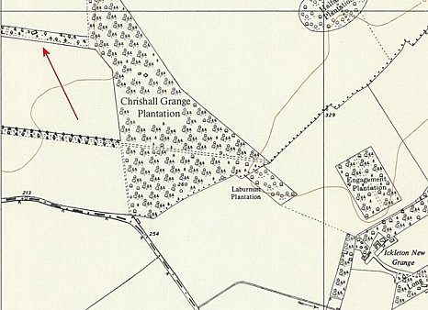
 | Ordnance Survey 1960

