Camp 599 (& 676) Puckridge Camp, Nr. Aldershot, Hampshire

Included in the 1945 ICRC Camp list – Labour Camp. 599. Puckridge Camp, Farnham, Surrey.

1947 camp list
676(G.W.Coy) | S | Puckridge Camp, Fleet Road, Aldershot, Hants | Aldershot 380 Ext 0347 | 30(W.O.) | V/1270/4

Prisoner of War Camps (1939 – 1948) - Project report by Roger J.C. Thomas - English Heritage 2003
OS NGR | No. | Name & Location | County | Cond’n | Type 1945 | Comments
SU 8491 1527 | 676 | Puckridge Camp, Fleet Road, Aldershot | Hampshire | 5 | German Working Camp | Precise location not identified. NGR for centre of Puckridge Hill. The site is occupied by magazine complex.

Location: I think the 1945 entry for Farnham may have been an error, and meant to say Fanborough which is close to Puckridge Barracks. Farnham in Surrey is about 4 miles from the Barracks.  The English Heritage NGR is incorrect. Puckridge Hill and Barracks are SU 850 527.  Before the camp:  Pow Camp: Italian Labour Camp, and later German Working Camp.  Early 1945 – Camp list; “Italian Working Company, 599, Camp 22, Watts Common, Aldershot.” Watts Common alongside Puckridge – see map.  April 1945 – Camp list; “Italian artisan working comp, 783, Puckridge Camp, Aldershot.” War establishment code; V/1373/1. NOTE, camp number 783, possibly a separate unit alongside the main Italian camp?  September 1945 – Appendix to HQ Southern Command War Diary; “599 Aldershot – Italian working company – capacity 300.”  Postal items seen – Letter-sheet to Italy 1946 as camp 676.  June 1947 – note for East Cams Camp 251 that Camp 676 was closing.  After the camp: 2020 still in military use.  Further Information: | 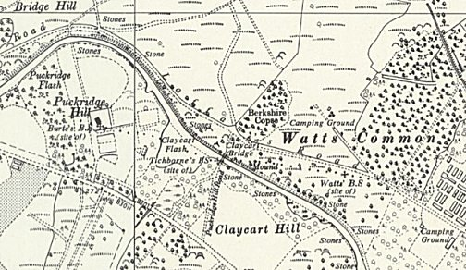
 | Ordnance Survey 1961

