Camp 598 Barton Grange, Corfe, Taunton, Somerset

Included in the 1945 ICRC Camp list – Labour Camp. 598. Barton Grange, Corfe, Taunton, Somerset.

Location: NGR ST 227 198  Before the camp: Barton Grange was a 16th/17th-century country house, most of which was demolished in 1931.  Pow Camp: Italian pow labour camp.  September 1945 – Appendix to HQ Southern Command War Diary; “598 Barton Grange, Taunton – Italian working company – capacity 300.”  After the camp:  Further Information: | 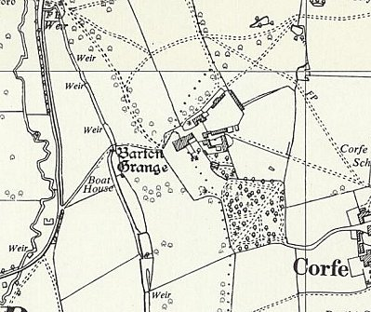
 | Ordnance Survey 1962

