Camp 595 Burstwick Camp, Hull, Yorkshire

Included in the 1945 ICRC Camp list – Labour Camp. 595. Address non communiqué.

Location: Burstwick is a village about 13km E of Hull. Memory – “The Italians lived in Keyingham for a time at what became the Hostel.” See below.  Before the camp:  Pow Camp:  Early 1945 – Camp list; “Italian Working Company, 595, Burstwick Camp, Nr.Hull.” The telephone number was ‘Keyingham 76.’ Keyingham is about 3 miles to the SE of Burstwick, and possibly indicates a more accurate location. Memories of an evacuee to Keyingham;  “…I was evacuated to the then tiny village of Keyingham, which is situated outside of Hull… We lived in a small cottage in Station Road and I vividly remember looking out of the rear bedroom window and seeing Hull ablaze, and it being an awesome sight. I also remember the Italian prisoners of war that used be there with their orange/yellow circles stitched on their clothes to show who they were. They always seemed pleasant to me, but of course they were probably glad to be out of it.”  https://www.bbc.co.uk/history/ww2peopleswar/stories/75/a4419975.shtml  After the camp:  Further Information: | 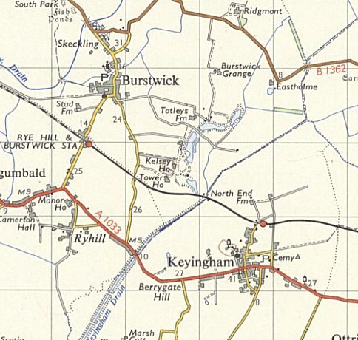
 | Ordnance Survey 1958

