Camp 591 (& 626) Wilcott Camp, Nesscliffe, Shropshire

Included in the 1945 ICRC Camp list – Labour Camp. 591. Wilcott Camp, Nesscliffe, Shrewsbury, Salop. Also; ICRC – Labour Camp. 626. Same address.

Prisoner of War Camps (1939 – 1948) - Project report by Roger J.C. Thomas - English Heritage 2003
OS NGR | Sheet | No. | Name & Location | County | Cond’n | Type 1945 | Comments
SJ 3749 1831 | 126 | 591 | Wilcott Camp, Nesscliffe | Shropshire | 2 |  | Pre-existing camp serving an ordnance depot. Presenty used by the army as Nescliffe Training Camp

Location: Site not shown on 1958 map.  Before the camp: Army camp for ordnance depot  Pow Camp: Italian and then German pows.  Historic Building Recording of Nissen Huts at Nesscliffe Camp. By Cotswold Archaeology, commissioned by Reds10 on behalf of the MoD, March 2021:  “The Huts were due to be demolished as part of a programme of building upgrade work. The level of recording was Level 2, according to Historic England guidelines, which is described as a 'descriptive' recording.  The Huts were constructed during the latter part of WWII to house Prisoners of War (POW). The site was formerly an army camp serving an ordnance depot prior to it being converted to a POW camp. It was decommissioned in 1948 | 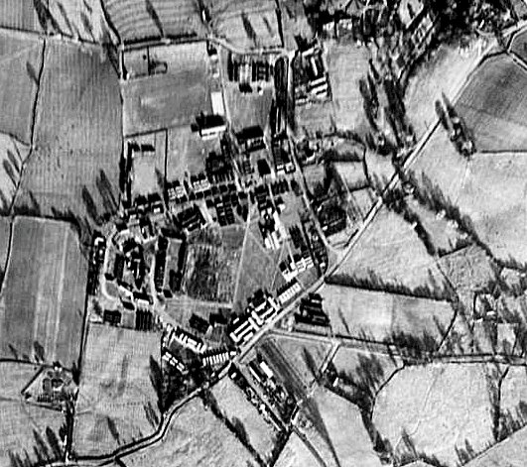 | 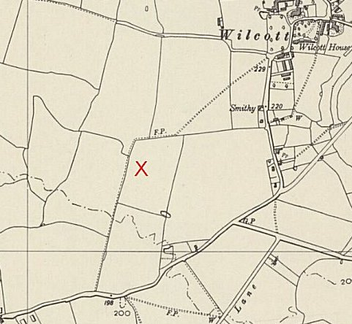
 | © MoD No. 541/214 frame 3036. | Ordnance Survey 1958
and became an army training camp.

The building recording has identified that the Huts are typical of the Nissen Hut typology, being constructed in a half circle composition formed of metal ribs clad in corrugated metal. Due to the more permanent nature of these Huts, they have been built on concrete bases with brick front and rear elevations, some with a central spine brick wall too. Internally they are clad in plasterboard or thin boarding fixed by timber battens.
Most of the Huts have been upgraded over time to include uPVC windows and gas heating. Evidence of former stove heating was seen in the repair of stove flue openings and chimneys in some Huts. Some of the Huts also retain more original features, such as metal Crittall style windows and panelled doors. The Huts have a range of uses, ranging from classroom to residential, and generally speaking the Huts used for residential purposes had been given the most upgrading treatment. Given the Huts are very similar in core construction but vary in detail and thermal performance according to use, assessment has recorded Huts by use type, noting different features inherent in the Huts based on their function.” https://archaeologydataservice.ac.uk/archives/view/1004635/index.cfm The report is available to download.

Italians recorded in 1942.

Early 1945 – Camp list; “Italian Working Company; 591, Wilcott Camp.”

Closed 1948

After the camp: 2020 Nesscliffe Training Camp

Further Information:

https://archaeologydataservice.ac.uk/archives/view/1004635/downloads.cfm

