Camp 407 (& 634 / 635) Weston-on-Trent Camps, Derby, Derbyshire

Prisoner of War Camps (1939 – 1948) - Project report by Roger J.C. Thomas - English Heritage 2003
OS NGR | Sheet | No. | Name & Location | County | Cond’n | Type 1945 | Comments
SK 3960 2818 | 128 | 634 | Weston Camp, Weston-on-Trent, Derby | Derbyshire | 3 | German Working Company | Irregular plan camp enclosed by a wire perimeter fence. See Camp no.635
SK 3955 2778 | 128 | 635 | Weston Camp, King's Newton | Derbyshire | 3 | German Working Company | Tarasiyka Ukranian Youth Centre. See Camp no.634.

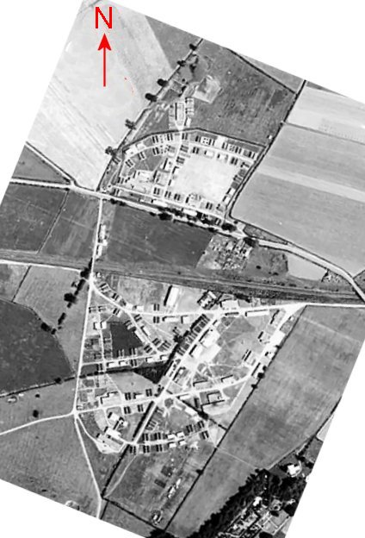  Location: Most lists do not include the number 407 for Weston-on-Trent. There was definitely a Camp 407 at Weston-on-Trent, but I do not know whether it was in the same place as 634 / 635.  Question – Did 634/635 merge to become Camp 407 at some point during Summer/Autumn 1946?  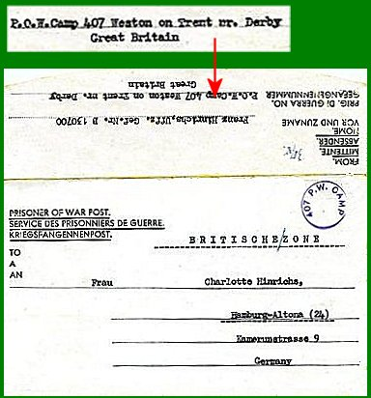  < 1947 pow mail to 407.  634 is shown on the map to the N of the road. 635 is the larger site, S of the road. About 1 km to the E / SE of Weston-on-Trent.  1945 aerial photo - Aerial Photo | Historic England  Before the camp: 634 / 635 Farmland. Military use.  Pow Camp 407: German pows.  Pow mail came up for sale on the ‘oldthings’ website – all from Camp 407, with the address ‘Weston-on-Trent, nr Derby’. They were sent 22 August 1946 to 2 February 1947 from | 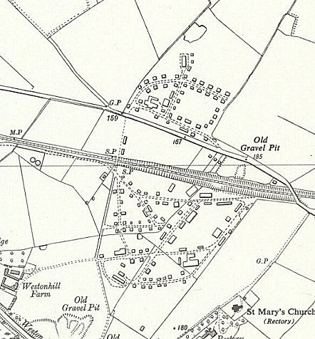
 | Ordnance Survey 1955
senior physician Dr.Gerrit Busmann to Pastor Busmann or Mrs Busmann in the English zone of Germany. (I have also seen mail from Gerrit Busmann from Camp 28 Knighthorpe and 166 Wollaton Park).

November 1946 – Camp magazine for 407, (The Spotlight) No.3; Richtstrahler : Lagerzeitung des P.O.W. Camp 407 Weston-Trent - The Wiener Holocaust Library

References to hostels at Bladon Castle, Rosliston and Ticknall.

The Camp leader was about to leave the camp; Willi Hertweck.

January 1947 - Camp magazine for 407; Richtstrahler : Lagerzeitung des P.O.W. Camp 407 Weston-Trent - The Wiener Holocaust Library

References to hostels at Bladon Castle, Rosliston and Ticknall.

Includes a New Year message from the Commandant; Major G Parry.

Camp 634 / 635:

Early 1945 – Listed as German Working Camps. 634 address; ‘Weston-on-Trent, Derby’ / 635 address; ‘Kings Newton, Derby.’ Both sites had same telephone number; Chellaston 2264, ext. 12.

9 March 1946 – Camp magazine No.10 for 634; Der Postillon : Wochenzeitung des P.o.W. Camp 634 - The Wiener Holocaust Library

April 1947 – “Weston” listed as a satellite camp to Knighthorpe Camp 28 (336 pows), together with the 3 hostels listed for camp 407. It remained open to early 1948.

After the camp: 2020 – 634 is shown as a farm / 635 is shown as Tarasivka. Converted water tower at the camp came up for sale at £500,000 in 2020.

Further Information:

IWM have a copy of the Camp 407 newspaper from Christmas 1946. Catalogue LBY E.J.410.

Hostels

Bladon Castle. Built 1795 - part folly, part country house. NGR SK 2698 2507. Just before and after these entries, the hostel was listed with Garendon Camp 28.

November 1946 – Attached to camp 407. Hostel leader; Koetz.

January 1947 – listed again with 407.

Rosliston. Just before and after these entries, the hostel was listed with Garendon Camp 28.

November 1946 – Attached to camp 407. Hostel leader; Lambrecht.

January 1947 – listed again with 407.

April 1947 – With Camp 28, same hostel leader; Fw Lambrecht.

Ticknall. Just before and after these entries, the hostel was listed with Garendon Camp 28.

November 1946 – Attached to camp 407. Hostel leader; Erdmann.

January 1947 – listed again with 407.

April 1947 – With Camp 28, same hostel leader; Uffz Erdmann (A).

April 1948 – listed for a short time as a hostel for Nether Heage Camp 58.

