Camp 407 Usselby Camp, Market Rasen, Lincolnshire

Prisoner of War Camps (1939 – 1948) - Project report by Roger J.C. Thomas - English Heritage 2003
OS NGR | Sheet | No. | Name & Location | County | Cond’n | Type 1945 | Comments
TF 097 934 | 112 /3 | 407 | Usselby Camp, Usselby, Market Rasen | Lincolnshire | 4 | Base Camp | Farmland

Location: Usselby is about 5km NW of Market Rasen. Possibly huts shown on map at side of the road running S from New Bridge. Historic England (Pastscape) records the camp being in the grounds rather than in the Hall – Map A.  Lincolnshire HER gives a different location from the English Heritage record above: “TF 0899 9224. Usselby Camp, in Osgodby parish, was a Prisoner of War camp during the Second World War. It is an example of a 'Base Camp'. In the official government numbering it was camp number 407 and referred to as Usellby Camp, Usselby, Market Rasen.” Map B  Before the camp: Usselby Hall is a Grade II listed building dating from the mid-18th century with early 19th-century alterations and additions, and built with red brick. Various military camps were located in the area during WW2.  Pow Camp: There are some reports that it was a camp for officers, however neither Pastscape, nor ‘LincstothePast’ state this and it is doubtful. | 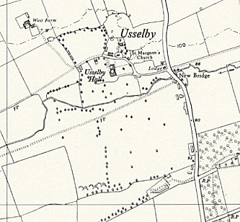 | 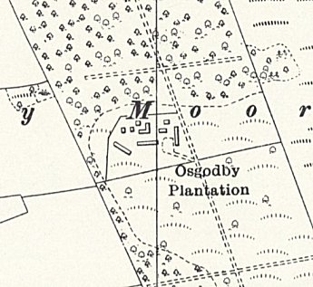
 | A Ordnance Survey 1956 B
Short lived as a camp as by November 1946, the number 407 was in use by Weston On Trent Camp.

After the camp: Farmland

Further Information:

