Camp 406 Scarnecross Camp, Launceston, Cornwall

Prisoner of War Camps (1939 – 1948) - Project report by Roger J.C. Thomas - English Heritage 2003
OS NGR | Sheet | No. | Name & Location | County | Cond’n | Type 1945 | Comments
SX 3341 8346 | 201 | 406 | Scarnecross Camp, Launceston | Cornwall | 4 | Base Camp | Site occupied by an industrial estate and housing

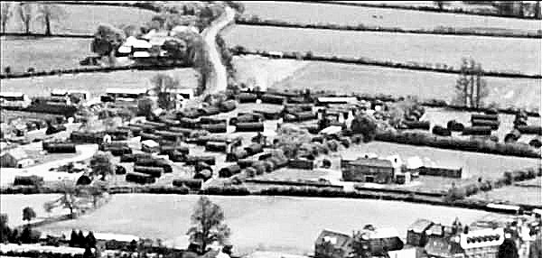  Post war aerial view of the camp – looking SOUTH. | 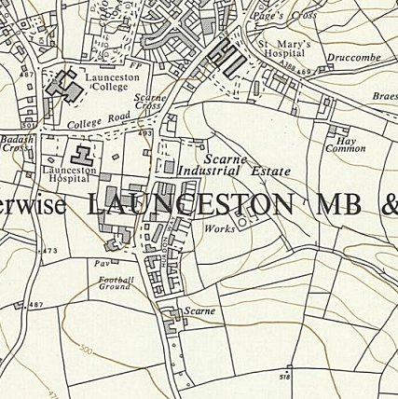
 | Ordnance Survey 1963

Location: South edge of Launceston.

Before the camp: British and then US troops.

Pow Camp: US camp site became utilised for the pow camp.

July 1946 - Note in a report for Bampton Road Camp 92, a number of pows were transferred from Camp 406.

After the camp:

Further Information:

