Camp 405 Barwick House Camp, Barwick, Yeovil, Somerset

Prisoner of War Camps (1939 – 1948) - Project report by Roger J.C. Thomas - English Heritage 2003
OS NGR | Sheet | No. | Name & Location | County | Cond’n | Type 1945 | Comments
ST 5600 1446 | 194 | 405 | Barwick House Camp, Barwick, Yeovil | Somerset | 4 | Base Camp | Restored parkland, cropmarks visible on Getmapping coverage.

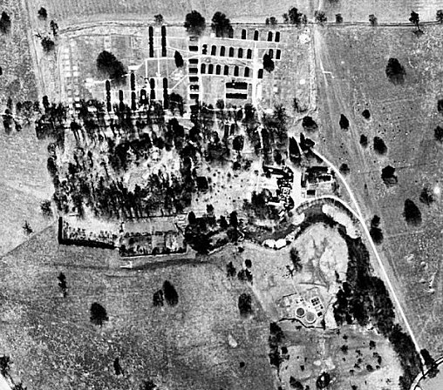  Location: The village is about 3.2km S of Yeovil.  1947 aerial photo:  Aerial Photo | Historic England  Before the camp: Country House and Park. The park was used as a transit camp for US troops prior to D-day.  Pow Camp: Reported to have held Italian and then German pows.  Somerset HER; 15458: Second World War camp, Barwick House. “Along the drive to the house and in the woods behind it are the concrete bases of a WW2 camp…  The bases along the drive are almost completely overgrown but surviving bits indicate 20 ft huts. The woods were not visited and neither was the sewage works to the south of the house which presumable dates to this period.  Barwick House Camp is identified in German records as a Prisoner of War Camp (No. 405). | 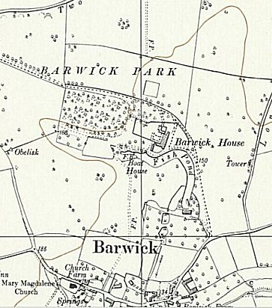
 | Ordnance Survey 1961
RAF vertical aerial photographs of c1946 show clearly an area of huts, some already dismantled, to the N of the house as well.

A large camp of Quonset huts was established by the 41st and 92nd Replacement Battalions through which several thousand soldiers passed on their way to the battlefields.”

After the camp:

Further Information:

