Camp 403 Brockley Camp, Brockley, Somerset

1947 Camp List
403(P.C.) | Brockley Camp, Brockley, West Town, Bristol | S. | Priswar, West Town | Flax Bourton 214 | Nailsea and Blackwell (G.W.R.) | (Blank) | v/202/4

Prisoner of War Camps (1939 – 1948) - Project report by Roger J.C. Thomas - English Heritage 2003
OS NGR | Sheet | No. | Name & Location | County | Cond’n | Type 1945 | Comments
ST 475 671 | 171 | 403 | Brockley Camp, Brockley | Somerset | 4 | Base Camp | Restored parkland.

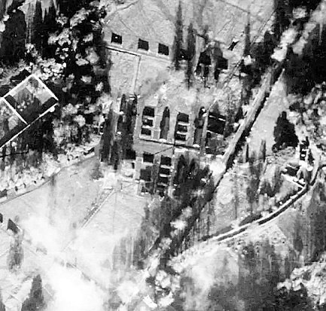  Location: part of the camp in aerial photo 1946; Aerial Photo | Historic England  Before the camp: Country estate.  Pow Camp: Capacity up to 500 pows, later expanded. Huts appear to be Nissen type.  Wikipedia – “Brockley was the location of a 300-person Prisoner of War camp during World War 2, initially housing Italian prisoners from the Western Desert Campaign, and later German prisoners post the Battle of Normandy.”  1946 – Intake of many pows from camps in the USA. Most had a very low morale as they had been misinformed in the US they were being repatriated. Instead, they found themselves in working camps in the UK.  May 1946 – Lecturer’s notes recorded that there were German and Austrian pows. The camp was being used as a repatriation camp for Austrians, with 100 German staff. | 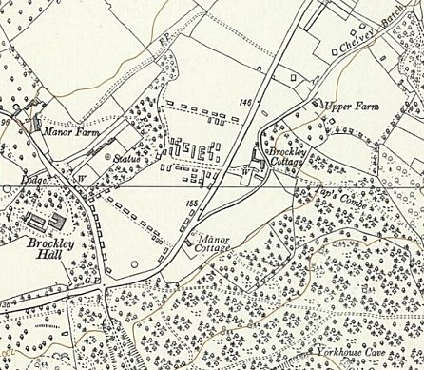
 | Ordnance Survey 1960

Oversight and development of re-education activities and English teaching for German pows was carried out by PID (Political Intelligence Department of the Foreign Office) / COGA (Control Office for Germany and Austria – UK). Visits and reports were made. The standard of the reports varied greatly. The visitors took little interest, if any, in activities other than re-education. They rarely mentioned welfare, sports, games, pastimes, crafts, etc of the pows. If there were still Italian pows in hostels, they were usually ignored by PID.

28 May 1946 – Brief report on a visit to examine conditions for Austrians prior to embarkation.

Commandant: Lt Col Digges. Camp leader: O/Gefr Werner Saenger
Interpreter: S/Sgt Gerber. Deputy C/L: Uffz Bernhardt Schier.

The Commandant seemed to be “contemptuous of PID,” however he was recorded as being unobstructive. As the Austrian pows were due for repatriation he was allowing them greater freedoms and wanted to remove the barbed wire.
The Camp Leader was well liked, except by the Interpreter who found him to be aggressive. He had been held in camps in the USA; “he has personality and organising ability.” The visitor gave him the political grade (A); anti-Nazi.

Deputy C/L; “a quiet man without much personality,” graded (B+).

The most striking personality was the dentist, U/Arzt Kurt Advena. He had good recommendations from a USA camp; he was graded (A+) and recommended for repatriation. Later entries stated that he was “deteriorating mentally,” and that he was not repatriated as he was performing medical duties due to the lack of a M.O.

The capacity of the camp had been expanded to 1500, however, 1700 were present. The first repatriations occurred during this visit. Despite the overcrowding, pows were said to be highly satisfied with the camp and the treatment they received.

June 1946 – Lecturer’s notes: Austrian pows were being repatriated, while German pows remained in captivity. Many of the Germans were “depressed and apathetic.”

One of the Austrians commented that he had been held in a concentration camp for 5 years, then held a pow in the USA for 2 years, before being placed in a camp in the UK.

June 1946 – Lecturer’s notes: Some of the Austrians were surprised to be repatriated so soon as they had been Nazi Party members. Letters sent by some who had already been repatriated reported that some pows were arrested on arrival due to their Nazi activity.

14 August 1946 – Re-education survey. Strength; 0 officers, 99 Other Ranks. All Austrian pows had departed – the 99 Germans were the permanent staff.

Commandant: Lt Col Digges. Camp leader: O/Gefr Werner Saenger (A)
Interpreter: Capt A H Wagner. Deputy C/L: Uffz Bernhardt Schier (B+)
German M.O.: None.

The Commandant continued to be against PID. The Interpreter Officer was only involved in translation work.

The German pows had hoped to be repatriated after the Austrians had left – this was not to be so. Restrictions were still in place for them and only the Camp leader and Protected Personnel were allowed to leave the camp.

The standard list of re-education activities was given. With so few pows these were not surprisingly limited;

Newspapers – British newspapers were passed on by some British staff. German papers were received irregularly.

Library – 122 books; adequate for 99 pows.

Lectures – Regular.

Discussion groups – None

Films – Supplied by YMCA every 3 weeks.

Wireless – “Adequate.”

Camp magazine – None

Press review – None.

English instruction – 7 pows were studying privately.

Other Camp activities –

Religion – The protestant Chaplain from Bedminster Camp 124 held a fortnightly service.

Education – None.

Entertainment – No theatre group of orchestra.
Autumn 1946 - The site became a repatriation camp with large groups of German pows staying for 1 to 2 weeks. The camp accommodated up to 1600 to 1700 pows and had a permanent pow staff of 111.

There was a new, unnamed, Camp leader, graded (C), [Nazi]. The Commandant believed he was capable of performing the job and that he was due to be regraded to (B).

November 1946 - Dr. Paul Schröder, rocket scientist who helped to develop the V2 rocket was held at Camps 184 and 403 before being transferred to Watten Camp 165.

21 November 1946 – A special report was issued following complaints by PID staff. The objects of the visit were to;

a. Apologize for incidents connected with a recent visit of 2 French officers sponsored by COGA.
b. Discover what the Commandant’s objections were to COGA.
c. Obtain his co-operation, or to request his removal.

Commandants were not required to promote re-education, which was developed by the Foreign Office – the camps were under the control of the War Office. The purpose of the camps was to hold pows and set them to work when possible, (not possible at this repatriation camp). If the camp was kept under control that was sufficient as far as many Commandants (and the War Office) were concerned.

The Commandant admitted that he had been angered by the arrival of the French officers, as he had not been informed they were coming or what their purpose was. Further communication errors by PID had then followed.

With regard to his attitude to PID/COGA, Lt Col Digges stated; “I am always filling in forms for COGA, but I don’t know what they are for; nothing seems to happen.” Further, as the pows had no work in this repatriation camp, there was no Welfare Fund (built up mainly from sales in the canteen) and so ‘extras’ could not be purchased. The pows had very little to do during their stay in this camp.

Aspects of the re-education list were re-examined with pretty shocking results considering how many pows were passing through;

Newspapers – None supplied, and no Welfare Fund to purchase any.

Library – still only 100 books, with no more sent for the 1000’s passing through.

Films – YMCA had stopped supplying films. None had been sent by PID or COGA for 8 months, (they did to many other camps). With no Welfare Fund or pow earnings they could not pay the flat screening fee and the 6d per person required by commercial suppliers.

Wireless – for the entire camp there was just 1 wireless set with 1 loudspeaker.

Camp magazine – ‘Rundschau;’ paper had not arrived to allow publication.

Exhibitions - held in many camps with text and pictures on a theme supplied by COGA; nothing had been sent.

English materials were very limited – e.g. just 4 copies of the main teaching text (GOS).

The report agreed that insufficient materials had been sent from PID for re-education of the 111 permanent staff, let alone the 1000’s passing through. The conclusions also admitted that complaints against the Commandant made by members of PID had been trivial and that he had not been given support or information. It frankly stated that; “COGA has neglected this camp.”

Recommendations were made to ensure that, “the last days P/W spend in this country [are] as profitable as possible, and that they should leave England with a good impression on their minds rather than a bad impression.”

Commandant Digges was not removed from this camp. He served until it closed and then, in April 1947 he was transferred to be Commandant at Eden Vale Camp 114 where he continued until that camp’s closure in May 1948.

13 / 14 February 1947 – Lecturer’s notes; 750 pows attended his lectures and they were greatly appreciative. The final comment was; “The Commandant and some other British officers are particularly suitable for such a camp.”

March 1947 – noted in a report on a lecturer that the camp was closing down.

Known Commandants:
1946 Lt Col Henry Geoffrey Goodson Digges, Royal Artillery. Transferred from this camp to Eden Vale Camp 114.

After the camp:

Further Information:

National Archives FO 939/317 – 403 Working Camp, Brockley Camp, Bristol. Dated 1946 – 1947. Used above.

