Camp 402 Lopcombe Corner Camp, Salisbury, Hampshire (aka Lopscombe)

Prisoner of War Camps (1939 – 1948) - Project report by Roger J.C. Thomas - English Heritage 2003
OS NGR | Sheet | No. | Name & Location | County | Cond’n | Type 1945 | Comments
SU 252 355 | 117 | 402 | Lopscombe Corner Camp, Salisbury | Wiltshire | 5 | Base Camp | Precise location not identified, NGR given for the village.

Location:  Before the camp: HER entry: NGR SU 26999 35496. “The site of a First World War airfield at Lopcombe Corner. It was operational from September 1917 to November 1919. The site may have been used during the Second World War as a Prisoner of War camp. There is little information on the site although it may have been used as the RAF Number 3 Training Depot. From the 1925 Ordnance Survey map the site is described as a disused aerodrome and the technical and domestic camps are clearly visible which include hangars and a hutted camp. Remains of some of these buildings have also survived today.”  In 1941 a list of proposed pow camp sites had ‘41’ as Lopcombe Corner, but it eventually became Camp 402.  Various forces are recorded as having been at ‘Lopcombe Corner’ – 18th Australian Brigade in 1940 – US 1st and 3rd Battalions, Anti-tank Company and Cannon Company in 1944 and various maintenance units.  Pow Camp:  By January 1947 – a different site at Southampton was listed as camp 402.  After the camp:  Further Information: | 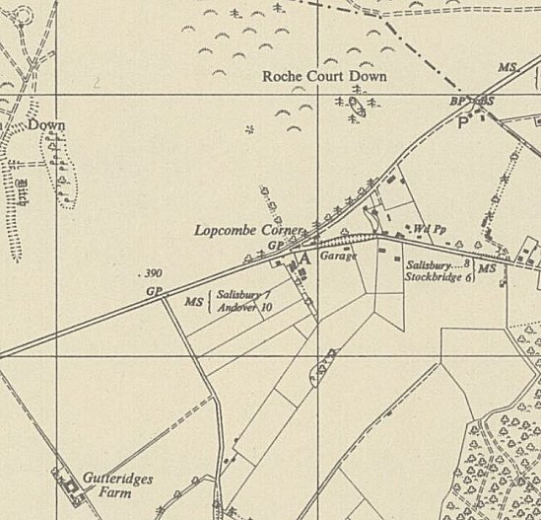
 | Ordnance Survey1958

