Camp 89 - Easton Grey Camp, Malmesbury, Wiltshire

Included in the 1945 ICRC camp list – Labour Camp. 89. Easton Grey Camp, Malmesbury, Wilts.

1947 Camp list
89(G.W.C.) | Easton Grey Camp, Malmesbury, Wilts | S. | Priswar, Malmesbury | Malmesbury 3112 or 3113 | Malmesbury | Lt.Col.J.G.Selby | v/1453/2
Name crossed out and R.M.Mayhill handwritten

Prisoner of War Camps (1939 – 1948) - Project report by Roger J.C. Thomas - English Heritage 2003
OS NGR | Sheet | No. | Name & Location | County | Cond’n | Type 1945 | Comments
ST 8915 8750 | 173 | 89 | Easton Grey Camp, Easton Grey,  Malmesbury | Wiltshire | 2 | German  Working Camp | STANDARD type. Light industrial and  agricultural use

Location: About 4 km W of Malmesbury.  Before the camp: Farmland  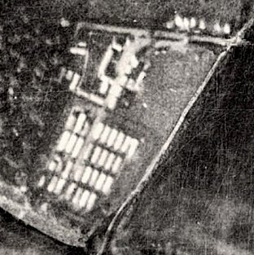  Pow Camp: Italian working camp / labour battalion up to 1945, then a German working camp. The site had a standard layout with a main pow compound, with guards’ huts and offices at the front alongside the road. Common buildings and facilities at standard type camps included water towers, offices, officer's mess, a canteen, guard rooms, barrack huts, ablution blocks, cell blocks, a camp reception station (medical facility/hospital), a cookhouse, dining rooms, recreation rooms and living huts or tents.  1942/1943 – Camp opened for Italian pows.  1948 aerial photograph >  1943 – Hostels listed for Italian pows: Thornbury; Chippenham; Purton.  5 May 1944 - Hostels listed for Italian pows from this camp, (WO 32/10737): Chippenham, Wiltshire; Devizes, Wiltshire.  May and November 1944 - The camp was listed as an Italian Labour Battalion under the Southern Command area and then as an Italian POW Working Camp, (WO 32/10737). The Italians were recorded as non-co-operators. | 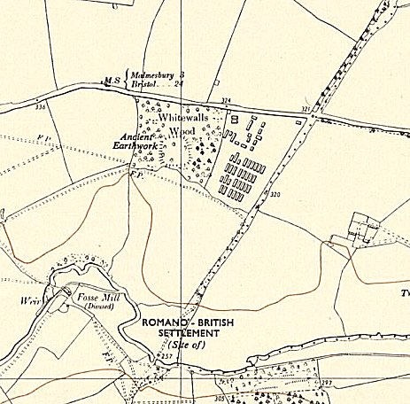
 | Ordnance Survey 1958
The Italians converted one of the huts to a chapel with an exquisitely painted ceiling.

Late 1944 – Italian Working Camp. Commandant; Major A E Boughton.

Oversight and development of re-education activities and English teaching for German pows was carried out by PID (Political Intelligence Department of the Foreign Office) / COGA (Control Office for Germany and Austria – UK). Visits and reports were made. The standard of the reports varied greatly. The visitors took little interest, if any, in activities other than re-education. They rarely mentioned welfare, sports, games, pastimes, crafts, etc of the pows.
Spring 1945 – Commandant Major G F Sutton, DSO, MC.

29 May 1945 – Segregation Section; Progress Report 89 (FO 939/383); A nominal roll of 100 German pows was listed as additional labour for this camp, transferred from Llanover Park Camp 200.

3 August 1945 – Segregation Section; Progress Report 149 (FO 939/383); the German pows at the camp had been politically screened. It was recommended that 4 Nazis, (C grade) be removed and replaced by 4 A/B pows from Camp 23.

September 1945 - Appendix to HQ Southern Command War Diary– Easton Grey, Malmesbury – German labour camp – capacity 800 – 103/336083 [old grid ref].

Italian hostels – Chippenham, Sherston, Thornbury, Nibley, Ladyfield, Lyneham – total cap 500

24-25 June 1946 – English Inspector’s report. Total strength – 1184 in main, 3 hostels and billets. 109 pupils in 5 classes at main and Thornbury hostel.

English Inspectors met teachers, gave talks, checked teaching texts and resources, and tested the pow pupils.

Books and dictionaries requested.

4/5 July 1946 – General survey. (Report mis-filed under FO 939/162). Strength; 0 officers, 1184 Other Ranks in main, 3 hostels and billets.

Commandant: Lt Col G F S Sutton DSO, MC. Camp leader: Stabsfeldwebel M Triflinger (A)
Interpreter: Capt Graham Deputy C/L: Ofw Koenig (A)
German M.O.: U/Arzt Ziedech.

The Commandant was absent, but believed to be supportive of re-education activities. It was stated that he was fair and looked after the pow’s welfare. Rank of Lt Col in recognition of the increased size of camp.

The Interpreter spoke little German, they were often used as intelligence officers rather than as interpreters.

150 pows arrived from camps in the USA. Most had very low morale as they had been misinformed in the US that they were being repatriated. Instead, they found themselves in working camps in the UK.

186 pows were transferred from Camps in Belgium where they had experienced extremely poor conditions. Many of these were young Waffen-SS men.

Political screening: | A+ | A | B | B- | C | Unknown
 | 1 | 58 | 376 | 1 | 33 | 64

Overall morale was high. The British staff were regarded as good and activities were taking place. Negative factors were; pows with homes in the Russian zone, pows from USA, no date set for repatriation, and bad news from home.

c.400 ‘youth’ pows (under-25). A compulsory meeting and talk (by doctor, padre, a lawyer, etc) took place weekly for them. Very unusual for it to be compulsory, it aroused resentment at first, but it was soon accepted.

A good team of pows developed re-education activities. The standard list was given:

Wochenpost and Ausblick – 220/50 received, more requested.

Newspapers – Adequate supply of British papers. Very few Swiss or German papers.

Library – 700 books. A lack of light literature.

Lectures – regular, approx. monthly.

Discussion groups – Fortnightly except during summer when either harvest work or other activities were preferred. 70-80 pows attended.

Films – YMCA every 3 weeks, PID films fortnightly.

Wireless – 1 set with 5 loudspeakers.

Camp magazine – “Spiegel,” [Mirror]; excellent, fortnightly. Stencils needed.

English – separate report.

Other camp activities –

Religion – 36 “freethinkers”, 696 protestants, 461 RC. Protestant Pastor Műller held Sunday services and a Bible class during the winter, he visited the hostels weekly. A German speaking RC priest from Malmesbury visited.

Education – classes for Spanish, commerce, drawing and agriculture. Some youth pows were ‘apprenticed’ to the baker, the cobbler and the tailor.

Entertainment – Regular theatre and music shows. 12 member orchestra. 40 member choir, also performed in churches. Music scores requested. A marionette theatre.

Summary – a very well run camp.

16/18 October 1946 – English Inspector’s Report. Strength; 1350 in main, 7 hostels and billets. 166 pupils in 9 classes at all sites.

Commandant: Major Lockart [new] Lagersprecher (Camp Leader): Fahnrich Heinz Wierz [new].

A new, unnamed, Staff Sgt Interpreter – “young Viennese, refined, charming and well-educated.”

2 pows in the main camp were Austrian.

A slightly less rosy picture was given regarding conditions at some of the hostels, with lack of teaching materials and no newspapers at most sites.

1947 – a small detachment of Bomb Disposal pows were based at a hostel for this camp at the village of Oaksey, though they were administered by Camp 6. (FO 939/83)

13/15 January 1947 – English Inspector’s Report. Strength; 971 in main, 7 hostels and billets. 92 pupils in 7 classes at all sites. Some pows studied privately.

Commandant: Lt Col G Selby, MC [new]

The camp overall was reported as being not satisfactory. Whether this is due to the new Commandant, or the description given 6 months earlier being too good, is not clear. It was stated that no British officer took any interest in re-education, as was the case in most camps.

17/19 May 1947 – English Inspector’s Report. Strength; 1219 in main, 7 hostels and billets. 68 pupils in 8 classes at all sites.

Lagersprecher: S/Gf G Krause [new].

There was a steady decline in the numbers learning English, as at most other sites. A graduate from Bristal University visited fortnightly to give lectures.

14/16 July 1947 – Re-education Report. Strength; 1 officer (the M.O.), 1312 OR.

Commandant: Lt Col Selby. Camp leader: SGefr Gűnter Krause (B)
Interpreter: S/Sgt Popper Deputy C/L: Ofw Heinz Ludwig (B-)
German M.O.: O/Arzt Heinrich Jung (B)

The Commandant was ‘co-operative’ regarding re-education activities – but that did not mean he actually did anything to promote them. The British staff were disinterested, and their attitude to the pows was “poor.” The only exception was the interpreter; it was stated that he was intelligent, but “lacking in personality… and shows little initiative.”

Camp leader, aged 28, bank clerk, single, protestant. Had been a member of the Hitler Youth and Nazi Party. Leader for two months – “a rather conceited young man.” He supported re-education activities, but did not lead any. “Needs watching for a while.”

Deputy C/L, aged 32, aircraft technician, married, protestant, member of the Nazi Party, but “seems quite sincere in his conversion.” New to this post.

German MO, aged 35, single, protestant. Member of Nazi Party. “Not a good type, an ex idealist Nazi and not yet fully convinced that he was wrong. Not to be trusted.” In post for 3 weeks.

Morale was only “fair to poor.” The usual reasons were given – slow repatriation, bad news from home, fear of Russia. Relaxation of fraternisation rules had improved things a little. Many were still politically sceptical regarding democracy. 324 pows repatriated to date.

40% of pows were youth – but the fortnightly compulsory meetings had ended.

The standard list of re-education activities showed a gradual deterioration;

Wochenpost and Ausblick – separate appendix.

Newspapers – adequate, but “type of paper is.. politically one-sided.” [Which side?] Still very few German or Swiss papers.

Library – 1034 books including new books sent by the International Red Cross. More fiction requested.

Lectures – regular, but only 80-150 attending.

Discussion groups – only a small group of 8-12 pows meeting fortnightly to discuss items in the information room.

Films – Adequate, though some films were considered to be poor.

Wireless – Adequate, except at Minety.

Camp magazine – 350 copies issued monthly. Shortage of paper noted, as elsewhere.

Press reviews – Ended, may restart.

English instruction – separate appendix.

Information room – converted hut to display text and pictures sent by PID Visual Education. Displayed in main then sent to hostels.

Other camp activities –

Religion – Little interest. Protestant padre, Uffz Paul Gerich (B) aged 44, married. “Not a very spiritual man, rather gross and crude; believes that a full stomach is the basis of all moral feeling.” Despite these comments the report stated he had done some quite good work in the camp.

Education – just a small French class run by the Interpreter.

Entertainment – A theatre group and small orchestra gave occasional concerts.

Many pows formed good relationships with local civilians. There were few formal arrangements with small groups visiting Bristol Magistrate’s Court; Bath Town Council; and Salisbury Model Parliament.

13-16 October 1947 – Re-educational Survey. Strength; 1 officer, 1199 OR.

A new Commandant, Lt Col R M May-Hill, started 4 weeks earlier.

No British Interpreter, a German pow was acting as interpreter - Joachim Wirth (B).

Overall morale was ‘moderately good’ owing to the previous stated reasons.

Simplified screening grades were in use: A 2 / B 1198. 2 pows were appealing their grades - the better the grade the sooner repatriated in theory.

Pows repatriated to date: 3 ‘whites’ (A graded); 111 ‘Groups’ (usually pows who had specific work skills identified by COGA, eg miners); 23 sick; 39 compassionate grounds, 4 protected personnel; 1 special (possibly under investigation).

The standard list of re-education activities was given with little change from the previous report. The small discussion group in the main camp had ended. Press reviews were displayed in the Information Room.

Entertainments – there was an attempt to revive the orchestra, no mention of the theatre or choir. Football and table tennis were the main recreation, including matches against local civilians. Pows were allowed to visit the theatre in Chippenham, though needed to request permission for shows that ended late.

Informal contacts were good. There were very few formal contacts in this rural area.

14 November 1947 - Camp number included in an ‘Urgent Memorandum’ (FO 939/270) regarding inspection of food parcels.

24/27 November 1947 – English Inspector’s Report. Strength; 954 in main, 6 hostels and billets. 59 pupils in 8 classes at all sites.

17-18 December 1947 – Re-educational Survey and to start a discussion group. Strength; 2 officers, 988 OR.

Commandant: Lt Col R M May-Hill Camp leader: SGefr Gűnter Krause (B)
Interpreter: S/Sgt Bailey [new] Deputy C/L: Nil
German M.O.: S/Arzt Eckart Heise (B+) [new]

Speedier repatriations improved morale. 180 pows notified of repatriation due in January 1948.

Informal contacts were excellent – many pows had invitations to stay over with families at Christmas, or attend Christmas dinner. Toys made by the pows were distributed to local children Some small concerts were given as well as participation in Christmas services.

There were some formal contacts with groups, but they were slight – YMCA, Chippenham TUC, a table tennis club, social evening at the Blind Society in Cricklade, Toc H, and local Quakers.

March 1948 – camp became a hostel for Eden Vale Camp 114, together with Lyneham, Ladyfield and Westonbirt hostels.

Known Camp Commandants
1944 Major A E Boughton. Indian Army. Later Commandant at Norton Camp 174.
1946 Lt Col G F S Sutton DSO; MC.
1946 Major Lockart
1947 Lt Col J G Selby, from the Royal Artillery.
1947 Lt Col R M May-Hill, from the Welch Regiment.

After the camp: 2019 a small light industrial site.

Further Information:

National Archives FO 939/169 – 89 Working Camp, Easton Grey Camp, Malmesbury, Wiltshire. Dated 1946-1947. Used above.

Camp magazine – No.1 – 16 November 1946 - Der Spiegel : Halbmonatzeitung des P.O.W. Camp 89 - The Wiener Holocaust Library

Camp numbers

 | Open |  |  | With other camps |  |  | Unknown |  |  | Not listed / not open

 | 1943 | 1944 | 1945 | 7/1946 | 10/1946 | 1/1947 | 5/1947 | 7/1947 | 10/1947 | 11/1947 | 12/1947
Easton Grey |  |  | German cap.800 | 760 | 672 | 648 | 552 | 606 | 585 | 650 | 557
Chippenham |  |  | Italian | 50 German | 48 | 2
Purton |  |  | With C25 | With C289
Thornbury |  |  | Italian | 84 German | 84 | 77
Devizes
Ladyfield |  |  | Italian |  | 2 | 47 | 82 | 85 | 79 | 82 | 76
Lyneham |  |  | Italian |  | 50 | 46 | 47 | 44 | 37 | 30 | 21
Nibley |  |  | Italian |  | 71 | 64 | 107 | 89 | 70 | 61 | 50
Sherston |  |  | Italian | 120 German | 115 | 75 | ? | 67 | 62
Westonbirt |  |  |  |  | 112 | 62 | 46 | 66 | 92 | 63 | 55
Minety |  |  |  | With C289 |  |  | 29 | 36 | 39 | 27 | 25
Latton | With C25 |  |  | With C289 |  |  | 47 | 54 | 40 | 41 | 40
Billets |  |  |  | 170 | 196 | (1) | (1) | 266 | 196 | (1) | 166
Total |  |  |  | 1184 | 1350 | 971 | 1219 (2) | 1313 | 1200 | 954 | 990

(1) Included in figures above. (2) The figures stated add up to 910, not 1219.

Hostels

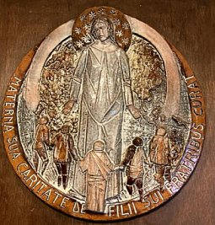 | Chippenham, Wiltshire. A building rather than huts. 10m S of Malmesbury. Local memories place it at Greenway Lane by St Paul’s School – approx. NGR ST 918 747  7/1946 – Hostel leader; Fw Heiden (A)  Another hostel nearby – see Ladyfield, below.  The plaque was made by Italian pows and delivered to Cannon Millet at St Mary’s R C Church, Chippenham. Inscription reads; “Italian soldiers, prisoners of the Second World War, would like to express their gratitude to the people of Chippenham for the humanity received during their imprisonment.”
   | 1943 | 1944 | 1945 | 7/1946 | 10/1946 | 1/1947 | 5/1947 | 7/1947 | 10/1947 | 11/1947 | 12/1947
  Chippenham |  |  | Italian | 50 German | 48 | 2

Devizes, Wiltshire.

Too few details to be able to identify.

 | 1943 | 1944 | 1945 | 7/1946 | 10/1946 | 1/1947 | 5/1947 | 7/1947 | 10/1947 | 11/1947 | 12/1947
Devizes

Ladyfield, (Chippenham). 10m from main camp. Huts. NGR ST 908 727.  Memories placed the hostel on the playing fields by Ladyfield Road. I have identified a likely group of buildings.  The gap in 1946 may be due to the hostel holding Italian pows – these were ignored in PID reports.  1/1947 – there were unspecified problems between the pows and the British staff. A later report in October recorded some issues arising with youth pows.  7/1947 – Hostel leader; Uffz Heinz Hildebrandt (B+), aged 36, clerk, married, protestant. “Intelligent and decent.” Active supporter of re-education. 12/1947 – Same leader.  March 1948 – became a hostel for Eden Vale Camp 114. | 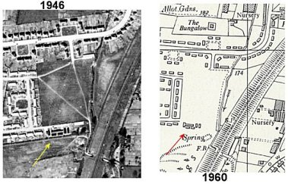
   | 1943 | 1944 | 1945 | 7/1946 | 10/1946 | 1/1947 | 5/1947 | 7/1947 | 10/1947 | 11/1947 | 12/1947
  Ladyfield |  |  | Italian |  | 2 | 47 | 82 | 85 | 79 | 82 | 76

Latton. (Cricklade). With Lodge Farm Camp 25 to 1945, then Lydiard Millicent Camp 289.

7/1947 – Hostel leader; Gefr Emil Becker (B-), aged 33, paint merchant, single, protestant. Member of Hitler Youth and Nazi party. “Politically negative but quite a decent type.”

12/1947 – Hostel leader; S/Gefr Werner Hartmann (B), was leader at Sherston.

 | 1943 | 1944 | 1945 | 7/1946 | 10/1946 | 1/1947 | 5/1947 | 7/1947 | 10/1947 | 11/1947 | 12/1947
Latton | With C25 |  |  | With C289 |  |  | 47 | 54 | 40 | 41 | 40

Lyneham. (Wootton Basset). 8 miles SE of Malmesbury. Huts.

The gap in 1946 may be due to the hostel holding Italian pows – these were ignored in PID reports.

10/1946 – No electric supply. Lighting by lamps / candles and there was a shortage of these. British and Germans were depressed by conditions at the site.

7/1947 – Hostel leader; Fw Alfred Keilhauer (B+), aged 35, printer, married, protestant. “Does not seem to get on well with his men.”

10/1947 – Hostel leader; Wm Johannes Műller (B) – “intelligent, has a sense of humour, and is re-educationally active.”

Still no electricity supply. Pows visited the cinema at the airfield to watch films. 12/ 1947 – Same leader.

March 1948 – became a hostel for Eden Vale Camp 114.

 | 1943 | 1944 | 1945 | 7/1946 | 10/1946 | 1/1947 | 5/1947 | 7/1947 | 10/1947 | 11/1947 | 12/1947
Lyneham |  |  | Italian |  | 50 | 46 | 47 | 44 | 37 | 30 | 21

Minety, (Cricklade).

7/1947 – Hostel leader; Maat Gerhard Moells (B+), aged 32, lorry driver, married, protestant - “Easily influenced by sensational news or rumour.”

A small discussion group. No electricity supply, pows visited Latton hostel to watch films.

12/1947 – Hostel leader; O/Wm Heinz Ludwig (B-), he had been deputy leader for the whole camp.

 | 1943 | 1944 | 1945 | 7/1946 | 10/1946 | 1/1947 | 5/1947 | 7/1947 | 10/1947 | 11/1947 | 12/1947
Minety |  |  |  | With C289 |  |  | 29 | 36 | 39 | 27 | 25
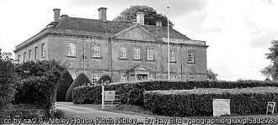
Nibley. (Wootton u/Edge). 15m NW of Malmesbury. Nibley Hall – ST 737 959.

10/1946 – No electric supply – lighting by oil lamps.

7/1947 – Hostel leader; Funkm Hugo Rutsch (B+), aged 33, printer, married, protestant. Member of Nazi party. “Decent type.” Supported re-education.

10/1947 – Still no electricity supply. 12/1947 – Same leader.

 | 1943 | 1944 | 1945 | 7/1946 | 10/1946 | 1/1947 | 5/1947 | 7/1947 | 10/1947 | 11/1947 | 12/1947
Nibley |  |  | Italian |  | 71 | 64 | 107 | 89 | 70 | 61 | 50

Purton. (Camp 160 - Military Hospital, Lydiard Park, Purton and Camp 289 Lydiard House, near by).

1943 – Italian pows.

 | 1943 | 1944 | 1945 | 7/1946 | 10/1946 | 1/1947 | 5/1947 | 7/1947 | 10/1947 | 11/1947 | 12/1947
Purton |  |  | With C25 | With 289

Sherston. 2 miles W of Malmesbury. Huts and a building. Memories place the site in Pinkney Park just NE of Sherston.

7/1946 – Hostel leader; SFw Voigt (A)

7/1947 – Hostel leader; SGefr Werner Hartmann (B), aged 33, forwarding agent, married, no religion. Member of the Nazi Party. “Quite frank and honest.”

 | 1943 | 1944 | 1945 | 7/1946 | 10/1946 | 1/1947 | 5/1947 | 7/1947 | 10/1947 | 11/1947 | 12/1947
Sherston |  |  | Italian | 120 German | 115 | 75 | ? | 67 | 62

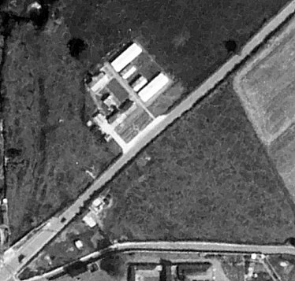  Thornbury. 18 miles from main camp, 10 m N of Bristol. Huts. Many of the details below are from: https://www.thornburyroots.co.uk/war/pow/#ww2  18 March 1943 - A letter from Spicers (builders) Ltd of Worcester who were contracted to install the drains mentions that the camp was to be erected by the Italian pows and suggests that the work done would be of very poor quality.  Memory from after the Italian armistice - "they were split up into two groups, those who wore green uniforms and those in brown. The former were the collaborators who went out daily to work on the farms and, apart from the curfew hours, were authorised to visit the town. The ‘browns’ were the fascist element who did not intend to help the British war effort and were initially given less freedom. However, they too were eventually allowed into town.”  1 September 1945 – Report in Western Daily Press that Alfredo Pieraccini, aged 36, was seriously injured by a horse-driven cart at a farm in Marlwood. He suffered injuries to the spine and head and was treated at Bristol Royal Infirmary.  Aerial photo 1950 | 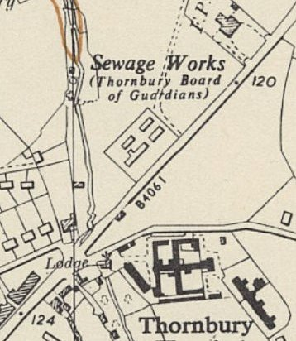
 | Ordnance Survey 1955
June 1946 – Report in the Gazette that some Gloucester farmers had reported that pows were making articles for sale and selling these to the public, which was against the law. This was widespread in all camps, most took no notice, others confiscated goods and money raised. Not all civilians objected – “The Italian prisoners who populated it were put to work on the local farms. In their spare time some of them made baskets which they decorated and sold for ‘pocket money.’ I bought two, one of which serves me to this day. In a few years’ time it will be an antique — like me!” https://www.bbc.co.uk/history/ww2peopleswar/stories/26/a5325626.shtml

7/1946 – Hostel leader; Ofw Stutz (A)

 | 1943 | 1944 | 1945 | 7/1946 | 10/1946 | 1/1947 | 5/1947 | 7/1947 | 10/1947 | 11/1947 | 12/1947
Thornbury | Italian |  | Italian | 84 German | 84 | 77

Westonbirt. 2½m NW of Malmesbury. Huts. “Adjoins the Hare and Hounds Hotel.” Hotel = ST 862 904.

10/1946 – Lack of teaching materials.

7/1947 – Hostel leader; OFhn Arthur Seibold (B-), aged 33, flying instructor, married, protestant. Member of Nazi party. “Typical German NCO type, non-political but seems sensible.” 12/1947 - Same leader.

March 1948 – became a hostel for Eden Vale Camp 114.

 | 1943 | 1944 | 1945 | 7/1946 | 10/1946 | 1/1947 | 5/1947 | 7/1947 | 10/1947 | 11/1947 | 12/1947
Westonbirt |  |  |  |  | 112 | 62 | 46 | 66 | 92 | 63 | 55

