Camp 50 - Garswood Park, Ashton-in-Makerfield, Lancashire

Included in the 1945 ICRC camp list – Labour Camp. 50. Garswood Park Camp. Ashton-in-Makerfield, Wigan, Lancs.

1947 camp list
50(G.W.C.) | Garswood Park Camp, Ashton-in-Makerfield, Wigan, Lancs | W. | Priswar, Aston-in -Makerfield | Ashton-in- Makerfield 7215/6 | Ashton-in-Makerfield | Lt.Col.L.Pratteley. | v/1453/2

Prisoner of War Camps (1939 – 1948) - Project report by Roger J.C. Thomas - English Heritage 2003
OS NGR | Sheet | No. | Name & Location | County | Cond’n | Type 1945 | Comments
SJ 5749 9849 | 108 | 50 | Garswood Park, Ashton-in-Makerfield | Lancashire | 4 | German Working Camp | STANDARD type. Site occupied by a school

There were two main sources for the entries below:

1. Two files of reports held at the National Archive, details below.

2. Research and a presentation by Anthony Pilgrim, (with The Makerfield Archive). He has made many pictures and a great deal of information available on - POW Camp 50 | Flickr . I am very grateful that he has allowed me to use some of the pictures and further information he collected. His site contains a good deal of further information on such matters as the backgrounds to the visiting lecturers.

Locations:  The main camp and 2 compounds were located within Garswood Park. The park is on the S edge of Ashton in Makerfield. There were many other hostels, see below.  Site A the main camp – NGR SJ 575 984.  Sites B and C – these were most likely the locations of Garswood Compounds I and II. This is not definitely confirmed, but evidence consists of:  - references that the compounds were within ½ mile from the main camp.  - references to the compounds being within Garswood Park.  - no other observed sites in the area. | 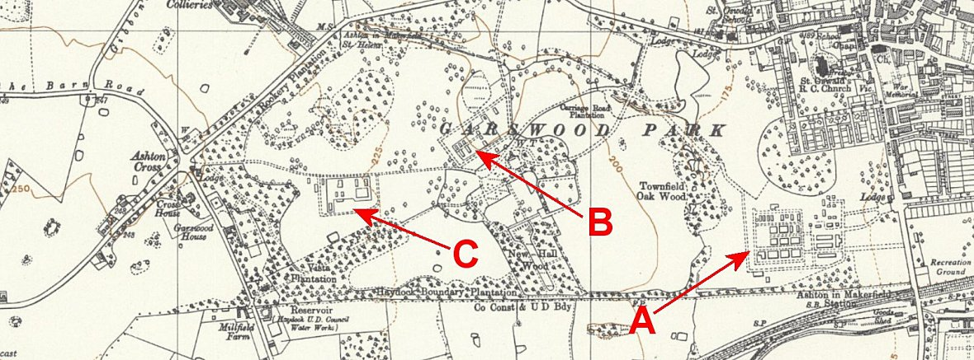
 | Ordnance Survey 1956
Before the camp: Parkland for a large country hall.

Site A was purpose built as a pow camp. Sites B and C: U.S. troops were billeted at Garswood Park up to D-day, (units of the 310th and 315th Field Artillery Battalions, and, 313th and 317th Infantry Regiments).

An entry in the ‘History of the 313 US Infantry’ stated:

“Both Garswood Park and Marbury Hall were almost completely devoid of facilities when the advance party arrived. Both areas had a few barrel-shaped buildings scattered about, which were used as kitchens and administrative buildings. But aside from these few structures neither location gave any evidence of being a probable camp site…. Companies C and D of the 749th Tank Battalion, already stationed in England, were detailed to assist in putting up the pyramidal tents which later served to house the troops.”
The ‘barrel-shaped buildings’ could have been Quonset or Nissen huts which are very similar.

The entry makes it sound as if there was just one camp, but separate details about the work of the 360th Engineer General Service Regiment clarifies that there were 2 US camps at Garswood Park, (and a further 2 at Golborne Park which also became compounds / hostels for Camp 50).

It is probable that sites B and C were the location for these US troop camps before D-day – and afterwards serving as the Garswood Compounds with the addition of hutted accommodation.

Pow camp:  During 1941 it was proposed to rapidly increase the number of Italian pows available as a workforce within the UK, (‘Man Power’ – 27 October 1941 WP (41) 247).  In order to distribute the expected large number of pows in 1942, the Ministry of Agriculture requested that new camps be built rather than existing ones expanded. 21 new sites were identified and Italian pow construction gangs were allocated from other camps to work with the Pioneer Corps, (Minutes of meeting ‘Employment of Italian Prisoners of War’, 9 December 1941 – the full minutes in UK Policy notes (ww2pow.uk).  December 1941 – Garswood Park was accepted as a site for a pow camp. An Italian pow construction gang was allocated from Warth Mills Camp 8 to work with the Pioneer Corps. A tented camp was established for the construction workers. The work was carried out under the responsibility of the Ministry of Works and Building. | 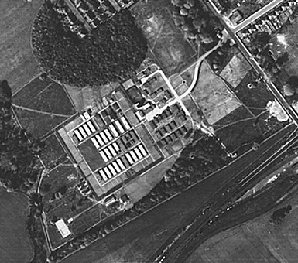 | 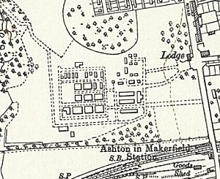
 | Aerial photo of the pow camp | Ordnance Survey 1956
The camp had a standard layout - British troops / administration area at the ‘front’ (East) – near to the road, and the pow compound at the rear.

30 September 1942 – List of POW Camps:

50 | Garswood Park Camp, Ashton-in-Makerfield, Wigan, Lancs | Capacity  750 | Command  Western | Telegraph: Priswar, Aston-in -Makerfield | Commandant:  Major J S Partington | Adj & Quartermaster:  Lt W H Snell | Italian Working Camp | W/E  v/447/3

October 1942 – the camp opened for Italian pows.

15 November 1942 – Strength; 2 officers; 728 Other Ranks.

16 November 1942 – Not surprisingly, the relationship between the camp and the local people appears to have been strained at the start:

“Complaints having been received as to the provocative actions of Italian Prisoners of War in giving the Fascist salute to pedestrians as the prisoners are passing along the roads of the district in lorries, it was

Ordered: That the Commander of the camp and the Police be requested to take all necessary steps to stop the practice of the prisoners, which was likely to cause general disturbances.” (Extract from Ashton-in-Makerfield UDC Finance & General Purposes Committee minutes, 16/11/1942 – Wigan Archives ref. UD Ash/A/A1/66).

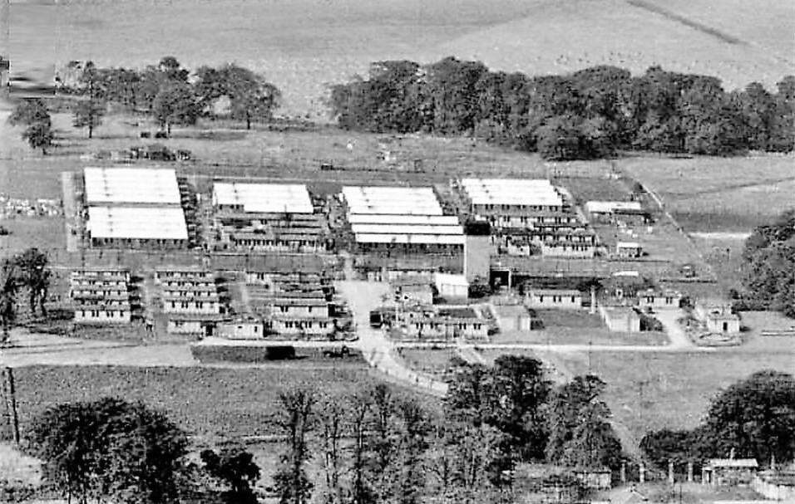 | < Aerial photograph by Aerofilms Ltd, 1947. Guards’ area at front, water tower in view. Clear perimeter for pow area at back, though by 1947 the barbed wire fence had probably been removed or at least lowered. Note - There are no Nissen type huts visible in this photo.  1943 – 6 hostels attached to Camp 50 for Italian pows: see table below.  September 1943 - Following the Italian Armistice, the camp was recorded as having mixed non-co-operator and co-operator Italian pows.  1943, Memories of Italian pows - “With the passing of winter, Italians billeted on the local farms had grown familiar with our district. It was, therefore, no surprise to meet an Italian soldier jauntily cycling along the lanes as we strolled across the field to Houghton Green on a pleasant Sunday evening in April. An approaching stranger, however, was highly indignant at the scene. “That's an Italian! They wouldn't let our lads do that in Italy” was his heated comment as we passed him by.  Arriving at Houghton Green we came upon a small group of Italians sharing in the village children's games. One young prisoner joined with a child in whirling a rope as the remainder vied with the youngsters in the art of skipping. Here was a typical example of the Italians' attitude towards their captors. One could hardly imagine a group of fanatical Nazi prisoners doing likewise...

News of Italy's unconditional surrender was announced during the 6pm BBC News Bulletin of 8th September 1943, bringing a feeling of intense relief at the prospect of an early end to the slaughter on the Italian mainland. Over at Southworth Hall Farm, however, six Italian soldiers, captured in 1940, heard the news in sullen silence. The capitulation had shattered their conviction that Italy would win through... ” [(1) “A North West Village At War”]

19 November 1943 - An International Red Cross visit took place - Italian prisoners, capacity 800.

27 March 1944 – “In the adjoining village of Houghton Green an Italian met with a fatal accident on Monday 27th March as a result of a fellow prisoner disobeying instructions. The unfortunate affair occurred outside an 18th century farmhouse, where a batch of prisoners had received instructions to remove a load of potatoes from a low roofed barn into a motor lorry stationed in the farmyard. Finding the journey to and from the vehicle rather irksome, a foolhardy prisoner surreptitiously started the engine, slipping in the clutch so clumsily that the lorry lurched backwards into the barn, fatally crushing a young compatriot against the end wall. A simple wooden cross inscribed “Soldato F Russo, Italian Army, 27.3.44” marks the victim's final resting place at Wargrave [i.e. Newton-le-Willows] Cemetery.” [(1) “A North West Village At War”]

It was not actually the final resting place. Soldato Francesco Russo was re-buried at Brookwood Military Cemetery with over 300 other Italians who died in the UK during WW2.

5 May 1944 – Hostels listed for Italian pows from this camp, (WO 32/10737): Moor Park, Preston, Lancashire; Wimbrick House, Ormskirk, Lancashire.

May 1944 – after the Italian armistice (September 1943), in May 1944, Italian pows were asked if they wished to work as, 'co-operators', which would allow them to be utilised on a much wider range of work, rather than as pows with employment restrictions imposed by the Geneva Convention. For co-operators the rates of pay were increased and some limited greater freedoms were allowed. 'Non-co-operators' could still be required to work, but on a more limited range of occupations. Garswood was noted as having both co-operator and non-co-operator Italian pows. They were often separated in different compounds / hostels, though I have not seen evidence for this at Garswood.

Memories – “we saw a notable change in the dress of Italians employed on local farms. The glaring identification patches on tunics and trousers had vanished and bold shoulder flashes marked ITALY indicated that the wearers had become “Collaborators” and were entitled to extra pay and liberty. Permission to visit theatres and cinemas was also granted and the sight of our late foemen reclining in the cosy seats of local cinemas was seen occasionally as the months went by...” [(1) “A North West Village At War”]

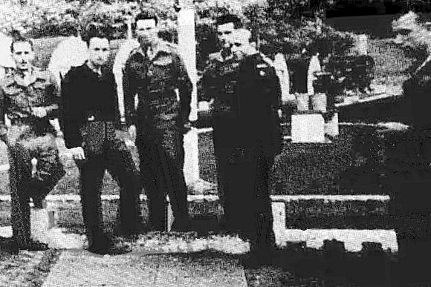 | Italian pows at Garswood.  < from wiganworld.co.uk  The pictures show Nissen type huts at Garswood.  The aerial photo above does not show this type of building – so were they part of the Compounds at Garswood I and II – described as being “barrel shaped buildings”? | 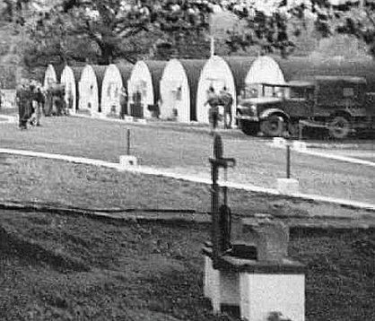

May 1944 and November 1944 - The camp was listed as an Italian Labour Battalion under the Western Command area, (WO 32/10737).

Memories – “Throughout their stay they were put to work on various projects, on local farms and in the locomotive sheds at Horwich. Our Italians, those who came to work on our farm, built a Dutch barn for us.

Every day they were brought in a truck. My family would not allow them in the house but confined them to a dusty, dirty outhouse where they ate their lunch. One Monday when the weather was foul and they could not work on the barn they sat around in the outhouse. It so happened that that was where my mother did the Monday wash. This particular Monday my mother was further harassed by the presence of the Italian prisoners. They sat on the troughs which contained the animal feed. They even sat on the boiler where the clothes were bubbling merrily. Mother's nerves were getting more and more frayed. However, when lunchtime arrived her heart was melted. The overseer arrived and handed out to each one half a loaf and one sardine. Some of the men made a hole in the middle of the bread and stuffed the sardine inside. To quench their thirst they were told to fill up their tin cups from the tap in the outhouse. This was covered in spiders' webs. Among the group was Carlo from Milan. He could just not bring himself to drink from this tap. He was heartsick. From that moment on my mother took them all under her wing. In fact, her kindness to them was talked about back home which led the postmistress from Naples, one Gilda Crisci, to write to her up to Mother's death in 1966.

I can picture every one of 'our Italians' even now fifty years later. There was Francesco, Oreste, Paolo, slim Giovanni. Little Giovanni came from Sicily along with Michaelo. The latter made me a little silver bracelet out of his cigarette case. The front has his initials and the back has 1939 engraved on it, the start of the war, but he was moved before the end of the war. I still have that little bracelet and fond memories. I also have a photograph of myself, their little Guiseppina as they called me, framed in silks.

Sometimes tempers flared as they worked on the barn. One day there was an almighty racket at the top of the farmyard. One young Italian thought himself a cut above the rest. To dig a hole for the Dutch barn supports was quite beneath him so he had lounged about all day. When the overseer returned in the evening he realised what had happened so the young Italian was made to dig. The rest of the gang stood around taunting him and blowing cigarette smoke into his face. This so enraged the young man that he went into a frenzy. He had a good command of English and when Grandad went out to find the cause of the commotion he screamed, “I work, he shout. I'll smash heez bloddy face in with theez shovel.”

We still wrote to them after the war but eventually they married and we lost touch.” [(2) “One Child's War”]

May 1945 – 3 pows billeted at a farm were accused of consorting with under-aged girls. “Italians and Girls – Court-martial proceedings against three young Italians were resumed at Ashton-in-Makerfield, to-day, when Ievole Giovanni, Millinaci Pasquale, Bruzzi Spedito, were charged with consorting with girls under the age of sixteen at a farm near Burscough, on dates in January.

The girls were alleged to have absconded from an approved school and to have either visited the farm or stayed about it…

Today, Giovanni told the court that one evening in January the girls came to the farm and said they were cold. There was snow, and they asked permission to warm by the fire. They were told they could do so, but must go away afterwards. All looked 19 or 20. The four witnesses who gave evidence the previous day had never spent the night at the farm to his knowledge. They stayed about a couple of hours. He had nothing to do with the girls. He slept upstairs at the farm, but could not say how it came about that some of the girls' belongings were found there…. Proceeding.” (The Liverpool Echo, 23 May 1945).

The girls had absconded from Northenden Road School, Sale. “The girls admitted running away and persuading the Italians to let them stay in the cottage with them, also that the men first told them that they ought to go back. They had also asked the girls to leave the cottage. One girl said she lived there just over a fortnight. Giovanni said most of the things the girls said were lies, and the defending officer described the girl’s story of staying at the cottage as a complete fabrication, adding that the girls looked older than their age, talked of sex with adult knowledge, and should be treated as women of the world.” (The Wigan Observer, 26 May 1945).

Two of the girls refused to give evidence, and the story that some of them were there for over two weeks was stated to be impossible.

Anthony Pilgrim noted – “Frustratingly, the outcome of the proceedings was not reported and I can find no further record of the three accused. It may be that news of the verdict was suppressed so as to prevent any repeat of the violence at Ashton that had occurred on the first day of the trial. Some newspapers linked the fracas - near the Warrington Rd/Gerard St junction - with disclosures made at the court-martial.”

May 1945 – possibly linked to the previous articles: “Court-Martial Sequel: 700 Italians’ One-day Strike After Fight in Lancashire Town – Seven hundred Italian collaborators, at Garswood Park Camp, Ashton-in-Makerfield, staged a one-day “sit-down” strike as a protest following a street fight between some of their colleagues and British Servicemen and civilians. They refused to do any work after the Commandant had confined them to camp as a precaution while an inquiry was held into the incident.

Tonight, however, their freedom of movement within a five-mile radius will be restored, and they will be allowed out of the camp in the normal way.

As an added precaution extra Military Police were drafted into the town today for the first time since the camp was established three years ago. They will patrol the streets, together with reinforced civil police.

The atmosphere in this mining town of 20,000 people to-day was tense, and the authorities and other inhabitants believe that special care will be needed if further trouble is to be avoided.

The fight followed the end of the first day's hearing at a British court-martial in the camp, of a case in which three Italian prisoners were charged with improperly associating with four 15-years-old British girls who had escaped from a Manchester approved school.

An eye-witness describing the scene today said: “A crowd of young men, including several just repatriated after being behind barbed wire in Italy, objected to the way a number of Italians were allowed to walk along the street with our girls. A large-scale, bitter fight developed, involving about 200, and the police, including the Italian Carabinieri, only cleared the Italians back to camp with difficulty. The crowd followed them to the camp, which is about 400 yards away, and continued to throw things at them. Several people were injured.” He commented: “The men round here don't like the Italians, but the women seem to. It is largely the fault of the girls, who throw themselves at them.” (Manchester Evening News, 24 May 1945).

The Wigan Examiner did not agree that the Court Martial and the hostilities between local young men and the pows were linked.

1 August 1945 - an urgent memorandum was sent to this camp, and others, about maintaining records of Italians who were classed as ‘co-operators’. At this point many, sometimes all, of the Italian pows were in hostels / billets.

Oversight and development of re-education activities and English teaching for German pows was carried out by PID (Political Intelligence Department of the Foreign Office) / COGA (Control Office for Germany and Austria – UK). Visits and reports were made. The standard of the reports varied greatly. The visitors took little interest, if any, in activities other than re-education. They rarely mentioned welfare, sports, games, pastimes, crafts, etc of the pows. If there were still Italian pows in hostels, they were usually ignored by PID.

1942 – 1945 : Father (later Canon) Michael Casey.  Fr Michael Casey was a curate at St Oswald's Roman Catholic Church, Ashton in Makerfield, from 1939 to 1945. He was assigned to take care of the Italian pows at Garswood; “….he learned to speak Italian – albeit with a Sligo brogue! At first, they were a sorry lot, thoroughly demoralised, far from home, having fought in a war not of their choosing, with an uncertain future ahead.  But Father picked them up, restoring their dignity and self-confidence. As well as attending to their spiritual welfare, he also saw to their physical and material needs. One of the activities he organised, quite predictably, was football. He formed, coached and, of course, played with teams which included one lad from Lazio club.  He charmed Major Partington, the Commandant, into giving them more freedom than most POWs had anywhere. When they were allowed to leave the camp, he appealed for parishioners to invite them into their homes, especially at Christmas. Many responded, bringing a taste of family life to the men, pining for their own loved-ones....  Nina Di Giulio has written that Giuseppe, an Italian chaplain, worked with Father in the camp for two years. The family loved Fr Michael who kept |  | 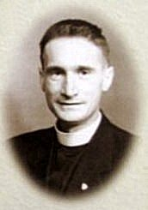
in touch and visited them after his missionary service in Nigeria. Nina wrote that they “enjoyed a fifty year correspondence” during which “he carried me through my life in happy times and sad times. He was my light, my anchor and a very dear friend.” Nor was this an isolated instance; the friendships he formed with the prisoners continued. He communicated regularly with them and their families; many of whom he visited after the war...” [From “He Walked Tall... The Story of Canon Michael Casey”, Mary Whittle, Self-Published 2002]
Fr Casey left Ashton in March 1945, initially to serve as chaplain to 5 British Ordnance Depot in Egypt.  Crib made by pows for St Oswald’s RC Church, Ashton-in-Makerfield >  Pow Violente from Genoa proposed the building of the crib as a present for Father Michael Casey, who was at the church from 1939 to March 1945. The Italian sculptor, Carrera (Arturo?) living in the UK was allowed to visit the camp to plan the crib with the pows.  The crib was made in sections from papier-mâché, cardboard and packing cases. It was assembled at the church on Christmas Eve. It was described as ‘magical’ and people came to see it throughout the war years.  Further details in; “He Walked Tall... The Story of Canon Michael Casey,” Mary Whittle, Self-Published 2002. | 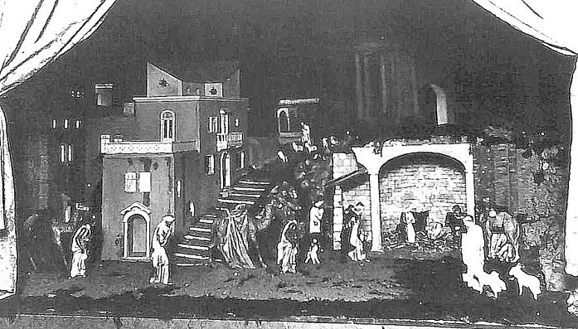

27 September 1945 – Visit by Mr Miller, English Language Inspector, from P.I.D.

Mr Miller’s brief report started; “This is an Italian P/W camp…” but all further details in his report concern the Germans, he did not even state how many Italian pows there were, just that there were 372 Germans.

The Italian pows were being placed in billets or in separate hostels prior to repatriation. The Germans were held in four separate compounds from the main Garswood camp. Two compounds were in Garswood Park, the other two were at Golborne. Small English classes were being held except at Garswood II Hostel.

November 1945 - a tragic event was recorded:  “Farm Deaths Mystery – Italians Collapsed At Work – Mysterious deaths of two Italian prisoners of war working on a Halsall farm were referred to at an Ormskirk inquest to-day. They were Pantaleone Cavalo, [Cavallo] aged 27, and Eugenie [Eugeni] Ragazzetti, aged 22, both stationed at the P.O.W. Camp, Garswood park, Ashton-in-Makerfield. They had worked for some time at Blundell House Farm, Halsall, for Mr Joseph Vose.  Herb Suspected – On Friday they were cleaning out ditches, and one of the men went a short distance away. When he did not return search was made for him and he was found in a collapsed condition in a ditch. Mr Vose was removing him to the farm for attention, but he died in the car. The second man later became ill and he died on the way to hospital.  It is suspected that the men had been poisoned by some herb they had eaten while working in the ditches. Their organs have been sent for examination to the Forensic Laboratory at Preston.  Mr C Bolton, the coroner, to-day took evidence of identification from another Italian prisoner and from Major Jardine, second-in-command at the camp. The inquest was then adjourned until December 21.” (Liverpool Echo, 26 November 1945). | 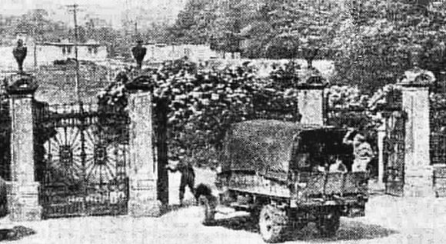  Caption; “A British sentry swings back the massive ornamental iron gates at Garswood Park Camp, Ashton-in-Makerfield, to admit an Italian working party.”

The verdict was ‘death by misadventure’ after the pows had eaten hemlock. The coroner directed that; “all Italian POWs working on farms should be warned against eating hemlock, a root known to Lancashire farmers as smallage, and which has some resemblance to celery.” (Liverpool Echo, 21 December 1945).

Both pows were later re-buried at the Brookwood Military Cemetery.

18 December 1945 – Very brief report by Mr R D Miller on his English Educational visit. Strength – 440 German pows – Italians not listed.

The camp had German and Italian Interpreter Officers.

March 1946 – many pows arrived from the US. After having been misinformed in the States that they were due to be returned to camps in Germany, their morale was severely affected to find that they were instead being sent to the UK to work.

9 March 1946 – one of the visiting lecturers to the camp was E. Amy Buller, (E = Ernestine, but she used her middle name). She gave many lectures at different camps where her focus concerned the need for Germans who had grown up under Hitler’s regime to challenge the Nazi ideology.  In her report there was a reference to the camp interpreter; “...the handling of the meeting and above all of the discussion was unfortunate. The Sergeant-Major (of German origin), extremely well-meaning and kind to me, took complete charge which made it difficult for me to get the direct contact or to handle the lecture and discussion as I wanted…. His handling tended to stifle discussion rather than encourage it.” After the lecture she suggested that those who wished to remain to discuss issues should remain and the rest could leave – “…the Sergeant announced rather brusquely, ‘Ask a question or go’ “.  The interpreter was S/Sgt Kurt Bloch. This was the first of several references to this controversial man in the files at the National Archive.  27 / 28 April 1946 – When Dr H L Gottschalk gave a lecture at the camp it was reported that the anti-Nazi pows found him to be too right-wing. In the report submitted following the lecture the acting Commandant stated that; “This lecturer appeared to be a strong Nationalist and expressed views of the | 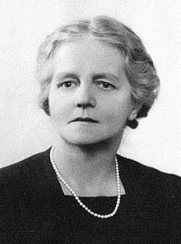
 | Amy Buller
German Right Wing Conservative Party.” At the end of May, in another report on a different lecturer, further remarks were raised regarding Dr Gottschalk’s visit, in particular that he had ended his lecture at one of the Garswood hostels with the words; “Deutschland Deutschland Űber Alles.” This was further investigated by the PID – statements were sent by the S/Sgt Interpreter and pows from Golborne Hostels, repeating the allegation, (12 June 1946).

These reports do not seem to have had any serious consequences – Dr Gottschalk continued to lecture and returned to Garswood in November 1947. It is an indication that the ‘anti-Nazi’ pows were actively opposing Nazism, alongside the Interpreter.

Mid-1946 - the camp was all German.

June 1946 – A Politische Arbeitsgemeinschaft (Political Working Group) was formed in the main camp to arrange discussions, activities and request lectures. S/Sgt Bloch, asked for volunteers at Golborne compounds to form a similar group, and another group was formed at Kirkby hostel.

Mr M Berger, a visitor lecturing about Trade Unions stated; “…S/Sgt Bloch is a very able man who understands how to handle P.O.W. and who carried out himself a great part for democratic re-education there, one could express appreciation for his outstanding achievements.

I have received the best impression in this camp so far. The institutions which exist there could be an example to others.”

This was the first of many very positive reports in the file about the effect of S/Sgt Bloch’s re-education work.

25 June 1946 – Mr Miller returned to make another English Inspector’s Report. Total strength 3000 in the main camp + hostels; all were German pows.

(Approximate numbers were given; main - 1200; Garswood I – 150; Garswood II – 120; Golborne I 150; Golborne II 120; Kirby 600; “and 4 more to be taken over” 800 – which gives a total strength of about 3140).

Acting Commandant – ‘Major Dampier.’ There was a good deal of change with additional pows arriving and new hostels.

Despite the large number of pows there were only 42 pupils studying English in the main camp.

The continuing low morale of many of the pows from the U.S. was commented on.

2-4 July 1946 – Major C H B Readman visited to report on; ‘Re-education progress’ and to select pows for special training courses at Wilton Park, (Beaconsfield). There had been 3 visits before this to review re-education, but those reports are not in the file. POW re-education was regularly inspected under the direction of COGA - Control Office for Germany and Austria.

Acting Commandant: Major Bennett-Dampier (previously 2nd i/c). HQ Camp leader: O/Fw Dlugesch (B-) [Dlugosch?]
Interpreter: S/Sgt K Bloch (German Jewish refugee) HQ Deputy C/L: -
German MO: St.Arzt Koech (C).

S/Sgt Bloch was highly regarded – “one of the best and most efficient interpreters I have yet encountered and takes a most active part in the re-education of the PW.”

Strength; 2 officers; 2578 Other Ranks. Political screening:

A+ | A | A- | B+ | B | B- | C | Unscreened
1 | 17 | 1 | 26 | 315 | 31 | 66 | 2123

Though many pows were yet to be screened, overall, the camp was regarded as politically grey/black (B / C) – there were very few communists. 2 pows had returned from the special training camp at Wilton Park – 2 more were due to attend, and there were a further 13 candidates.

Morale was only regarded as ‘fair.’ The positive aspects were good treatment, little evidence of barbed wire, and being able to work which earned them money. However, the pows transferred from the US were still depressed and mail from the American and French zones was very bad - unusually the Russian zone was not mentioned.

The majority of pows worked at local farms – the 235 billetees were living at 83 different farms. No complaints had been received from the farmers.

Youth pows, (usually regarded as under-25) were largely keen to participate in re-education activities. 80 pows were under 20, and 310 between 20 to 25. There was a well attended youth political class.

The standard list of re-education activities was given:

Wochenpost and Ausblick – 600 / 40 copies received.

Newspapers – 14 daily British papers were received, some more came from the British staff. It was being arranged so that the hostels received at least one newspaper. The PID sent ‘some’ German newspapers.

Library – 672 books which was insufficient for this camp.  Lectures – every 3 weeks in the main camp. These were popular, they were given in the dining hall which only had a capacity of 350, so sometimes 2 lectures had to be given. Titles included; ‘Call to German Youth’; ‘What is democracy’; ‘German Trade Unions’…  Discussion groups – a small group of 15 met twice a week. The visitor suggested that this could be increased.  Films – every 3 weeks from the YMCA.  Radio – 5 sets in the main camp and at least 1 in every hostel. Foreign stations were difficult to get – the BBC German programme was the main broadcast listened to.  Camp Magazine – “excellent” – was fortnightly, but owing to paper shortage it became monthly. 400 copies printed with 10 pages.  Press review – twice a week in the main camp and in most hostels. The visitor wanted to ensure that this occurred in all hostels.  English instruction – was taking place in the main camp and most hostels – separate appendix. 250 copies of ‘English For All’ were received and was liked.  Other camp activities:  Religion – There was a church hut in the main camp. The Evangelical padre, O/Fkmeister Dantz – “…an unattractive personality. He is not popular in camp and takes no part in re-educational activity. He takes the view that politics and religion should not be mixed. He visits most hostels.”  A monk, Schornstein, held prayers for RC’s. A British priest also visited occasionally. Pows from the hostels either attended local churches or were visited by a priest. | 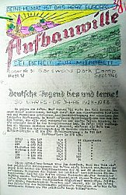
“Aufbauwille – Deine Heimat is Das Herz Europas Sei Bereit Zur Mitarbett.”
The Will to Build - Your Home Is The Heart Of Europe - Be Ready To Join) Sept 1946.

Education – no classes other than English.

Theatre – The theatre held 150. A new theatre group had been formed, prior to this only light entertainment had been performed.

Orchestra – just 5 members playing light music and jazz.

22-27 July 1946 – 2 visitors from the Segregation Section of PID arrived to carry out screening. Camp strength; 2 officers and 2409 OR.

A+ | A | A- | B+ | B | B- | C | C+ | Not known
2 | 87 | 1 | 161 | 1185 | 207 | 570 | 28 | 170

There were no changes to the senior British or German personnel. The Commandant and the Interpreter received further praise for their re-education work. One particular comment about the Interpreter is worth noting to compare with later reports; “The excellent work performed by the Interpreter C.S.M. Bloch is showing very good results.”

The German doctor, previously rated C, was regarded with suspicion and allegations had been made that he had falsely arranged for some early repatriations on medical grounds.

1 August 1946 – the Political Working Group organised an anti-war rally in the main camp.

13 – 15 September 1946 – Rev Dr D Meyer-Kluegel gave lectures on ‘The Christian Social and Political Responsibility’. Each lecturer submitted a report, most were fairly brief, some were hand-written – this lecturer submitted 2 pages of typed notes that gave a good deal of information.

“With regards to re-education and morale this Camp and all its Hostels are the best lecturer has seen so far. The morale is high, also now among those men who came from USA…
A great number of the men seem to come from old Trade Unionist and Labour families. Several men have been in concentration camps and Nazi prisons for underground ant-Nazi activities, and they are lecturing about these things and their comrades believe them.

The high morale and educational level at this camp and all its hostels is particularly the work and merit of the Interpreter C.S.M. Bloch. He has organised really splendid study groups under the leadership of genuine and active anti-Nazis, and these study groups are a great success and have achieved great strides in the re-education of the men. Lecturer had many occasions for personal talks with the various study leaders, all these men regretted deeply that their enthusiastic training adviser CSM Bloch will soon be leaving….”

September 1946 – Camp magazine, No. 11; Aufbauwille : Lager Nr. 50 Garswood Park Camp - The Wiener Holocaust Library

Entry in the magazine - Franz Cholewa, former camp spokesman from Garswood, died on July 27, 1946, following a serious operation.

September 1946 – the camp magazine ‘Aufbauwille’ gave details of camp life (abridged below) – the translation is by Anthony Pilgrim:

“'Transfer' has been the main topic.. for the past 2 weeks. During this time nearly 600 comrades have been sent to other labour camps: from the main camp 100, from Kirkby Hostel 319, from Garswood 27, from Penketh 85, and from Aughton Green 42.

For this reason, September 15th was the last opportunity for football fans to see our “red shirts”, all but two of whom have now left us. In a brisk game they maintained their winning form against old rivals the “blue shirts”, beating them 5-1.

On September 23 Das Kleine Haus will present a crime-comedy “Der Juwelendieb” (“The Jewel Thief”)..

The cinema brought us the English film “Jack in [sic] all trades”, the singing and dancing of the main actors being particularly enjoyed.

In his lecture “Economic Problems of the Weimar Republic”, Comrade Junker showed us what was going on behind the scenes in German industry after the First World War... Our guest speaker Revered Meyer-Kluegel was a great success with his remarks on the social and political responsibility of Christians...

The farewell evening on September 22nd for our 51 returnees [i.e. those returning to Germany] drew such a large attendance that many could only peer in through the windows… our British camp commandant was the first to speak.. he spoke in appreciation of their co-operation in regard to the newspaper, theatre etc., and told those remaining in the camp that they are not forgotten and that, so far as the rules permit, he will do all he can to allow other comrades to follow.

As he has often done before.. CSM Bloch, proved that despite having lost his homeland through Nazi rule he still loves Germany - especially his “Alt-Berlin” (“Old Berlin”). He said that those who had established the political community in our camp were now going back home, and hoped that all who did not want to see another 1918 and were determined to build a better Germany could soon follow. [Various ‘returnees’ gave similar remarks]. The evening included performances by our camp quintet and the recitation of two Erich Kästner poems, “Die Tretmühle” (“The Treadmill”) and “Kannst Du das Land, wo die Kanonen blühn?” (“Can you see the land where the canons flourish?”)..

Readers are.. encouraged to take part in the activities of the Politische Arbeitgemeinschaft and its youth section. The latter gathered each Monday “to familiarise our young comrades with the basics”, whilst on Wednesday evenings at 8.15pm a short but interesting lecture was given on a topical issue: “In the subsequent discussion, everyone can openly and freely comment on the statements and express their own opinion”.

S/Sgt Bloch sent copies of ‘Aufbauwille’ to the PID. After he left this was no longer carried out and so the September 1946 issue is the last to be filed at the National Archive, though the magazine did continue.

17-20 December 1946 – Dr R Koch made a report on re-education and screening. Strength; 2 officers; 1573 OR.

Commandant: Lt Col Prattley. HQ Camp leader: O/Fw Dlugosch (B-)
Interpreter: S/Sgt Karpe HQ Deputy C/L: -
German MO: St.Arzt Koech (C) / Dr Goettlicher (A).

The new Commandant was seen as “co-operative.” There was a new interpreter; “He lacks personality and interest in re-education.”

Screening figures | A+ | A | B+ | B | B- | C | Unscreened
 | 2 | 24 | 147 | 620 | 163 | 217 | 402
There were 150 appeals regarding screening – the better the grade, the sooner repatriated, in theory. Repatriations had started – 80 so far.

Morale was recorded as “fair.” Negative factors were bad news from Germany, slow speed of repatriation, and continuous changes in the pows. Positive factors were understanding treatment, re-education, entertainment, and a decrease on the restrictions for pows. If they were politically interested, the pows were mainly supporters of the SPD. There were 12 active communists, but others had changed their views on hearing news from the Russian zone. “Nazis are lying low.”

20% of the pows were youth (under-25). A youth group had been formed, but only 20 pows attended.

The standard list of re-education activities:

Wochenpost and Ausblick – separate appendix

Newspapers – It was expected that a greater variety would be received and supply to the hostels improved. 6 German newspapers sent by COGA each week.

Library – 927 books; still insufficient for this camp.

Lectures – 4 lectures during the last 3 months

Discussion groups – there was a political committee of 12 men. Weekly meetings were held. “An attempt has been made to put the committee on a broader political basis.” There were also discussion groups in the hostels, but there seemed to be little activity other than regular meetings at Penketh.

Films – every 3 weeks from the YMCA. Expected to get more films from COGA from January.

Wireless – satisfactory.

Camp magazine – 400 copies of 14 pages issued every three weeks. Request for more paper to allow a fortnightly publication.

Press review – weekly

English Instruction – separate appendix. ‘English for All’ very popular.

Information Room – more material wanted.

Other activities:

Religion – Protestant padre; O/Funkm Danz (B+) – “unpopular and without influence.” RC priest; Schwarz (B) – “seems more popular.” Regular services in man and hostels.

Education – None.

Entertainment – A theatre group and orchestra. Plays and music needed. “Sport is handicapped by the lack of football boots.”

The conclusions made by Dr Koch were negative and dispirited – “Brit staff can not influence re-education in this camp. Not enough suitable PW’s are available, re-education material is not adequate. The development of the political discussion groups has to be watched.”

Within this report was a remarkable paragraph about the former interpreter who had been discharged from the army in October. The visitor commented; “the forceful methods which he employed did more harm than good.” He further stated that Bloch had held strong left-wing views and the camp committee had become; “a purely socialist intolerant group” – and that he had influenced repatriation for particular pows, and “nobody dared to utter opinions different from Bloch’s.” This new visitor implies that the negative views were from the Camp Leader and “other reliable PW’s.”

In a final sentence, Dr Koch stated; “At a general meeting I explained the real purpose of political activities in a PW camp and tried to disperse the atmosphere of ‘gestapo-mentality’ and general mistrust.”

This is a pretty incredible about-face on previous comments about S/Sgt Bloch.

CSM Bloch was the camp interpreter, he also took the lead in developing re-education and gave lectures to the main camp and hostels about Germany.

The first comment about Bloch was made by Amy Buller in March 1946 – it was the only negative statement made up until December 1946 when Dr Koch arrived. Various highly positive remarks were made by visiting lecturers and inspectors mentioned above. Reports by other lecturers remarked on Bloch’s work; “…obviously making a success of the work, in which he has a real interest” – “The political education in this camp and its hostels is advanced partly due to the efforts of Staff Sargeant Bloch…” - “The work done by the Staff-Sergeant Interpreter, I think his name is Bloch, is excellent.” - “In spite of his Jewish origin, he is amazingly popular and gets on well with the men in all camps.”

There are too many positive comments to accept Dr Koch’s point of view. There is no record that Dr Koch did or did not meet Sgt Bloch, and he was no longer at the camp to defend himself. The Commandant who worked with Bloch had also changed. With only vague references to ‘other reliable PW’s,’ Dr Koch does not record a single pow speaking in favour of Sgt Bloch – despite there having been articles written by pows in the camp magazine in praise of him and comments about his popularity.

To contradict the assertion that; “nobody dared to utter opinions different from Bloch’s,” a visiting lecturer later stated that; “To my mind this camp has changed much since I visited it for the first time in Dec. 1946. There is considerably less interest in education of any sort and the general trend of comment and criticism (always very alive here) is not too good.” – Dr G S Wagner, August 1947.

The accusation about influencing repatriation is also questionable – as a similar accusation had been made against the German M.O. in July 1946.

I wonder if Sgt Bloch was seen by some as being over zealous in his re-education work and association with the anti-Nazi pows in the camp? Perhaps this was seen as ‘threatening’ to other pows with a Nazi background. By the time Dr Koch gave his report, repatriation was well underway. Many of the ‘A’ category (anti-Nazi) pows were the first to be sent back to Germany – note his comment in Aufbauwille: “those who had established the political community in our camp were now going back home.” Did this create a power struggle inside the camp between a dwindling group of pows who were actively campaigning against war and Nazism – and those who were resentful of having their past lives and political allegiances called into question?

Background - CSM Kurt Bloch

Abridged details from research by Anthony Pilgrim: Kurt was born in Berlin on 20 March 1901, he married Ella Moses in 1926. The Schöneberg district marriage register records that the couple were divorced in 1931, but this seems to have had no effect on their domestic situation or professional activities. The 1937 Berlin telephone directory placed them at Dircksenstr. 51, also the location of the Kamm-Bloch factory [listed in the Jewish business directory as being a comb factory] of which Ella was named as “inhaberin” or proprietor. They were again included in the personal listings in the 1938 directory, but there was no mention of the factory. The factory was ‘taken over’ in 1938 and liquidated in 1940.

It appears that Kurt left Germany on 14 November 1938. Ella soon followed. In the meanwhile, on 10 January 1939, Kurt's German birth registration had been amended to record his name as “Israel” in accordance with the Nazi law on identification of those deemed to be of Jewish extraction.

The 1939 Register for England and Wales placed them in Bradford, where Kurt was listed as a “Hair Comb Maker”, and Ella as engaged in “Unpaid Domestic Duties”. The Bloch & Adler comb factory in Bradford, in which Kurt and/or Ella presumably had some interest, employed several European Jews who had arrived via Kindertransports etc. One of them, Albert Waxman (1924-2019), would later join the RAF and serve as interpreter at POW Camp 265 Park Farm, near Peterborough.

Kurt and Ella were briefly interned as “enemy aliens”. Records show that Kurt was released on 8 November 1940 on account of his acceptance for enlistment in the Auxiliary Military Pioneers Corps of the British army. Ella was simultaneously released from her internment on the Isle of Man and, on 7 January 1941, she returned to Bradford.

In October 1946, Kurt was naturalised as a British subject under the “Crown service” provisions of the British Nationality and Status of Aliens Act. Shortly after this he was discharged from the army and so left the Camp. He and Ella settled in London, remaining there until their deaths in April 1968 and July 1965 respectively.

[A very similar situation arose at Stamford Camp 106 (10) with S/Sgt H Greenwood. Greenwood was also a German Jewish refugee. He was described as excellent and positively leading re-education until the end of 1946. After he was discharged from the army, he too received very heavy criticism].

18-21 March 1947 – Dr Koch returned to make a report on re-education. Strength 3 officers; 1344 OR.

Commandant: Lt Col Glendinning HQ Camp leader: O/Fw Dlugosch (B)
Interpreter: S/Sgt Karpe HQ Deputy C/L: -
German MO: St.Arzt Koech (C) / Dr Goettlicher (A).
The Commandant had newly been appointed and had not yet taken up his duties. He was described as being “inexperienced in P.W. work” – however, in the next report it was stated that he had previously been an Inspector of prisons in Germany.

Screening figures had a similar distribution to previous;

A+ | A | B+ | B | B- | C | C+
2 | 34 | 169 | 737 | 235 | 45 | 1

70 appeals were pending – 78 out of 78 had been heard and allowed. This was a general pattern with pows being upgraded in many camps. Dr Koch had upgraded 127 former C category pows. 578 pows repatriated to date.

Dr Kock thought that morale had improved – mainly due to privileges for pows, contact with civilians, increased repatriations, camp activities and entertainment. A main negative aspect was news from Germany. They were “no longer frightened to express their political views.” A dummy election of just 54 pows had taken place in the camp with the results – SPD 70%; CDU 25%; SED 4%; Liberals 1%.

Youth – 20% who were not regarded as a problem. (Penketh hostel was a lot higher).

Re-education activities were stated to have improved during the last three months, but the standard list was virtually the same as the last report. There were a few more books, but no evidence of improvements in other areas. Not only had the requested additional paper for the magazine not been fulfilled, it was still issued every 3 weeks, but at a reduced run of 300 down from 400.

Other activities;

Religion – similar report to previous, but now recorded that RC’s also attended local services.

Education – “Many subjects are taught” – it was usual for visitors to list the subjects, but Dr Koch did not do so.

Entertainment – the theatre group and orchestra continued. There was a 45-member choir who also sang in Wigan. Sports activities were organised.

Activities were satisfactory in the main camp, but not so in the smaller hostels. He stated that pows were still reluctant to accept official educational appointments – “an unpleasant reminder of the CSM Bloch era.”

Warth Mills Camp 177 and Myerscough hostel were due to be administratively taken over by Garswood and its pows were due to arrive in April.

12 April 1947 – Mr R D Miller returned to give another English Inspector’s Report. Strength; 1340.

Major Dampier, 2nd in command, was listed as Commandant, so presumably the new Commandant had still not arrived.

There were 3 classes in the main camp with just 59 pupils – and only a further 39 at the four hostels.

13 April 1947 – Camp 50 POW/Haydock Charity Match Programme, 13 April 1947, below.

There were many local matches as the fraternisation regulations were eased. Some matches attracted up to 4000 spectators. It was while he was playing for the Camp 50 football team that Trautmann became a goalkeeper.

3 – 6 June 1947 – Dr R Koch returned to make a report on re-education. Strength; 4 officers, 1822 OR.

Commandant: Lt Col Glendinning HQ Camp leader: O/Fw Dlugosch (B)
Interpreter: S/Sgt Davies HQ Deputy C/L: Uffz. Kuehr
German MO: St.Arzt Koech (B). (spelling – Koesch; regarded from C)
Dr Goettlicher (A). Dr Mayenfeld (B-). Dr Kebbert (B+)
The new commandant had taken up his post. The Commandant and Adjutant spoke German.

The new camp interpreter had been at Warth Mills Camp 177; “is 23 years old and is unpopular with the PsW, because he is overbearing, tactless and wants to demonstrate that he is the man who really runs the camp.” Warth Mills, Bury Camp 177 had been taken over as a satellite camp for Garswood.

Simplified screening was in place: | A | B+ | B | B-
Simplified screening was in place: | 5 | 370 | 1195 | 256

Pows repatriated to date – 850 from Camp 50 / 900 from Camp 177, further numbers for Bury Camp were included in the figures for Camp 50.

Morale was still considered to be just ‘Fair.’ Positive aspects were friendly relations with civilians, (football, concerts, entertainments) and permission to be out until 10 p.m. Negative aspects continued to be news from Germany and frequent changes to pows. The interpreter came in for further criticism; “Officious behaviour” and his “interference in every aspect of camp life.”

30% of the pows were youth – but the former youth-group had been disbanded.

The standard list of re-education activities was given – with very little difference from the previous report apart from some comments about Bury Camp (see below). Many activities were being affected by long hours of work during the summer months.

The theatre group, orchestra and choir gave concerts to pows and to local civilians – however their activities were reduced during the summer months. 2 members of the Halle Orchestra visited the camp.

Contacts with outside bodies included religious groups. There were various other possible contacts, in particular with educational bodies, but they had not yet started.
1945 – 1948 : Bert Trautmann  Bert Trautmann was probably one of the first German pows to arrive at Garswood.  The biography, ‘Trautmann’s Journey’ states that he was transferred from Marbury Hall Camp 180 in 1945 to be the driver for the Commandant at the Italian pow camp. It incorrectly names the Commandant as ‘Sir Arthur Glendenning.’ In 1945 the Commandant was Lieutenant Colonel R G Ireland, and there were another 2 Commandants before Lieutenant Colonel Glendinning, was appointed in early 1947. This could just be down to memory lapses.  The book also states; "After a few months Glendenning retired and another commandant came to take his place, a large bluff man who had been a POW himself in Germany...." BUT, Glendinning was the last Commandant at Garswood.  The book records that Trautmann met S/Sgt Bloch, but it gets Bloch’s forename wrong and records that he left Germany in 1936, whereas research shows it was in 1938.  21-24 June 1947 – Some general comments from visiting lecturer, H A Kluthe: “I was surprised to find such a good camp in one of the dreariest and most depressing regions of England. This has various reasons. The most important is perhaps that none of the British officers here indulges in that petty nagging which all to often poisons the atmosphere of a whole camp. Of equal importance is the friendliness of the people of Lancashire with whom the Ps/W have many contacts. This has created a pro-British feeling which, unfortunately is not found very often these days.” | 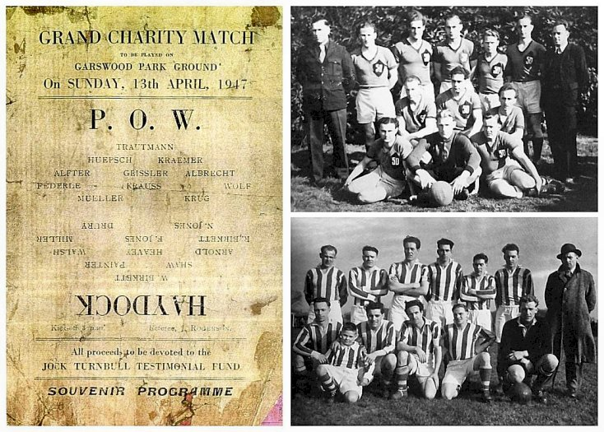
 | Trautmann and team in the top photo wearing the shirt with team badge ‘50’
19 – 22 August 1947 – Dr R Koch carried out another report on re-education. Strength; 5 officers, 1961 OR.

Commandant: Lt Col Glendinning (detached to Camp 76) HQ Camp leader: St/Fw [Otto] Kaesler (B)
Acting Commandant: Major Patterson HQ Deputy C/L: Fw. Lemmerz (B)
Interpreter: S/Sgt Sheldon German MO: Dr Goettlicher (A).
St.Arzt Koesch (B). Dr Mayenfels (B-). Dr Kebbert (B+)

The new Interpreter had previous experience in an Internment camp in Germany and the visitor expected him to do a good job.

The previous Camp Leader had been repatriated. The new Camp Leader had been the Hostel Leader at Kirkby – “a professional soldier, dignified and with authority but rather unpolitical, he seems a suitable choice.”

Simplified screening was in place: | A | B+ | B | B-
Simplified screening was in place: | 9 | 427 | 1161 | 369

Pows repatriated to date – 1230.

Overall morale was still graded as ‘fair’ – but was deteriorating at the main camp and nearby hostels at Garswood and Golborne. The main reason was; “a tightening up of discipline following a visit by the P/W-Inspector. The wearing of caps and buttoned up blouses during the present hot weather is generally considered an unnecessary hardship.” The pows also expressed their dislike of British personnel using bad language. Political interest by the pows had increased – particularly following contacts with local citizens and international news.

25% youth pows – there were no particular arrangements for these.

There were a few changes to re-education activities:

Discussion groups – had all ceased during the summer months.

Camp magazine – 500 copies weekly. It was considered that the ‘level’ of the paper was slightly lower, but interest had increased.

Information room – was receiving new material from the Visual Education Section.

An increasing list of outside contacts was detailed, including pows attending local conferences and discussion groups; meetings at the YMCA; attendances at court sessions; and links with the Halle Orchestra.

The theatre group had disbanded, but there were plans to restart it. It was noted that sport played an important part of camp life.

7 / 9 October 1947 – E F Peeler provided an English Inspector’s Report. Strength; 1762.

There was just one small class of 13 pupils at Bury – all other classes for English had closed, mainly due to “apathy”. This was reflected in most camps.

21 – 24 October 1947 – Another report on re-education by Dr R Koch. Strength; 4 officers, 1737 OR.

A couple of changes to the senior staff. There was another new Interpreter Officer – S/Sgt Lustig – he had been transferred from Merry Thought Camp 76, Cumberland, and was regarded as; “unsuitable. Only 20 years old, of Sudetan-Czech origin, he is not sure of himself, unpopular with the men and therefore unable to influence re-education.” The German M.O. Dr Goettlicher was no longer listed.

Screening was rarely used by this time – simplified numbers were given; A – 4; B – 1737. 1551 pows had been repatriated to date.

Myerscough Hostel was being reduced prior to closure.

Morale and political progress were thought to have improved and was graded as ‘good.’ Positive factors included the new Commandant’s sympathetic treatment, friendly relations with locals, good and plentiful food. A negative factor was the recent order that private clothing could not be worn. Pows were regarded as being apathetic towards political activities, though the order to dismantle factories in Germany was very much opposed.

Standard list of re-education activities;

Newspapers – adequate

Library – 3000 books + a further 1000 at Bury, but many were old.

Lectures – regular, of mixed interest, (an English poetry reading only had 3 pows attending, whereas a lecture on ‘Germany of Today’ had 200 pows.

Discussion Groups – none.

Films – YMCA and Travelling Films fortnightly and popular.

Wireless - adequate

Camp magazine – 500 copies fortnightly, “but the intellectual level of the Magazine is only moderate”.

Press Review – weekly with 70 pows attending in main camp + others at the hostels.

Information Room – An exhibition about ‘Trade Unions’ was being displayed at Bury.

Other activities:

Religion – same padre / priest. Mr Katz, a Baptist from Liverpool, visited.

Education – classes for Book-keeping and Russian.

Entertainment – the theatre group did not re-start with many ex-members having been repatriated. The orchestra had dwindled to 8 men. The 43 members of the choir sang at various churches. Sports were organised and an important part of camp life.

Outside contacts continued in the same way as before.

14 November 1947 - Camp number included in an ‘Urgent Memorandum’ (FO 939/270) regarding inspection of food parcels.

10/11 December 1947 – Mr E F Peeler gave an English Inspector’s Report. Strength 1286.

There was 1 class with 8 pupils, though it was thought many pows were studying English privately.

Late 1947 - Relationships between pows and local people were very much improved from when the camp started. In Parliament:

“Mr. Hale asked the Secretary of State for War whether he is aware that a number of people in Oldham are anxious to entertain during the Christmas period prisoners of war, formerly stationed in Oldham and now stationed in Ashton in Makerfield; and whether he will give the necessary authority for this to be done.

Mr. Shinwell - In accordance with the concessions which I announced in reply to a Question by my hon. Friend the Member for South-East Essex (Mr. Gunter) on 25th November, commandants have authority to approve applications from within a radius of 100 miles, which in this case includes Oldham. (House of Commons, 19 December 1947, Vol 445).

December 1947 / January 1948 – there was a chance for some pows to attend extra-mural courses at Sheffield University. For 1 month starting 23 January, pows were to live at Potters Hill Camp 296, they would work during the day and attend evening courses at the University. There was a record of five pows attending, studying English, German, Science and Law.

13/16 January 1948 – Dr R Koch visited for a General Survey. Strength; 3 officers, 1126 OR.

Changes to the senior personnel. A new Deputy Camp Leader – O/Fw Schweppenhaeser. There were 2 German M.O.s - Dr Kobbert at Garswood, and Dr Mayenfels at Bury.

The interpreter was due to leave – you have to wonder if Dr Koch did not like them in general – “he proved utterly unsuitable and useless.”

Screening; A – 2; B – 1127. 2020 pows had been repatriated to date.

Morale was seen as good – for the same reasons as before, the exception being at Altcar with an; “unsuitable British NCO.”
Political progress had been set-back by international events. The 4-power conference in London had failed, there was an economic crisis in Germany. Many pows did not believe that the occupying powers were rebuilding Germany – “Dismantling of factories, confiscation of all industrial patents, cheap exports… are mentioned as example.”

There was little change to any of the activities previously reported on.

2 – 5 March 1948 – Dr R Koch paid his last visit to the camp to carry out a General Survey. Strength; 2 officers, 905 OR.

Screening; A – 2; B – 905. 2200 pows had been repatriated to date.

A survey was conducted in camps still open at this time concerning pow attitudes to the British, (following a PID circular dated 25.2.1948). It was pointless, carried out far too late and in totally random ways. Some visitors simply gathered whoever was around and asked them to give a show of hands to the questions, some only asked a ‘selected’ group – most did not state how the data was gathered or the numbers involved. For what it is worth (nothing?) the results for Garswood were:

Hate – 0% / Dislike – 1% or less / Distrust – 20% / Indifference – 20% / Liking – 59%

“The men from the Russian Zone who have to return for family reasons are very uneasy. Youngsters from the Western Zones, who belonged to the Waffen SS, receive information that they will meet with difficulties if they wish to complete their studies (Teachers Training Colleges, Universities, etc), in spite of the so called ‘Youth Amnesty’. There are rumours that the French have deported most SS men and paratroopers.”

There was a range of outside contacts, but some of these were only available to very small groups of pows, and were very limited in scope. The final list for the main camp was:

a. Wigan; Mining and Technical College, and the Police Court.
b. Lancs Education Committee Evening classes.
c. Elementary School at Earlstown – Upholland Grammar School - Approved School Newton-Le-Willows.
d. Youth Clubs at Ashton and Haydock.
e. YMCA Canteens and Clubs.
f. United Europe meeting
g. Lancs Standing Conference of Youth Organisations.
h. Rotary Club Tyldesbury.

1 April 1948 - The last Germans left for Camp 189 (Dunham Park) - Garswood Park camp closed.

Known Camp Commandants:

1942 - ?; Major J S Partington

1945 – June 1946; Lt Col R G Ireland (Corps of Royal Military Police)

June 1946 - Summer 1946; Acting Commandant Major Bennett-Dampier

Summer 1946 – Spring 1947; Lt Col Eric Charles Prattley (1899-1975), from the Royal Norfolk Regiment. Taken prisoner by the Japanese and incarcerated in Changi Prison.* Also Commandant at Headington C43 and Basildon C246. [*Japanese Index Cards of Allied Pows, National Archives WO 345/42].

Early 1947; Lieutenant Colonel Glendinning (previously served in Germany as inspector of prisons, etc).

After the camp: The site for two schools; St Edmund Arrowsmith Catholic High School and Byrchall High School.

Further information:

National Archives – FO 939/132 and 300 - 50 Working Camp, Garswood Park Camp, Ashton in Makerfield, Lancashire. Dated 1945 – 1948. Used above.

(1) “A North West Village At War: A memoir of Winwick and its environs from 1939 to 1945”, Frank Goulding, Cheshire Libraries & Museums 1987.

(2) “One Child's War,” Josephine Fleming, in “Memories of the Past: Local people recall the period before and during the Second World War,” Wigan MBC 1993.

Camp numbers:

 | Open |  |  | With other camps |  |  | Unknown |  |  | Not listed / not open

 | 9/42 | 11/42 | 43 | 5/44 | 9/45 | 7/46 | 12/46 | 3/47 | 4/47 | 6/47 | 8/47 | 10/47 | 12/47 | 1/48 | 3/48
Garswood |  | 730 |  |  |  | 746 | 508 | 691 | 684 | 800 (*3) | 704 | 704 | 497 | 434 | 393
Bickerstaffe |  |  |  | ? |  | 76
Staging Camp
Salesbury Hall |  |  |  |  |  | With C177
Peninsula Barracks
Longridge |  |  |  |  |  | With C177
West Derby
Moor Park |  |  |  |  |  | With C177
Wimbrick House
Aughton Green |  |  |  |  |  | 61
Garswood I |  |  |  |  | 372 | 129 | 42 | 65 | 65 | 60 | 171 | 176 | 51 | 51
Garswood II |  |  |  |  | 372 | 131 | 58
Golborne I |  |  |  |  | 372 | 125 | 59 | 88 | 75 | 68 | 178 | 143 | 90 | 76 | 49
Golborne II |  |  |  |  | 372 | 117 | 49
Kirkby |  |  |  |  |  | 454 | 177 | 65 | 78
Penketh |  |  |  | Camp 290 |  | 404 | 213 | 175 | 270 | 46 | 82 | 107 | 47 | 43 | 31
Wheathill |  |  |  | With C290 |  | 102
Lowercroft |  |  |  |  |  |  | 100
Bury Satellite | Camp 177 Warth Mills, Bury (also had other camp numbers, starting as camp 8 in 1940) |  |  |  |  |  |  |  |  | 347 | 312 | 240 | 231 | 193 | 186
Myerscough |  |  |  |  |  |  |  | With C177 |  | 158 | 113 | 51
Altcar |  |  |  |  |  |  |  |  |  |  |  |  | 56 | 57
Deysbrook Det |  |  |  |  |  |  |  |  |  |  |  |  |  | 40
Detached |  |  |  |  |  |  | 150 | 124 | ? | 111 | 166 | 118 | 138 | 84 | 168
Billeted |  |  |  |  |  | 235 | 219 | 139 | 134 | 236 | 240 | 223 | 176 | 151 | 80
Total | Cap 750 | 730 | Cap 800 | ? | ? | 2580 | 1575 | 1347 | 1340 | 1826 | 1966 | 1762 | 1286 | 1129 | 907

Hostels

Altcar. 11 miles from the main camp.

January 1948 – Probably at what is now Altcar Training Centre, Merseyside. It was listed as having previously been a detachment. Hostel leader O/Maat Schemien.

 | 9/42 | 11/42 | 43 | 5/44 | 9/45 | 7/46 | 12/46 | 3/47 | 4/47 | 6/47 | 8/47 | 10/47 | 12/47 | 1/48 | 3/48
Altcar |  |  |  |  |  |  |  |  |  |  |  |  | 56 | 57

Aughton Green, Sheffield – 12 miles from the main camp. Hutted camp with electric lighting.

July 1946 – reported to have been previously linked to Penketh Camp 290 – but it had been listed as a hostel to Garswood since 1945.

Hostel leader – Fw Kotscha, Emil (A) – “Elderly Sudeten German, definite anti-Nazi but rather a ‘yes-man’. Not the best type of hostel leader, but manages fairly well in this Hostel which consists mainly of Sudeten Germans.” Although the atmosphere was described as “quite good”, and there being; “no apparent bad influences,” it was stated there was a low morale due to bad news or lack of news from Czechoslovakia – and a mistrust and fear of the USSR.

 | 9/42 | 11/42 | 43 | 5/44 | 9/45 | 7/46 | 12/46 | 3/47 | 4/47 | 6/47 | 8/47 | 10/47 | 12/47 | 1/48 | 3/48
Aughton Green |  |  |  |  |  | 61

Bickerstaffe, Ormskirk – 15 miles from the main camp. Hutted camp with electric lighting.

Location – local memories place it near to what was called ‘Old Coach Road.’ One description – “pass the turnoff to Rainford you see a lane going to the right into the woods the T junction at the end is the Old Coach Road from the East Lancashire Road that cuts through it. Just before you reach the junction the camp was on the left.” Another – “The old coach road is a single tarmacked road [although it is now very neglected, muddy and getting overgrown] that runs from the East Lancs Road to Bickerstaffe.”

There are memories of Nissen huts at the camp. ‘Pereira’ remembers – “the fading painted signs on the side of the huts in German. Please do not misunderstand me they did not read "Remember the Fatherland" or any other such Teutonic slogans, but as best I could translate in my schoolboy German; "Sound horn before entry" and "Key storage here" was as marshal as it got.” https://www.sthelens-connect.net/forums/topic/9824-the-old-coach-road/

July 1946 – Hostel leader – O/Maat Schulz. Franz-Josef (B+). “Speaks excellent English and is a good type.”

4 September 1946 – from the camp magazine – “Willi Schwegler – Hostel Bickerstaffe, born 20 November 1916. On 4 September, fatally struck by lightning while working in a field.” A report of the inquest into Obergefreiter Schwegler's death is in the 6 September 1946 edition of the Liverpool Echo. He was later reinterred in the German Military Cemetery at Cannock Chase, Staffordshire.

 | 9/42 | 11/42 | 43 | 5/44 | 9/45 | 7/46 | 12/46 | 3/47 | 4/47 | 6/47 | 8/47 | 10/47 | 12/47 | 1/48 | 3/48
Bickerstaffe |  |  |  | ? |  | 76

Bury Satellite Camp – previously Camp 177 (separate details – also had other numbers starting as Camp 8 in 1940 – aka Warth Mills).

June 1947 – Commanding Officer; Captain Pollard.

Hostel leader: SS O/Junker Schmidt (B-) – “a regular policeman, has been a member of the NSDAP since 1932, but had to leave the Party in 1933 when he joined the German Army. In 1944 he was transferred to the 12th (HJ) SS Division as O/Junker (Officer cadet). Though a man with such a record should never have been appointed Camp Leader, he seems to have done a good job and it would be a mistake to remove him now when he is i/c of 350 men.” [HJ = Hitler-Jugend – Hitler Youth; the 12th Division committed numerous war crimes].

“Jansen (A), the RC priest makes a very good impression.”

The visitor, Dr Koch, witnessed a religious sect, the Zionists, visiting the camp. He regarded their visits as; “without value and are regarded by the PsW as cheap entertainment. The Commandant has agreed to stop their activities.” At a time when pows were being allowed to participate in other local entertainments, this seems rather po-faced.

The Society of Friends organised various lectures at the camp. Contacts had been made with Toc-H, Manchester Council, and UNA, (promoting the UN).

28-29 July 1947 – Mr R D Miller gave an English Inspector’s Report. Strength 400.

Officer i/c: Lieutenant Perrie Lagersprecher: Schmidt. (He was listed as hostel leader up until the camp closed in 1948).

There were two English classes meeting twice a week with 50 pupils.

It was expected that this satellite camp would become a hostel and numbers reduced from 400 to 108, though numbers in later months did not go down to that figure.
August 1947 – Outside links continued, some pows attended Radcliffe Council meetings.

March 1948 – Links listed with:

a. Society of Friends visited the camp.
b. WEA Bury and Prestwich
c. Local Alderman Fletcher visited the camp.

 | 9/42 | 11/42 | 43 | 5/44 | 9/45 | 7/46 | 12/46 | 3/47 | 4/47 | 6/47 | 8/47 | 10/47 | 12/47 | 1/48 | 3/48
Bury Satellite | Camp 177 Warth Mills, Bury (also had other camp numbers, starting as camp 8 in 1940) |  |  |  |  |  |  |  |  | 347 | 312 | 240 | 231 | 193 | 186

Deysbrook. 15 miles from the main camp. At first described as a detachment, then one entry as a hostel.

January 1948 – Hostel leader: Fw Maassen.

 | 9/42 | 11/42 | 43 | 5/44 | 9/45 | 7/46 | 12/46 | 3/47 | 4/47 | 6/47 | 8/47 | 10/47 | 12/47 | 1/48 | 3/48
Deysbrook Det |  |  |  |  |  |  |  |  |  |  |  |  |  | 40

Garswood I Hostel, Garswood Park. Hutted camp with electric lighting. See map – page 1.

September 1945 – 1 pow teacher of English – Hermann Schulten; 12 advanced pupils.

July 1946 – Hostel leader; Wm. Wirtz, Artur – he was given a political rating of (B) in one report, and (A) in the next. “Wilton Park man, excellent type and good organiser.” Wilton Park was a special training camp promoting re-education.

December 1946 – Hostel leader; O/Maat Schulz (B+) – previously leader at Bickerstaffe hostel.

March 1947 – Only 1 Garswood hostel listed from this time on. Hostel leader; St/Feldw. Wardetzki (B) who had been listed previously as CL for Garswood II. He continued as leader until summer/autumn 1947.

October 1947 – Hostel leader; OWm Block (B-), continuing to the hostel closure.

- - - - - - - - - - - - - - - - - - - - - - - - - - - - - - - - - - - - - - - - - - - - - - - - - - - - - - - - - - - - - - - - - - - - - - - - - - - - - - - - - - - - - - - - - - - - - - - - - - - - - - - - - - - - - - - - - - - - - - - - - - - -

Garswood II Hostel, Garswood Park. Hutted camp with electric lighting.

September 1945 – no teacher of English. Interpreter due to start – Wilhelm Radermacher.

July 1946 – Hostel leader; O/Fw Ender (B)

December 1946 – Hostel leader; St/Feldw. Gardetzki (B) Spelling? Wardetzki later.

From March 1947 only 1 entry is made for Garswood Hostel – further entries listed above.

 | 9/42 | 11/42 | 43 | 5/44 | 9/45 | 7/46 | 12/46 | 3/47 | 4/47 | 6/47 | 8/47 | 10/47 | 12/47 | 1/48 | 3/48
Garswood I |  |  |  |  | 372 | 129 | 42 | 65 | 65 | 60 | 171 | 176 | 51 | 51
Garswood II |  |  |  |  | 372 | 131 | 58
Golborne I |  |  |  |  | 372 | 125 | 59 | 88 | 75 | 68 | 178 | 143 | 90 | 76 | 49
Golborne II |  |  |  |  | 372 | 117 | 49

Golborne I Hostel (about 3 miles from main camp). NGR SJ 597 965. Hutted camp with electric lighting.  Two US army camps were established in Golborne Park – “A diary left by Col W S Van Arsdale, states: "We were billeted on an English golf course named Golborne Park, a private golf club. The administrative buildings such as kitchen and mess halls and Battalion HQ consisted of Quonset huts. All other quarters for enlisted men and officers were tents..." A question has been raised whether the huts were Quonset or Nissen as the two look very similar.  3 September 1945 – Progress report 153 recorded a new hostel for Italians at Golborne Golf Club. (FO 939/383).  September 1945 – 1 pow teacher of English – Gűnter Tannenbaum; 18 beginners, 4 advanced.  December 1945 – The pow teacher, Gűnter Tannenbaum, was no longer allowed to teach; “because his knowledge of English apparently encouraged him to take French leave in Wigan one Saturday afternoon, and afterwards to boast to his comrades of the good time he had had.”  Research by Anthony Pilgrim; “TANNENBAUM, Günther, aged 21” may have been the same individual whose escape from Camp 50 was reported by the Lancashire Evening Post and other newspapers on 3 July 1946:  “Police are keeping watch for a German prisoner of war, Hans Günther Tannenbaum, aged 21, a member of the Luftwaffe, who escaped early yesterday morning from a camp in Ashton-in-Makerfield. He is wearing Air Force blue trousers and a brown jacket with patches, speaks good English, has a fresh complexion and fair hair.”  I can find no record of the prisoner's re-capture.”  July 1946 – Hostel leader; Fw Ehmke, Wilhelm (B+) – “Willing to co-operate but not a strong character.” He continued to be leader until the hostel closed in 1948. Overall good political activity and participation at this hostel. | 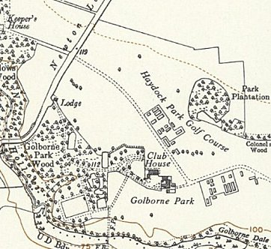
 | The two compounds in Golborne Park / Haydock Park Golf Course – OS 1956
March 1947 – Only 1 Golborne hostel listed from this time on.

- - - - - - - - - - - - - - - - - - - - - - - - - - - - - - - - - - - - - - - - - - - - - - - - - - - - - - - - - - - - - - - - - - - - - - - - - - - - - - - - - - - - - - - - - - - - - - - - - - - - - - - - - - - - - - - - - - - - - - - - - - - -

Golborne II Hostel (about 3 miles from main camp). Hutted camp with electric lighting.

3 September 1945 – Progress report 153 recorded a 2nd new hostel for Italians at Golborne Golf Club. (FO 939/383).

September 1945 – 1 pow teacher of English – Berthold Brudek; 40 beginners, 12 advanced.

July 1946 – Hostel leader; Fw Ullbrich, Egon. Was given a political rating of (A) in one report, and (B+) in the next. “Speaks very good English. 12 years a merchant in Haiti. Returned to Germany July 1939 to take over his father in law’s business. Keen on re-education – popular, efficient and willing.”

From March 1947 only 1 entry is made for Golborne Hostel – entries listed above.

 | 9/42 | 11/42 | 43 | 5/44 | 9/45 | 7/46 | 12/46 | 3/47 | 4/47 | 6/47 | 8/47 | 10/47 | 12/47 | 1/48 | 3/48
Golborne I |  |  |  |  |  | 125 | 59 | 88 | 75 | 68 | 178 | 143 | 90 | 76 | 49
Golborne II |  |  |  |  |  | 117 | 49

Kirkby – 12 miles from the main camp. Hutted camp with electric lighting.

July 1946 – Hostel leader; St.Fw Kaessler (B). No changes in leader noted through to April 1947.

April 1947 – noted that 80% of the pows were Rumanian and Hungarian. This caused some difficulties as many did not speak German.

May 1947 – a visiting lecturer noted that the Romanian and non-German speakers had been “shifted to Scotland”.

 | 9/42 | 11/42 | 43 | 5/44 | 9/45 | 7/46 | 12/46 | 3/47 | 4/47 | 6/47 | 8/47 |  | 10/47 | 12/47 | 1/48 | 3/48
Kirkby |  |  |  |  |  | 454 | 177 | 65 | 78
Longridge (Alston Lodge). NGR SD 6100 3700  Gets a mention as a hostel for Italian pows in 1943 attached to Garswood.  Listed as a hostel for Warth Mills Camp 177 in September and October 1946. |  |  |  |  |  |  |  |  |  |  |  | 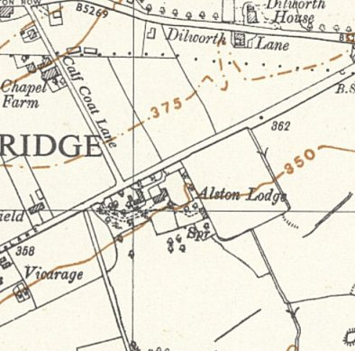
   | 9/42 | 11/42 | 43 | 5/44 | 9/45 | 7/46 | 12/46 | 3/47 | 4/47 | 6/47 | 8/47 | 10/47 | 12/47 | 1/48 | 3/48
  Longridge |  |  |  |  |  |  | With C177
 |  |  |  |  |  |  |  |  |  |  |  | Ordnance Survey 1956

Lowercroft – 25 miles from the main camp. In / near a large army camp centred SD 775 110.  Probably attached to a different main camp before the single entry in one report (Warth Mills?).  December 1946 – Hostel leaders Gefr. Juettner (A) and Hpt.Feldw. Herrmann (B+). No reason given as to why there were two leaders.  “During World War 2, a prisoner of war camp was set up in the Lowercroft Road area – just down the road from Ainsworth Village. The British Officers and Guards were housed on the left-hand side of the road near the bottom of Whitehead Lodge. The Italian prisoners of war were housed in Nissan Huts (long rows of wooden huts) on the right-hand side of the road with sentries posted at the gates.  Towards the end of the war the Guards used to march the prisoners down to the railway sidings (off Bolton Street Bury) to unload the wagons. They worked side by side with local women who were doing the work because the men were away fighting in the war. The prisoners would trade little toys they had made in the camps for 5 ‘Woodbines’ and the women would take the toys home for their children.  After the war, while the Italians were still at the camp, they were allowed out to visit local families and to have Christmas lunch with some of them. One can only imagine the joy this brought them at such a special time as not having seen their families for years must have been heartache. Local children were regularly allowed to visit the camp and many befriended the prisoners who often gave them tea – without milk or sugar – and a slab cake made by the prisoners or one of the little toys they had made. After the Italians were repatriated, Bury Council used the Officer and Guards quarters to house council tenants until they could be housed in official council houses. The Officer’s house was a brick detached house on a slightly higher level and the Guards quarters were smaller | 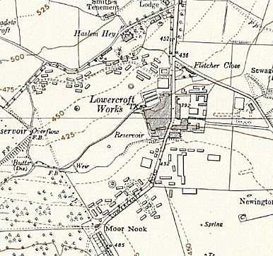
 | OS 1956 some of the army and pow camp still shown
wooden semidetached houses situated down a slight slope surrounding a central area. This little estate, consisting of about 20 dwellings, was a very pleasant place to live and a thriving friendly community. Eventually the houses were demolished and the residents housed in purpose built council houses and the new private housing estate which we see today was built.” https://ainsworthhistorysociety.org/onewebmedia/Prisoner%20of%20War%20Camp.pdf

Although this history only mentions Italian pows, a report shows that there was a short period when Germans were held here.

 | 9/42 | 11/42 | 43 | 5/44 | 9/45 | 7/46 | 12/46 | 3/47 | 4/47 | 6/47 | 8/47 | 10/47 | 12/47 | 1/48 | 3/48
Lowercroft |  |  |  |  |  |  | 100

Moor Park, Preston. Moor Park is a large park to the north of the city centre of Preston.

A brief mention that it was a hostel for Italian pows in 1944.

Memories – “Later in the war, an Italian prisoner-of-war camp was set up in the park. These men lived in Nissen huts. Boys at the Grammar School, of whom I was one, learnt Italian in our dinner breaks from ‘Jasper’ (Mr Fielding) so that we could talk to these prisoners. They had a great deal of freedom and the Italians who came to a morning service in our Church as mentioned in this magazine about two years ago, probably came from there.” [A.Hindley; www.fulwoodmethodist.org.uk/fmcmag/easter%202006/moor/moor_park.htm]

Facebook entry by Ronnie Reader; “…As you entered the Park from Deepdale Road at Park Walk on the right was a brick building that housed Cook House, Wash Room etc. Gerard House then a number of Nissen Huts for Prisoners down to St Paul’s entrance…” Memories of German prisoners, believed that the camp closed in 1947/8.

SanctoBernardo on BBC WW2 People’s War – “The nearby Moor Park had originally had trenches cut across it to prevent parachute or airplane landings, but then by 1943 as I began school it became a POW cap of two tiers; the inner barbed wire circle was for Germans and the outer for Italians who wore these brown suits with big blue or yellow circles on the jacket back. The Italians were allowed out to work on farms etc and they decorated the most ornate Christmas crib I had ever seen in the local Catholic chapel.” I think the 2 separate sections of the camp would have occurred 1945 for a short time as the Italians were moved on and Germans arrived.

 | 9/42 | 11/42 | 43 | 5/44 | 9/45 | 7/46 | 12/46 | 3/47 | 4/47 | 6/47 | 8/47 | 10/47 | 12/47 | 1/48 | 3/48
Moor Park |  |  |  |  |  | With 177

September / October 1946 – listed as a hostel attached to Warth Mills Camp 177. 41 then 15 pows, so looks like it was closing down.

Myerscough – previously a hostel for Warth Mills Camp 177.

June 1947 – Hostel leader; U/Schaf. Schneider (B-) – “He joined the party and S.A. (Scharf.) [Scharführer - squad leader] in 1932 and served with the Waffen-SS as Uscha. [Unterscharführer – junior squad leader] with the acting rank of a Hpt.Schaf.” Despite his record it was recommended that he be allowed to continue as leader. He was still in place when this site closed in 1947.

Political complexion was seen as poor and in need of re-education.

August 1947 – An improvement in political outlook was noticed after the removal of a few pows with bad influence.

 | 9/42 | 11/42 | 43 | 5/44 | 9/45 | 7/46 | 12/46 | 3/47 | 4/47 | 6/47 | 8/47 | 10/47 | 12/47 | 1/48 | 3/48
Myerscough |  |  |  |  |  |  |  | With C177 |  | 158 | 113 | 51

Peninsula Barracks, Warrington

The barracks were opened in 1878 in O'Leary Street, Warrington.

Just one mention that the barracks were used as a hostel with Italian pows in 1943.

 | 9/42 | 11/42 | 43 | 5/44 | 9/45 | 7/46 | 12/46 | 3/47 | 4/47 | 6/47 | 8/47 | 10/47 | 12/47 | 1/48 | 3/48
Peninsula Barracks

Penketh – 11 miles from the main camp. Hutted camp with electric lighting. Formerly Camp 290 – separate details and map.

3 May 1946 – in her visiting lecturer’s report, Alice Hirschfeldt reported that there had been a “great celebration” on Saturday 3 May at St Ambrose Church, Widnes, when “the Lord Bishop of Liverpool dedicated a stain-glass window given by the PsW.”

The Church history notes that; “The window in the fourth arch of the south aisle arcade was given by the German prisoners of war from Penketh hostel in South Lane, who marched to church each Sunday, in grateful memory of services held in church from 1946-1947. The window cost £60. £20 of this was given by the P.O.W. Welfare Fund, £7.4s.0d by the prisoners and the balance from the sale of toys made by the prisoners. It depicts St Boniface the (English-born) patron saint of Germany.” [A History of St Ambrose Church in Halton View Widnes].

The window had been designed by Trena Mary Cox. After the dedication there was “a tea-party in the church hall and a concert given by the choir and band of Camp 50”.

July 1946 – Hostel leader; St.Fw Borgwardt (B), (different spelling in next report – Borgvad) – continued in place until late 1947. “Regular soldier – not a very impressive character, appears too apathetic… This hostel is in need of a great deal of re-education. It has recently been taken over from 290 Camp and consists very largely of W.S.S. [Waffen SS] who have recently arrived in this country via Belgium, and who for the most part have not yet seen the ‘K.Z.’ film” [The KZ film was about concentration camps].

6 August 1946 - SS Corporal August Theobald died at Penketh Hostel. Born 13 September 1907 at Herxheim am Berg, Rheinland-Pfalz. The cause of death is not stated. He is buried at the German Military Cemetery at Cannock Chase, Staffordshire.

19 August 1946 - the hostel chapel was inaugurated with Pastor Danz from the main camp giving the sermon.

13 – 15 September 1946 – Rev Dr D Meyer-Kluegel gave a lecture at this hostel. He made the following remarks about one of the pows – “At this hostel is a man whose name is Baring. He was born in 1904 and studied Laws. He is a typical opportunist, he became a Nazi Party member in 1933 and then he became a high civil servant (Oberregierungsrat and Ministerialrat). Apparently by people at Camp 174 (Norton Theological Training Camp) he has been appointed as Camp Pastor for this hostel. He made a rather long speech in the discussion, mainly agreeing, mostly disagreeing with lecturer, but above all excusing himself for having joined the Nazis. The majority of the audience raised strong objections to his being Camp Pastor, and lecturer therefore suggested that, if he really wanted to serve Jesus, he should resign from being Camp Pastor and give a genuine anti-Nazi, preferably a younger man, one of his comrades at the hostel or from the Main Camp, the chance to take over his work. He promised to do so.”

[The Rev Dr D Meyer-Kluegel had given a lecture at a hostel for Willingham House Camp 256 in July 1946 when he had made comments on another camp-pastor stating that he was a Nazi. The pastor was later recommended to be removed].

March 1947 – High number of youth pows with 55% - mostly SS.

October 1947 – Hostel leader; Rottf. [Rottenfűhrer] Thill (B).

8 men attended Toc H meetings in Widnes and contacts had been made with the Widnes Town Council.

11 April 1947 – Runcorn Weekly News - abridged article about the hostel.

‘PRISONER OF WAR / Food : Beer : Cigarettes : Home : Work / The Life of a German at Penketh – “As I walked through the open and unguarded gates of the German Prisoner of War camp at Penketh, I was struck by the neat and orderly way in which the huts were laid out…

For some time past these prisoners of war have been seen in the streets of Widnes, in their conspicuous garb of brown and green patched suits. Many people have observed them, many people have felt sorry for them, knowing that some at least have lost traces of their families in Germany, and are in fact displaced persons. Other people think they ought not to be treated so liberally, and those people are remembering the concentration camps at Belsen and Buchenwald. But the way to ultimate world peace is not the way of the vindictive, and to teach these men that the average British citizen is a kind, considerate and fair person….

[Just after the war there was a general negative attitude towards Germans, especially after news of the concentration camps was revealed. Changes in attitudes arose slowly and campaigns called for assisting Germany to become a democratic ally, to move on from the past, and to establish a repatriation programme for the pows. Christmas 1946 many families invited pows to their homes. March 1947, following official⁽¹⁾ and news reports⁽²⁾ of deteriorating morale for pows, restrictions were relaxed further, in particular travel limits and participation in outside activities. However, due to demands for labour within the UK the government was reluctant to increase the rate of repatriations.

Examples - ⁽¹⁾ Memorandum from The War Office to the Cabinet, 30 August 1946, CP(46)327. ⁽²⁾ Daily Mail editorial, 21 August 1946 calling for repatriation dates to be set.

“The prisoners of Penketh treat the liberties they receive with great seriousness and they are careful not to violate the rules…. But they have one big grouse – they think they are not being used to the full to do useful work. ‘Let us go home,’ they say, ‘where we can settle down to do a job of work worth while, and so help to put Germany back on her feet, or if that is not possible, give us an approximate date when we will go home…. At the moment a few of the prisoners work in the industrial plants of Widnes, chiefly doing sweeping jobs. Others, who are trained technicians go to army depots and work at their trade, but the majority do little useful work…

Heinz Stehlke, aged 34, was interviewed – “… his home was in Danzig, for he has not heard from his parents for some considerable time…. His pay... is 6s a week, and this money is paid to him in tokens. He cannot spend it outside the camp, but only at the canteen, where he can buy beer and cigarettes, and various other unrationed sundries. On top of this he may be able to earn a bonus of 9s a week by working in a factory or helping with the harvest. This money he does not receive, but it is saved for him or, if he desires, is sent home to his relatives.

“He is allowed out for walks, from 10am until dusk, which at the moment is adjudged as 8pm. As the nights grow lighter, so dusk will become later, and so he will have extra liberty. He says that he spends his time in walking, and visiting an English family in the Widnes district, who have, as it might be termed, “adopted” him. There he has meals, and takes part in the family leisure.

“He told me that he had worked at Orrs Zinc White until very recently, but the work has now finished. There, he was in charge of the German prisoners who were engaged in cleaning duties, and unloading coal. He liked the work because he received the 9s bonus, and kept himself occupied. He described the living quarters as very good, and said that they had reasonable room and excellent ablutions.

“At this point the British N.C.O. in charge of the camp came into the room where the interview was being conducted, and along with Heinz, he was greatly amused by the next question: “How do the British soldiers treat you?” Heinz thought for a time and then replied, “very well”, and judging by the impression I gained during my short stay in the camp, I think this is very true.

“I asked him what his impressions of the English way of life were, and he immediately expressed thanks on behalf of himself and the other prisoners for the kind way in which the majority of Widnesians had received them…” He was surprised that the standard of living in England was as low as it was. He was receiving roughly the same rations as civilians. Cigarettes were in short supply everywhere due to transport problems, they were low quality and nicknamed ‘stinkers’. Beer from Widnes was popular, but the pows were not able to buy much from their allowances at the camp canteen. The profits raised in the canteen, and the sale of toys (officially by giving the toys to locals who then sold them) had been used to buy a window for St. Ambrose Church. Recreations included table tennis and football. The camp had its own team which played local amateur teams. Some also took English lessons. Most pows would walk to Widnes, some attended matches at Naughton Park.

“Letters from home… the frequency of these depends to a large extent on the zone from which they are posted. Generally letters arrive within a week of posting. Those letters tell of bad conditions in Germany, and all the prisoners are convinced that the food situation in the Fatherland is very bad. I pressed this point very closely, for it is easy to get wrong impressions from the letters of relatives, who are under the yoke of a victor, but Heinz, along with the interpreter and camp leader, said that the tales from home were so consistent in hundreds of letters that there could be no doubt that what they said was true.

To sum up, it would seem that the average German prisoner of war is treated very well in England. They seem, to judge by the internees of Penketh, to be smart, intelligent, clean and well principled young men, who realise the mistakes made by their leaders in the past, and whose only wish is to go home and start life afresh in a true democratic manner, to the furtherance of the peace of the world.”

 | 9/42 | 11/42 | 43 | 5/44 | 9/45 | 7/46 | 12/46 | 3/47 | 4/47 | 6/47 | 8/47 | 10/47 | 12/47 | 1/48 | 3/48
Penketh |  |  |  | Camp 290 |  | 404 | 213 | 175 | 270 | 46 | 82 | 107 | 47 | 43 | 31

Salesbury Hall - NGR SD 6727 3564

A brief mention that it was a hostel for Italian pows in 1943.

 | 9/42 | 11/42 | 43 | 5/44 | 9/45 | 7/46 | 12/46 | 3/47 | 4/47 | 6/47 | 8/47 | 10/47 | 12/47 | 1/48 | 3/48
Salesbury Hall |  |  |  |  |  | With C177

Staging Camp (Preston)

A brief mention that it was a hostel for Italian pows in 1943.

 | 9/42 | 11/42 | 43 | 5/44 | 9/45 | 7/46 | 12/46 | 3/47 | 4/47 | 6/47 | 8/47 | 10/47 | 12/47 | 1/48 | 3/48
Staging Camp

West Derby (Liverpool).

A brief mention that it was a hostel for Italian pows in 1943.

 | 9/42 | 11/42 | 43 | 5/44 | 9/45 | 7/46 | 12/46 | 3/47 | 4/47 | 6/47 | 8/47 | 10/47 | 12/47 | 1/48 | 3/48
West Derby

Wheathill – 14 miles from the main camp. Country House. Linked to Penketh Camp 290 before being taken over by Garswood.

July 1946 – Hostel leader; O/Fw Juch (B-). “Goodish type, quite willing to help in re-education, but needs more experience and in particular assistance from a T.A. [Training assistant]. Like Penketh, this hostel was previously in 290 Camp and consists very largely of W.S.S.” [WSS = Waffen-SS]

“This is the blackest of the hostels with 85 SS men out of a strength of 102 PW.” It was recommended that these men be transferred to the main camp; this may have been carried out as the hostel is not listed again with C50.

 | 9/42 | 11/42 | 43 | 5/44 | 9/45 | 7/46 | 12/46 | 3/47 | 4/47 | 6/47 | 8/47 | 10/47 | 12/47 | 1/48 | 3/48
Wheathill |  |  |  | With C290 |  | 102

Wimbrick House, Ormskirk

A brief mention that it was a hostel for Italian pows in 1944.

 | 9/42 | 11/42 | 43 | 5/44 | 9/45 | 7/46 | 12/46 | 3/47 | 4/47 | 6/47 | 8/47 | 10/47 | 12/47 | 1/48 | 3/48
Wimbrick House

