Camp 296 – Ravenfield Park Camp, Rotherham, Yorkshire

Prisoner of War Camps (1939 – 1948) - Project report by Roger J.C. Thomas - English Heritage 2003
OS NGR | Sheet | No. | Name & Location | County | Cond’n | Type 1945 | Comments
SK 4847 9550 | 111 | 296 | Ravensfield Park Camp, Rotherham | Yorkshire | 4 |  | Farmland

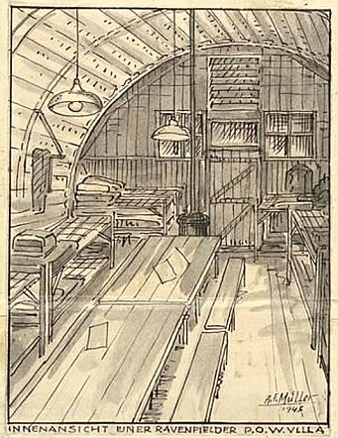  Location: SK 4847 9550. The camp was in Ravenfield Park, near to the fish ponds.  Guard officers used Ravenfield Hall.  Previous use: Large country estate.  POW camp: There are some memories of Italian pows before 1945.  March 1946 – Independent camp 296. Camp magazine; Die Fähre : Zeitung der Deutschen Kriegsgefangenen in England - Lager Ravensfield Park - The Wiener Holocaust Library  Camp leader; Heitzer.  Picture – “An inside view of a Ravenfield pow villa.”  An article stated that 2 hostels had been gained – Barnsley Road and Hoyland.  September 1946 – listed as a hostel for Lodge Moor Camp 17 with c.700 pows. | 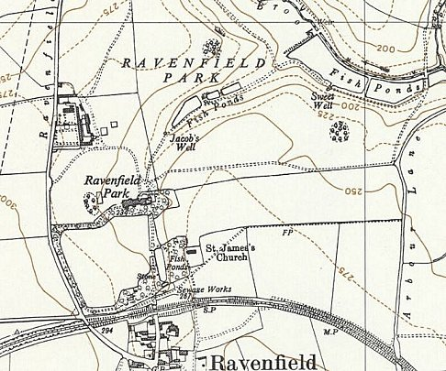
 | Ordnance Survey 1956

Oversight and development of re-education activities and English teaching for German pows was carried out by PID (Political Intelligence Department of the Foreign Office) / COGA (Control Office for Germany and Austria – UK). Visits and reports were made. The standard of the reports varied greatly. The visitors took little interest, if any, in activities other than re-education. They rarely mentioned welfare, sports, games, pastimes, crafts, etc of the pows.

15/18 July 1947 – Independent German Working Camp. Survey of re-education. Progress report. Strength; 278 officers, 1189 other ranks.

The visitor believed that this was the 1st report for this re-formed independent camp.

Numbers: |  | Officers | O.R. | Total
 | Ravenfield HQ | 263 | 207 | 470
 | High Green Satellite | 1 | 784 | 785
 | Woolley hostel | - | 99 | 99
 | Billetees | 14 | 99 | 113

Commandant: Lt Col Winberg Camp leader: Major Gerhard Weiser B93702
Interpreter: 2nd Lt C O l Juulman Deputy C/L: Fw Georg Schwarz
German M.O.: St.Arzt Hans Nietzschmann

The Commandant had taken command just 2 days earlier. He was new to pow work and interested in re-education.

I.O. Juulman was “very young” and not regarded as a strong influence for re-education.

The Camp leader was also new to his position. He had previously been a hostel leader and gave an, “excellent impression.”

There had been a major change for officers at the camp. Under the Geneva Convention, officers did not have to work, but the 278 officers at Ravenfield during this review had volunteered to carry out agricultural work. The previous Camp leader, Major von Fircks, his deputy and 20 officers did not wish to work and so were transferred to Quorn Camp 9. Major von Fircks and the deputy had, “acted like prototypes of the Junker class,” and grievances arose with the O.R. pows. It was expected that overall morale in the camp would improve with these changes.

Simplified political screening figures were given: A 13 / B 1454. 119 pows were appealing against their grades – the better the grade, the sooner repatriated, in theory. 721 pows repatriated to date.

Pows were working long hours for the harvest. Good relationships with local civilians were noted.

‘Youth’ pows (under 25) were held at Woolley hostel. They were not seen as a problem.

The standard list of re-education activities was given:

Wochenpost and Ausblick – 250 Wochenpost, more requested.

Newspapers – “adequate.” A range of British papers purchased using the Welfare Fund, and copies were distributed to the hostels.

Library – 2500 books purchased mainly using the Welfare Fund, and copies distributed to the hostels.

Lectures – regular, but attendance had fallen, partly due to long working hours. It was expected that attendance would increase.

Discussion group – ceased due to the repatriation of its leaders.

Films – One to two films per week, this is more than most camps. Films supplied by commercial companies; Gaumont British and Travelling Films. Again, this is unusual as other camps had YMCA and just one or other of the commercial companies. The quality of Travelling Films was described as “deplorable.”

Wireless – Electricity at HQ was supplied by generator, therefore only battery sets could be used. German stations could not be received.

Camp magazine – ‘Die Zeit’ issued monthly. Although of a high standard, it was suggested that some more ‘popular’ articles should be included.

Press review – 3 pages issued 6 times a week.

English instruction – separate appendix

Information room – none.

Other camp activities –

Religion – Protestant chaplain, OGefr Georg Schroer. A RC chaplain from Camp 17 visited. There was little interest. There was no church; services were held weekly in the dining hall.

Education – no classes.
Entertainment – No theatre group. An 8 piece orchestra. Popular sports – football, rugby (very rare for this sport to be listed), table tennis and athletics.

An art exhibition was held in May – said to be of a high standard, civilians and the press were invited. New privileges allowed pows to attend local shows and cinemas.

21-24 October 1947 – Re-education survey. Strength; 281 officers, 825 OR.

Due to a decrease in the number of pows, the camp was being downgraded to a Major’s command, and Lt Col Winberg was due to leave.

Just one change to senior personnel; the Interpreter had left and not been replaced.

The Camp Leader was doing very well at maintaining the awkward balance in the camp with officers and OR. It was noted that some officers were of “the old type;” they found it difficult to change their views and many continued to wear insignia of rank. Despite this, overall, good political progress had been made.

An extra effort was made to care for those in billets, rarely seen elsewhere. Each billet was supplied with: 1 copy of Wochenpost / Ausblick / English for All / the daily news sheet bound in a weekly edition, 2 monthly camp newspapers and educational / library books.

There were few changes to activities in camp:

Films – supplied by C.O.I. mainly documentaries; Travelling Films, YMCA and some from the Prisoner of War Division.

Camp magazine – in response to the request for more popular articles, a second magazine was published; ‘Halbzeit.’ The new magazine concentrated more on camp news, local events, sport and short stories. Both magazines were very popular.

Information room – this was created to display exhibitions of text and pictures on a theme.

Education – some lessons at the satellite camp. Some pows were taking W.E.A. courses for international affairs (23 pows), literature (7), psychology (4), philosophy (3) and music appreciation (2).

Entertainment – the orchestra was suffering from repatriations and unlikely to continue.

Outside contacts –

Further art and handicraft exhibitions were held at Moorgate Church Hall and the town halls at Rotherham and Doncaster. They were a great success, open for 3 days and attracting 7-8000 visitors.

Visits to West Riding and Rotherham Police Courts, Doncaster County Council. Visits to museums in Sheffield.

Attendance at meetings of religious communities at Thrybergh, Rotherham, High Green and Sheffield.

Attendance at conferences in Doncaster.

Late passes were allowed for pows to attend plays and concerts.

April 1948 – listed as a hostel for Sandbeds Camp 53.

Known Commandants:
1947 Lt Col Winberg; Royal Armoured Corps. Later with Motcombe Park Camp 47.

Further information:
National Archives: FO 1120/244, used above.

After the war:
High Green Satellite. [Potters Hill Camp 127 was located at High Green – I am not certain that this was the same site].

July 1947 – 1 officer, 784 OR.

Camp leader; Fw Theodor Lies; new to the position; “colourless but co-operative.”

German MO; O/Arzt Dr Horst Etzler;

Re-education activities barely existed – this was blamed on the previous (unnamed) leader. At one lecture only 1 pow turned up. It was believed this would improve with the new camp leader – 30 pows attended a lecture during the review.

A new wireless set and loudspeakers were being installed capable of receiving German stations.

10/1947 – same leader.

British officer i/c; Capt Smallwood.

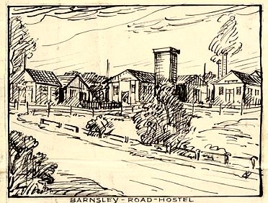
Hostels

Barnsley Road Doncaster. On Barnsley Road, Scawsby, opposite St. Leonard's church – NGR SE 552 049.

Previously attached to Potters Hill Camp 127.

Picture from the camp magazine.

3/1946 – Translated article in camp magazine;

“On Sunday (March 10th), 75 German comrades moved into the hostel vacated by the Italians, which belongs to Camp 296. The comrades transferred here from Camp 127 were largely replaced by work groups from the main camp, whose commute to and from work was significantly shortened by the relocation to this subcamp.

The staff has now increased to 76, consisting of 6 permanent staff members; the rest are on work assignments outside the camp. Currently, 5 barracks are available, including 2 living barracks (accommodating 70 men), 1 kitchen barrack with mess halls, an attached dining hall, an office for the camp administration, and a room for British staff. The sanitary facilities barrack contains a bath, washrooms, and toilets. Also worth mentioning is the living quarters at the entrance for the English commander and a small store.

A flower garden, already planted by previous ‘campers,’ detracts from the otherwise pleasant impression of the entire site. The past few days have been spent cleaning the camp. Minor repairs are still needed. The garden has been refreshed; further clearing for planting vegetables will begin in the next few days.

Heinrich Sefirian, well-known to many in 296, is taking care of our physical well-being. Although the hostel is small, this allows for a much stronger sense of camaraderie.

A selection of entertaining books is available for intellectual stimulation. Two English language groups (for beginners) will start this week. Newspapers and reports arrive weekly. We maintain regular contact with the main camp.

A meadow adjacent to the camp has already been used by the younger members for a game of football.”

Not listed with this camp in July 1947.

Hoyland

Previously attached to Lodge Moor Camp 17 and then Potters Hill Camp 127.

3/1946 – “Hoyland sends its greetings! So, its finally happened. The union is complete. We have joined you, or rather, been ushered into your fold…..”

Not listed with this camp in July 1947.

Woolley

Previously attached to Lodge Moor Camp 17, Potters Hill Camp 127 and then Post Hill Camp 91.

7/1947 – 99 O.R.

Hostel leader; Owm Otto Mueller; “colourless but co-operative.”

10/1947 – same leader. It was recommended that he be replaced.

