Camp 294 Thedden Grange & Fishers Camp, Alton, Hampshire

1947 Camp List
294(G.W.C.) | Fisher’s Camp, Alton, Hampshire | S | Priswar Alton | Alton 3231 | Alton | Major E.R.C.Warrens D.S.O. | v/1452/2

Prisoner of War Camps (1939 – 1948) - Project report by Roger J.C. Thomas - English Heritage 2003
OS NGR | Sheet | No. | Name & Location | County | Cond’n | Type 1945 | Comments
SU 683 391 | 185 | 294 | Fisher's Camp, Theddon Grange, Alton | Hampshire | 5 | German  Working Camp | Precise location not identified, NGR  given for Theddon Grange.

Location: Fishers Camp and Thedden Grange were two separate camps. They were linked in the English Heritage entry above as they were unaware of the location of the HQ camps.  Thedden Grange was the first HQ, NGR SU 683 391. 1947 Aerial photo: View map: Ordnance Survey, OS Air Photo, 6 inch to the mile (1:10,560), Sheet 41/63 N.E. - Ordnance Survey Air Photo Mosaics, 1944-1950  Fishers Camp, NGR SU 731 407, was just off the A31 London Road. 1946 Aerial photo: Aerial Photo | Historic England  Before the camp:  Thedden Grange – Country house and estate.  Fishers camp – large house and grounds. Recorded as a barracks in rates book by 1941. Became No.4 Military Prison and Detention Barracks for Canadian troops as an annexe to ‘No.1 Canadian Detention barracks’ at Headley Downs, Hampshire. There was an escape by two Canadian pows from here in February 1946. | 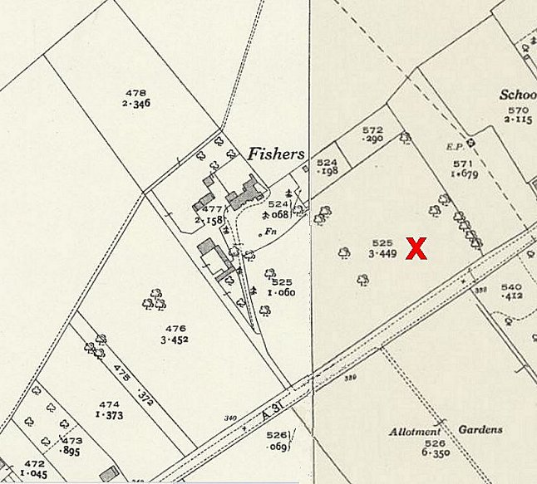 | 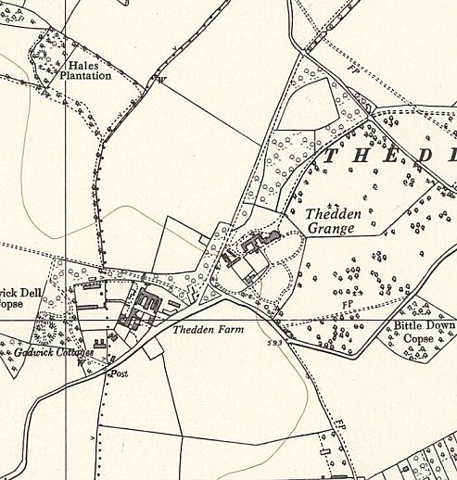
 | Ordnance Survey 1939 | Ordnance Survey 1961
Pow Camp(s):

Thedden Grange - Nissen huts in the grounds.

September 1945 – Listed with Mortimer Camp 88 – Germans, capacity 100.

1945 - Listed with Camp 41 – must have been just a brief time. (Progress report 154 – FO 939/383).

Oversight and development of re-education activities and English teaching for German pows was carried out by PID (Political Intelligence Department of the Foreign Office) / COGA (Control Office for Germany and Austria – UK). Visits and reports were made. The standard of the reports varied greatly. The visitors took little interest, if any, in activities other than re-education. They rarely mentioned welfare, sports, games, pastimes, crafts, etc of the pows. If there were still Italian pows in hostels, they were usually ignored by PID.

1945/46 – became independent Camp 294.
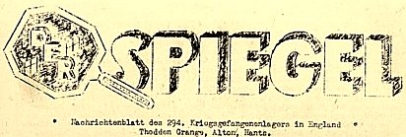
1946 – Intake of many pows from camps in the USA and Canada. Most of the ex-US pows had a very low morale as they had been misinformed in the US they were being repatriated. Instead, they found themselves in working camps in the UK.

March 1946 – Camp magazine; https://www.whlcollections.org/image/112869/

7-9 and 14 August 1946 – 294 Thedden Grange; Progress Report by PID / “Select British Zone whites for repatriation.” Strength; 4 officers, 1156 Other Ranks.

Recorded as the 3rd visit, but the first 2 reports are not in the National Archive file.

Commandant: Major Warrens. Camp leader: Fwbl Linnenkohl (B+)
Interpreter: None Deputy C/L: None
German M.O.: St.Arzt Dr Schwiese (B+)

Major Warrens was appointed as Commandant 10 days earlier. He had been Commandant at East Cams Camp 251. He was enthusiastic about re-education work. There had been a previous commandant who took no interest in re-education.

The previous Camp Leader, Gummprecht (B) was described as, “a harmless nonentity.” He was replaced as overall Camp leader in May by Fwbl Linnenkohl who had previously been held in camps in the USA.

The new intake of pows from American camps almost doubled the size of the camp. The HQ site at Thedden Grange was then divided into 2 compounds - Camp A, leader:Fwbl Lubberstedt (B+) and Camp B, leader: Ofw Haase.

Very few pows had been politically screened: | A | B+ | B | C | Unscreened
 | 19 | 11 | 25 | 13 | 1092

Urgent and repeated requests were made by the Commandant for the pows to be screened. The grades of pows affected the speed with which they were repatriated - the better the grade, the sooner repatriated (in theory). As so many pows had not been screened at all, the majority justifiably felt they were being treated unfairly. The PID visitor quickly graded a number of pows while he was on site in order to at least get repatriations moving to the British zone.

Morale was said to have been one of “gloom and apathy,” but there were already signs of improvement with the new Commandant and Camp Leader.

About 1/3 of the pows were ‘youth’ (under 25). It was hoped a discussion group would be started for them, (no record of it having done so).

The standard list of re-education activities was given. The previous neglect was apparent in many areas:

Wochenpost and Ausblick – 120 copies of Wochenpost received. More requested.

Newspapers – Only a very small number of British papers purchased by the Welfare Fund; 4 for HQ, 2 for the hostels and 1 for the medical centre. Very few German and Swiss papers were being sent by COGA.

Library – “Completely inadequate.” Just 100 books sent by COGA for 1160 pows.

Lectures – Irregular. When they occurred, they were highly appreciated. Pows who attended courses at the Special Training camp at Wilton Park gave some lectures.

Discussion groups - recently started, weekly.

Films – supplied by COGA and YMCA every three weeks at HQ and Bramdean. Soon to start at Stroud Farm. Cuckoo’s Corner pows were transported to Thedden Grange.

Wireless – satisfactory at all sites.

Camp magazine – started, but then ceased as COGA had not sent supplies of paper.

Information room – None.

English instruction – Separate appendix.

Other camp activities –

Religion – A protestant lay priest, Lt Becker (B+) had been sent from the special theological camp 174. He was described as a “very hard and enthusiastic worker.” Sunday services had 80 pows at HQ and 50% at Bramdean. He also organised facilities for RC pows.

Education – Classes for French, Spanish, Latin, maths, history and literature. Classes were small during the summer.

Entertainment – A small orchestra had been formed.

Thedden Grange had just been inspected by the G.O.C. Aldershot and Hants District and been condemned as unsuitable as HQ due to its general layout and accommodation. It was decided the site would be reduced to a pow hostel and a new HQ be formed at Fishers Farm, about 3 miles away.

Fishers Farm Camp – the site had been a Canadian detention barracks up to early 1946. The camp buildings were later listed in 1949 as; 26 Nissen huts – Kitchen (cookhouse and bakehouse), 2 linked huts used as a sick bay, Recreation room, Showers, Drying Room, 2 Messing Huts, Theatre.

28 October – 8 November 1946 – HQ at Fishers Camp (Thedden as a hostel). German Working Camp. Report of visit by the Segregation Section concerning screening. Strength; 2 officers, 1107 OR.

A new interpreter; S/Sgt Burger. He did not believe in re-education, but the visitor was not concerned as he was due for demobilisation.

Camp leader Linnenkohl, aged 36, a wholesale provision merchant. He had been a Nazi party member; “for business reasons.” He was regarded as an able and energetic leader.

Political screening: | A+ | A | A- | B+ | B | B- | C | C+
 | - | 117 | 1 | 190 | 624 | 101 | 73 | 3

Some of the billeted pows were C grade (Nazis). Though they were not considered to be a danger, it was recommended they be brought back to HQ so that they would benefit from re-education activities. It was also recommended that the three C+ pows be sent to a different camp.

Religion – The camp became a base for 3 pow RC padres for the Aldershot and Hants district. One RC priest was under investigation, but no further details. Two other RC priests were “harmless.” Protestant activity was still under the control of Lt Heinrich Becker.

2,3,7 January 1947 – Re-education survey. Strength; 3 officers, 1017 OR.

Commandant: Major Warrens. Camp leader: Fwbl Max Linnenkohl (B+)
Interpreter: S/Sgt Burger Deputy C/L: Werner Faehnrich (B+)
German M.O.: St.Arzt Dr Wolfgang Schwiese (A) – upgraded from B+

In addition to the overall camp leader, there was a leader at Fishers Camp; Ofw Heinrich Luebberstedt (B+), soon to be repatriated.

The Commandant was praised for his caring relationships with the pows.

Simplified screening figures were given; A 46 / B 904 / C70. 108 pows were appealing against their grades. 141 pows repatriated to date.

Morale was recorded as high due to; Christmas, visits from COGA, football matches, increased freedoms allowed to pows, and excellent relationships with the British staff.

289 pows were ‘youth.’ They were not seen as a problem.
Re-education activities had slightly increased:

Wochenpost and Ausblick – separate appendix.

Newspapers – 13 British dailies and a few at the weekend. Very few German and Swiss papers.

Library – “Inadequate.” 722 books, but only 386 were read.

Lectures – Regular.

Discussion groups – Held weekly and successful.

Films – supplied by YMCA and an unnamed commercial company. The commercial films received complaints that they cost 6d and carried an additional 12 shillings from the Welfare Fund.

Wireless – satisfactory at all sites.

Camp magazine – fortnightly, 250 copies. Paper and stencils in short supply.

Information room – Recently started, showing exhibitions of text and pictures on theme, e.g. ‘The British Parliament.’

English instruction – 5 beginner’s classes and 3 advanced.

Other camp activities –

Religion - 50% RC and 50% Protestant. 3 RC priests; 2 of which were sound, the third, Richard Classen (believed to hold the rank of Lt Col, but this was not certain) was still under review. He stated that he had been sent by the Military Government in Luebeck, “to take over the leadership of all Catholic PW priests in this country.” This did not happen and the visitor had no knowledge of this. Protestant padre Becken received high praise for his work at this camp and others.

Education – Small classes held for maths (2 classes), machine drawing, and constructional engineering.

Entertainment – an active orchestra and theatre group.

5-7 May 1947 – Re-education survey and screening ‘C’ grade pows. Strength; 2 officers, 849 OR.

Commandant: Major Warrens. Camp leader: Hans Koerner (B)
Interpreter: S/Sgt Burger Deputy C/L: None
German M.O.: St.Arzt Dr Wolfgang Schwiese (A)
Fishers Camp leader; Kurt Weber (B).

Despite previous comments in November 1946, that the Interpreter was due to be demobilised, he was still in place. He was considered to be unsuitable for the post.

Hans Koerner’s abilities were under review. He had been elected by the pows, but was not considered to be a strong character.

Screening figures: A 3 / B 848. All (C) pows had been upgraded. 141 appeals still pending. 343 pows repatriated to date.

Good morale. All employers of pow labour were well satisfied and treated the pows well.

There were few changes to activities:

Attendance at discussion group meetings had fallen to about 20.

Outside contacts – Visits had been made to the local court room and council meetings.

Religion – RC priest Richard Classen had been posted away from this camp.

Education classes – had reduced in numbers; 1 maths class (4 pupils), engineering (3), Engineering drawing (5), German (5).

Entertainment – a new theatre had been built at HQ.
MID JUNE 1947 – Camp 294 had been taken over East Cams Camp 251. Fishers became a satellite camp and continued to administer Cuckoo’s Corner. Bramdean became a hostel directly administered by East Cams. All 3 sites closed in 1948 – see C251…. The unsuitable Interpreter was also transferred to C251 and received a very bad report.

Known Commandants:
1946 - Major E.R.C.Warrens D.S.O. Previously Commandant at East Cams Camp 251.

Camp numbers

 | Open |  |  |  | With other camps |  |  | Unknown |  |  | Not listed / not open

 | 8/1946 | 11/1946 | 1/1947 | 5/1947 | 6/1947
HQ | Thedden - 585 | Fishers - 325 | Fishers - 287 | Fishers - 373 | With C251
Bramdean | 147 | 146 | 137 | 120 | With C251
Cuckoo’s Corner | 40 | 39 | 36 | 76 | With C251
Stroud’s Farm | 135 | 119 | 110 | 113
Thedden Grange Hostel | (above as HQ) | 239 | 248
Billetees | 253 | 241 | 202 | 169 | -
Total | 1160 | 1109 | 1020 | 851 | -

After the camp: Fishers Camp was used for emergency housing for a short time - the Holybourne Theatre was later built on the site.

Further Information:
National Archives FO 1120/244 – Re-educational survey visit reports for camps 294 to 298. Dated 1 January 1946 – 31 December 1948. Used above.

IWM have a copy of the magazine dated March 1947. Ref LBY E.J. 417

The National Portrait Gallery have a photograph of Commandant E R C Warrens taken in 1936 by Bassano Ltd

Hostels

Bramdean (12 miles from Thedden Grange). Located at Brockwood Dean near to Bramdean (NGR SU 633 270). It consisted of various wooden buildings, surrounded by a high wire fence with barbed wire top, and several raised observation boxes skirting the perimeter. One memory recalled Italian pows, in which case it would have been opened well before this first entry.

15 March 1946 – mentioned in camp magazine.

8/1946 – Hostel leader; OFhnr Craemer (A), “co-operative.” Held its own discussion group.

11/1946 – Hostel leader; Uffz Hans Werner (A), elected by fellow pows. 1/1947 – same leader.

5/1947 – Hostel leader; Gerhard Lohberger (B)

 | 8/1946 | 11/1946 | 1/1947 | 5/1947 | 6/1947
Bramdean | 147 | 146 | 137 | 120 | With C251

Cuckoo’s Corner Hostel. 3 miles from Thedden Grange.

Cuckoo’s Corner, NGR SU 741 412 top right of map (Fishers Camp is shown as ‘Holybourne Brewery’ on this map, bottom left.  Used as a military camp from 1939 – Pow hostel by 1944.  Rateable assessment no. 2048, occupier Ministry of Works, P.of W.Camp at Cuckoos Corner, RV £30. Listed for half years ending 30 Sep.,1944 and 31March 1945, in the unsewered area.  Memories – four or five huts with the guards in the hut nearest to the road.  Held Italian pows up to Summer 1946.  8/1946 – Hostel leader; Ofw Hefner (B); “harmless, but colourless man.” Small hostel and pows usually attended Thedden Grange HQ for lectures, films, etc.  1/1947 – Hostel leader; Uffz Huebel Heinrich (B+). 5/1947 – same leader.  6/1947 – a hostel administered by East Cams camp 251 | 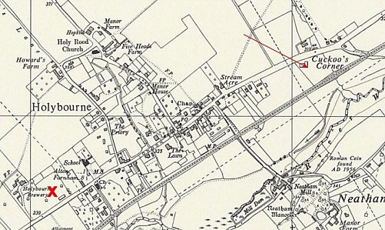
   | 8/1946 | 11/1946 | 1/1947 | 5/1947 | 6/1947
  Cuckoo’s Corner | 40 | 39 | 36 | 76 | With C251
 | Ordnance Survey 1962
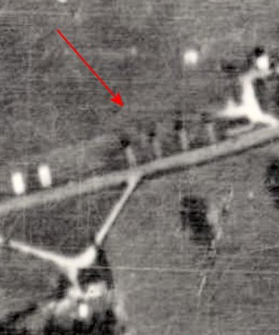
Stroud’s Farm. 12 miles from Thedden Grange. “Hutted in pleasant surroundings.” NGR SU 723 236.

Held Italian pows up to Summer 1946.

8/1946 – Hostel leader; Ofw Rachfall (B) elected by fellow pows. The hostel had been “dirty and dilapidated” but was being rapidly improved. The PID visitor requested that a hut be made available for re-education activities. The pows were described as being “rather militaristic” and more so than the rest of the camp.

11/1946 – same leader. The hostel had more C grade pows than other sites.

1/1947 – Hostel leader; Uffz Werner Knaak (B). 5/1947 – same leader. Small classes for French and Spanish held.

 | 8/1946 | 11/1946 | 1/1947 | 5/1947 | 6/1947
Stroud’s Farm | 135 | 119 | 110 | 113
< 1948 View map: Ordnance Survey, OS Air Photo, 6 inch to the mile (1:10,560), Sheet 41/72 S.W. - Ordnance Survey Air Photo Mosaics, 1944-1950

Thedden Grange Hostel

11/1946 – Hostel leader; O/Fw Hermann Haase (B), he had been Compound B leader when Thedden was HQ. 1/1947 – same leader.

