Camp 293 Carronbridge Camp, Carronbridge, Dumfries

1947 Camp List
293(G.W.C.) | Carronbridge Camp, Carronbridge, Dumfries | Sc | Priswar, Thornhill Dumfries | Thornhill 386 | Thornhill | Major P.G.Devenish | v/1452/2

Prisoner of War Camps (1939 – 1948) - Project report by Roger J.C. Thomas - English Heritage 2003
OS NGR | Sheet | No. | Name & Location | County | Cond’n | Type 1945 | Comments
 |  | 293 | Carronbridge Camp, Carronbridge | Dumfries |  | German Working Camp | Scotland

Location: Huts shown on the OS map. NGR NX 861 996. About 1 km NE from Drumlarig Castle; about 1.8km NW of Carronbridge village.  Before the camp: During 1941, most of the Norwegian army in Scotland built and moved into a barracks at Carronbridge. The site was used for training various military units – the barracks later housed British and Polish infantry, and the Canadian Forestry Corps. This site and the barracks became the pow camp.  Pow Camp: “At least 58 buildings and huts, some of the Nissen type are visible on the vertical air photographs within the perimeter fence with another 26 huts for staff and personnel outside. The perimeter fence is clearly visible on the photographs. The sewage works for the camp, is still shown on the current OS 1:2500 scale digital map, at NX 86006 99421.” (Information from RCAHMS (DE), April 2006)  1944 – listed as Camp182A, a satellite camp to Barony Camp 182.  1946 – Additional intake of pows from camps in Canada. Many were C grade; they had been captured early in the war and retained their Nazi ideology. | 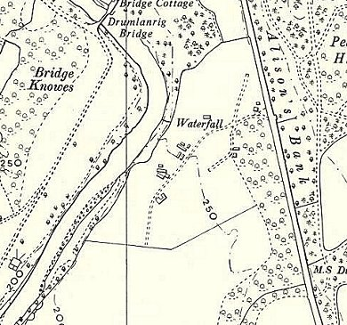
  Oversight and development of re-education activities and English teaching for German pows was carried out by PID (Political Intelligence Department of the Foreign Office) / COGA (Control Office for Germany and Austria – UK). Visits and reports were made. The standard of the reports varied greatly. The visitors took little interest, if any, in activities other than re-education. They rarely mentioned welfare, sports, games, pastimes, crafts, etc of the pows. If there were still Italian pows in hostels, they were usually ignored by PID.
 | Ordnance Survey 1957

28 June – 1 July 1946 – Report of a visit by the ‘Segregation Section’ mainly for political screening. Strength; 2 officers (the M.O.’s), 1090 Other Ranks. (Includes 90 billeted).

Commandant: Major Devenish Camp leader: Ofw Willi Sadau (A)
Interpreter: None Deputy C/L: Stabsfw Walter Grossklaus (B)
German M.O.: Stabsarzt Dr Klemann (C) [or Kleemann] & Unterarzt Hermann Heister (B-)

The Commandant was co-operative and interested in re-education – however, he did not develop activities. He was able to speak German. “He is fair and just to the P.W. with whom he is popular.”

Camp leader Sadau, aged 51, a painter and decorator. He had been a member of the SPD with no link to the Nazi party. In 1939 he spent 4 months in Hamburg-Wolfsbuettel Concentration Camp having been denounced for assisting Jews. He was having some difficulties managing some of the ex-Canadian pows, but ran the camp to the satisfaction of the Commandant. “He is a fatherly type and it is obvious that the strain is beginning to tell on him.” He was recommended for repatriation.

Deputy leader, aged 39, had worked with the police and as a farmer. No Nazi party affiliations.

The Senior M.O., aged 37. Nazi Party member – “untrustworthy type and states he cannot pass any verdict or give any decision on National-Socialism at present…. Credited by the Camp leader as being an ardent Nazi.”

The assistant M.O., aged 28. Nazi Party connections; “A weak character, easily led.”

Political screening of 299 ex-Canadian camp pows: | A+ | A | A- | B+ | B | B- | C | C+ | Unknown
Political screening of 299 ex-Canadian camp pows: | 0 | 7 | 0 | 34 | 133 | 64 | 51 | 9 | 1

The other c.700 pows were unscreened. There had been some political interest in communism, but this had declined as news was received from the Russian zone of Germany. Many from the Russian zone were afraid to declare an interest in democracy, fearing victimisation on return to their homes.

Religion – Protestant padre, Uffz Alfred Műller (A), aged 33. “A good type very interested in his work.” He had attended the special theological course at Camp 174. Sunday services had a congregation of 80/90 – but only 4 of the ex-Canadian pows attended.

At this time, it was expected that the camp was to become a satellite camp for Barony Camp 298 (was 182), but that did not happen.

1 August 1946 – Camp magazine, No.13; Unsere Welt : Lagerzeitung Camp 293 : Carronbridge - The Wiener Holocaust Library

Part of article – “The future of the camp. We were delighted to learn a few weeks ago that our camp will remain unchanged in its leadership and administration. Major Devenish will continue to be responsible for the camp's management as commandant. This means that the camp will retain its autonomy.”

11 December 1946 – Report by the Segregation Section regarding further screening. Strength; 1 officer, 837 OR.

Commandant: Major P G Devenish Camp leader: O/Maat Hermann Bohnsack (B+)
Interpreter: S/Sgt Willner (Polish) Deputy C/L: Wm Karl Forster (B)

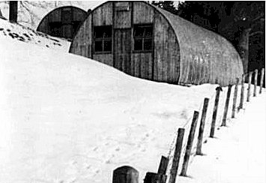
The Interpreter did not appear to be efficient and his knowledge of English, “leaves much to be desired.”

The new Camp leader, aged 46, a druggist and later policeman, was appointed in September. He had been held in camps in the USA. “Appears sound and sensible;” though he had been a member of the Stahlhelm.

Deputy leader Forster, had been a member of the Hitler Youth; “Fairly intelligent makes a very good impression.”

Political screening: | A+ | A | A- | B+ | B | B- | C | C+ | Unknown
Political screening: | 38 |  |  | 708 |  |  | 92 |  | -

Some C grade ex-Canadian pows had been transferred to other camps.

13-16 January 1947 – re-education report. Strength; 1 Officer, 737 OR. (81 in billets).

1 change noted for senior personnel; German M.O.: Stabsarzt Dr Kleemann, had been upgraded to (B).

In this report the Polish Interpreters command of German was also criticised.

Simplified screening figures were given: A 22 / B 623 / C 93. 19 appeals against screening grades had been heard; 18 were accepted, (the better the grade, the sooner repatriated, in theory). 145 pows had been repatriated to date – this included some specially selected due to their profession as miners, forestry workers, etc.

Morale was recorded as “average.” Positive factors were additional freedoms recently allowed, and good education and welfare arrangements in the camp. Negative aspects were always slow repatriation and bad news from home, especially from the Russian zone. There were no active Nazis, and the Nuremburg trials were having an effect on political attitudes. It was expected that many of the C grade (Nazi) pows would be upgraded at the next screening.

80/100 pows were ‘youth’ (under 25). They were not seen as a problem.

The Director of studies, Romels (B-), previously a school teacher, was under review. The visitor believed he was an opportunist and was not convinced he had rejected Nazism. However, he was active and was receiving good reports, so no further action was taken. Activities had decreased in recent months, partly due to repatriation of many leaders, and partly due to the greater freedoms allowed for pows to walk out of camp in free time. It was hoped the Director of studies would increase interest. The standard list of re-education activities was given:

Wochenpost and Ausblick – separate appendix.

Newspapers – A wide range of British papers were received, purchased by the camps welfare fund. Some German and Swiss papers were sent by COGA.

Library – 700 books, including 160 text books. Only 200 fiction books, many in a bad state.

Lectures – Regular. 300-400 attended, with discussions held afterwards.

Discussion groups – Weekly, organised by the camp committee (Arbeitsgemeinschaft). Attendance 80/130.

Films – Supplied by Wochenschau (free) and YMCA (2d charge = 2 pence). Gaumont British films came for a short time, but were found to be too expensive, (in other camps they charged 6d and a further flat charge to the Welfare Fund). 80-90% of the camp attended.

Wireless – “satisfactory.” Set was able to receive broadcasts from Germany.

Camp magazine – Fortnightly of about 180 copies and circulated to billets.

Press review – Daily news summary issued.

English instruction – separate appendix.

Information room – Showed exhibitions of text and pictures on a theme. Currently, ‘Youth and Education.’

Other camp activities –

Religion – 70% evangelical, 30 % RC. Protestant padre Mueller was popular; about 100 pows attended his services. A priest from Barony Camp 298 visited fortnightly, with about 50 pows attending.

Education – Classes for agriculture, forestry, slating (roof slating?) and French.

Entertainment – There was a small theatre group. The orchestra of 12 members gave a fortnightly concert of a range of music. 30 pows formed a successful and popular choir.

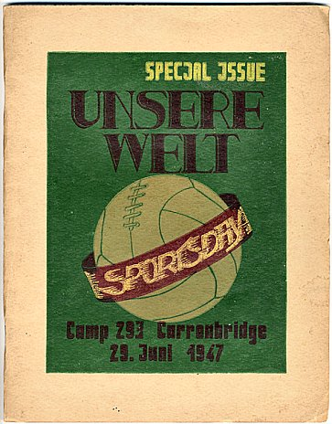
27/29 May 1947 – re-educational survey. Strength; 2 officers, 735 OR, including 75 billeted. [Officers – the 2nd MO was an Unterarzt, some visitors counted this rank as an officer, others did not].

Just 1 change to senior personnel – there was no Interpreter.

M.O. Kleemann, previously graded C then raised to B, was in charge of sport and wrote articles for the camp magazine.

Simplified political screening given; A 5 / B 732. C grades had either been upgraded or sent to other camps. 1 appeal was still pending. 445 pows repatriated to date.

Morale was “fair.” The camp was isolated and there was little opportunity for contact with the local population. Good relationships between the British staff and pows was noted. Football, chess, entertainment, wood-work and hand work were the main activities.

There were few changes to the list of re-education activities. Discussion groups met fortnightly instead of weekly as the weather got better. Travelling Films Ltd had replaced Gaumont British, but attendance was down to 40% due to the cost.

29 June, 1947 - A special edition of the camp magazine was issued for a Sports Day. Produced in German and English with articles about the camp, lives of prisoners, and sports.

5-7 August 1947 – Re-education survey. Strength; 2 officers, 683 OR, including 66 billetees and 6 in hospital.

1 change to senior personnel; a new Interpreter; S/Sgt Deutsch.

Screening figures – B 685. No further appeals. 516 pows repatriated to date.

Payment for work in Sterling was allowed; this consequently resulted in a 30% reduction of the camp’s Welfare Fund.

The pows had little political interest and there was general apathy. Interest in re-education activities was falling – e.g. only 25 attended the last lecture. YMCA and Travelling Films continued with some films from the Scottish Information Office. Pows were able to visit the local cinema. The only classes held were for English.

Outside contacts were increasingly developed at most camps, however, due to its isolation, the only visit made from this camp was a party of 8 pows who visited a printing press in Dumfries.

6/8 October 1947 – Re-education survey. Strength 1 officer, 586 OR, including 72 billetees and 5 in hospital.

Commandant: Major Devenish Camp leader: Schoetz
Interpreter: S/Sgt Deutsch Deputy C/L: Forster
German M.O.: Dr Kleemann

Note that German ranks and political gradings were omitted. Many of the pows however believed that it was unfair for them to be still treated as soldiers under military regulations. No screening figures were given. 605 pows repatriated to date.

Camp Leader Bohnsack, had given up the position due to health reasons. The new leader was a barber; he made a good impression and was, “intelligent and capable.”

Morale was still recorded as “fair.” Many pows were sending goods home, but there was a wide range of restrictions. (An interesting reversal on parcels being sent TO pows).

There had been further deterioration in participation in re-education activities. The camp magazine was produced monthly instead of fortnightly. The discussion group and Information room had ceased altogether.

Padre Mueller was visiting Barony Camp 298 as its padre had fallen ill.

The theatre group continued. The orchestra was still successful and was giving a concert at a local town hall.

Outside contacts – 12 pows visited a meeting of Dumfries Town Council.

There are no further reports in the National Archive file.

Known Commandants;

P G Devenish previously Commandant at Chrishall camp 270 and later Ninewells 236

After the camp: There was a Polish resettlement camp at Carronbridge, but I am not sure if it was on the same site.

Further Information:
National Archives FO 1120/243 – Re-educational survey visit reports for camps 286 to 293. Dated 1 January 1946 – 31 December 1948. Used above.

Canmore - http://canmore.org.uk/site/186798

The German Federal Archive has a copy of the camp magazine. A copy of the Sports Edition is held by Dumfries Museum, (www.futuremuseum.co.uk shows a few pages).

