Camp 292 Donna Nook Airfield, North Somercotes, Louth, Lincolnshire

1947 Camp List
292(G.W.C.) | Donna Nook Airfield, North Somercotes, Louth, Lincs | N | Priswar, North Somercotes | North Somercotes 239 | (Blank) | Lt.Col.R.M.Mayhill | v/1453/2

Prisoner of War Camps (1939 – 1948) - Project report by Roger J.C. Thomas - English Heritage 2003
OS NGR | Sheet | No. | Name & Location | County | Cond’n | Type 1945 | Comments
TF 424 979 | 113 | 292 /b | Donna Nook Airfield, Ark Road, North Somercotes | Lincolnshire | 3 | German Working Camp | Former RAF Donna Nook. Precise location not identified, NGR given for approx centre of dispersed sites.

Location: 2 probable sites shown either side of Ark Road  Before the camp: Farmland. The nearby RAF Donna Nook Airfield to the east was opened in 1940 and closed in 1945. RAF huts – possibly army as well (see House of Commons report below).  Pow Camp: Pastscape stated that the camp was known as 292 and 292b – which may explain the two sites on either side of Ark Road. (292a was Kirmington satellite camp).  Late 1944 / Early 1945 - The pow camp opened. Recorded as a German Working camp, but with mixed nationalities. Polish, and later Ukrainian pows were also held here – German and Polish pows were kept at separate sites.  22 October 1946 - There was a mention of the camp in the House of Commons in 1946:  “Mr. Osborne asked the Secretary of State for War if he is aware that Army huts near North Somercotes, Lincolnshire, are being broken up and used for firewood by men of the P.O.W. No. 292 Camp; what disciplinary action he intends to take; and what steps he is taking to preserve this public property.  Mr. J. Freeman - My right hon. Friend no longer has any responsibility for this camp, apart from the section used by prisoners of war, which has suffered no damage. Only one case of damage by prisoners to the other hutting has been reported. This occurred on 11th October, and disciplinary action has been taken. My right hon. Friend is, however, bringing the Question to the notice of my right hon. Friend the Minister of Works.  Mr. Osborne - Is the hon. Gentleman aware that I have a letter here from a farmer on whose ground these huts stand, in which he says that two large huts and two small ones were destroyed on 24th September? My evidence is contrary to that of the hon. Gentleman.  Mr. Freeman - I also have a letter from the officer responsible, and my information is different, but if the hon. Gentleman will let me see his evidence, I will look into it.” (Hansard, 22 October 1946, Volume 427). | 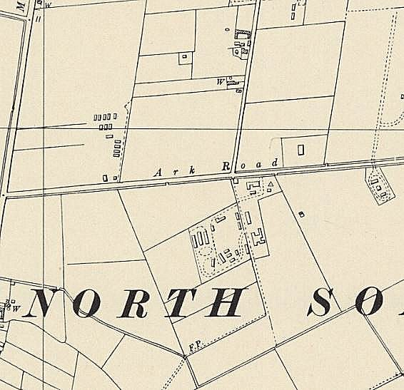
 | Ordnance Survey 1956

Oversight and development of re-education activities and English teaching for German pows was carried out by PID (Political Intelligence Department of the Foreign Office) / COGA (Control Office for Germany and Austria – UK). Visits and reports were made. The standard of the reports varied greatly. The visitors took little interest, if any, in activities other than re-education. They rarely mentioned welfare, sports, games, pastimes, crafts, etc of the pows. If there were still Italian pows in hostels, they were usually ignored by PID.

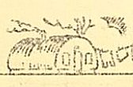
May 1947 – Camp magazine, No.1; Der Monatsspiegel : Lagerzeitung des POW Camps 292a : satellite Camp Kirmington/Lincs. - The Wiener Holocaust Library

Produced at the satellite camp. A tiny illustration showed that Nissen huts were used.

26-28 August 1947 – Re-educational survey. Strength; 2152 other ranks.

Commandant: Lt.Col. R M May-Hill (from the Welch Regiment). Camp Leader: Ogefr.Kokocinski, Bronislaw (B+)
Interpreter: S/Sgt L Vayden. Deputy C/L: Ogefr. SMALEC, Michael (B).
German M.O.: U/Arzt Szopka, Rudolf (B)

Political screening figures: | A | B+ | B | B-
Those claiming Polish nationality | 6 | 103 | 868 | 10
Others | 40 | 201 | 739 | 185

393 pows had been repatriated to date.

It was noted that there was hostility between the Donna Nook main camp with Polish pows, and the large satellite camp at Kirmington and two hostels with German pows.

Many claiming to be Polish would have nationality problems as Poland rejected many who had fought for the Germans. The nationalities for some of the pows was in doubt:

“Ogefr Kokocinski Bronislaw (B+) Camp leader for the pro-Polish component of this camp at Donna Nook (HQ). He is 40 years of age, savings-bank bookkeeper in Poland before the war, a large person with personality, states that he is Polish and has little interest in Germany, and is being repatriated to Poland.”

The deputy C/L stated he was Polish, but wanted to stay on in the UK.

“The Protestant padre Gefr. Cerecki Adolf (A) is Polish claiming German nationality… Pechuta Constantin (A) the RC padre who arrived just as I was leaving. He is claiming Polish nationality.”

Morale was regarded as fairly high throughout the camp. Some pows had been transferred from RAF pow camps and were not so satisfied with conditions at Kirmington. Morale was raised as pows had a ‘walking out’ limit of 10 miles and many expected to be repatriated in the near future.

For the pro-Polish pows at Donna Nook, most were democratically minded, with just 2 considered to be still Nazis, and four communists. The German component was seen to still have a few Nazis, but there were no problems arising. About 30% of the pows were ‘youth’ (under-25), but they did not present a problem.

With the two distinct nationalities, re-education activities were organised separately. There were different interpreters for Polish / German pows. At Donna Nook a lot of re-education was religious based as most pows were Roman Catholic – the two padres led these activities.

The visitor was mainly focussed upon activities that happened in the German ‘component’ – Kirmington and the two hostels. Re-education was limited partly due to the lack of leadership outside of the HQ site. The list of standard activities in his report referred mainly to the German pows:

Newspapers - Wochenpost and Ausblick received. 12 daily British newspapers; some periodicals such as Picture Post; some from Germany and Switzerland.

Library - 1468 German books, but 500 of these were the Gospel of St John, and 380 English textbooks. [The Polish camp also had 1647 German books].

Lectures - Regular and with good attendance, though it was noted more would attend if they were not tired after working overtime at this time of the year.

Discussion groups - Not so successful in the German component, though the youth (under 25) showed greater interest. Greater success at Donna Nook where it was led by the protestant padre.

Films - YMCA and Travelling Films Ltd on alternate weeks.

Wireless - Kirmington had a radio room with amplifier and 6 loudspeakers. The two hostels had their own radios.

Camp magazine - 100 copies of ‘Der Monatspiegel’ [The Monthly Mirror] were produced. [None recorded at Donna nook].

Press review - Being developed.

English instruction - 43 pupils with 5 teachers + 50 of the 75 billetees. Uptake was higher at Donna Nook, but many were studying on their own.

Information room - also used as the reading room. Just one exhibition to date.

Other activities:

Religion: There was a chapel at Kirmington used by the RC; a padre from Willingham House Camp 256 also visited – protestant pows attended local churches. At Donna Nook the RC attended churches at Louth and Grimsby and had visits from the padre at Pingley Farm Camp 81.

Entertainments: A theatre group of 15; an orchestra of 9. Donna Nook also had an orchestra of 9.

Kirmington Satellite and hostel had no football pitch and had to play at other camps. Elsham Hall Hostel had a football pitch.

Some outside contacts were being developed –

Donna Nook – Christian Scientist meetings at Louth and Grimsby. Louth local Methodist meetings.

Kirmington and hostels – Brigg was the only town within 10-mile radius – Toc H meetings, Council meetings and local church activities.

29-31 October 1947 - Re-educational survey. Strength – 2158 other ranks.

Commandant: Lt.Col. H C Sansom (Pioneer Corps). Camp Leader: Ogefr.Kockocinski, Bronislaw (B+) [or Kokcinski] Polish.
Interpreters: S/Sgt L Vayden; S/Sgt MacDonald; S/Sgt Richmond Deputy C/L: Ogefr. SMALEC, Michael (B). Polish.
German M.O.: U/Arzt Szopka, Rudolf (B). Polish.

The new Commandant started in September and was described as; “…definitely a live wire. He both preaches and practices the doctrine of leadership by example…”

The Polish Interpreter S/Sgt Vayden had been joined by two more Interpreters for German. Vayden was described as having; “wide linguistic capabilities and a ‘Card index’ memory; he is apt to be a little dictatorial and rather starves the two German interpreters (who are at Kirmington) of information.” This led to increased problems between the camps.

Simplified screening figures were given: A 25 (24 Polish) – B 2133. 2800 pows had been repatriated to date.

Morale was seen to be fairly good among the Germans – “who get on fairly well with the Poles on the rare occasions when they are in contact.” The Polish pows had a lower morale as their repatriation was not as well organised and they were being arbitrarily selected in batches through the Polish Council.

35% of the German pows were ‘youth’ (under-25), but this was not regarded as a problem.

Re-education activities had decreased due to the extremely long hours being worked for the harvest. The Poles continued to have mainly religious based activities. For Germans, the standard list was recorded:

Library – extremely poor. Out of 1100 books, 630 were German and many were in a very poor state.

Newspaper – satisfactory selection

Discussion groups – little interest.

Films – As before. Popular with the Poles, less so with the Germans.

Wireless - satisfactory

Camp Magazine – German editions of 100 copies per fortnight produced on a home-made duplicator; “fairly good”. There was also a Polish magazine in the HQ.
Press review – weekly newspaper cuttings at Kirmington.

English Instruction – postponed during harvest.

Information Room – one show about ‘Das Englische Parlament’ was appreciated and more requested.

Lectures – Popular.

Other camp activities –

Religion – strong in the Polish Camp. German Padres from Brigg and Market Rasen visited Kirmington and Elsham once a fortnight.

Education – postponed during harvest.

Entertainments – Theatre group of 10 men + orchestra of 8 men at Kirmington.

Outside contacts were difficult as the camps were isolated. It was hoped that the new Commandant would re-vitalise re-educational activities after the harvest was gathered.

5-6 December 1947 – Dr J Klein, a visiting lecturer, gave two lectures at the camp and hostel on the subject ‘The World Food Situation’. His report damning regarding what appears to have been a vindictive regime against the German pows in the Kirmington Satellite Camp:

“The morale in this camp is bad and is getting worse. The main reason is that they are remote-controlled by the Polish camp. Decisions, taken in Kirmington are never final. Parcels, after having been searched and passed by Capt.Ringer [Officer i/c at Kirmington Satellite] are searched again by the Polish interpreter at HQ [Donna Nook] and things removed. They never know what they are being allowed to take home on being repatriated. Sometimes, they are being stripped of boot-polish, needles, shaving sticks, razor blades and other stuff, bought in the canteen… (A pair of second-hand shoes was refused because soles are banned and there were soles on the shoes!!) What is worst is that they often do not get their stuff back. All this was confirmed to me by the commandant of the satellite camp, Capt Ringer. The main culprit seems to be the interpreter at H.Q”.

Few pows attended lectures at this camp and many pows were young.

2-5 March 1948 – Re-educational Survey. Strength; 0 officers, 1140 OR. Polish at HQ, Germans at the 2 hostels.

As with previous reports, there was little interest in the Polish pows, comments focussed on the Germans.

No change to senior personnel.

All announcements in the main camp were made in Polish. This caused complaints from Germans who were passing through from the hostels and staying at HQ for 2 to 8 days prior to repatriation. Pows at HQ whose nationality was rejected by the Polish authorities, were being sent to the Russian zone of Germany.

A complaint was backed by the visitor regarding hand luggage that was permitted for repatriation. In this camp it was restricted to 5 lbs (5 pounds weight), including the receptacle. The visitor pointed out this was not the case in any other camp he had visited.

A survey was conducted in camps still open at this time concerning pow attitudes to the British, (following a PID circular dated 25.2.1948). It was pointless, carried out far too late and in totally random ways. Some visitors simply gathered whoever was around and asked them to give a show of hands to the questions, some only asked a ‘selected’ group. At Donna Nook 2 groups of German pows were selected – 1, a group being repatriated to the French zone, 2, a group going to the US zone. There was no explanation why or how these groups were chosen. For what it is worth (nothing?) the results were:
Attitudes to British: | Hate | Dislike | Distrust | Indifference | Benefit of doubt | Liking
 | 1-2% | 3-5% | 30% | 40% | ‘others’

A general dislike of this particular camp was expressed by the Germans.

The camp closed soon after this report.

Known Camp Commandants:
? – September 1947 Lieutenant Colonel R M Mayhill (May-Hill). Later Commandant at 89 Easton Grey Camp 89.
September 1947 - ? Lieutenant Colonel H C Sansom

After the camp: Many of the Polish and Ukrainian pows remained in the UK. Site area greatly damaged / demolished by floods in 1953. The Airfield site became a bombing range and nature reserve.

Further Information:

National Archives –
FO 939/333 – 292 Working Camp, Donna Nook Camp, North Somercotes, Lincolnshire. Dated 1947-1948. Used above.

FO 1120/243 – Re-educational survey visit reports for camps 286 to 293. Dated 1 January 1946 – 31 December 1948. Used above.

Camp numbers

 | Open |  |  |  | With other camps |  |  | Unknown |  |  | Not listed / not open

 | 1944 | 8/1947 | 10/1947 | 3/1948
HQ |  | 1031 | 1036 | 756
Kirmington Satellite |  | 580 +5* | 545 | With C81
Kirmington hostel |  | 265 | 310 | With C81
Elsham Hall |  | 196 | 190
Holton |  | With C256 |  | 266
Hallington |  | With C256 |  | 73
Billetees |  | 75 | 77 | 55
Total |  | 2152 | 2158 | 1140

* 3 sick, 2 working in hospital.

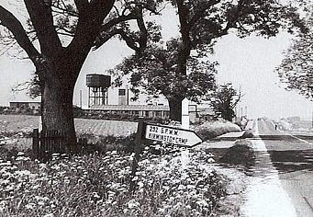  Kirmington Satellite Camp. Lincolnshire.  NOTE – there was also a smaller Kirmington Hostel – see below.  Location: Photograph of the camp described as being on Forty Foot Lane, Kirmington >  Below, 1947 aerial photo of Forty Foot Lane showing a camp, and most likely the site shown.  Aerial Photo | Historic England  July 1946 - listed as a hostel for Willingham Camp 256. With just 15 pows present, there was a comment that: “not at present in use. Under preparation for intake.” | 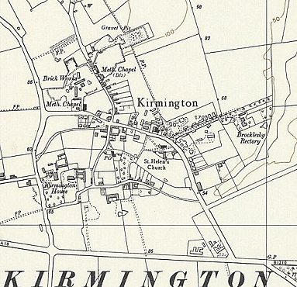
 | Ordnance Survey 1956

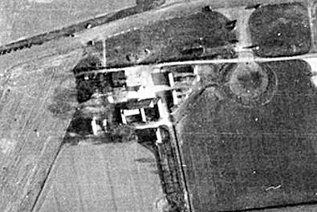
Possible that the 15 pows were a workforce preparing the camp for use, and that it was then transferred shortly after to be a satellite for Camp 292 Donna Nook
26-28 August 1947 – 580 pows. Administered by Donna Nook.

Officer i/c: Capt F J Ringer. Interpreter S/Sgt W MacDonald.

Camp leader: Uffz.Boerger, Friedel (B) – “…has been in office for 1 month… 25 years of age and is a music student, a quiet respectable person still gaining experience and becoming aware of his duties towards mankind.” Same October 47.

Study leader – Ofw.Kurt Mueller (B+) – “an outspoken person of 28 years, clerk in civil life.”

October 1947 – 2 German interpreters have been appointed, but tensions continue with them and the S/sgt Polish Interpreter at the main camp.
1948 - Kirmington listed as a hostel for Pingley Farm Camp 81 – was this the satellite or hostel or both?

 | 1944 | 8/1947 | 10/1947 | 3/1948
Kirmington Satellite |  | 580 +5* | 545 | With C81

Hostels

Elsham Hall Hostel. Listed under Castlethorpe Camp 148 and Pingley Camp 81, before attachment to Donna Nook.

August 1947 – 196 pows. Camp leader Fw.Mackel, Artur (B+) –“ Hostel leader at Elsham Hall and deputy Camp Leader at Kirmington Satellite camp is a looming Bavarian personality of 37 years, bank inspector in civil life. He affected a taciturn attitude after he discovered that there were some facets of Nazism unknown to him. As he is prospective chief C/L I gave him some hints as to where his weakness lay and reminded him of his duties to mankind.” October 1947 – same leader.

Study leader – Kurt Schroeder; “24 years of age… a pleasant youngster, clerk in civil life.”

 | 1944 | 8/1947 | 10/1947 | 3/1948
Elsham Hall |  | 196 | 190

Hallington. Previously with Moorby Camp 79 (1945) and then reformed with Willingham House C256.

3/1948 – Hostel leader; A Braunisch. Good relationships with the local population.

 | 1944 | 8/1947 | 10/1947 | 3/1948
Hallington |  | With C256 |  | 73

Holton. Previously with C256.

3/1948 – Hostel leader; J Brieske. Pows were being transferred to camp 79. Good relationships with the local population.

 | 1944 | 8/1947 | 10/1947 | 3/1948
Holton |  | With C256 |  | 266

Kirmington Hostel

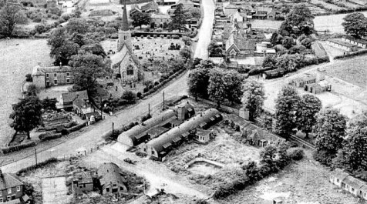
HER entry seems to refer to the hostel rather than the satellite camp. It only refers to “former pows,” and the size of the camp “160 people” was too small for the satellite.

“Grid reference: TA 510 411…. A former WAAF camp in Kirmington village was later used to house former prisoners of war who volunteered to stay and work on the land, under the War Agricultural Association scheme. It was located opposite the parish church. There were around 160 people in the camp, with 20 people to a hut. One former prisoner, interviewed for 'Nostalgia' magazine in 2002, stayed at Kirmington between March 1948 and December 1948. After this date, other lodgings had to be found. The magazine included photographs taken inside and outside the huts at Kirmington.”
https://www.heritagegateway.org.uk/Gateway/Results_Single.aspx?uid=MLS21365&resourceID=1034

August 1947 - 265 pows. Camp Leader Ogefr. Schneider (B-) – “appointed a week ago is a rough opportunistic type who joined the NSDAP in 1930 and had the audacity to state that he had never been a Nazi. He gave his profession as “Theater-wissenschaftler” [theatre scholar? Possibly student?] which defied his elucidation.” He was being given a chance as hostel leader, but the officer i/c was ready to have him removed. Same October 1947 and considered to have greatly improved.

1948 – listed with Pingley Camp 81.

 | 1944 | 8/1947 | 10/1947 | 3/1948
Kirmington hostel |  | 265 | 310 | With C81

