Camp 291 Kitty Brewster Farm, Blyth, Northumberland

Prisoner of War Camps (1939 – 1948) - Project report by Roger J.C. Thomas - English Heritage 2003
OS NGR | Sheet | No. | Name & Location | County | Cond’n | Type 1945 | Comments
NZ 2838 8209 | 81 | 291 | Kitty Brewster Farm, Blyth | Northumberland | 4 | German Working Camp | Former Heavy Anti-aircraft battery (HAA Bty). Site occupied by industrial estate.

Location:  Before the camp: Farmland  Pow Camp: Italian and then German pows.  December 1945 – total strength 451, according to Northern Command HQ..  May 1946 – Camp magazine; Lagerzeitung : P.W. Camp 291 - The Wiener Holocaust Library  A competition was held to give the magazine a better name.  Refers to Seaton Delaval Hall as a hostel.  I have seen references that state this camp became a hostel for Darras Hall Camp 69 – however, there was no record of this in that camp’s reports. It did state in July 1947 that the new camp leader at Camp 69, Hfw Kessler (B+), had previously been leader at Kitty Brewster.  After the camp: Possibly used as a hostel for homeless families.  Further Information:  The book ‘Blyth Memories Part 2’ by Jim Harland (Summerhill Books – 2011) contains some details about this camp, but I have not read the book. | 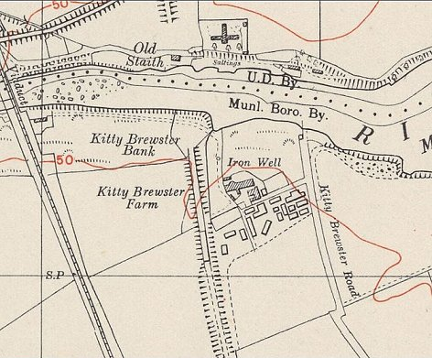
 | Ordnance Survey 1951

Seaton-Delaval Hall

Listed with Darras Hall Camp 69 from 1947.

