Camp 290 South Lane Camp, Barrows Green; Lancashire (became Penketh Hostel)

Included in the 1945 ICRC camp list – Labour Camp. 290. South Lane Camp, Barrow Green, Bold, Widnes, Lancs.

Prisoner of War Camps (1939 – 1948) - Project report by Roger J.C. Thomas - English Heritage 2003
OS NGR | Sheet | No. | Name & Location | County | Cond’n | Type 1945 | Comments
SJ 5416 8789 | 108 | 290 | Penketh Hostel, South Lane Farm, South  Lane, Barrow's Green | Lancashire | 3 | German  Working Camp | Former Heavy Anti-aircraft battery  (HAA Bty)

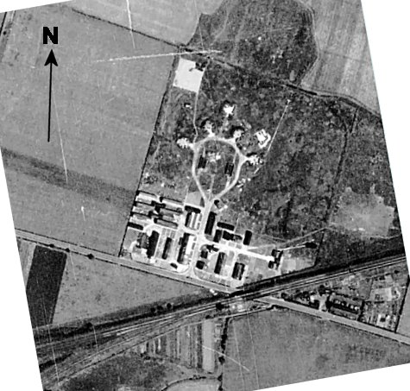  Location: Next to South Lane farm and railway line.  1945 - Aerial Photo | Historic England  Before the camp: Farmland. Barrows Green 3.7” HAA Battery; one of the sites protecting the huge RAF/USAAF airbase at Burtonwood.  Pow Camp: Initially held low risk Italian pows in the Royal Artillery barrack huts. By 1945 it held German pows.  There is still a tower which is argued to be - a water tower / guard tower / gun and searchlight placement (Pastscape state it was a water tank).  A pow hostel was listed: Wheathill. | 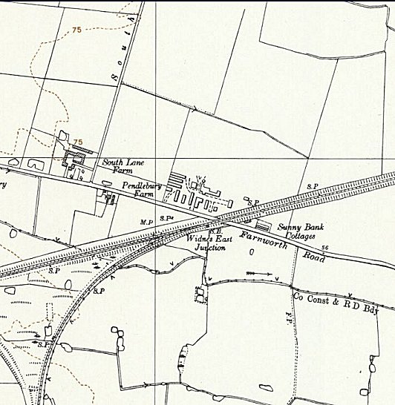
 | Ordnance Survey 1954
Summer 1946 – became a hostel for Garswood Camp 50, called Penketh. Closed in 1948.

After the camp: Used for a short time as a hostel for displaced people.

Further Information:

Wheathill – recorded attached to C50 in 1946 with a large number of SS; then no further details.

