Camp 289 Lydiard House, Lydiard Millicent, nr Swindon, Wiltshire

Included in the 1945 ICRC Camp List – Labour Camp. 289. Lydiard House, Lydiard Millicent, Swindon, Wilts.

1947 Camp List
289(G.W.C.) | Lydiard House, Lydiard Millicent, Swindon, Wiltshire | S | Priswar, Swindon | Purton 224 | Swindon | Major H.S.A.Keynton | v/1452/2

Prisoner of War Camps (1939 – 1948) - Project report by Roger J.C. Thomas - English Heritage 2003
OS NGR | Sheet | No. | Name & Location | County | Cond’n | Type 1945 | Comments
SU 0899 8621 | 173 | 289 | Lydiard House, Lydiard Millicent, Swindon | Wiltshire | 4 | German Working Camp | Camp associated with a military hospital.

Location: Lydiard House (Camp 289) at Lydiard Millicent was not the same as Lydiard Park and House (Camp 160), they are about 2km apart.  Lydiard Millicent is about 6km W of Swindon. The map shows two possible sites (or both). Just to the west of the house is a small group of buildings / to the east is a quadrilateral area.  Note there was a HQ camp (called here Lydiard House to distinguish it) and a hostel based in Lydiard Millicent.  Before the camp:  Details about Camp 160 have been added to some of the published information about this camp incorrectly assuming that they were the same place. | 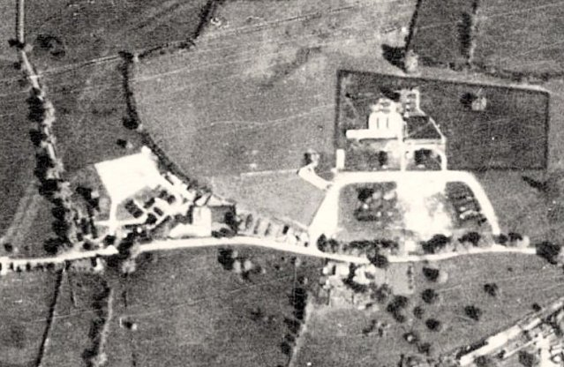 | 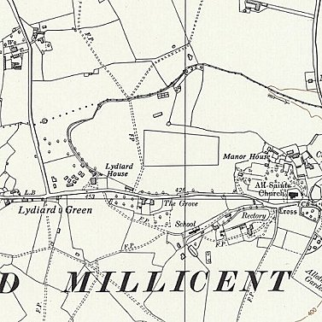
 | 1945 - View map: Ordnance Survey, OS Air Photo, 6 inch to the mile (1:10,560), Sheet 41/08 N.E. - Ordnance Survey Air Photo Mosaics, 1944-1950 | Ordnance Survey 1960
1. Lydiard Millicent was recorded as a pow hostel with Lodge Farm Camp 25: Italian pows. The information does not give details as to whether this became the Lydiard House HQ or the Lydiard Millicent hostel later attached to 289.

1943 – Seen; Pow letter-sheet dated November 1943 to Italy.

September 1945 – listed in the Appendix to HQ Southern Command War Diary as an Italian hostel attached to Lodge Farm Camp 25.

2. Pow Camp: Italian then German pows.

c.September 1945 – The Lydiard House site became independent Camp 289.

Oversight and development of re-education activities and English teaching for German pows was carried out by PID (Political Intelligence Department of the Foreign Office) / COGA (Control Office for Germany and Austria – UK). Visits and reports were made. The standard of the reports varied greatly. The visitors took little interest, if any, in activities other than re-education. They rarely mentioned welfare, sports, games, pastimes, crafts, etc of the pows. If there were still Italian pows in hostels, they were usually ignored by PID.

1946 – Additional intake of many pows from camps in the USA. Most had very low morale as they had been misinformed in the US that they were being repatriated. Instead, they found themselves in working camps in the UK.

28/30 August 1946 – German Working Camp. General survey and screening. Strength; 1 officer (the M.O.); 930 Other Ranks. This was the 2nd visit, but the first is not included in the National Archive file.

Commandant: Major J Cheslyn-Hall Camp leader: Uffz Troesch (B)
Interpreter: S/Sgt Moeller Deputy C/L: -
German M.O.: Ass.Arzt Hauck (B)

The Commandant was reported as supporting re-education activities - however, see next report.

Political screening: | A | B+ | B | B- | C | Unscreened
 | 16 | 46 | 223 | 91 | 206 | 349

Morale was recorded as, “slightly above average.” There were good relationships with the Commandant and British staff. Some ‘troublemakers’ had been removed and sent elsewhere. The main negative factors were lack of information about repatriation and bad news from home.

40% of pows were ‘youth’ (under-25). They were not seen to be a problem.

Pows were working very long hours during the harvest and many activities suffered due to this. The range of activities was poor in comparison to many other camps. The standard list of re-education activities was given:

Wochenpost and Ausblick – 200 Wochenpost; no Ausblick.

Newspapers – A range of British papers. Very few German or Swiss papers received.

Library – None. COGA were due to send some books.

Lectures – regular and generally popular.

Discussion groups – Carried out, but attendance dwindled during the summer months.

Films – Only YMCA supplied films. A short while after this, Gaumont British also supplied films, but then removed the camp from its list – probably due to lack of numbers.

Wireless – ‘satisfactory’ at all sites.

Camp magazine – none.

Press review – a weekly sheet of news extracts supplied to hostels.

English instruction – separate appendix.

Other camp activities –

Religion – No camp padres. Pows able to take part in services organised in local churches.
Education – Classes for building and agriculture had started, but attendance fell during summer.

Entertainment – None. It was hoped to start an orchestra.

29 January – 1 February 1947. Visit by a member of the ‘Segregation Section’ mainly to carry out further screening. Strength; 0 officers, 721 OR.

Acting Commandant: Captain H S Keynton, R.A.

Interpreter Staff Sergeant Moeller was from the Pioneer Corps. He was; “elderly and of German extraction. He had a spell in a Concentration Camp in Germany, and received a rough deal from the SS. In consequence he is slightly biased and considers most of his charges as Nazis. On the whole however he is quite successful and takes a great interest in his job.”

The new German M.O. Sigmund Mayer-Rosa (B-), was described as; “a slimey individual.” He had been a member of the SS and in the automatic arrest category. Since he became MO the number of sick and light duty personnel had increased – it was suspected he was allowing this more than he should. His removal was recommended.

Political screening: | A+ | A | A- | B+ | B | B- | C | C+ | Unknown
 | - | 4 | 1 | 92 | 278 | 131 | 101 | - | 114

15/16 February 1947 – Screening billetees. Re-education report. Strength; 1 officer; 716 OR.

Commandant: Major Keynton Camp leader: O/F/Maat Karl Hossbach (B+)
Interpreter: S/Sgt E W Moeller Deputy C/L: -
German M.O.: Ass.Arzt Mayer-Rosa (B-)

In this report the previous Commandant, recorded as supportive, was reported to have been demobilised, and; “unco-operative” to the extent that no political progress had been made by the pows. This would seem to be borne out by the totally inadequate list of activities in the camp.

The new Commandant had been promoted from captain.

The camp leader was a professional soldier; “rather stodgy and does not keep himself well informed to what is going on – seems to have little real interest.”

Political screening: | A | B+ | B | B- | C
 | 5 | 94 | 335 | 152 | 128

Re-screenings resulted in many pows being upgraded, which lifted their morale – the better the grade, the sooner repatriated, in theory. The British staff in general were regarded as “a little harsh to those considered Nazis.”

The inadequate re-education activities had deteriorated further. Changes noted:

Library – Completely inadequate. 112 German books and 101 English. Some of these books were considered unsuitable.

Discussion groups / Press reviews – ended.

Camp magazine – issued fortnightly. Paper and stencils needed to continue.

Education and Entertainment – none. The hoped for orchestra was apparently still in the process of being formed.

The report gave an impression of neglect and apathy within the camp. It was hoped that a new Study leader would get things moving.

By May 1947 – listed as a hostel for Lodge Farm Camp 25 – “This was the HQ of camp 289…..” 2 hostels were also transferred to camp 25. Closed early 1948.
Known Camp Commandants:

1946 - Major John Vincent Cheslyn-Hall. From the Royal Regiment of Artillery. Previously with Camp 42.

c1947 Major Harold Stanley Ambrose Keynton. With the Tank Corps in WW1 / Somerset Light Infantry. Commandant at Wynols Camp 61 in mid 1947, then Mardy camp 118.

Camp numbers

 | Open |  |  |  | With other camps |  |  | Unknown |  |  | Not listed / not open

 |  | 8/1946 | 1/1947 | 2/1947
HQ | With C25 | 131 | Numbers not given | 66 | With C25
Chiseldon | Was C668 | 62 | Numbers not given | 59 | With C25
Highworth |  | 409 | Numbers not given | 235 | With C25
Latton | With C25 | 68 | Numbers not given | 48 | With C89
Minety |  | 47 | Numbers not given | 37 | With C89
Purton | With C89 / C25 | 59 | Numbers not given | 46
Lydiard Millicent Hostel |  |  | Numbers not given | 106 | Possibly with C25
Billetees | - | 156 | 118 | 120 | -
Total | - | 931 | 721 | 717 | -

After the camp:

Further Information:

National Archives FO 1120/243 – Re-educational survey visit reports for camps 286 to 293. Dated 1 January 1946 – 31 December 1948. Used above.

Wiltshire and Swindon History Centre – have a letter reference F5/505/5 - ‘Letter Apr'45 from Acting Chief Constable of Wiltshire to Estate Surveyor, Ministry of Works re. using War Department site at Lydiard Millicent to house 500 Italian POWs (non-co-operative) as alternative to Crowdys Field, Cricklade Road, Swindon’.

Hostels

Chiseldon (Previously Camp 668). 10 miles from HQ.

8/1946 – Hostel leader: None. Was Illge, who had just been repatriated, but not replaced.

2/1947 – Hostel leader; Paul Greger, (B+). “Well liked and is doing a good job.”

By May 1947 - transferred to camp 25.

 |  | 8/1946 | 1/1947 | 2/1947
Chiseldon | Was C668 | 62 |  | 59 | With C25

Highworth. 10 miles from HQ.

11 August 1946 – opened for German pows, mainly sent from Devizes camp. Very good hutted accommodation.

8/1946 – Hostel leader: Kraemer (B), regular soldier and ex-policeman; “a sensible, quiet type who is proving satisfactory.” There was a wireless and 2 loudspeakers. Books and papers in very short supply.

2/1947 – Hostel leader; Felix Heim (B). “Nothing special.”

By May 1947 - transferred to camp 25. Closed in Spring 1948.

 |  | 8/1946 | 1/1947 | 2/1947
Highworth |  | 409 |  | 235 | With C25

Latton. 5 miles from HQ.

8/1946 – Hostel leader: Schierl (A)

2/1947 – Hostel leader; Emil Becker (B-). “Doing job quite well.”

 |  | 8/1946 | 1/1947 | 2/1947
Latton | With C25 | 68 |  | 48 | With C89

Lydiard Millicent Hostel.

2/1947 – Hostel leader; Walter Nockermann (B+). “Doing a good job.”

Possibly transferred to C25 merged with the HQ site.

 |  | 8/1946 | 1/1947 | 2/1947
Lydiard Millicent Hostel |  |  |  | 106 | Possibly with C25

Minety. 6 miles from HQ. No electric supply.

8/1946 – Hostel leader: Knorr (B+).

2/1947 – Hostel leader; Heinz Krause (C). “Most unsuitable. His removal was requested and agreed to.”

 |  | 8/1946 | 1/1947 | 2/1947
Minety |  | 47 |  | 37 | With C89

Purton. 2 miles from HQ.

8/1946 – Hostel leader: Scherer (A).

2/1947 – Hostel leader; Alfred Briege (B-). “Quite satisfactory.”

 |  | 8/1946 | 1/1947 | 2/1947
Purton | With C89 / C25 | 59 |  | 46

