Camp 287 Perdiswell Hall, Droitwich Road, Claines, Worcester, Worcestershire

Included in the 1945 ICRC Camp list – Labour Camp. 287. Perdiswell Hall, Worcester.

Prisoner of War Camps (1939 – 1948) - Project report by Roger J.C. Thomas - English Heritage 2003
OS NGR | Sheet | No. | Name & Location | County | Cond’n | Type 1945 | Comments
SO 8538 5763 | 150 | 287 | Perdiswell Hall, Droitwich Road, Claines, Worcester | Worcestershire | 5 | German Working Camp | Former RAF Worcester. Precise location not identified, NGR given for centre of landing ground.

Location: the NGR given above is for Perdiswell Hall.  Before the camp: The Hall was an 18th C house and estate. Requisitioned at the start of the war and operated mainly as an Elementary Flying Training School as part of RAF Worcester until 1945.  Pow Camp:  1945 - First listed with German pows as a hostel for camp 54. Possibly held Italian pows before this.  The lists above suggest that the site became an independent camp for a short time.  Memories - "However, I vividly remember one day at Shrub Hill when a train arrived with scores of German P-o-Ws, all with red diamonds sewn on the back of their uniforms.  "They were accompanied by only a couple of British soldiers, and I followed as they were marched along Lowesmoor to The Cross and then up Barbourne and Ombersley Road. They then turned into Checketts Lane and were marched straight across Droitwich Road into the grounds of Perdiswell Hall, where they were to be billeted in the old military huts.” https://www.worcesternews.co.uk/news/7758310.pow-family-steps-foward/  c.September 1946 - Perdiswell became a satellite camp for Hampton Lovett Camp 54  After the camp: The Hall was damaged by a fire in 1956 and demolished by the City Council.  Further Information: | 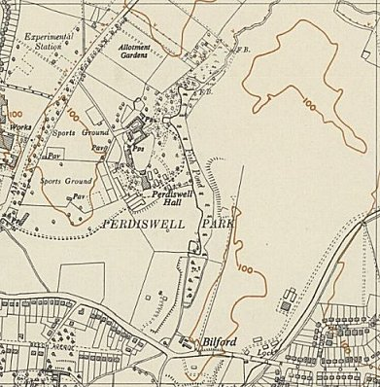
 | Ordnance Survey

