Camp 284 Swanbridge Camp, Penarth, Glamorganshire

Prisoner of War Camps (1939 – 1948) - Project report by Roger J.C. Thomas - English Heritage 2003
OS NGR | Sheet | No. | Name & Location | County | Cond’n | Type 1945 | Comments
 |  | 284 | Swanbridge, Sully | Glamorganshire |  |  | Wales

Location: Information received but not confirmed: “Behind the watch tower now converted to a house on the old Swanbridge Road. Remember a concrete road going into the field.”  Before the camp:  Pow Camp:  After the camp:  Further Information: | 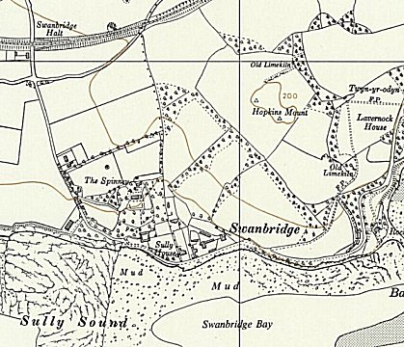
 | Ordnance Survey 1964

