Camp 17 - Lodge Moor Camp, Redmires Road, Sheffield, Yorkshire

Included in the 1945 ICRC camp list – Base Camp. 17. Lodge Moor Camp, Sheffield.

1947 Camp list
17(B.C.) | Lodge Moor Camp, Sheffield. | N. | Priswar.Sheffield | Sheffield 32916/7 | Sheffield. | Lt.Col.A.P.Jackson. | v/202/4

Prisoner of War Camps (1939 – 1948) - Project report by Roger J.C. Thomas - English Heritage 2003
OS NGR | Sheet | No. | Name & Location | County | Cond’n | Type 1945 | Comments
SK 2795 8598 | 110 | 17 | Lodge Moor Camp, Redmires Road, Sheffield | Yorkshire | 3 | Base Camp | Pre-First World War army camp. Capacity substantially increased by the provision of tented accommodation. Guarded by double wire perimeter fences and watch towers. Footings and perimeter wall remain extant

Location: SK 279 859. Just off Redmires Road and next to Lodge Moor Hospital.  Previous use: Army training camp and WW1 pow camp, (called Redmires Camp). From 1925 to 1935 the site was used as a temporary extension by the Lodge Moor Hospital.  POW Camp: Holding Italian, and then German, Ukrainian + other nationality pows. At some time in 1944 it was the largest camp in the UK, holding up to 11,000 pows. To begin, mainly hutted, (over 80 huts), but increasingly, and unacceptably, over-crowded with tents used. Frequent complaints about muddy conditions and poor food.  An archaeological survey was carried out by Sheffield University. Rob Johnson, one of the archaeology students who surveyed the remains of the site, said: “Reading about the living conditions was probably the most striking thing during my research. The prisoner of war camp was a very unpleasant place to stay; the prisoners were fed food out of galvanised dustbins, had to stand outside in the mud, rain and cold for several hours a day during roll call, and since it was so overpopulated as a transit camp, they were squashed into tents or the barracks with little personal space.”  9 September 1941 - One of 2 transit camps for the first bulk arrival of about 1000 Italian pows from Africa. (Prees Heath Camp 16 being the other taking 1454 pows). There were concerns over the health of the pows with diseases such as malaria. The initial selection of sites to transfer the pows form this camp, was duly altered to ensure the environment would be healthy.  December 1941 - The camp was listed as having Italian pows, some of whom were formed as a construction crew to build Camp 52.  24 May 1943 - ICRC inspection. Italian prisoners, capacity 3000+. The overall report was good. However, a year later conditions had deteriorated with over-crowding.  1943 – hostels listed for Italian pows; Hoyland Common / Treeton, Sheffield / Woolley / Stoney Middleton.  Record that ‘ardent fascist’ Italian pows were held in a detention section of the camp up to 1945. | 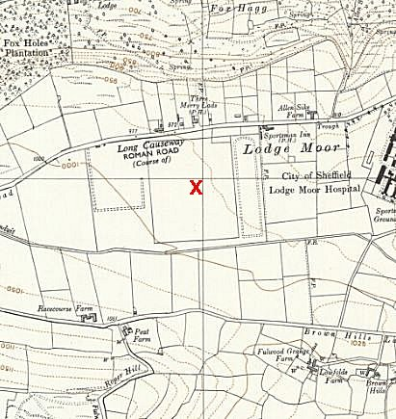
 | Ordnance Survey 1956 – boundaries shown

1944 - ICRC inspection described accommodation as, “insufficient / uninhabitable.”
Winter of 1944/45 - POW Bruno Ullrich described conditions: “We lived in our clothing day and night, and our uniforms became like cardboard. Food was prepared in galvanised dustbins, which led to a good deal of gastro-enteritis.”

16 February 1945 – an attempted mass escape occurred by cutting through the perimeter wire. Two pows were shot and injured by guards, Alfred Steinbacher and Hans Kunz.

13/14 March 1945 – Luftwaffe pow, Friedrich Fink, was shot dead as he was climbing through a cut fence. Date of death recorded as 14 March, he was later re-interred at Cannock Chase German military Cemetery.

24 March 1945 - There were many escape attempts from 1941 to 1945. One tunnel escape attempt ended with the murder of a German pow. A group of pows accused one prisoner, Gerhart Rettig, of being an informer as he had apparently been seen talking to a guard near to the entrance of the tunnel that was later discovered. He was chased, caught and severely beaten. He was taken to hospital, but died from severe injuries to the head. Rettig was later buried at the Cannock Chase German Military Cemetery.

Four pows were held responsible for Rettig’s death; Unteroffizier Heinz Ditzler - Soldat Juergen Kersting - Feldwebel Emil Schmittendorf - Armin Kűhne. They were tried by military court at Kensington Palace Gardens (London Cage). Ditzler and Kersting were acquitted because of insufficient evidence. 18-year-old Kűhne and 31-year-old Schmittendorf were found guilty and were hanged on 16 November 1945 at Pentonville Prison in London.

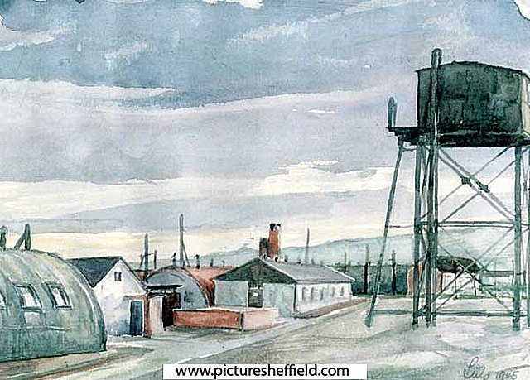 | Later in 1945, conditions appear to have settled to acceptable levels with many pows shipped to other camps.  11 – 13 October 1945 – Report on English Instruction.  “This camp has six compounds, three tented and three hutted, only the latter being used.” Each compound had a capacity for 2000 pows. Pows were constantly changing and the camp usually held between 4000 to 5000. No hostels listed.  Compound 1 held Other Ranks – it was a work camp, (Arbeitslager).  Compound 2 held officers, they were not working.  Compound 3 held 800 pows, but only 200 of them at work.  Commandant: Lt Col A P Jackson, stated to be cooperative with re-education work.  Interpreter Officer: Capt Zeilinger (Austrian). Also supportive of re-education. He had; “fought with Tito in the Balkans, and describes himself as a ‘Political Commissar.’ He screens Ps/W for transfer or repatriation.”  The report stated that 2 of the pows were under arrest for murder – but does not state if this was related to the murder of Rettig, above.
  Oversight and development of re-education activities and English teaching for German pows was carried out by PID (Political Intelligence Department of the Foreign Office) / COGA (Control Office for Germany and Austria – UK). Visits and reports were made. The standard of the reports varied greatly. The visitors took little interest, if any, in activities other than re-education. They rarely mentioned welfare, sports, games, pastimes, crafts, etc of the pows. If there were still Italian pows in hostels, they were usually ignored by PID.
Painting of Lodge Moor Camp, with permission from: www.picturesheffield.com
Original by Heinz Georg Lutz - architect and Wehrmacht officer, held in the camp, September 1945 - April 1948. He made linocuts and watercolours of the camp and the area around it.

There were 17 pow teachers of English with 640 pupils. The visitor requested a range of text books to be sent and paid for by the officers. There were also some French classes.

The visitor gave 2 lectures to Officers, and another 2 for O.R’s, he also tested some pows on their standard of English. A large Nissen hut served as a lecture hall.
14 March 1946 – Camp Magazine No.36; Zu Neuem Ufer; Zu Neuem Ufer : Zeitung der Kriegsgefangenen des Lagers 17 - The Wiener Holocaust Library

15 July 1946 – English Inspector’s Report. Listed as a Transit (Base) Camp. Strength 6372, including 3761 officers. Mostly German, 98 Austrians.

4502 in huts, 1870 in tents. No hostels listed. Camp leader (Lagersprecher): Hptm (Dr) Wolters.

11 classes for English with 435 pupils. No beginners’ classes, just some intermediate and mainly advanced. Complaints were made that books ordered had not arrived.

29 July 1946 – Daily press review No.7; Zu Neuem Ufer : Zeitung der Kriegsgefangenen des Lagers 17 - The Wiener Holocaust Library

28/29 September 1946 – English Inspector’s Report. Strength 2800, 2000 in main camp – 800 in 2 hostels (Ravenfield and Woolley). All in huts.

Many of the pows had previously been held in camps in Canada.

30 English classes, but down to 279 pows, including some beginners. In one hut the 40 officer pows only spoke in English – 3 more similar huts were planned.

Despite the size of this camp and that the majority were officers, PID/COGA seem to have done very little. The visitor was surprised that no lecturers had yet been sent.
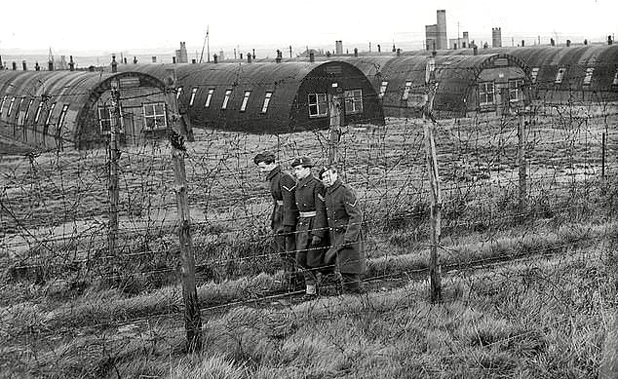 |  |  | Christmas 1946 - a service was held at Sheffield Cathedral for the pows. A choir from the camp sang during the service which was attended by the Bishop of Berlin.  1946/47 - severe winter, many pows were utilised for snow clearing.  February 1947 – Most of the officers were sent to other camps – a small number remained on the permanent pow staff.  Most of the re-education and general education activities that were organised by the pows came to a halt.  10 March 1947 – English Inspector’s Report. Total strength 2917, all in huts. No hostels.  New lagersprecher: Kapitän Leutnant Elfe.  The nature of the camp had changed to a transit/repatriation camp. There was a permanent pow staff of about 300 – others stayed for up to 14 days before repatriation.  There were no English classes.  17/19 August 1947 – ‘Re-education Progress Report’. This was the first report of this kind and was very much later than most other camps. Strength: 30 officers; 1939 Other Ranks.
 |  | Officers |  | OR
 | Permanent staff: | 8 |  | 365
 | Detention: | 2 |  | 29
 | Detached: | 3 |  | 8
 | Transit: | 17 |  | 1537

Commandant: Lieut Col P W Dollar Camp Leader: Fw Rudi Dubbermann
Interpreter: Captain F E Goldman Deputy C/L: Faehnr. Heinz Brocke
Adjutant: Captain Lester German M.O.: Stabsarzt Dr Kurt Recker

3 Compound leaders: I: Fw Karl Wilding II: St/Fw Walter Uecker III: Fw Rudi Dubberman (also camp leader).

There was little interest in re-education from the British staff.

The Camp leader was described as; “a decent, but unspectacular type. He has considerable administrative duties and neither time nor interest in re-educational activities.”

Morale for the pow staff was regarded as ‘fair.’ They were busy, but it could be depressing to see so many others being repatriated while still being held. Though the camp itself was described as ‘depressing,’ the accommodation was; “very good, the surroundings of the camp most beautiful and Sheffield is only a 4d bus ride from the camp.” There was little interest in politics. Few were ‘youth’ (under-25).

Morale for transit pows was mixed. Although going home, 14 days in a camp with nothing to do and no pay, and the strict discipline in the camp, gave; “an unfortunate last impression of Great Britain to them.”

The standard list of re-education activities was given. There were very few activities due to the nature of the camp with pows in transit;

Wochenpost and Ausblick – separate appendix

Newspapers – 21 daily and 12 Sunday papers were bought. To be increased to provide for pows in transit.

Library – 12,961 books – a remarkable number, but the Commandant did not wish to lose any to other camps.

Lectures – were taking place, but arrangements were haphazard.

Discussion groups – none.

Films – “adequate.”

Wireless – 1 set with 9 loudspeakers. Some faults with the system.

Camp magazine – none.

Press review – 20-minute broadcasts, three times a week.

English Instruction – separate appendix.

Information room – the Visual Education Section of COGA sent exhibitions, but they were scattered and ineffective.

Other activities:

Religion – 20 pows attended daily services by RC priest, Peitz. The priest also held conferences and talks where up to 120 attended. About 15 pows attended daily services by the protestant priest, Hoepfner. He was very popular, but was due for repatriation. Both priests stated that interest was decreasing.

Education – no classes other than English.

Entertainment - Pow staff spent their leisure time outside of the camp. The local population was stated to be friendly.

On the front cover of this report is a pencil written note pointing out that though this camp was also a reception area for Ukrainians, the report gives no indication of that. The Ukrainians were ex-members of the Waffen-SS Division Galizien.

11/12 September 1947 – lecturers visited the camp and spoke to large audiences. After each lecture reports were sent in to COGA by the lecturer and from the camp. The camp reports were often written by the German camp leader. The lecturer on these 2 days was a Dr.Bohner who spoke on subjects including; ‘German Collapse’ and ‘Berlin and Germany 1945’. Members of the audience and the camp leader criticised him for being too pro-Russian, and the Commandant stated he did not want the lecturer to return.

17 – 20 November 1947 – ‘General re-education survey’. Strength; 9 officers; 311 OR – only the permanent pow staff. Many others in transit. Ukrainians were not listed as they were not part of re-education work by COGA. The senior staff had not changed. There was an additional interpreter; S/Sgt Joly.
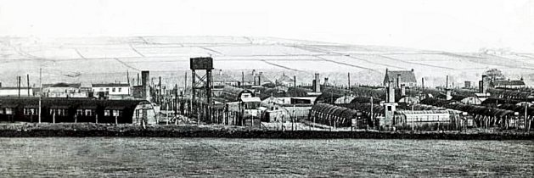 | The report stated; “Both the commandant and I.O. take considerable interest in the activities and welfare of the Ps/W, but they are disappointed by the apathy of the prisoners and their disinclination to do anything for themselves.” The interest of the British staff was not reflected in previous reports. It also pointed out that the camp staff were very busy and other activities were just side-lines.  No change to morale or political outlook. The standard list of re-education and other activities was little different from before. The camp had its own cinema barrack which could hold up to 250 and films were shown regularly. The information room had been properly organised.  There were protestant and RC chapels.
Lodge Moor 1949

Entertainment – the Ukrainians had formed a small band.

24 pows attended classes at the Workers Education Alliance (WEA) in Sheffield. Groups had attended Sheffield Council meetings and the local police court proceedings. Pows were able to use Sheffield public library. A number of free tickets were received for concerts in the city.

21 / 22 November, 1947 – A visiting lecturer, W Derkow, made comments about general conditions – “Compared with other Repat Camps, 17 does not make a favourable impression. Too much barbed wire, a too rigid military discipline.” He also commented on the negative effect that a cut in rations had on pows being repatriated – rations were cut as the pows were not working.

Over the next few months, a few lecturers commented on false rumours in circulation in this and other camps. One was that German butter and other foods were on sale in Britain, while Germany suffered shortages; another was that food offered to Germany from Argentina had been destroyed. These tales were exploited by pows with grievances or holding on to Nazi views to stir up negative attitudes towards the British.

1947 - some of the Ukrainian pows at the camp started a hunger strike to protest against being returned to their homeland. The strike was called off when it was announced that only volunteers and undesirables with bad records would be returned.

5 December 1947 – English Inspector’s Report. Strength; 545 Germans, 97 Ukrainians = 642 permanent staff. Total strength varied between 3000 to 5000.

Just 2 English classes with 13 pupils. 20 others attended English classes at the WEA.

19/21 April 1948 – Re-education survey. Staff strength; 17 officers (including 4 Ukrainians); 346 OR.

Commandant: Lieut Col P W Dollar Camp Leader: Fw Lamprecht
Interpreter: Captain F E Goldman Deputy C/L: Faehnr. Heinz Brocke
Adjutant: Captain Wallis German M.O.: O/Arzt Demmler / Dentist St/Arzt Meister
Padres: Protestant Lt Meisner / RC Major Peitz.
2 Compound leaders – H/Schaf Wender / Faehnr Brocke.

A survey was conducted in camps still open at this time concerning pow attitudes to the British, (following a PID circular dated 25.2.1948). It was pointless, carried out far too late and in totally random ways. Some visitors simply gathered whoever was around and asked them to give a show of hands to the questions, some only asked a ‘selected’ group – most did not state how the data was gathered or the numbers involved. For what it is worth (nothing?) the results for Lodge Moor were:

Hate 7% / Dislike 15% / Mistrust 25% / Indifferent 24% / Benefit of the doubt 15% / Liking 14%

Negative attitudes expressed: individual bad experiences; belief that the British hated the Germans; anti-German films shown in Britain; bad conduct of British troops in Germany.

Mistrust arose from: Situation in Germany; belief that Germany prevented from getting food by occupation authorities; fears that the west would not stand up to Russia; planned destruction of factories in Germany; seizure of German patents.

Positive attitudes expressed: Civilian contacts; improved understanding of the Germans by the British; friendships formed. In all camps the major factor, negative or positive, was always contacts with locals. POWs from Lodge Moor had developed friendly relationships with many local families.

Known Camp Commandants;
Lt Col Albert Percy Jackson OBE (Pioneer Corps – awarded OBE in 1946 honours).
Lt Col P W Dollar – from the 4th Queen’s Own Hussars – previously at Birdingbury Camp 97.

After the camp: Displaced people were housed in the camp – starting with 1,300 Ukrainian civilians arriving in May 1947. Ruins of various buildings can be found – frequently photographed and many online.

Further information:

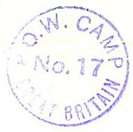
National Archives: FO 939/ 102 and 103 – 17 Base Camp, Lodge Moor Camp, Sheffield, Yorkshire – dated 1945 to 1948. Used above.

Details and press cuttings about the murder at: www.chrishobbs.com
Several pages of details in ‘Churchill’s Unexpected Guests’ – S Jackson – 2010 - The History Press

The Imperial War Museum has a copy of the magazine Zu Neuem Ufer, dated January 1947. Ref LBY E.J. 453. The German Federal Archives also has a copy, unknown date.

CFA Archaeology undertook a community volunteer excavation at the WWI and WWII former Lodge Moor Prisoner of War camp at Redmires Plantation, Sheffield, South Yorkshire during August 2022. https://www.cfa-archaeology.co.uk/education-outreach/lodge-moor-pow-camp-at-redmires-plantation/

Sheffield Local Studies Library, Central Library, Surrey Street, has a letter from the artist, Herr Lutz, about his experiences as a POW at Lodge Moor - 6803 M (215509365).

Sheffield Museum has a set of doll’s house furniture made by an Italian pow. The items were donated by Mrs Doris Taylor who often walked by the camp with her son.

Hostels

Hoyland Common

1943 - listed as hostel for Lodge Moor with Italian pows.

1945 – listed as a hostel for Potters Hill Camp 127

1946 – listed with Ravenfield Camp 296

Ravenfield. 15 miles from the main camp.

September 1946 – hostel to Lodge Moor Camp. 700 pows in huts. No English teaching. Pows working long hours gathering the harvest.

10 March 1947 – not listed with this camp.

April 1948 - listed as a hostel with Sandbeds Camp 53.
Stoney Middleton. Site formerly a military camp with the Lancashire Fusiliers – with searchlights and AA guns. Located at what is now Meadow Close, NGR SK 235 751.  1943 - listed as hostel for Lodge Moor with Italian pows.  1945 – no longer listed with this camp. Memories of German pows here.  Excellent local history website with further memories - http://smhccg.org/village-history/prisoner-of-war-camp/  1946 / 1947 – With New Drill Camp 248, then Norton Camp 248.  December 1947 – listed as a hostel with Nether Heage Camp 248 (58) | 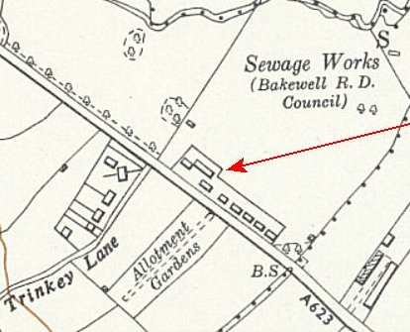
 | Ordnance Survey 1955
Treeton, Sheffield. Previously AA gun site.

1943 - listed as a hostel for Lodge Moor with Italian pows.

Memories - “I know there was an Italian POW camp up on the hill near the woods.”

1944 – hostel attached to Nether Headon Camp 52.

Woolley (Sheffield)

1943 - listed as hostel for Lodge Moor with Italian pows.

November 1945 – listed as a hostel for Potters Hill Camp 127.

September 1946 – back as hostel to Lodge Moor Camp. 100 pows in huts. No English teaching. Pows working long hours gathering the harvest.

July 1947 – listed with Ravenfield Camp 296.

