Camp 74 - Racecourse Camp, Road Street, Tarporley, Cheshire (aka Tarporley).

Included in the 1945 ICRC camp list – Labour Camp. 74. Racecourse Camp, Tarporley, Cheshire.

1947 Camp list
74(G.W.C.) | Racecourse Camp, Tarporley, Cheshire | W. | Priswar, Tarporley | Tarporley 208 | Beeston Castle | Lt.Col.B.M.Holdman | v/1453/2

Prisoner of War Camps (1939 – 1948) - Project report by Roger J.C. Thomas - English Heritage 2003
OS NGR | Sheet | No. | Name & Location | County | Cond’n | Type 1945 | Comments
SJ 5407 6372 | 117 | 74 | Racecourse Camp, Road Street, Tarporley | Cheshire | 4 | German Working Camp | STANDARD type.

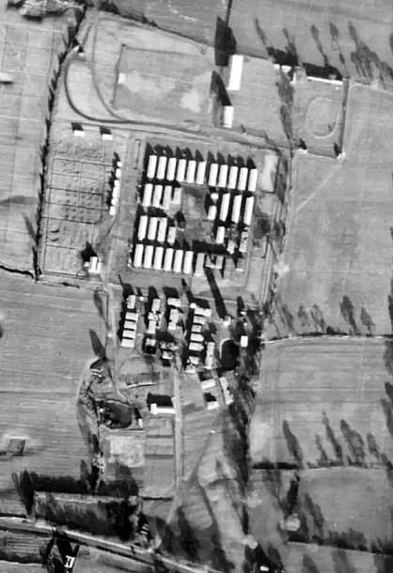  Location: Off the A51 ‘Road Street’, sometimes called ‘Rode Street’ on modern maps. On the NW edge of Tarporley. Marked on the map as a hostel. NGR SJ 5410 6365.  Before the camp: The racecourse opened in 1776. Its last race was in 1939. On earlier OS maps the ‘Tarporley Hunt Steeplechase Course’ can be seen circling the site of the pow camp.  Pow Camp: Opened in 1942 and listed as an Italian Labour Battalion, then a German working camp. Standard type with a main pow compound and British huts at the ‘front’ can be seen in the 1947 aerial photo. Sewage Works for the camp shown at the top of the map.  1943 – 7 hostels listed for Italian pows, (see chart below).  25 November 1943 there was an International Red Cross visit; Italian prisoners, capacity 800.  5 May 1944 a hostel was listed for Italian pows from this camp, (WO 32/10737) - Comberbach, Nantwich, Cheshire.  May / November 1944 the camp was listed as an Italian Labour Battalion under the Western Command area, (WO 32/10737). | 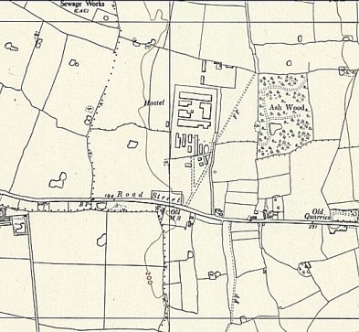
 | Ordnance Survey 1954

Late 1944 – Commandant Major B M Heldman. (Soon given temporary rank of Lt.Col).

1 August 1945 an urgent memorandum was sent to this camp, and others, about maintaining records of Italians who were classed as ‘co-operators’.

Oversight and development of re-education activities and English teaching for German pows was carried out by PID (Political Intelligence Department of the Foreign Office) / COGA (Control Office for Germany and Austria – UK). Visits and reports were made. The standard of the reports varied greatly. The visitors took little interest, if any, in activities other than re-education. They rarely mentioned welfare, sports, games, pastimes, crafts, etc of the pows.

3-6 April 1946 – Mr F E L Priggen made the first visit to the camp for the Political Intelligence Department (PID). The camp was listed as an ILB (Italian Labour Battalion) with 900 Italians, however the visitor only looked at provisions for German pows. Strength; Germans - 0 Officers; 294 Other Ranks in hostels + 54 in billets.

‘Special Objects of Visit’: 1. General Survey; 2. Vet billetees; 3. Select spare white cooks [‘white’ = non-nazi]; Select candidates for the special training camp at Wilton Park.

Commandant – Lt Col B M Heldman - ‘extremely interested in PID activities’ Camp leader: F Strang
Adjutant – Captain Swan – similar comments to Commandant. Deputy C/L: None
Interpreter – none. German M.O.: None

German leaders in the hostels were not yet confirmed.

Political screening of the German pows had only been partially completed – overall the camp was graded as ‘grey.’ There were 3 candidates for Beaconsfield (Wilton Park).  The camp was expanded to hold German pows with the addition of several hostels – most of the pows were transferred from Glen Mill Camp 176 and Warth Mills Camp 177.  “History of the Camp – The main camp founded as an I.L.B. in 1942, holds at present approximately 900 Italian co-operators. The German skeleton staff of 15 arrived at the beginning of March and will increase slightly in the near future. It is, however, not expected that the main camp will be germanized at present….” (It became a German camp just a month later).  The German part of the camp was still being established. Re-education activities were starting under the leadership of 46-year-old OWm. H Schafer (A) – “who never had any connection with the party and who is a democrat in every respect.” He was assisted by E W Schafer (est B+) – it was not stated if the two men were related. Each hostel had a cultural committee or leader who reported to H Schafer, he in-turn reported to the PID. (He was repatriated shortly after this report leading to some disruption of activities). The Inspector hoped further activities would be established and expanded.  There were some difficulties for the camp:  “The administration of the widely scattered hostels and 54 billetees is difficult at present. The camp is further under the following additional disadvantages: | 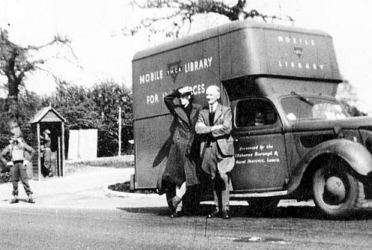
 | YMCA mobile library at entrance to the camp in 1944. YMCA also supplied films. Sentry box in background.

1. Lack of British I.O. or Int.Sgt. as well as shortage of English speaking German Interpreters;
2. shortage of British staff;
3. lack of transport (a tour of approx..200 miles is required to inspect all billetees).”

Morale at the camp was considered to be fair, but “the intakes from USA settle down rather slowly and are still disillusioned” – these pows had been falsely informed in the USA that they were being returned to Germany before being transferred to the UK. There were low stocks of daily ‘necessities. “Reliable ‘whites’ drew attention to the communist tendency prevailing amongst intakes from camp 176 (USA). In my view this is exaggerated and is due to the different re-educational methods employed in USA. So e.g. PW from USA complained about the wearing of badges of distinction by C/L’s and why the latter are not chosen by free elections.”

About 25% of the pows were youth (under-25), but this was not seen as a problem.

Standard re-education activities had barely started, but many were planned:

Newspapers – some newspaper and copies of Wochenpost were being received – more required.

Library / Lectures / Discussion groups / Films / Camp magazine / Press reviews / English Instruction – not started though some were planned.

Wireless – a set in every hostel except Deeside. The wireless in the main camp was Italian property.

Other activities –

Religion – inadequate services; commandant due to develop this.

Education – none yet.

Theatre / Orchestra – none.

29 June 1946. Tarporley Camp took over Boar’s Head Camp 147, (from then, referred to as Walgherton Hostel), and its hostels, with 1295 Pows. 65% of these pows were from Camps in the USA, some were from Canada and Belgium. Many of these pows were under-25, 60% recorded later in the year. About 500 of the pows were working for I.C.I. and the remainder on farms or nursery gardens.

8 and 12 July 1946 - an English Language Inspector, R D Miller, visited Tarporley Racecourse Camp and Boar’s Head Camp. Tarporley was listed as the HQ Camp 74, a German Working Camp.

Mr Miller gave brief details of books and facilities for teaching English. He listed the German pow teachers at each hostel with brief background details. He noted a shortage of books and basic teaching equipment at some hostels.

There was a temporary shortage of hutted accommodation and 150 pows were in tents.

Commandant: Lieutenant Colonel Heldman. Lagersprecher (Camp Leader): Kuhlmann.

11-12 July 1946. In addition to the English Inspector’s Report, there was a visit by Major C H B Readman and Mr S Denham Jacobs to make a Re-education Report. Strength – 2 officers and 2995 other ranks. Political screening had not fully taken place with 2561 of the 2997 still with unknown. The camp was regarded to be politically ‘Dark Grey.’

Camp Commandant: Lt.Col. Heldman Camp Leader: O/Gefr. W Kuhlmann (B)
2nd i/c Maj Thomewill Deputy C/L: O/Gefr. F Ollesch? (Cannot read entry).
Adjt. Capt Swan German M.O. Dr Will (HQ) / Dr. Commes (Walgherton)
Interpreters: S/Sgts Reingewarz and Jackson (at Walgherton)

A shortage of officers and staff was noted again.

Large intakes of pows had been made:
18/4/46 150 from Dunham Park Camp 189
7/5/46 750 from Glen Mill Camp 176
27/5/46 80 from Camp 189 (aa).
29/5/46 250 from Marbury Hall Camp 180

Morale was satisfactory / Welfare was not good, but no further explanation was given / Health was good. Mail was normally being regularly received, except at former Camp 147 who had not received any for just over a month.

Re-education activities continued to be slow to develop. This was stated to be partly due to long hours being worked in the Summer months – though other factors were beginning to appear, (see below). Classroom accommodation was ‘uniformly bad’ with dining halls being used. The previous list of activities had developed very little.

A camp magazine that had been produced by Camp 147, was continued for the whole camp - “Die Lupe” (The Magnifying Glass).

15 September 1946 – Camp magazine, no.2; Tarporley Express : Camp 74 - The Wiener Holocaust Library

20 October 1946. English Inspector’s Report. Mr Miller returned to the camp to inspect facilities for teaching English.

The Commandant and Lagersprecher had not changed. There were 616 pows in the main camp (all in huts), 1100 in 14 hostels and 270 billetees.

Classes were held in a hut with electric lighting and a stove (in need of repair). There was also a theatre which held 200.

The Inspector visited 10 hostels, and mentioned hostels at Rowton, Kinnerton, Alvanley and Crewe Hall “recently taken over” – (Alvanley may have been a hostel to the main Crewe Hall Camp 191. Crewe Hall had been a camp mainly for officers – as there was no increase in the number of officers on the strength for Tarporley, they must have been sent elsewhere.

6 / 10 January 1947. Report on re-education / Screen Pows. 3 officers and 1806 other ranks.

The Camp Leader, W Kuhlman was due to be repatriated, to be replaced by Fahnenj.Wachtm Kindler (B) after he had been to the training centre.

Political screening figures from September 1946:

A+ | A | A- | B+ | B | B- | C
1 | 11 | 1 | 416 | 869 | 416 | 95

440 pows had been repatriated to date.

The initial comments about the commandant being “extremely interested” in re-education were replaced with the meagre comment; “The Commandant co-operates.”

The two interpreters – “S/Gt Jackson an Alsation is doing a good job. He is popular with the British Staff and the P.W’s and shows interest in re-education. S/Gt Regengewurz is too young, inexperienced and unpopular to influence re-education. He is being posted to No.2 Camp.”

Morale had deteriorated; “Very low in the main camp. The men are bitter and cynical. Responsible factors are bad news from Germany and slow speed of repatriation…… Methods and results of the segregation in this camp are violently criticised and some of this criticism is supported by British Staff and reliable German camp staff. Understanding treatment by the British staff is much appreciated. The privileges recently granted influence morale favourably. Morale in the hostels is higher than the main camp.”

Political grading / segregation was particularly important to the pows as it affected the date for their repatriation. Criticism of the grading methods used was widespread throughout the pow camps.

The lack of progress on developing activities for pows no doubt also played a part in the low morale. Looking through reports for other camps, good morale was usually associated with active camps. The differences between attitudes/morale in the main camp compared to the hostels was further shown in comments about re-education: “Political re-education does not exist in the main camp. Study Leader Tennigkeit (B) a secondary school teacher, organises languages lessons only. He does not show much initiative. The position in the hostels is much more satisfactory.”

The conclusions clearly showed the Inspector’s disappointment in this camp from his first visit: “The camp has been neglected, only one short T.A. [Training Advisor] visit was paid to the camp since it was formed in May 1946….”

2-4 March 1947. English Inspector’s Report. A new inspector, Mr E F Peeler. Main camp (632) + 12 hostels (741) + billetees (263) = 1896 pows.

Same Commandant. A new Camp Leader, Kindler. A large number of pows were being transferred prior to repatriation.

25-29 March 1947. Visit to report on re-education and regrade pows. 2 officers, 1763 other ranks. Small variations to numbers of pows given in 2 March report. 761 pows repatriated to date.

The Commandant was due to retire on 1 May, at the same time as the camp would become part of Marbury Hall Camp 189. Same Camp Leader. Interpreter S/Sgt Ginzberg.

Screening figures:

A+ | A | B+ | B | B- | C | C+
1 | 27 | 353 | 851 | 514 | 3 | 16

“Morale has improved during the last three months.” The main reasons given for this were:

1. More pows being repatriated.
2. Removal of the colour coded patches denoting political grading, which was being phased out.
3. Change of camp leadership
4. Intensified educational and other activities.

However, as noted in most camps, there were the negative influences of bad news from Germany and delays in receiving mail.

Political Progress – “Political interest is increasing. Most of the Ps/W have not yet made up their minds for which party they will vote after their repatriation. Men from the British Zone generally prefer Dr.Schumacher.” [Kurt Schumacher, Social Democratic Party, who did not win].

The re-grading had taken place, but the camp received a large intake of ‘Black / C’ grade pows; “I have upgraded 130 men, most of whom were previously graded ‘C’. Of 300 men who recently arrived from camp 175, [Flaxely Green, Staffordshire] 28 were graded C+. I have upgraded 13 to B-. The remaining 15 will now be posted to a C+ Camp, 2 youngsters to the Youth Camp [Radwinter]. At least 2 of the C+ are very dangerous men, named in CROCAS and supposed to be frozen by War Crime Commission (LDC). These 15 Ps/W should not have been posted to an ordinary working camp where their presence is resented by their comrades and the British Staff, and where they can do a lot of harm.” [CROCAS should be CROWCASS – The Central Registry of War Criminals and Security Suspects.]

1 May 1947 - Tarporley became a satellite camp to Marbury Hall Camp 189 – its hostels were also transferred.  May 1947 - Satellite camp leader; Ofhr.Walter Kindler (A)  August 1947 - Satellite camp leader; Fw.Risse (B). He was still there in February 1948  October 1947 – The satellite camp commandant was described as a strict disciplinarian in a camp visit report. “Morale at Tarporley Satellite is low owing to the attitude of Capt Jeffreys against whom serious allegations are made.” No further details of the allegations were given, however, Captain Jeffreys was still there in February 1948 with the comment; “Cpt.Jeffreys at Tarporley is also cooperative.”  The Interpreter, S/Sgt Ginzberg, was recorded as being unpopular, he was discharged in October 1947.  Camp magazine – “Tarporley-Express”  The camp closed in 1948. | 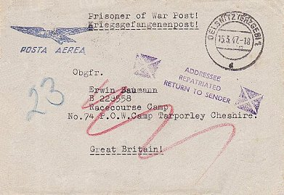
 | “ADDRESSEE REPATRIATED RETURN TO SENDER”

After the camp: For a while used as a hostel for European Voluntary Workers. Site demolished in mid-1950’s.

Further information:

National Archives FO 939/154 – 74 Working Camp, Racecourse Camp, Tarporley, Cheshire. Dated 1947. (Used above).

Aerial photographs - NLAP 106G/UK/1459 Frame 2183 02-MAY-1946, and NLAP 58/1091 Frame 190 20-APR-1953

‘POW Camp 74 and Satellites’ – Graham D Dodd – Nantwich Museum - 2023

‘Tarporley Racecourse, R.O.C. Post, Army and P.O.W. Camp,’ by John Barford Lindop, 1998. A copy in the Imperial War Museum – Catalogue LBY K. 99/955

Some pictures and info - https://www.facebook.com/groups/102205169850122/user/100000283548874/

Story of Italian pows presenting gift in 1942 - https://www.manchestereveningnews.co.uk/news/greater-manchester-news/little-box-showed-even-war-24283535

Numbers of pows at Tarporley Camp and hostels.

 | Open |  |  | With other camps |  |  | Unknown |  |  | Not listed / not open

 | Tarporley Racecourse Camp 74 |  |  |  |  |  |  |  |  | Tarporley as Satellite to Camp 189
 | 1942  Italians | 1943  Italians | >1946 |  | 4/46 no. of Germans | 7/46 | 10/46 | 1/47 | 3/47 | 5/47 | 8/47 | 10/47 | 2/48
Main |  |  | Italians.  Cap.800 |  | 15 + ≈900 Italian | 1031 all German | 616 | 695 | 632 | 540 | 430 | 326 | 278
Comberbach |  |  |  |  | 50 | 65 | With Camp 189
Blacon Point
M. H. Chester
Sandbach |  |  | With 147 |  |  | 82 | 62 | 54 | 51 | With 189
The Dale, Upton
Winsford
Wrenbury |  |  | C147? |  |  | 45 | 38
Alvanley |  |  | With Camp 191 ? |  |  |  | Not given
Bromborough |  |  |  |  | 64
Broxton |  |  |  |  | 45 | 48 | 52 | 46 | 49 | With Camp 189
Crewe Hall |  |  |  | Camp 191 |  |  | Not given
Deeside |  |  |  |  | 39 | 41 | With C283
Eddisbury |  |  |  |  | 54 | 63 | 52 | 48 | 43 | With Camp 189
Hankelow Court |  |  |  |  | C147 | 143 | 88 | 123 | 91 | With Camp 189
Holmes Chapel |  |  |  |  |  | 167 | 115 | 92 | 90 | With Camp 189
Kinnerton |  |  |  |  |  | 56 | Not given | 62 | 48 | With Camp 189
Liverpool CSD |  |  |  |  |  | 41 | Not given | 19 | 11
Malpas |  | With 118 |  |  |  | 36 | 40 | 40 | 34 | With Camp 189
Mobberley |  |  |  |  | C147 | 147 | With Camp 189
Rowton |  |  |  |  | 27 | 28 | Not given | 23 | 23 | With 189
Red Brow |  |  |  |  |  | 122 | With Camp 189
Walgherton |  |  | Camp 147 |  |  | 280 | 186 | 156 | 123 | With Camp 189
Warburton |  |  |  |  |  | 28 | With Camp 189
Warmingham |  |  | With 191 & 147 |  |  | 57 | 44 | 38 | 34 | With Camp 189
Weston |  |  |  |  | C147 | 210 | 211 | 167 | 104 | With Camp 189
Billetees |  |  |  |  | 54 | 292 | 270 | 221 | 263 | With Camp 189
Detached |  |  |  |  |  | 15 | Not given | 26 | No further records of detached pows
Total |  |  |  |  | 348 + 900 | 2997 | 1986 | 1809 | 1896 | See Camp 189

Camp 189 – see under Marbury Camp 180

Hostels

Alvanley  There is a small cluster of buildings to the left of the map (SJ 4925 7414) on Primrose Lane – which some have said was the location. There is a record of a small army camp there for about 40-50 soldiers, there were also 2 searchlights and a sentry box – this site was used as a workers’ hostel later.  (There was another small site on Towers Lane, by Done’s Farm, with 2 anti-aircraft guns and ATS/army personnel – later Prime Minister Ted Heath served some of his army time there – some state that the camp was there).  The hostel was possibly linked to Crewe Hall camp before October 1946.  Just one mention in the Camp Reports - October 1946 it was reported to be a hostel, but no indication of number of pows given. | 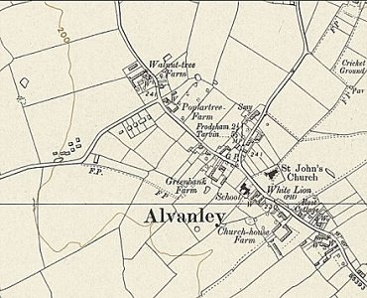
   | 1942  Italians | 1943  Italians | >1946 | 4/46 no. of Germans | 7/46 | 10/46 | 1/47 | 3/47 | 5/47 | 8/47 | 10/47 | 2/48
  Alvanley |  |  | With Camp 191 ? |  |  | Not given
 | Ordnance Survey 1954
Blacon Point (C.S.D. Blacon Point (Chester)) Command Supply Depot.

1943 – recorded as a hostel for Italian pows. Probably attached to a different main camp after this.

 | 1942  Italians | 1943  Italians | >1946 | 4/46 no. of Germans | 7/46 | 10/46 | 1/47 | 3/47 | 5/47 | 8/47 | 10/47 | 2/48
Blacon Point

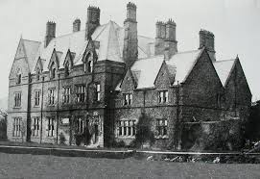  Bromborough – “nr Birkenhead 23 miles” At Woodslee House and grounds. NGR SJ 3450 8275. The house was requisitioned for use by the army, later becoming the pow hostel. In the grounds were up to ten huts, a cookhouse and ablutions.  26 March 1946 founded with pows from Warth Mills Camp 177. (May have existed before this with Italian pows).  April 1946 – Temporary Camp Leader – Wm. W Pahl (B)  “The PW of Bromborough Hostel will very shortly be moved to a new hostel at Preston-on-the-Hill.”  A hostel discussion group was due to start led by; “Fw. L Zimmerhackl (est B+), a former member of a RC youth movement who is also in charge of English instruction, and O.Gefr. W Petersen (est B).”  There were 64 German pows recorded in April 1946 – after this the hostel was no longer listed.  Memories of Dot Fuller; “There was a guard house where the present-day lodge house now is. There was a barrier to prevent access to the camp on the road. Dot would see the prisoners in the camp on a regular basis. There were German and Italian prisoners there at one time. They lived in wooden huts like pavilions… | 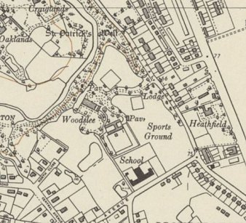
 | Ordnance Survey 1954
….The prisoners would go out to farms in the area to work. It was not such a difficult life because as a prisoner you were well fed and escaped any danger of being killed in action. Many prisoners were quite ‘happy’ being out of the war.” From - www.dibbinsdale.co.uk/history/woodslee-history/

 | 1942  Italians | 1943  Italians | >1946 | 4/46 no. of Germans | 7/46 | 10/46 | 1/47 | 3/47 | 5/47 | 8/47 | 10/47 | 2/48
Bromborough |  |  |  | 64

Broxton – 8 miles from Tarporley. Map and further details with Marbury Hall Camp 180 / 189.

6 March 1946 - founded with pows from Glen Mill Camp 176. (May have existed before this with Italian pows).

April 1946 – Camp Leader – to be confirmed – Ofw. R Woschek (B). A hostel discussion group was due to start led by; “Uffz P Teichmann (est B+) a former SPD man.”

 | 1942  Italians | 1943  Italians | >1946 | 4/46 no. of Germans | 7/46 | 10/46 | 1/47 | 3/47 | 5/47 | 8/47 | 10/47 | 2/48
Broxton |  |  |  | 45 | 48 | 52 | 46 | 49 | With Camp 189

Comberbach - 10 miles.

5 May 1944 - a hostel was listed for Italian pows from this camp, (WO 32/10737) - Comberbach, Nantwich, Cheshire.

6 March 1946 - RE-founded with pows from Camp Glen Mill Camp 176.

April 1946 – Camp Leader – to be confirmed – St.Wm. F Twesten (est B+). A hostel discussion group was due to start led by; “H/L Twesten (B+), who is actively interested in re-education and will co-operate with Wm. O Recknagel (est B).”

 | 1942  Italians | 1943  Italians | >1946 | 4/46 no. of Germans | 7/46 | 10/46 | 1/47 | 3/47 | 5/47 | 8/47 | 10/47 | 2/48
Comberbach |  |  |  | 50 | 65 | With Camp 189

Crewe Hall – See Camp 191.

 | 1942  Italians | 1943  Italians | >1946 |  | 4/46 no. of Germans | 7/46 | 10/46 | 1/47 | 3/47 | 5/47 | 8/47 | 10/47 | 2/48
Crewe Hall |  |  |  | Camp 191 |  |  | Not given

Deeside (Chester) – 14 miles from Tarporley. Unknown location.

14 March 1946 – founded with pows from Warth Mills Camp 177. (May have existed before this with Italian pows). Listed as a building.

April 1946 – Camp Leader – to be confirmed – Owm. Reiche (est B-). A hostel discussion group was due to start; “a strong committee was formed to counteract a small and inactive group of anti-British PW. The committee consists of:
Gefr. H Wesche, a degraded HFw. Who deserted with 94 men (est B+). Wesche never had any connection with the party and is democrat.
O.Gefr. Holtappels (est B+), a member of a RC youth organisation.
O.Gefr. H Leppert (est B+) also a member of a RC youth organisation, holding a certificate issued by his home town, stating that bearer is politically reliable.
O.Maat E Schneider (est B+), who was expelled from HJ [Hitler Youth], will also arrange for English instruction.”

Later recorded as a hostel attached to Ledsham Hall Camp 283, same leader.

 | 1942  Italians | 1943  Italians | >1946 | 4/46 no. of Germans | 7/46 | 10/46 | 1/47 | 3/47 | 5/47 | 8/47 | 10/47 | 2/48
Deeside |  |  |  | 39 | 41 | With C283

Eddisbury, Delamere – 6 miles from Tarporley

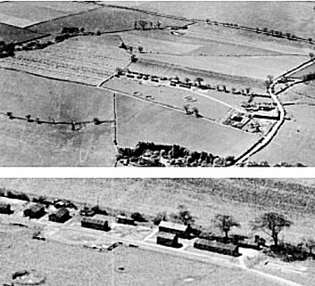
“Prisoner of War Camp and anti-aircraft site on Eddisbury Hill…. Italian POWs…. I recently discovered an aerial photograph of Eddisbury, taken at the end of WW2, clearly showing accommodation structures and some large circular features. Mike Platt, the farmer, between crops in the spring, kindly invited a group of archaeologists to investigate the site. With the aid of a drone, geophysics and satellite technology we were able to pinpoint areas of potential interest, and investigate what if anything, could be found.

We know the site was occupied by the Lancashire Fusiliers during the Blitz on Liverpool, when accommodation huts, searchlights and gun batteries were constructed. Later in the war the site became an Italian POW camp. It is not known how many prisoners were here, but there are memories of guards and prisoners with circular discs on their clothing. It must have been quite an easy life for a POW in England. They were well looked after, local farmers used to collect prisoners to help on their farms for the day. Close examination of the aerial photograph shows a garden between the huts and benches for socialising.(we found quite a lot of broken beer and wine bottles!). For the “dig” we pinpointed a couple of the “circles” and with the help of Mike and his digger we were soon able to examine any evidence. The circle was approximately 6 feet deep, lined with a layer of black cinders and in the centre there were concrete blocks for supporting the legs of a gun/searchlight. We think the circle was surrounded by a wall of sandbags.

Being wooden, there was, so far, no trace of the buildings, however there was plenty of evidence of 1940s occupation. A couple of rubbish pits were found with broken glass, bottles, bits of machinery, a 1934 battery, an enamel cup, the sole of a boot, and the star find, an Art Deco style Brylcreem jar dating from the 1940s.

Elsewhere a military button and fragments of 2 shilling pieces, one complete, with a large dent in it, which must have been used for target practice (2s in 1945 is the equivalent to 4 pounds today)… The photographs… show the 1940s aerial view, one of which enlarged to show a garden area.”

Delamere and Oakmere News - https://delamereandoakmere.co.uk/wp-content/uploads/2021/07/issue-52-web.pdf

6 March 1946 – RE-founded with German pows from Glen Mill Camp 176. A hutted camp

April 1946 – Camp Leader – to be confirmed – St.Fw. Schreiber (est B+). A hostel discussion group was due to start led by; “H/L Schreiber who is politically reliable, will arrange for suitable speaker.”

 | 1942  Italians | 1943  Italians | >1946 | 4/46 no. of Germans | 7/46 | 10/46 | 1/47 | 3/47 | 5/47 | 8/47 | 10/47 | 2/48
Eddisbury |  |  |  | 54 | 63 | 52 | 48 | 43 | With Camp 189

Hankelow Court. Map and further details with Marbury Hall Camp 180 / 189.

Mid 1946 – Administered by Boar’s Head Camp 147.

 | 1942  Italians | 1943  Italians | >1946 | 4/46 no. of Germans | 7/46 | 10/46 | 1/47 | 3/47 | 5/47 | 8/47 | 10/47 | 2/48
Hankelow Court |  |  |  | C147 | 143 | 88 | 123 | 91 | With Camp 189

Holmes Chapel. Map and further details with Marbury Hall Camp 180 / 189. Large house and huts.

3 September 1945 – Progress report 153 recorded a new hostel for Italian pows at Sandiford, Holmes Chapel, capacity 100. (FO 939/383).

 | 1942  Italians | 1943  Italians | >1946 | 4/46 no. of Germans | 7/46 |  | 10/46 | 1/47 | 3/47 | 5/47 | 8/47 | 10/47 | 2/48
Holmes Chapel |  |  |  |  | 167 |  | 115 | 92 | 90 | With Camp 189

Kinnerton. Hutted camp.

 | 1942  Italians | 1943  Italians | >1946 | 4/46 no. of Germans | 7/46 | 10/46 | 1/47 | 3/47 | 5/47 | 8/47 | 10/47 | 2/48
Kinnerton |  |  |  |  | 56 | Not given | 62 | 48 | With Camp 189

Liverpool C.S.D. (Command Supply Depot.). Listed as a house.

July 1946 – comment in report “conditions are unfavourable [for lessons] owing to the fact that the Ps/W are merely attached for a specific task”.

 | 1942  Italians | 1943  Italians | >1946 | 4/46 no. of Germans | 7/46 | 10/46 | 1/47 | 3/47 | 5/47 | 8/47 | 10/47 | 2/48
Liverpool CSD |  |  |  |  | 41 | Not given | 19 | 11

Malpas. Map and further details with Marbury Hall Camp 180 / 189.

4 July 1946 – Founded. (May have existed before this with Italian pows). Accommodation in stables building.

 | 1942  Italians | 1943  Italians | >1946 | 4/46 no. of Germans | 7/46 | 10/46 | 1/47 | 3/47 | 5/47 | 8/47 | 10/47 | 2/48
Malpas |  |  |  |  | 36 | 40 | 40 | 34 | With Camp 189

Military Hospital Chester

 | 1942  Italians | 1943  Italians | >1946 | 4/46 no. of Germans | 7/46 | 10/46 | 1/47 | 3/47 | 5/47 | 8/47 | 10/47 | 2/48
M. H. Chester

Mobberley. Map and further details with Marbury Hall Camp 180 / 189.

Mid 1946 – Administered by Boar’s Head Camp 147.

 | 1942  Italians | 1943  Italians | >1946 | 4/46 no. of Germans | 7/46 | 10/46 | 1/47 | 3/47 | 5/47 | 8/47 | 10/47 | 2/48
Mobberley |  |  |  | C147 | 147 | With Camp 189

Red Brow. Map and further details with Marbury Hall Camp 180 / 189.

 | 1942  Italians | 1943  Italians | >1946 | 4/46 no. of Germans | 7/46 | 10/46 | 1/47 | 3/47 | 5/47 | 8/47 | 10/47 | 2/48
Red Brow |  |  |  |  | 122 | With Camp 189
Rowton – 8 miles from main camp. Map and further details with Marbury Hall Camp 180 / 189.

6 March 1946 - Founded with pows from Camp 176. (May have existed before this with Italian pows). A stables building.

April 1946 – Camp Leader – not confirmed – Ofw. Witt (est B+)

 | 1942  Italians | 1943  Italians | >1946 | 4/46 no. of Germans | 7/46 | 10/46 | 1/47 | 3/47 | 5/47 | 8/47 | 10/47 | 2/48
Rowton |  |  |  | 27 | 28 | Not given | 23 | 23 | With 189

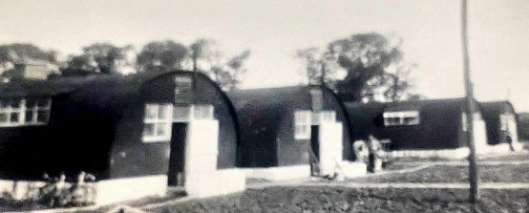

Sandbach. Map and further details with Marbury Hall Camp 180 / 189.

1943 – recorded as a hostel for Italian pows, attached to Camp 74

1945 – listed with Boar’s Head Camp 147

1946 – back with Camp 74.

1947 – a short time with Marbury Hall Camp 189.

< Just after it was a pow camp – being used for displaced persons.

https://historyug.wordpress.com/2014/12/21/ww2-pow-camp-sandbach/

 | 1942  Italians | 1943  Italians | >1946 | 4/46 no. of Germans | 7/46 | 10/46 | 1/47 | 3/47 | 5/47 | 8/47 | 10/47 | 2/48
Sandbach |  |  | With 147 |  | 82 | 62 | 54 | 51 | With 189

The Dale, Upton (Chester). NGR SJ 401 699.  1943 – listed as a hostel for Italian pows. | 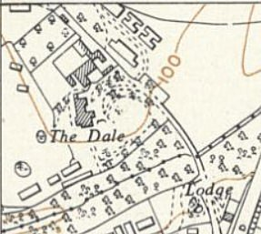
   | 1942  Italians | 1943  Italians | >1946 | 4/46 no. of Germans | 7/46 | 10/46 | 1/47 | 3/47 | 5/47 | 8/47 | 10/47 | 2/48
  The Dale, Upton
 | Ordnance Survey 1954
Walgherton (aka Boar’s Head) - See Camp 147

 | 1942  Italians | 1943  Italians | >1946 | 4/46 no. of Germans | 7/46 | 10/46 | 1/47 | 3/47 | 5/47 | 8/47 | 10/47 | 2/48
Walgherton |  |  | Camp 147 |  | 280 | 186 | 156 | 123 | With Camp 189

Warburton

 | 1942  Italians | 1943  Italians | >1946 | 4/46 no. of Germans | 7/46 | 10/46 | 1/47 | 3/47 | 5/47 | 8/47 | 10/47 | 2/48
Warburton |  |  |  |  | 28 | With Camp 189

Warmingham

Was with Crewe Hall Camp 191 - Boar’s Head Camp 147 – then Tarporley Camp 74 – then Marbury Hall Camp 189. Details with Marbury Hall Camp 180 / 189.

 | 1942  Italians | 1943  Italians | >1946 | 4/46 no. of Germans | 7/46 | 10/46 | 1/47 | 3/47 | 5/47 | 8/47 | 10/47 | 2/48
Warmingham |  |  | With 191 & 147 |  | 57 | 44 | 38 | 34 | With Camp 189

Weston. Map and further details with Marbury Hall Camp 180 / 189.

Mid 1946 – Administered by Boar’s Head Camp 147.

 | 1942  Italians | 1943  Italians | >1946 | 4/46 no. of Germans | 7/46 | 10/46 | 1/47 | 3/47 | 5/47 | 8/47 | 10/47 | 2/48
Weston |  |  |  | C147 | 210 | 211 | 167 | 104 | With Camp 189

Winsford (C.S.D. Super-Cinema). Located in Winsford, Cheshire. The Wharton Town Hall was an imposing Tudor Revival style building on the Market Place which was built in 1890. It was operated as the Cinema from around 1913. Later renamed Super Cinema, it was closed as a silent cinema by 1927.

1943 – listed as a hostel for Italian pows.

 | 1942  Italians | 1943  Italians | >1946 | 4/46 no. of Germans | 7/46 | 10/46 | 1/47 | 3/47 | 5/47 | 8/47 | 10/47 | 2/48
Winsford

Wrenbury. NGR SJ 589 479 – now Canal Cottages opposite Dusty Miller P.H.

Mid 1946 – May have been administered by Boar’s Head Camp 147.

 | 1942  Italians | 1943  Italians | >1946 | 4/46 no. of Germans | 7/46 | 10/46 | 1/47 | 3/47 | 5/47 | 8/47 | 10/47 | 2/48
Wrenbury |  |  |  |  | 45 | 38

