Camp 57 - Merrow Down Camp, Merrow, Guildford, Surrey

Included in the 1945 ICRC camp list – Labour Camp. 57. Merrow Down Camp, Guildford, Surrey.

1947 Camp List
57(G.W.C.) | Merrow Down Camp, Guildford, Surrey | E. | Priswar, Guildford | Guildford 62911 | Guildford | Lt.Col.A.C.M.Rowland | v/1453/2

Prisoner of War Camps (1939 – 1948) - Project report by Roger J.C. Thomas - English Heritage 2003
OS NGR | Sheet | No. | Name & Location | County | Cond’n | Type 1945 | Comments
TQ 022 500 | 186 | 57 | Merrow Down Camp, Guildford | Surrey | 4 | German Working Camp | STANDARD type.

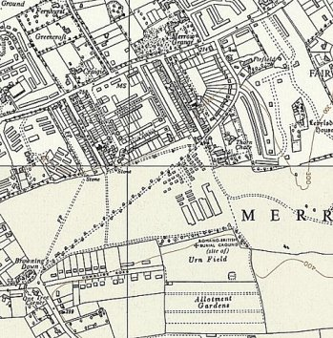 | 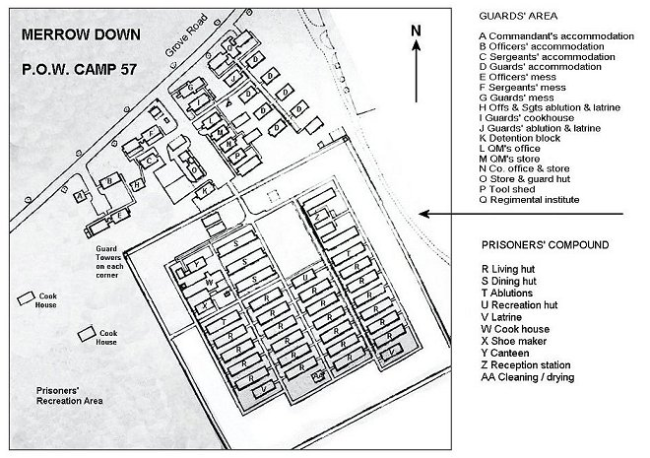
Ordnance Survey 1961 | Plan of the camp – adapted from display board on Merrow Down

Location: On the E side of Guildford.

Before the camp: Part of Merrow Down

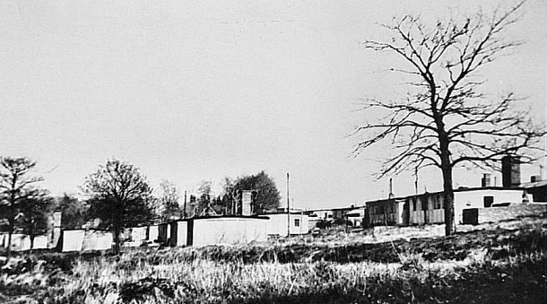 | Pow Camp: Built 1941/1942.  1942 – The camp opened for Italian pows. Wooden huts surrounded by barbed wire fencing with lookout towers on the corners of the camp. Listed as an Italian Working Camp / Labour Battalion to 1945/6, then German pows. Reported that Germans were not allowed to this camp until after the war as it was too close to Tyting House which was used as SOE Special Training School 28 and a Security Section.  Some prisoners cleared ditches, carried out road maintenance, or helped at local farms and market gardens.  1942 - Record of two Italian pows escaping. They were recaptured in Leatherhead, Surrey.  3 July 1943 - There was an International Red Cross inspection - Italian prisoners, capacity 1050.  1943 – 6 hostels listed for Italian pows, see chart below.  5 May 1944 – 8 hostels listed for Italian pows, (WO 32/10737).
Merrow in the 1950’s with thanks to Courtney F - Guildford Heritage Service’ (Cat.TG.1082)
May and November 1944 - The camp was listed as an Italian Labour Battalion under the South East Command area then as an Italian POW Working Camp, (WO 32/10737). The Italians were recorded as non-co-operators.

8 June 1945 - Norwood News; “Italian Prisoner taken ill: An Italian Prisoner-of-War, Lauriota Giuseppe, was taken suddenly taken ill while working at the Ministry of Works yard, Crystal Palace on Monday. He was taken to Beckenham hospital but was not detained. He comes from Merrow Down Camp, Guildford.”

1 August 1945 - an urgent memorandum was sent to this camp, and others, about maintaining records of Italians who were classed as ‘co-operators’. At this point many, sometimes all, of the Italian pows were in hostels / billets.

At some point when Italian pows were based here, the Commandant was recorded as Major Yates, and the Camp leader was Secondo-Capo Luigi Angelini.

Oversight and development of re-education activities and English teaching for German pows was carried out by PID (Political Intelligence Department of the Foreign Office) / COGA (Control Office for Germany and Austria – UK). Visits and reports were made. The standard of the reports varied greatly. The visitors took little interest, if any, in activities other than re-education. They rarely mentioned welfare, sports, games, pastimes, crafts, etc of the pows.

29 October 1945 – English Education Visit.

The report stated that this was an Italian Labour Battalion with 3 German hostels – no further mention of the Italians was made. Some English teaching had started, but there was a shortage of texts and reading books.

21/22 May 1946 – Progress Report on re-education. Strength; 2 officers, 2510 Other Ranks. NOTE the Italian pows in main camp and hostels were not included.

Commandant: Lt Col Dallas Edge, M.C. Camp leader: Not listed
Interpreter: Capt Salvi German M.O. O/Arzt Dr Quast (A)

The commandant was stated to be; “keenly interested in welfare and re-education.”

Political screening: | A+ | A | A- | B+ | B | B- | C | C+ | Unscreened
 | 6 | 121 | 29 | 43 | 393 | 17 | 71 | 2 | 1830
Morale was generally low. Many pows had been transferred from camps in the USA. They had been incorrectly informed in the US that they were being returned to Germany, instead they found themselves in British pow working camps. 50 pows had arrived from camps in Canada – nearly all C grade Nazis, some of whom were still politically active. Another 30 Waffen-SS men were transferred from Camp 238 and had previously been held in camps in Belgium where conditions had been extremely poor. The visitor made his feelings clear about the C grade pows – “The specimens I examined were sub-human things, totally unfit for a decent working camp.” He recommended that most of these pows should be removed to other more secure camps.

700-750 pows were ‘youth’ (under-25), they were considered to be a problem, but little could be done with so many C grade pows influencing them.

Re-education activities had barely begun and there was a shortage of materials, (display texts, leaflets, etc).

The standard list of re-education activities was given:

Wochenpost and Ausblick – Wochenpost was received, but more copies were requested.

Newspapers – A small selection of British newspapers were paid for from the camp welfare fund, (monies mainly raised from sales in the canteen). PID sent a small number of German papers - they were asked to send more British and German papers.

Library – Totally inadequate, just 196 books kept at Hallam hostel, nearly all text books. PID were asked to send more.

Lectures – regular. It was suspected that some pows, especially at Hallams were boycotting lectures.

Discussion groups – not started.

Films – Inadequate. PID films shown only at Hallams fortnightly.

Wireless – German pows had the use of three ‘utility sets.’ They also used sets belonging to Italian pows. A grant had been made to the Italians to buy a set in 1942, and a further grant to the Germans in 1945, but arrangements were inadequate.

Camp Magazine – a first draft had been prepared and sent to PID for scrutiny. The Interpreter considered it to be “crude and provocative.”

English Instruction – separate report.

Other activities –

Religion – 2 protestant clergy; Hauptmann Boelitz (A) and Betts (A). There was a visiting English priest for RC pows. Some pows were allowed to visit English churches.

Education – one class at one hostel.

Theatre – an active theatre group only at Hallams. Playscripts requested.

Orchestra – none. Insufficient funds for instruments.

13 June 1946 – English Inspector’s Report. Strength 2511 (+ Italians not recorded). 280 pupils in 10 classes at all sites.

The main camp was still Italian, with 61 German pow members of staff. The 177 billetees were based at 50 farms over a very wide area.

The shortage of books, texts etc was repeated.

19-21 and 26-28 June 1946 – Re-education progress report and start activities at new sites. Strength; 2 officers, 2610 OR. (Italians still at main camp not counted).

It was expected that the main camp would soon have only German pows. The nearby Merrow Wood site was being constructed by Italians.

Commandant: Lt Col Dallas Edge, M.C. Camp leader: Fwbl Sieme (A+)
Interpreter: 2nd Lt Stanley Deputy C/L: O.Fwbl Skoppek (A)
German M.O. O/Arzt Dr Quast (A)

The commandant was stated to be still eager to promote re-education – however, very little was achieved.
The Interpreter had been in post for 1 month – “a keen and conscientious worker and is especially to be congratulated on his tactful handling of the troubles which had arisen at Hallams Hostel” (see below). It was recommended that he should be assisted by a S/Sgt.

The camp leader, Josef Sieme, aged 27, had been hostel leader at West Byfleet and before that in a US pow camp. A Catholic youth teacher, but was unable to become a professional teacher as he refused to join any Nazi organisation. Rated as excellent.

Deputy Camp leader – “politically sound and suitable.”

German badges of rank had been removed and the Commandant was using a system of stripes for the camp staff to indicate the position they held.

Morale was still low – especially amongst the pows sent from the USA. Full political screening had still not taken place for 1854 pows and this was causing problems. Some Nazi elements attempted to undermine political progress and stated that democracy was as corrupt as any dictatorship. Lack of news from home, especially for the ex-US pows, had a bad effect. More activities were needed in the camp. There were some communist pows, but they were not regarded as a particular problem, except for a group of Nazi opportunists posing as communists to stir up trouble.

Although some improvements had been made for re-education activities, the overall provision was still unsatisfactory –

Newspapers, library, films, wireless – insufficient.

A discussion group had started at The Hallams. A camp magazine was produced at West Byfleet (Camp 57B) - “Die Fackel - Lagerzeitung Des POW Camps 57” (The Torch – Newspaper for Camps 57; 2 copies linked below; a Christmas 1946 copy is held by the Imperial War Museum, Catalogue LBY E.J.351).

Other activities –

Religion – 3 protestant clergy, 1 officer and 2 OR – but no German RC priest

Education – classes only at two hostels.

Entertainment – an active theatre group at Hallams only. Still no orchestra due to lack of funds.

It was again stated that PID supplied materials were inadequate.

July and August 1946 – 2 Camp magazines; Die Fackel : Halbmonatszeitung des German PoW-W Camp 57B - The Wiener Holocaust Library

28 September 1946 – English Inspector’s Report. Strength 2353. No Italian pows. 166 pupils in 11 classes at all sites.

A new camp leader (Lagersprecher): Steinghagen, previously hostel leader at Cherfold.

From late 1946 - Memories of pows being allowed to visit Guildford without guards as security was relaxed. One pow, Gerhard Breitenfeld, stated that:

"While I was at Merrow there were only a few guards. We virtually ran it ourselves…. I applied for some farm work and after saying that I could milk by hand I was sent to Sir Eric Bowater's farm in East Horsley. I was billeted with five other Germans. I got the job as I didn't mind working weekends. I ended up getting paid about 36 shillings a week."

Breitenfeld, having heard that his family farm in Germany had become absorbed into Poland and seized, decided to pursue the chance of settling in England.

"I was told I could stay in Britain as long as I worked in agriculture for the next five years. I went to Godalming where I obtained a pass to remain in this country, but had to report to Ripley police station every six months." (Information from weyriver.co.uk ).

21 January 1947 – English Inspector’s Report. Strength 1957. 170 pupils in 11 classes at all sites.

A new Commandant: Lt Col A C M Rowland

14/15 April 1947 – English Inspector’s Report. Strength 1848. 107 pupils in 8 classes at all sites.

Repatriation of teachers increasingly affected English lessons.
17/18 July 1947 – English Inspector’s Report. Strength 2440. 97 pupils in 9 classes at all sites.  A new camp leader: Helmdach  The camp became the central library of German and English books for the International Red Cross for the whole of ‘England’ (G.B.?).  Some pows attended WEA discussions and local theatres every 2 or 3 weeks. New privileges were coming into force giving greater freedom to walk out of camp and to using sterling currency, previously only camp token money was allowed. No pows attended the planned talk on English – they had all left the camp.  The pows continued to work at various farms, sawmills and market gardens, contributing to the supply of food, etc which is why they were being held here – but, there were some who worked for large houses and landowners as cheap labour. Generally, people turned a blind-eye to this, including the pows.  29 October – 1 November 1947 – Re-education survey. Strength; 3 officers, 1551 OR.  Commandant: Lt Col A C M Rowland Camp leader: Fw Willi Helmdach (B)  Interpreter: S/Sgt A Norton Deputy C/L: Fw Rolf Menzdork (B)  German M.O. O/Arzt Dr Hans Joachim Quast (A) & A/Arzt Dr Alfred Muench (A)  The camp leader was aged 28, an electrician from Danzig, he was not interested in re-education, but co-operated as required.  Simplified screening was in place – A 3; B 1551.  Morale was recorded as generally, ‘rather low.’ | 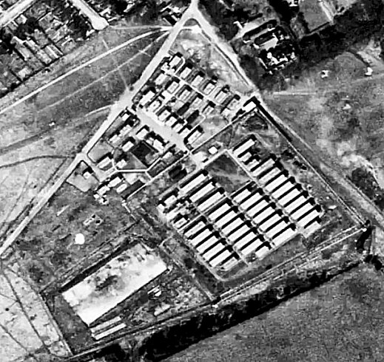
 | Aerial photo 1947 - RAF/CPE/UK/1982
The visitor stated that he believed low morale was down to few re-education activities taking place. Despite all previous comments about the lack of materials sent by PID/COGA, he praised the good influence of the material supplied. He also commented that contact with local civilians were diversions that militated against organised activity in the camps. I believe he was totally mistaken, especially regarding local contacts – this was by far the most positive influence upon pows outlook as shown in many personal records, comments and diaries.

Most pows were politically apathetic, with many still doubtful over the benefits of democracy. There was a communist element, mainly amongst those who were to return to the Russian zone.

The standard list of re-education activities was given;

Newspapers – Regular supplies of British papers. The visitor commented that the hostels received only “low grade dailies” and he arranged for the Daily Telegraph to be added. Some Swiss and German papers were received.

Lectures – regular, but only 5-10 % attended.

Discussion groups – had ceased except for a small group at Shackleford.

Library – Excellent, especially with the IRC library.

Films – YMCA, Travelling Films and (COI) Information films visited the camp. Travelling Films were restricted by transport difficulties. No mention of what happened at the hostels.

Wireless – HQ, Norbryght and Chobham – good; Nutfield and Shackleford – weak; Shackleford had a broken set for some time.

Camp magazine – Well produced, 250 copies fortnightly.

Press review – only at Nutfield. Some press extracts were displayed on boards around the camps.

Information room – some exhibition material had been sent by PID, but did not arouse much interest. Current materials were about the UNO.

Other activities -

Religion – Little interest, up to 10% attendance. Services held mainly on week-days; no explanation, but I would think the padres were visiting other camps.

Protestant Padre, Hptm Paul Boelitz, (A) aged 50 – the visitor was not sure why he had been given an A grade.

RC chaplain, Hans Glasner, aged 37, was well liked. He also visited Kingsfold Camp 46, and possibly others. His length of captivity had left him resentful towards the British.

Education – A few small classes – no details given.

Entertainment – Sport and other entertainments were highly popular.

Outside contacts – apart from informal links the pows developed with locals, there were few formal contacts;

There were very few visitors – the only one’s mentioned were a lantern slide show on the Life of Christ, a song recital, and visits by a Quaker. Quakers were often active in the camps and provided valuable services, (e.g. helping to trace family).

Visits had been made to; local concerts, Guildford Technical College Evening Classes, the Bishop of Guildford’s house, UNESCO lectures.

When camp leader, Willi Helmdach was repatriated, he wrote the following letter – “...soon most of us will be reunited with our families, sharing their hardships, our long separation at an end. Before we go we want to say thank you as well as goodbye to the people of Guildford, who have given us the entry to their homes, offered us their friendship, and shown us that here in England the spirit of goodwill still lives. This is the recollection we shall take back with us, the message we shall bring to our people in Germany... Thank you - auf wiedersehen!" (Re-published in the Surrey Advertiser, October 2007).

6/8 November 1947 – English Inspector’s Report. Strength 1412. 51 pupils in 9 classes at all sites.

Links with the Guildford Technical College included courses in biology, chemistry, bookkeeping, mathematics, engineering, Spanish, French and English. The College also arranged for pows to attend concerts and trips to London.

A pow had recently died of infantile paralysis – no further details.

14 November 1947 - Camp number included in an ‘Urgent Memorandum’ (FO 939/270) regarding inspection of food parcels.

9/11 March 1948 – English Inspector’s Report. Strength; 817. 24 pupils in 6 classes.

A new camp Commandant: Lt Col Carter.

April 1948 - The camp closed.

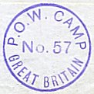
During the life of the camp there are reports of two suicides, by an Italian and a German pow – but I have no further details.

Known Camp Commandants;

Pre1945 Major Yates.
1945 Lt Col Dallas Edge, M.C.
1947 Lt Col A C M Rowland. From the Oxford and Buckinghamshire Light Infantry.
1948 Lt Col Carter
After the camp: The huts were used as temporary housing for local people until 1958. Site now returned to Merrow Downs – some traces visible.

Further information:

National Archives – FO 939/139 57 Working Camp, Merrow Down Camp, Guildford, Surrey. Dated 1946 – 1948. Used above.

Camp and hostels
 | Not open |  | Unknown |  | Open |  | With another camp

 | 1942 | 1943 | 1944 | 1945 | 5/1946 | 6/1946 | 9/1946 | 1/1947 | 4/1947 | 7/1947 | 11/1947 | 3/1948
Main |  |  |  |  | 45 ⁽¹⁾ | 59 ⁽¹⁾ | 496 | 649 | 594 | 860 | 451 | 540
Betchworth
Shackleford |  |  |  | 144 G | 147 | 155 | 134 | 118 | 108 | 135 | 114
Shawfield F
Shawfield H
Winchfield |  |  |  | With C88
Winkfield
Ash Rectory
Horley
Hallams |  |  |  | 220 G | 438 | 426 | 383
Garlands E |  |  |  | 94 G
Chobham |  |  |  |  | 940 | 913 | 365 | 315 | 327 | 515 | 220 + 32 | 109
Cherfold |  |  |  |  | 300 | 291 | 222 | 185 | 208 | 233 | 192 | 61
W. Byfleet |  |  |  |  | 400 | 485 | 432 | 370 | 324
Charlwood |  | With C46 |  |  | 72 | 72 | 75 | 68 | 63 | 71
Merrow Wood |  |  |  |  |  | 34 | 21
Norbryght |  |  |  |  |  |  | With C238 |  |  | 275 | 239 | 72
Nutfield |  |  |  |  |  |  | With C238 |  |  | 61 | 36
Billets |  |  |  |  | 170 | 177 | 225 | 282 | 224 | 290 | 270 | 35
Total |  | 1050 cap. |  |  | 2512 | 2511 | 2353 | 1957 | 1848 | 2440 | 1554 | 817

(1) + Italian pows in main camp.

Satellite Camp.  Chobham. “A pleasantly situated hutted satellite camp, but spread over too large an area to be easily administered.” Centred on NGR SU 96 65 – dozens of huts spread out >  Canadian troops before D-day.  Pow camp attached to a different main camp before these entries.  Squatters moved in to some of the huts while pows were based in others:  1945 Memories – “The camp was filling up with families and many children of my own age. We, like everyone else, assumed that our stay there would be short-term, but it would be many years later that we left. No one in authority prevented the families moving in. To us all it seemed we had been given permission. | 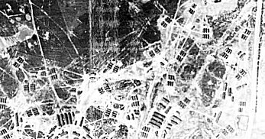
 | Aerial photo 1947
One thing people noticed was that two compounds at the camp were being guarded by British soldiers, and restriction signs were posted for all to see, one by the main Chertsey Road above Brickhill and the other next to the main road leading to Sunningdale. Fences were erected, plus some barbed wire, there were entrances that were guarded with sentries and rising pole barriers, and it was not long before we realised why. Large trucks started arriving at the camp, and it was not long before those on board started to disembark. They were lined up on the parade ground, and still more lorries continued to arrive. It was not long before word got round that these were German Prisoners of War. This was a tense moment for us all. One moment we were listening to broadcasts on what we then called a wireless about the war and the terrible things that were happening, and next we had the same people as neighbours…..

Christmas was upon us. Paper chains we made ourselves. For presents there were apples, oranges, perhaps a book. And then there was the biggest present ever: a knock at the door and we opened it and standing there was a guard and two prisoners with small parcels wrapped in newspaper with pieces of string. In broken English they wished us a happy Christmas. Times like this you wish you had a camera. Mum had a brooch made from some sort of Perspex, the girls rag dolls, and us boys a jigsaw, all made by the Germans. Well, I suppose they had plenty of time to spare, but it was a lovely gesture, a moment never to be forgotten.”

From - https://valleyend150.wordpress.com/2017/06/25/chobham-camp-squatters-1945-1952-by-patrick-rolinson/
Photos show mixed types of huts in use.

6/1946 – Camp leader; Hfwbl Albrecht (B+); “efficient and co-operative.” German MO O.Faehnrich Luebcke (B)

Numerous disciplinary offences occurred and some attempts at intimidation by Nazis and ‘so-called’ communists. Some ringleaders had been transferred, but more was needed. Very few re-education activities were taking place.

No wireless. A few small education classes had started.

As the pow camp was reduced in size, more squatters moved in: “On the 22nd August 1946, when a number of families approached the ‘N.C.O’ in charge in a P.o.W. section of the Chobham Common camp, German soldiers happily assisted them in taking over six of the empty huts. It was reported that Chobham Camp’s resident non-commissioned officer refused to help ‘officially’ but allowed the German prisoners at the camp to help voluntarily if they wished. The prisoners ‘scrubbed huts’ and one man was quoted as saying that he was pleased to see the families who had moved in that day and that he wanted to help them.” From a dissertation by Louise Williams - https://oro.open.ac.uk/89830/1/WILLIAMS_A826_RVOR.pdf

11/1947 – described as Chobham I and Chobham II. Numbers were given for the whole site, except on this one occasion.

Camp leader; Fw Paul Ferley (B+), aged 38, an apiarist (bee-keeper), “very quiet and earnest” – no interest in politics.

 | 1942 | 1943 | 1944 | 1945 | 5/1946 | 6/1946 | 9/1946 | 1/1947 | 4/1947 | 7/1947 | 11/1947 | 3/1948
Chobham |  |  |  |  | 940 | 913 | 365 | 315 | 327 | 515 | 220 + 32 | 109

Hostels

Shawfield Farm SU 887 507 / House SU 887 506 / Rectory SU 897 506  Ash, Shawfield Farm and Shawfield House.  1943 / 1944 – listed as a hostel for Italians.  Ash, Rectory – just one entry as a hostel for Italians.  All three sites were probably attached to a different main camp after these entries. | 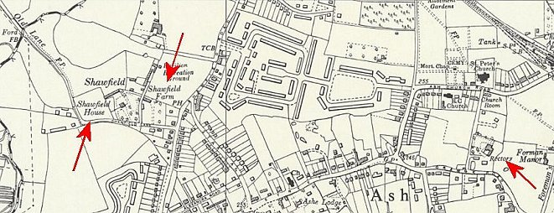
 | Ordnance Survey 1961

 | 1942 | 1943 | 1944 | 1945 | 5/1946 | 6/1946 | 9/1946 | 1/1947 | 4/1947 | 7/1947 | 11/1947 | 3/1948
Shawfield F
Shawfield H
Ash Rectory

Betchworth, Surrey

1943 / 1944 – listed as a hostel for Italians.

Probably attached to a different main camp after these entries.

 | 1942 | 1943 | 1944 | 1945 | 5/1946 | 6/1946 | 9/1946 | 1/1947 | 4/1947 | 7/1947 | 11/1947 | 3/1948
Betchworth

Charlwood. Huts. TQ 236 431

See Kingsfold Camp 46 for map.

 | 1942 | 1943 | 1944 | 1945 | 5/1946 | 6/1946 | 9/1946 | 1/1947 | 4/1947 | 7/1947 | 11/1947 | 3/1948
Charlwood |  | With C46 |  |  | 72 | 72 | 75 | 68 | 63 | 71

Cherfold. A large country house and huts. SU 956 342  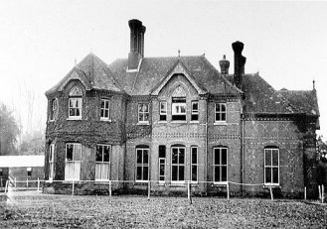  In use by British Army at start of war.  Probably attached to a different main camp before these entries.  6/1946 – Hostel leader; Ofbwl Steinhagen (B); his abilities were doubted and under review – he was considered to be a good disciplinarian. Beautiful scenery, but very poor facilities were noted, insufficient space for re-education and recreation, and unsatisfactory sanitary arrangements. No electric supply. Poor battery operated wireless.  Some pows remained active Nazis. Several anti-Nazis requested the visitor to arrange for them to be removed.  11/1947 – Hostel leader; Fw Paul Thiede (B) | 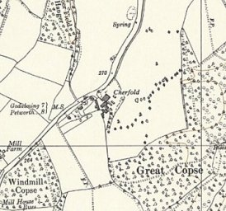
   | 1942 | 1943 | 1944 | 1945 | 5/1946 | 6/1946 | 9/1946 | 1/1947 | 4/1947 | 7/1947 | 11/1947 | 3/1948
  Cherfold |  |  |  |  | 300 | 291 | 222 | 185 | 208 | 233 | 192 | 61
 | Ordnance Survey 1961

Garlands - Ewhurst. “A smallish country house.” TQ 090 406.  3 September 1945 – Recorded as a new hostel for 100 Italians in Progress Report 153 (FO 939/383)  Probably attached to a different main camp after this entry. | 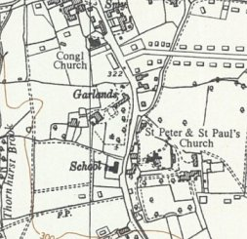
   | 1942 | 1943 | 1944 | 1945 | 5/1946 | 6/1946 | 9/1946 | 1/1947 | 4/1947 | 7/1947 | 11/1947 | 3/1948
  Garlands E |  |  |  | 94 G
 | Ordnance Survey 1961

(The) Hallams / Hallams Farm - (TQ 038 454). “A small country mansion, beautifully panelled” + huts.  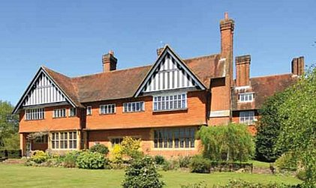  This site had been an independent camp for just 3 weeks.  5/1946 – Hostel leader; Stwmr Elgleb (A)  The hostel had been used to accommodate mainly ‘white’ (A grade) pows; 3 had attended the special training course at Wilton Park. New intakes were mainly C grade pows described as “virulent Nazis” and there had been trouble in the hostel. The Wilton Park men wrote to the commandant stating that the hostel leader was a concealed Nazi who had grown more obstructive and actively sabotaged re-education. The commandant was not sure about the leader and asked the visitor to investigate.  The visitor believed that either Elgleb was weak and not up to his job, or was indeed a “cunning Nazi.” Further observations were requested.  6/1946 – same hostel leader. There had been a dispute between the leader and others at the hostel who were trying to promote activities. This matter had been resolved by the interpreter; however, the leader’s abilities remained under review. | 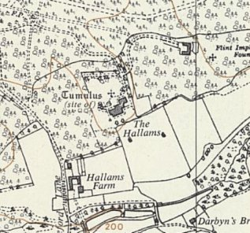
 | Ordnance Survey 1961

There were 50 pows from Canadian camps – they were a problem (as in most other camps). They were Nazis who had been captured early in the war and shipped to Canada. They had not experienced the deprivations and devastation that war had brought to Germany. There were also 30 Waffen-SS men who had been held in camps in Belgium. Generally, these were young men who had been given no choice as to which unit they were to serve – as in most camps they were not regarded as a particular problem.

Excellent education programme – German grammar, British and American history, German history, arithmetic, algebra, book-keeping, architecture, art, electricity, botany, French and Latin.

 | 1942 | 1943 | 1944 | 1945 | 5/1946 | 6/1946 | 9/1946 | 1/1947 | 4/1947 | 7/1947 | 11/1947 | 3/1948
Hallams |  |  |  | 220 G | 438 | 426 | 383

Horley, Surrey

1944 – listed as a hostel for Italian pows.

Probably attached to a different main camp after this entry.

 | 1942 | 1943 | 1944 | 1945 | 5/1946 | 6/1946 | 9/1946 | 1/1947 | 4/1947 | 7/1947 | 11/1947 | 3/1948
Horley

Merrow Wood

6/1946 – Hostel being prepared by Italian pows.

9/1946 – still being prepared, now by Germans. Some doubts that it would open as a pow camp. Closed for pows soon after.

 | 1942 | 1943 | 1944 | 1945 | 5/1946 | 6/1946 | 9/1946 | 1/1947 | 4/1947 | 7/1947 | 11/1947 | 3/1948
Merrow Wood |  |  |  |  |  | 34 | 21

Norbryght, near Redhill. Huts. TQ 352 488  Previously attached to Brook House Camp 238.  11/1947 – Hostel leader; Owm Willi Weine (B), aged 34, professional soldier. | 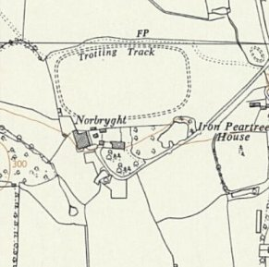
   | 1942 | 1943 | 1944 | 1945 | 5/1946 | 6/1946 | 9/1946 | 1/1947 | 4/1947 | 7/1947 | 11/1947 | 3/1948
  Norbryght |  |  |  |  |  |  | With C238 |  |  | 275 | 239 | 72
 | Ordnance Survey 1961

Nutfield

Previously attached to Brook House Camp 238. Probably Holmesdale, Nutfield Camp 615 prior to this.

11/1947 – Hostel leader; Uscha Friedrich Lahmann (B-), aged 25, “despite his grading he is very well spoken of by the S/Sgt Onterpreter.”

 | 1942 | 1943 | 1944 | 1945 | 5/1946 | 6/1946 | 9/1946 | 1/1947 | 4/1947 | 7/1947 | 11/1947 | 3/1948
Nutfield |  |  |  |  |  |  |  | With C238 |  | 61 | 36

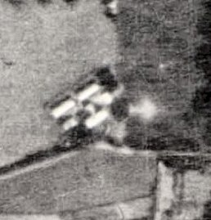  Shackleford, Godalming, Surrey. Huts. SU 933 451. Aerial photo 1948.  1943 – listed as a hostel for Italian pows.  5/1946 – Hostel leader; Ofbwl Mueller (A) – “in every way suitable for the position.”  “A pleasant hutted hostel.” One hut was used for dining, canteen, radio, education, and entertainment – another hut requested. A pow give lectures on astronomy and classes for mathematics.  6/1946 – same leader.  11/1947 – Hostel leader; Wm Herbert Haftmann (B+), aged 29, commercial artist – “pleasant and his men are happy”. He was active in cultural education activities. | 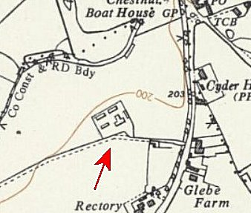
 | Ordnance Survey 1961

 | 1942 | 1943 | 1944 | 1945 | 5/1946 | 6/1946 | 9/1946 | 1/1947 | 4/1947 | 7/1947 | 11/1947 | 3/1948
Shackleford |  |  |  | 144 G | 147 | 155 | 134 | 118 | 108 | 135 | 114

West Byfleet. Huts. In reports sometimes called a hostel, at other times a satellite camp.

Probably attached to a different main camp before these entries.

6/1946 – Hostel leader; Fwbl Schlieper (B+); “popular, but he is rather a colourless individual.” 100 pows from the USA had recently arrived.

There were 8 political A+ pows who were nearly all former inmates of prisons and concentration camps. One of these denounced a pow who had been a warder at the concentration camp in which he had been incarcerated. It was remarked how unfair it was for an ex inmate and a warder to be held at the same site being given the same treatment.

No wireless.

 | 1942 | 1943 | 1944 | 1945 | 5/1946 | 6/1946 | 9/1946 | 1/1947 | 4/1947 | 7/1947 | 11/1947 | 3/1948
W. Byfleet |  |  |  |  | 400 | 485 | 432 | 370 | 324

Winchfield, Hook, Hamphire. (Camp 588 Shapley House was also listed for Winchfield, Hants.)

1943 / 1944 – listed as a hostel for Italian pows.

1945 > - Listed with Mortimer Camp 88.

 | 1942 | 1943 | 1944 | 1945 | 5/1946 | 6/1946 | 9/1946 | 1/1947 | 4/1947 | 7/1947 | 11/1947 | 3/1948
Winchfield |  |  |  | With Camp 88

Winkfield, Windsor, Berks

1943 / 1944 – listed as a hostel for Italian pows. Probably linked to a different main camp after these entries.

 | 1942 | 1943 | 1944 | 1945 | 5/1946 | 6/1946 | 9/1946 | 1/1947 | 4/1947 | 7/1947 | 11/1947 | 3/1948
Winkfield

