Camp 4 (and 921) - Windlestone Hall Camp, Rushyford, County Durham

Prisoner of War Camps (1939 – 1948) - Project report by Roger J.C. Thomas - English Heritage 2003
OS NGR | Sheet | No. | Name & Location | County | Cond’n | Type 1945 | Comments
NZ 26 28 | 93 | 4 | Windlestone Hall Camp, Rusheyford | County Durham | 5

Location: NZ 263 286 for centre of Hall. 3½ miles SE of Bishop Auckland.  Entry in * ‘Prisoner of War Camps in County Durham;’ “The prisoners of war were housed in Windlestone Hall itself as well as within the grounds.”  Previous use: The estate was owned by the Eden family from the 13th Century. The Hall was built in 1835 incorporating a previous Elizabethan manor house.  1897 (Robert) Anthony Eden was born at the Hall – he would serve as Foreign Secretary and Prime Minister.  1936 the Eden family sold the Hall and estate which included 20 farms and 53 cottages.  POW Camp: 1940 - Recorded as being opened, (Appendix to WO 199/405)  Lasted for a while as an independent camp (4), then became a hostel for Gilling Camp 288 and then Harperley Camp 93.  The camp has attracted several incorrect stories. Some websites state that; “Rudolf Hess was held there on his way from Scotland” - he wasn’t. “It was open in November 1939” - it wasn’t. “It held dangerous German prisoners,” [no more than any other camp of this kind].  However, there is also one story relating to female pows which has been stated as incorrect, but may actually be true! | 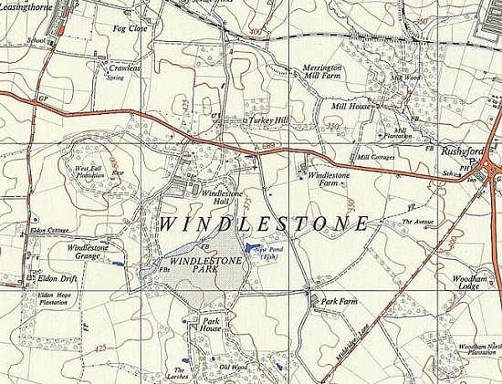
 | Ordnance Survey 1953
Female pows

Early 1945 - Entry in National Archive file HO 215/201, listed under a section for “Hospitals and Special Camps:”

A few weeks later a list of amendments was issued:

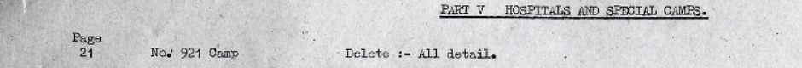

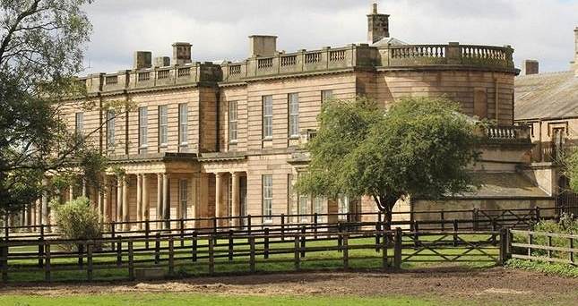
So, for a short time, Windlestone was relisted as Camp 921 and for “captured women employed with enemy forces.” Without further details it is not possible to state how they had been “employed with enemy forces” – but my guess is they were ‘protected personnel,’ i.e. medical staff.

It is known that female medical staff were based (imprisoned?) at some camps as medical staff, e.g. Maria Sűtfels, Krankengymnastin (Physiotherapist) served at Belfast Military Hospital Camp 161 in 1945. Was Windelstone used for a short time to gather such personnel before sending them on to other camps / hospitals? It is also possible that some female protected personnel were temporarily accommodated here while working at nearby Oaklands Military Hospital, (see Harperley Camp 93).

There were two newspaper articles about this, one in ‘The Journal,’ March 2006, and then the same claim, but with a bit more detail, in ‘The Northern Echo’, May 2006. The second article appeared with the sensationalist headline; “Were female Nazis kept within these walls?” The originator of the news story was Ruth Atkinson who was investigating a rumour about women pows at Windlestone. She claimed that 150 women were secretly detained there as pows for 18 months, and that some were, “active Nazis”.

The Journal - "It proved very difficult to find anybody who remembered the women prisoners. I spoke to some of the older members of the local workingmen's club and they swore blind that no women prisoners had ever been detained there…. After advertising locally, eyewitnesses came forward to report seeing the women being taken to church.” The article continued to state that the ICRC in Geneva; “…wrote back saying they had a record of women prisoners…. Ruth flew there to meet a friendly archivist who showed her records establishing there had been 150 women prisoners there for about 18 months during 1944 and 1945.”

Northern Echo – “Although none of the locals she interviewed could remember seeing them, it also states in the reports that the women were dressed in ATS uniforms…. It seems strange that the German women were issued with British ATS uniforms", says Ruth. "It's not known whether the nurses wore their ATS attire to church, but if they did it might explain why people couldn’t remember them.” The women were also; “allowed to go for walks of one to two hours every day with the Womens’ Auxiliary Territorial Service (ATS)…. Fabrizio Bensi, an ICRC archivist, handed her a large envelope. There in black and white was confirmation that German nurses had been held as prisoners at Windlestone Hall during the war. Many had been captured in 1944 from across Europe, including Rostock, in northern Germany, Brussels in Belgium, and Brest and Normandy in France.”

Further in the Northern Echo – Ruth contacted the Channel Islands Occupation Society; “The society provided Ruth with physical evidence of her claim, a grainy black and white photograph of nurse Gretchen Killmann, who had been captured in the Channel Islands in 1945. Ruth discovered her maiden name had been Jessen and that she had ‘married Jurgen Killmann by proxy over the telephone before leaving the islands as a POW.’ She was then taken to Windlestone.”

“Ruth also came across another astonishing revelation, some of the women had been pregnant while at Windlestone.

Luise Stretter, born on August 2, 1925, gave birth to Heinrich Josef Stretter on December 22, 1944, while held prisoner of war at Windlestone, said the report.

Hildegard Lindig, born December 23, 1916, had the prisoner of war number A372429. She was captured in Brussels on September 3, 1944. Her report continued: "March 28, 1945 present in Windlestone Hall camp, requested to be repatriated as quickly as possible due to pregnancy."

I have looked up the Entries for Birth records which show:

Date | Surname | First name(s) | Mother | District | Vol | Page
Dec 1944 | Stretter | Heinrich J | Stretter | Durham W | 10a | 423
Sep 1945 | Lindig | Eleonore | Lindig | Durham W | 10a | 343

In The Northern Echo, Ruth stated; "There are a lot of conspiracy theories and they could be true. I believe the women were Nazis as in the documents the women were said to have national socialist views." But everyone has different views…. I made the film to question the British Government, to make people think, and also I think it’s important to record the memories of older people."

“Ruth finished her documentary, entitled The Women of Windlestone, earlier this year. But she concedes she may never find the answers she is looking for.”

After the camp: The hall was used for a while to house Latvian European Voluntary Workers. Between 1957 to 2006 the Hall became Windlestone Hall School, a residential special school. Part of the site was also used as a respite care centre for disabled people. It was sold on to a private investor with his own dubious history.

