Camp 283 War Department Camp, Ledsham Hall, Cheshire

1947 Camp List
283(G.W.C.) | W.D.Camp, Ledsham Hall, Ledsham, Little Sutton, Wirral, Cheshire | W | Priswar, Little Sutton | Hooton 3304 | Ledsham | Major F.S.Eaton T.D. | v/1452/2

Prisoner of War Camps (1939 – 1948) - Project report by Roger J.C. Thomas - English Heritage 2003
OS NGR | Sheet | No. | Name & Location | County | Cond’n | Type 1945 | Comments
SJ 3528 7594 | 117 | 283 | W.D. Camp, Ledsham Hall, Ledsham, Little Sutton | Cheshire | 3 | German  Working Camp | Large complex of tented  accommodation with a small number of huts

Location: Possible huts shown on map just below Ledsham Hall.  Before the camp: Reports of a US army camp at this site from 1943 to 1944.  Pow Camp:  September 1945 - Camp opened. (Recorded in report below).  June 1946 – Camp magazine; Der Weckruf : Monatschrift 283 - The Wiener Holocaust Library  28 July – 1 August 1946 – Members of the ‘Segregation Section’ of PID visited to carry out political screening. Strength; 2 officers, 655 Other Ranks at HQ, 1 hostel, 0 billeted.  Commandant; Major F S Eaton. Camp leader; O/Masch Max Jaeckel (B)  Interpreter; Lieut C F Simon Deputy C/L; Uffz Heinz Becker (B)  The Commandant had been a pow in Germany, he was posted to this camp in January 1946. He had little interest in re-education. Like most Commandants he was mainly concerned with discipline and getting the pows to work – including the C+ (Nazi) pows.  The Interpreter Officer was described as “keen on his job which he discharges with interest and efficiency.” | 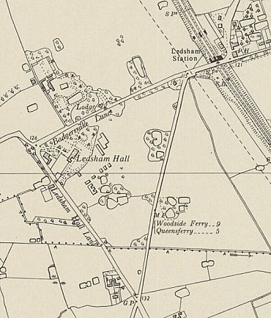
  Oversight and development of re-education activities and English teaching for German pows was carried out by PID (Political Intelligence Department of the Foreign Office) / COGA (Control Office for Germany and Austria – UK). Visits and reports were made. The standard of the reports varied greatly. The visitors took little interest, if any, in activities other than re-education. They rarely mentioned welfare, sports, games, pastimes, crafts, etc of the pows. If there were still Italian pows in hostels, they were usually ignored by PID.
 | Ordnance Survey 1954

Camp leader Jaeckel was; “A very solid type. Appears at first to be a harsh man but is well thought of by British staff and Germans and is very efficient.”

German M.O., St.Arzt Werner Holzki (A); “Quietly efficient but unprepossessing. He is not popular at the Hostel on account of his strictly medical and no-preferential treatment of POW.”

Political screening: | A+ | A | A- | B+ | B | B- | C | C+ | Unknown
 | 1 | 22 | 1 | 92 | 268 | 163 | 92 | 10 | 8

The visitors believed that political progress had been made by many of the pows due to the Nuremberg trials and having watched the compulsory film about concentration camps. The only reference to morale was that it had suffered due to the reduction of the cigarette ration to 10 per week.
3-6 December 1946 – Report on re-education and further screening. Strength; 2 officers, 684 OR.

This was the 6th visit by PID including the 1st report above – the other 4 reports are not in the National Archive file.

There was just 1 change to senior personnel; Deputy C/L; O/Feldw Schulze (B)

Political screening: | A+ | A | A- | B+ | B | B- | C | C+ | Unknown
 | - | 19 | 1 | 104 | 308 | 150 | 100 | 4 | 0

The visitor did not think much of the Camp Leader, describing him as; “a typical stupid Prussian senior NCO, an efficient bully. Jaeckel has turned Communist. He is pro-Russian, anti British and he obstructs re-education, glorifying the day when the Russians will take over the whole of Europe.” I think it is fairly certain he was due to return to the Russian zone. The Commandant promised to investigate and to replace him by the Deputy leader. If this was carried out, Jaeckel would have been transferred to a different camp.

Morale was recorded as “low.” Longing for repatriation was always the main negative factor. Promises that greater freedoms to walk out in spare time and reduce non-fraternization rules had not yet occurred at this camp, and that caused bitterness. The strict military discipline enabled pows to challenge ideas of democracy and reducing militarism. Many pows received bad news from home which added to the depression.

The standard list of re-education activities was given:

Wochenpost and Ausblick – 250-280 / 50 copies received respectively.

Newspapers – 6 daily papers and some weeklies were received at HQ. None recorded for the hostels.

Library – 600 books, more needed.

Lectures – visiting lecturers monthly.

Discussion groups – started, but then cancelled due to long working hours for harvest and lack of interest.

Films – Very poor, last film supplied by the YMCA was 5 weeks earlier. The visitor stated that COGA films showing Nazi atrocities had “reached saturation point.”

Wireless – “satisfactory” at all sites.

Camp magazine – Being published. Paper and stencils requested from COGA.

Press review – Published daily and sent to hostels.

English instruction – 44 pupils in 3 grades with 4 teachers. Sufficient number of textbooks.

Other camp activities –

Religion – Protestant padre Meyer (A), held regular services at all sites. A RC priest from Chester conducted services in the church at Hooton. The camp leader tried to persuade pows not to attend services.

Education – Lessons on technical and agricultural subjects.

Theatre – Light entertainment shows every 6 weeks.

Orchestra – 9 players giving concerts each Sunday.
May 1947 – listed as a ‘hostel’ for Marbury Hall Camp 189 (see 180). Hostel leader; Fhr. Walter Lange (B+) – still there in October 1947. February 1948 leader Uffz. Surma.

Numbers of pows

 | Open |  | Uncertain |  | Closed |  | With other camp

 |  | August 1946 | December 1946
HQ |  | 329 | 296 | With C189
Eastham |  | 328 | 253
Bridge Trafford |  |  | 10
Deeside | With C74 |  | 43
Newferry |  |  | 41
Billetees |  | 0 | 43 | -
Total |  | 657 | 686
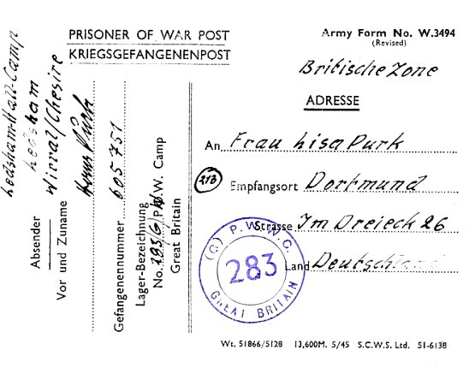

Known Commandants:
1946 Major F S Eaton T.D., with the Lancashire Fusiliers. Later (May 1947) recorded with Sudeley Camp 37).

< Pow postcard – July 1946.

After the camp:

Further Information:

National Archives FO 1120/242 – Re-educational survey visit reports for camps 279 to 284. Dated 1 January 1946 – 31 December 1948. 2 reports used above.

Hostels

Bridge Trafford. 7 miles from HQ, small village. Probably attached to a different HQ before this entry.

12/1946 – Hostel leader; Gefr Veith (B).

 |  | August 1946 | December 1946
Bridge Trafford |  |  | 10

Deeside. 6 miles from HQ. Previously attached to Tarporley Camp 74.

12/1946 – Hostel leader; O/Feldw Reiche, he had been leader when attached to C74.

 |  | August 1946 | December 1946
Deeside | With C74 |  | 43
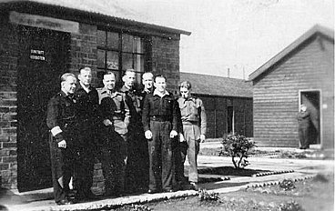
Eastham. 4 miles from HQ. Plymyard Avenue, where the South Wirral High School is now located; NGR SJ 349 798.

Memories – “Towards the end of the Second World War, as the military action in Western Europe moved increasingly further eastwards, and the threat of German air raids receded, the anti-aircraft guns in Plymyard Avenue were removed and the Camp given over to the housing of Italian Prisoners of War (PoWs). Plymyard Avenue soon became an attraction to the inhabitants of the village and the promenading along Plymyard Avenue to gaze at the incarcerated Italians a regular feature of their Sunday afternoons. When news reached the local populace that the Italians had been replaced by German PoWs… the Camp became an even greater attraction to Sunday afternoon strollers desirous of gazing upon the now caged erstwhile enemies…..

One sunny Saturday afternoon in early Autumn 1946 I was walking past St Mary’s Parish Church when I spotted two German PoWs standing at a distance to watch a wedding party being photographed outside the Lychgate. Equipped with my first rudimentary German from my recent lessons at school, albeit blissfully unaware of the “no fraternisation” rule I approached the two PoWs, greeted them in German and enquired after their health, introducing my name to them and enquiring after their names. The taller of the two was Otto Foerstel from Thuringia in eastern Germany, and the name of the shorter of the two was Ernst Eckart from Bavaria. They were both former Senior Non-Commissioned Officers in the German Forces and had been allowed out of Camp because they were “Trusted Ones” and both were part of the “Trusted Team” of former NCOs who manned the Plymyard Camp guardroom. The Camp [Hostel] Commandant was a British Army Warrant Officer and there were a handful of British soldiers acting as Camp Guards. However, as I was to discover, there was a fairly easy-going regime and in no way comparable to the images of German camps for British PoWs as depicted in films…..

…15th December, 1946, it was announced on the BBC that the British Government had lifted the ban on fraternisation with German PoWs, and even encouraged British families, if there were German PoWs in their neighbourhoods and they felt able to do so to invite them into their homes at Christmas. Shortly after this announcement I accompanied my father to Plymyard Camp to request that Otto and Ernst be allowed to visit us at Christmas. Up to this point I had continued regular contact with them, visiting them in the guardroom at the entrance to Plymyard Camp when they were on duty, and can clearly remember that distinctive smell of the coke-fired stove, which provided the only heating.

Once the “no fraternisation” rule was lifted and permission granted to enter British homes both Otto and Ernst became very welcome regular visitors to our home in Bridle Road. Otto and Ernst were repatriated to Germany at the end of 1947 or early 1948, and we continued to keep in touch by correspondence, certainly with Ernst until his death. However, Otto had returned to his home in Thuringia located in the Russian Zone of Occupation, and his correspondence with us in England was very short-lived. I imagine it was treated with suspicion by the Communists and he may have suffered for it, or decided that it was not wise to continue. It was gratifying to read what Ernst wrote to me in February 1952: “I often have to think of our first meeting and on the lovely hours when I was able to sit with you all by the open fireplace. How especially lovely was that first Christmas 1946 with you all, when I was able again for the first time to feel at ease, as if I was at home. That was really very nice of your parents.”

From; South Wirral High School’s Wartime Past - South Wirral High School – has other pictures.

With memories of Italian pows, the site would have been open before these entries:

8/1946 – Hostel leader; O/Fw Erich Korbien (A). He had attended the special training course at Wilton Park. “Intelligent and very keen… excellent and effective.”

12/1946 – Hostel leader; St.O/Feldw Giese (B-). Had a theatre group, but no re-education activities.

 |  | August 1946 | December 1946
Eastham |  | 328 | 253

Newferry. 7 miles from HQ. Must have been attached to a different HQ before this entry.

“During World War 2, New Ferry and its shoreline played an important role in the national crisis. The Shorefields overlooking the river were host to an anti-aircraft gun emplacement, defending Liverpool and Birkenhead from attack by German bombers and manned by Poles…. Following the war, when the gun emplacements were removed, the barracks were used as a temporary internment camp for German POWs during 1946 and 1947. There was no barbed wire surrounding the "camp", and the prisoners were allowed out during the daytime where they found work on local farms; they simply had to return to the camp each night by the allotted curfew time.“ History of New Ferry

12/1946 – Hostel leader; St.Wactm Sabotta (B)

 |  | August 1946 | December 1946
Newferry |  |  | 41

