Camp 282 Brissenden Green Camp, Brissenden, Kent

Prisoner of War Camps (1939 – 1948) - Project report by Roger J.C. Thomas - English Heritage 2003
OS NGR | Sheet | No. | Name & Location | County | Cond’n | Type 1945 | Comments
TQ 941 393 | 189 | 282 | Brissenden Green Camp, Brissenden, Ashchurch | Kent | 5 |  | Precise location not identified, NGR given for village.

Location: Brissenden Green with Potter’s Farm bottom left of map.  Before the camp:  Pow Camp: Believed to have been on land close to Potters Farm.  A website gives a history of the farm - “…it was confirmed that Italians were held in a camp in 20 acre Wood (to the East of the Farm) and that these prisoners made the children on the farm necklaces of coloured beads. This is in line with experience at other Italian camps were the internees created chapels as well as colourful and creatively decorated camp accommodation. Like many other camps, no remnants from the camp remain as these were dismantled at the end of the war when the land was returned to agricultural production.”  www.pottersfarm.co.uk  At this moment – from reading the camp reports – it seems that Hengherst House, Woodchurch was a satellite/hostel for Brissenden Camp 282 prior to 1946. (NOT fully confirmed)  15 March 1946 – Camp magazine; Der P.O.W. : Monatzeitung des Lagers 282 - The Wiener Holocaust Library | 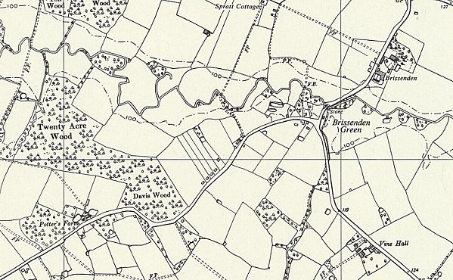
 | Ordnance Survey 1961
In 1946 Brissenden Green and Woodchurch were attached to Stanhope Camp 86. (Confirmed by reports in FO 939-166).
At the end of 1947, Hengherst House became the new HQ with the number 86 when Stanhope closed, and Brissenden Green continued to be a hostel. (Confirmed by reports in FO 939-166).
After the camp:
Further Information:

