Camp 281 Aldborough Camp, Norwich, Norfolk

Prisoner of War Camps (1939 – 1948) - Project report by Roger J.C. Thomas - English Heritage 2003
OS NGR | Sheet | No. | Name & Location | County | Cond’n | Type 1945 | Comments
 |  | 281 | Aldburgh (Aldborough) Camp, Norwich | Norfolk | 5 | German Working Camp | No satisfactory location could be found near Norwich.

The location listed is strange as Aldburgh is south of Norwich, while Aldborough is north of Norwich. Just over 40 miles separates the 2 places. The listing of a hostel at Cley (next the Sea) in the north of Norfolk indicates that Aldborough is the more likely location.

Aldborough Hall is located NW of Aldborough village at TG 1698 3506

Location:  Before the camp:  Pow Camp:  1946 – Additional intake of many pows from camps in the USA. Most had very low morale as they had been misinformed in the US that they were being repatriated. Instead, they found themselves in working camps in the UK.  March ? 1946 - Camp magazine; Der Regenbogen : 281 P.W.W. Camp - The Wiener Holocaust Library  The magazine mentions pows arriving from camps in the USA.  After the camp:  Further Information: | 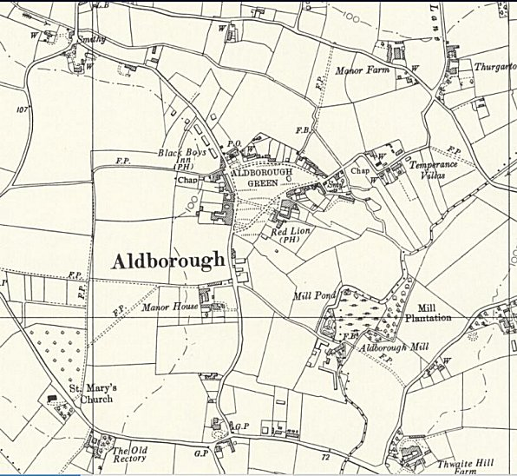
 | Ordnance Survey 1957

Hostel

Cley

3/1946 – Mentioned in the camp magazine regarding a chess tournament and sports. One reference regarding chess tournaments referred to “comrade Kitzan, R, is being relocated to the Cley Hostel” – and for other sports; “the transfer of many handball and football players to Hostel Cley.”

