Camp 277 Fladbury Golf Course, Fladbury, Worcestershire

Prisoner of War Camps (1939 – 1948) - Project report by Roger J.C. Thomas - English Heritage 2003
OS NGR | Sheet | No. | Name & Location | County | Cond’n | Type 1945 | Comments
SO 997 470 | 150 | 277a | Fladbury Golf Course, Fladbury, Pershore | Worcestershire | 4 |  | Site occupied by a golf course

Location: The shape indicated on the OS map may be the border fence for the pow camp.  Before the camp: Farmland.  Pow Camp:  Memories – “Somewhat more unusually there were Americans based mostly in tents on the golf course up at the crossroads and along the river….. The Yanks left a sentry box, (like seen in POW films) just inside and to the left of the Blue Gate field which was immediately over the railway bridge and running alongside the railway line. This sentry box was used again when later on the camp on the golf course was used to house German and Italian prisoners of war. These prisoners wore a uniform with a large ring on the back. They mostly did agricultural work.” (BBC People’s War – Contributed by Audrey Jean Wall, Article A4142170).  The camp does not appear in the list of known Italian pow camps, so it may have been a hostel administered by a different camp pre 1945.  Fladbury was HQ camp 277 for just a short amount of time:  Spring 1946 – The administration HQ 277 moved from Fladbury to Recreation Ground, South Littleton. Fladbury then became a hostel for Recreation Ground Camp 277. (And gained the suffix letter (277a) used in the English Heritage report above).  There was a camp newspaper ‘Der Brűcke’ (The Bridge).  After the camp: 2020 Evesham Golf Course.  Further Information:  The German Federal Archive has a copy of the camp magazine. | 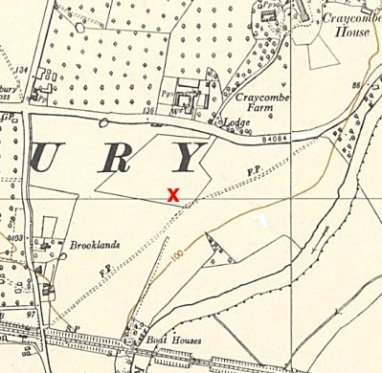
 | Ordnance Survey 1954

