Camp 110 - Stuartfield Camp, Mintlaw, Aberdeenshire (aka Crichie)

Included in the 1945 ICRC camp list – Labour Camp. 110. Stuartfield Camp, Mintlaw Station, Aberdeenshire.

1947 Camp list
110(G.W.C.) | Stuartfield Camp, Mintlaw Station, Aberdeenshire | Sc. | Priswar, Mintlaw | Stuartfield 211 | Mintlaw | Lt.Col.J.S.Spencer, O.B.E. M.C. T.D. | v/1453/2

Prisoner of War Camps (1939 – 1948) - Project report by Roger J.C. Thomas - English Heritage 2003
OS NGR | Sheet | No. | Name & Location | County | Cond’n | Type 1945 | Comments
 |  | 110 | Stuartfield Camp, Mintlaw Station | Aberdeenshire |  | German Working Camp | Scotland

Location: NGR NJ 974 449. About 3.5 km S of Mintlaw Station.  Before the camp: Farmland  Pow Camp: Listed as Italian working camp / labour battalion to at least 1945, then German pows.  HER – “A number of buildings still survive, although in a dilapidated state. A circular concrete structure, said to be the ablutions area, still stands… The POWs worked on neighbouring farms till the end of the war. The Italian prisoners built their own Roman Catholic chapel, reported to have been demolished after the war.” Aberdeenshire Council Historic Environment Record - Aberdeenshire - NJ94SE0034 - CRICHIE  “Many of the prisoners based at Crichie were extremely clever at fashioning things out of virtually nothing. They would take coins and make rings, they could make jewellery from anything, and using polishes like cedar they would make crucifixes, ornaments, pencil cases and even slippers.  One prisoner was known to have made a banjo out of wood and its bridges were constructed from tooth brushes, while another German doctor was particularly good at tapestry and stitched a chair back which was greatly admired by all who saw it. Another prisoner used to entertain the locals with magic tricks, making things disappear and reappear.  And they could turn their hands to culinary skills too. During the winter when it was snowing the Italians would get cream from the nearby farm and make ice cream using the snow to freeze it.”  1943 – camp opened. The camp was surrounded by barbed wire fencing, later reduced. | 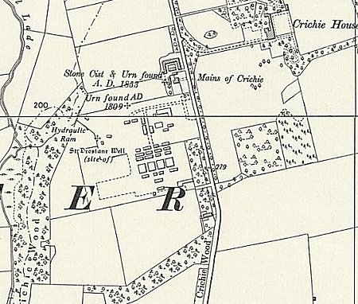
 | Ordnance Survey
28 May 1943 - International Red Cross inspection - Italian prisoners, capacity 500.

1943 – three hostels listed for Italian pows: Cornhill, Cruden, Huntly.

May 1944 - The camp was listed as an Italian Labour Battalion under the Scottish Command area, (WO 32/10737). The Italian pows were recorded as being co-operators.

1 October 1945 - A fatal accident inquiry was held at Aberdeen Sheriff Court for an Italian pow. National Records of Scotland; Reference SC1/16/1945/21;

“Guerrino Gramola, private, Italian Army (prisoner of war), Stuartfield Prisoner of War Camp, Mintlaw, died on 26 May 1945 while travelling on a train between Mintlaw and Aberdeen, when he jumped off the train on to the line.” He was later reinterred at Brookwood Military Cemetery.

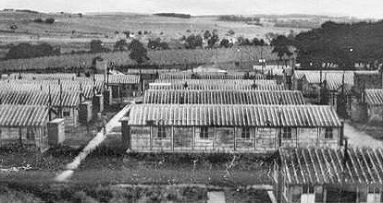 | 1 August 1945 - an urgent memorandum was sent to this camp, and others, about maintaining records of Italians who were classed as ‘co-operators’. At this point many, sometimes all, of the Italian pows were in hostels / billets.  1947 – Camp Chaplain; Fridolf Heydenreich.  17-18 June 1947 - As part of the re-education programme administered by the Control Office for Germany and Austria (COGA), Paul Bondy, a German-speaking refugee gave lectures at the main camp and 1 hostel (unnamed). He recorded a camp complement of 1,000.  25 November 1947 - Fatal accident inquiry for a German pow. Aberdeen Sheriff Court. National Records of Scotland; Reference SC1/16/1947/17;  “Ernst Knappenberger, German prisoner of war No. 661516, Prisoners of War Camp, North Blachrie, Fyvie, Aberdeenshire, died on 21 Oct 1947 cycling on the Cuminestown-Fyvie road, and at a part thereof 100 yards south of the Cottage Hospital, parish of Fyvie, Aberdeenshire, when he collided at Hillhead Cottage, Fyvie, and was thrown to the ground.” [North Blachrie, possibly a hostel or a billet]. He was later reinterred at the Cannock Chase German Military cemetery.
From ‘Back In The Day,’ North-east edition, March 2009 + picture of camp chapel below.

Christmas 1947 – Camp Magazine - Nordlicht : Lagerzeitung des 110 GPW - WKG - Camp Stuartfield - The Wiener Holocaust Library ‘Nordlicht’ = Northern Lights.

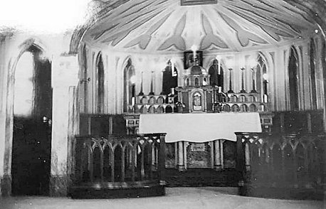
Known Camp Commandants:
1947 Lieutenant Colonel J S Spencer, O.B.E. M.C. T.D., from 6 BN Duke of Wellington’s Regiment.

After the camp: Site used to house displaced persons. 2019 Farm

Further Information:

IWM hold a copy of Nordlicht from Jan-Feb 1947. Catalogue LBY E.J. 403

IWM – Recollections of F B Hession, NCO guard with Pioneer Corps at No 110 Stuartfield Camp at Stuartfield, GB, 1942-1945: description of camp; duties; character of prisoners of war; relations with civilians; post-war civilian employment. [Reel 2] https://www.iwm.org.uk/collections/item/object/80013173

http://canmore.org.uk/site/264794

POW NUMBERS

 | Open |  |  | With other camps |  |  | Unknown |  |  | Not open

 | 1943 | 1945 | 1946 | 1947 | 1948
Main | Cap. 500
Cornhill
Cruden
Huntly
Billets
TOTALS

Hostels

Cornhill. [Not the same Cornhill as listed with Wooler Camp 108].

Information from Jim MacKay, researcher for 'Out of the Blue', camp 5 at Duff House:

“The site was in Cornhill, a small village between Banff and Keith in what was Banffshire, now Aberdeenshire. As a young schoolboy I remember seeing the concrete foundations of either 2 or 3 huts to the west of the Memorial Hall. The houses of Duff Terrace were later built on the site and there are no remains to be seen. One of the wooden huts was dismantled after the war and relocated across the main street and used as a joiner's workshop by Jimmy Shearer. Long since replaced by a more permanent workshop by subsequent owners of the site.” NGR NJ 585 581.

Cruden

Huntly  Location believed to be NGR NJ 500 401, (not confirmed). | 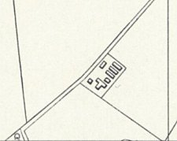
 | Ordnance Survey 1959

