Camp 61 - Wynolls Hill, Broadwell, Gloucestershire (Wynols)

Included in the 1945 ICRC camp list – Labour Camp. 61. Wynolls Hill Camp, Broadwell, Coleford, Glos.

1947 Camp List
61(G.W.C.) | Wynolls Hill Camp, Broadwell, Coleford, Glos. | S. | Priswar,Broadwell, Lane End | Coleford 2198 | Lydne, Glos (G.W.R.) | Lt.Col.R.Morton | v/1453/2

Prisoner of War Camps (1939 – 1948) - Project report by Roger J.C. Thomas - English Heritage 2003
OS NGR | Sheet | No. | Name & Location | County | Cond’n | Type 1945 | Comments
SO 588 106 | 162 | 61 | Wynolls Hill, Broadwell, Coleford | Gloucestershire | 4 | German Working Camp | STANDARD type. Site occupied by housing

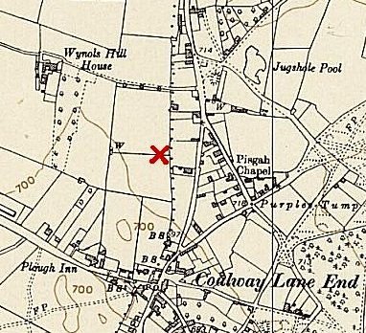 | Location: On the W edge of the Forest of Dean. 1.5 km E of Coleford. Spelling of the name appears with 1 or 2 ‘L’s in Wynols.  Before the camp: Farmland  Pow camp:  1942 - Italian working camp / labour battalion.  Historic England described the camp as being 300m x 300m – and based on aerial photographs taken in 1946 - “The camp comprised a rectangular fenced compound, measured 120m by 177m and was orientated north-west / south-east. Its entrance was probably midway along the north-eastern side, where a number of buildings are visible. The compound contained five rows of up to nine huts, and a semi-circular structure which was situated at the midpoint of the S-W side, at SO 5864 1061. | 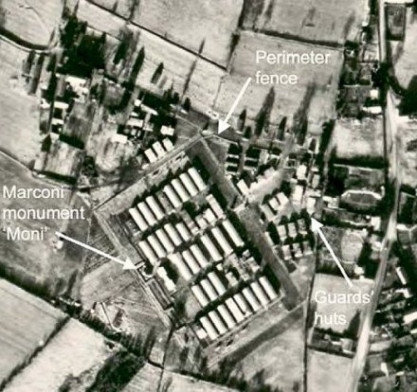
Ordnance Survey 1954 |  | From: The Forest of Dean Mapping Project, Gloucestershire
Some buildings were pre-fabricated concrete used for general facilities, cookhouse, ablutions, latrines… Other buildings clustered to the NW and NE with a row of two groups of Nissen huts extended along the N side of the camp. Wynols Hill House, situated to the west, (shown on the map) was used as part of the camp. There was a medical centre, canteen (shop), and a chapel in one hut.

Just outside of the pow compound, 6 of the huts were used for a while (c.1945) by the 129th Forestry Company Royal Engineers who worked in the area felling trees.

21 July 1942 - International Red Cross visit. 482 Italian prisoners were in tents while some built the camp and others were involved with forestry work. Expected capacity 750.

8 July 1943 – IRC visit. 825 Italian prisoners, (580 main camp; 144 in three hostels; 101 billeted) - capacity 950. A theatre group, orchestra, education classes and sports were the main recreation activities.
1943 - After the Italian armistice, co-operator pows were held here.

1943 and 5 May 1944 - Hostels listed for Italian pows from this camp, (WO 32/10737): Llancloudy, Herefordshire / Newent. Gloucestershire. [Note the IRC report stated 3 hostels].

May 1944 and November 1944 - The camp was listed as an Italian Labour Battalion and then an Italian POW Working Camp under the Southern Command area, (WO 32/10737).

1944 - A very large monument to Marconi was designed in the camp by Sergeant-Major Bruno Porciani (*note later) to celebrate the fiftieth anniversary of the development of the first successful long-distance wireless telegraph in 1894. It was made of concrete and other materials that could be found in the area. The central tower was hollow and after the war a popular, though dangerous place for the local boys to climb.  Historic England - “This structure was a memorial to Marconi and was built by the prisoners themselves. The structure was concrete and was painted to resemble pink marble and decorated with the coats of arms of sundry Italian cities and states. At its back stood a 20ft high spire beneath which a bust of Marconi was placed. An inscription on the tower dates the monument to Christmas 1944.”  1 August 1945 - an urgent memorandum was sent to this camp, and others, about maintaining records of Italians who were classed as ‘co-operators’. At this point many of the Italian pows were in hostels / billets.  September 1945 - Appendix to HQ Southern Command War Diary – Wynolls Hill, Coleford; Italian labour camp + 2 hostels; Italian hostel – Ross-On-Wye – cap 40 / German hostel – Llancloudy – cap 70 | 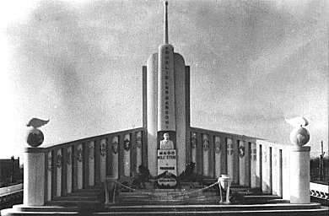

1945 / 1946 - “To the NE of this camp the remains of a small tented prisoner camp, enclosed within a triangular fence with three corner guard towers, were also recorded from aerial photographs... Outside the fence to the north was a group of dispersed huts, presumed to be the guards' huts, and to the south-east of enclosure was the camp's sewage works. This site was photographed in October 1945 and December 1946, during which time the number of tents had reduced by half, possibly due to repatriation or relocation. This small camp has no existing record and may have been a short-lived temporary overflow camp.”

FOREST OF DEAN NMP Fiona Small and Cathy Stoertz (Eds), Sharon Bishop, Edward Carpenter and Helen Winton - English Heritage 2006

< A tented prison camp within a triangular perimeter fence, to the north-east of Broadwell.

Up to mid-1946 - For a while, as German pows arrived, there were still some Italians in the camp. The two groups were kept separate.

Oversight and development of re-education activities and English teaching for German pows was carried out by PID (Political Intelligence Department of the Foreign Office) / COGA (Control Office for Germany and Austria – UK). Visits and reports were made. The standard of the reports varied greatly. The visitors took little interest, if any, in activities other than re-education. They rarely mentioned welfare, sports, games, pastimes, crafts, etc of the pows.

15 March 1946 – English Education visit. Only a small group of Germans in Llancloudy hostel.

Very few reading or teaching materials. The man leisure activities were football, chess and cards. Mail was not getting through to many pows – one commented he had not heard from his wife for 21 months.

7/9 May 1946 – Report on re-education / Political screening. Strength; 0 Officers, 122 Other Ranks (only Germans counted).

Although the majority of pows were Italian, they were not considered in this report. The name of the camp had already changed to ‘61 German Working Camp’ as the Italians were moved out and Germans arrived. 300 Italians were expected to leave in the near future, and 120 Germans to arrive on 11 May.

Commandant: Major D de B Lipscombe Camp leader: Italian, not named.
Interpreter: For Italians – not named.

Political screening: | A | B+ | B | B- | C | C+ | Unscreened
 | 4 | 4 | 47 | 31 | 23 | 1 | 12

It was found that some of the C pows and the C+, had been placed in billets, they were removed immediately.

The commandant showed little interest in re-education. Commandants were not required to promote re-education, which was developed by the Foreign Office – the camps were under the control of the War Office. The purpose of the camps was to hold pows and to set them to work when possible. Many Commandants preferred to concern themselves with welfare and other activities rather than re-education – though some did not do that either. If the camp was working and kept under control that was sufficient as far as many Commandants (and the War Office) were concerned.

Despite the lack of interest in re-education shown by the commandant and hostel leaders, the standard list of activities was given:

Wochenpost / Ausblick – 25 / 6 copies received.

Newspapers – British papers only received from British staff and farmers. A few German papers had been sent to Llancloudy hostel.

Library; lectures; discussion groups; films; camp magazine – None.

Press review – attempt made at Ross 1.

There were no education classes, theatre or orchestra.

17/18 June 1946 – English Inspector’s Report. Strength – 404 German pows, (there were still some Italian pows at the camp). 97 pupils in 9 classes at all sites.

Camp leader: Fldwbl Golombek.

21 July 1946 - English Inspector’s Report. Strength – 830 German pows (all Italians had left). 69 pupils in 7 classes at all sites.

A new camp leader: Obermaat B Zauber, was hostel leader at Llancloudy.

The welfare fund, raised by sales of goods in the canteen, was very low and so materials etc could not be purchased. A shortage of books and teaching aids at all sites.

18 August 1946 - Camp magazine, No.3; Besinnung : Wynols Hill Camp : Zeitung des Lagers 61 - The Wiener Holocaust Library. Includes a note of welcome to the new hostel at Highnam Court.

13-15 October 1946 - Paul Bondy, a German-speaking refugee gave lectures at the main camp and 3 hostels. He recorded a camp complement of 1,100.

19 November 1946 - English Inspector’s Report. Strength – 1269 German pows. 131 pupils in 11 classes at all sites.

A new commandant: Lt Col Moreton

13/14 May 1947 – Re-education report. Strength; 1 officer, 1100 OR.

Commandant: Major Keynton Camp leader: O/Maat Bruno Zauber (B)
Interpreter: S/Sgt Nebel Deputy C/L: Ofw Becker (B)
German M.O.: S/Arzt Rudolf Stiava (B-) (or Stiawa)

The new commandant co-operated with re-education activities, but was not actively involved with them.

S/Sgt Nebel – “very reserved, mono-syllabic young man who supports re-education but plays no active part in it himself.”

Camp leader, aged 47, had been a member of the Nazi Party. “Shows little political understanding but supports re-education activity and has done well as camp leader.”

German M.O., aged 30, volunteered for Waffen-SS – “Intelligent but not a good type.”

A Youth (under-25) Group Leader had been appointed – Sfw Kurt Guenther (B+), aged 44, ex policeman – “Quiet, sensible man with an understanding of the problem of the youngsters and has done much to help them.”

Simplified screening was in place: A 22 / B 1074 / C 5. 150 pows repatriated to date.

Morale was stated to have improved in the main camp due to; 1. Upgrading of many political grades (the better the grade, the sooner the repatriation in theory); 2. contact with civilians; 3. Recent removal of British Quartermaster who had upset many pows. Negative factors were, 1. Slow repatriation; 2. Bad news from home.

There was a camp ‘parliament’ with each hut sending one elected representative. Re-education activities had greatly improved, but were being hampered as pows were able to leave camp up to 10 p.m. The standard list -

Newspapers – adequate everywhere, paid for from the Welfare Fund. Some Swiss and German newspapers also received.

Library – 360 books (50 new from the YMCA) + books on loan from Gloucester County Library. Another 100 books at Ross. Not really sufficient for a comp of this size and more books requested.

Lectures – there had been a ‘pause’ due to bad weather, but had restarted, including the hostels.

Discussion group – weekly in main camp of average 40, but up to 100 pows.

Films – Difficulties due to weather conditions – YMCA films had not visited for some months, Gaumont British were about to stop attending. Travelling Films had visited once.

Wireless – Adequate except at Highnam which needed an additional speaker.

Camp magazine - ‘Die Bestimmung’ (Determination or Destiny), 107 copies fortnightly. Difficulties obtaining paper.

Press review – Weekly in main, Ross and Highnam.

Information room – An exhibition of materials on ‘The English Press’ had been held in main and was touring the hostels.

Contacts -As well as informal contacts, some formal contacts were established with weekly meetings at Coleford Baptist Church, and a pow club on Saturday afternoons in Ross, (though the value of this club was doubted).

Other activities –

Religion – Interest was very small. A new Protestant padre, Fhn Friedrich Schroeder (A), aged 41, had been a member of the Nazi Party. RC’s attended services at Coleford.

Education – None

Entertainments – a theatre group of 23 pows gave monthly performances. The orchestra had ended due to repatriations.

15/16 May 1947 - English Inspector’s Report. 27 pupils in 2 classes at main camp.
7 July 1947 – ICRC visit – 1075 pows – 456 main camp; 296 Highnam Court; 198 Ross; 63 Llanclowdy (Llancloudy); 62 billeted. It was noted that the morale in the camp had improved greatly.

17/18 July 1947 – Re-education report. Strength; 1 officer, 1095 OR.

A new Camp leader; Ofw Peter Becker (B), had been deputy, aged 33, professional soldier, married, RC. “Seems a decent type.”

A new deputy C/L: Sfw Friedrich Faerber (B), aged 48, ex policeman / tax official, married, protestant. “Not a very inspiring type.”

It was noted that the M.O. was now embarrassed by his membership of the Waffen-SS and that his attitude was improving.

Simplified screening: A 6 / B 1090. 20 pows were appealing against their political grades. 210 pows repatriated to date.

Morale was seen as fair. Further privileges had helped to raise morale. The attitude of the British staff was recorded as good and that the new Commandant was liked. There was little interest in politics. Russia’s attitude to Germany caused concern.

25% were ‘youth’ pows. The youth group had very limited success – “mainly owing to the greater attraction of female companionship outside the camp.”

The standard list of re-education activities was given – with few changes from the previous report;

The library had 850 books, mainly due to a fresh supply by the Swiss Red Cross.

The Film circuits had been sorted out with YMCA and Travelling Films visiting fortnightly at main and 2 hostels – Llancloudy was omitted as there was still no electric supply.

Due to the isolation of the camps, formal contacts were difficult to develop. Small groups from main camp could attend Gloucester Town Council meetings.

Entertainment – 18 members of a theatre group. An orchestra had been re-started and had given an outside performance in Ross.

7/8 August 1947 - English Inspector’s Report. Strength 1054. 59 pupils in 7 classes at all sites.

9/10 & 13 October 1947 – Re-education report. Strength; 1 officer, 1010 OR

The S/Sgt interpreter had left and not been replaced.

Simplified screening in use: A 1 / B 1010. c.350 pows repatriated to date.

Morale was said to be ‘fair’ – with pows; “very fatigued and apathetic.” Unsettling news had been received that this camp was due to become a satellite camp for Camp 263, Relationships with the British staff and Commandant were good, and civilian contacts had improved. Most pows were politically apathetic. There was a growing anti-Russian feeling as a result of news from home.

Re-education activities were affected by long harvest work and repatriations, but most continued in reduced form.

Difficulties with films had arisen again. YMCA had ceased to come. Travelling Films continued and films from CBI were shown occasionally, [CBI? I think this means COI – Central Office of Information].
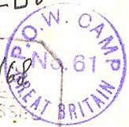
Late 1947 – Wynolls Hill became a satellite camp for Leckhampton Camp 263; Churcham and Highnam hostels were also transferred.

Known Camp commandants:
c.1943 Major A Harris, moved to Camp 45 Trumpington.
c.1946 Major D. de B Lipscombe. East Surrey Regiment / Pioneer Corps.
c.1946 Lieutenant Colonel R Morton (or Moreton? Was this ex commandant at Grizedale).
c.1947 Major Harold Stanley Ambrose Keynton. He was with the Tank Corps in WW1 / Somerset Light infantry. Previously commandant at Lydiard House Camp 289. Became Commandant at Mardy camp 118.

Camp and hostels + number of pows where known:
 | Not open |  | Unknown |  | Open |  | With another camp

 | 1942 | 1943 | 9/1945 | 5/1946 | 6/1946 | 7/1946 | 11/1946 | 5/1947 | 7/1947 | 8/1947 | 10/1947
Main |  | 580 | 600 cap I | ? I ⁽²⁾ | 121 | 532 | 655 | 520 + 1⁽³⁾ | 476 | 461 | 484
Llancloudy |  | 144 ⁽¹⁾ | 70 cap I | 72 G | 67 | 70 | 71 | 62 | 61 | 61
Newent |  | 144 ⁽¹⁾ | With C46
Ross-on-Wye 1 |  |  | 40 cap G | 30 G | 27 | 22
Ross-on-Wye 2 |  |  | With C197 |  | 164 | 170 | 205 | 186 | 190 | 193 | 200
Highnam Court |  |  |  |  |  |  | 292 | 277 | 293 | 260 | 214
Churcham |  |  |  |  |  |  |  |  |  |  | 35
Billets |  | 101 | ? | 20 G | 25 | 36 | 46 | 55 | 76 | 79 | 78
Total | 750 cap. | 825 | 710 cap. | ? | 404 | 830 | 1269 | 1101 | 1096 | 1054 | 1011

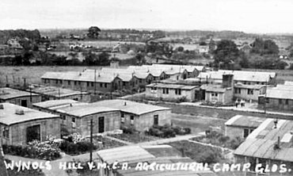
1 + another hostel, possibly Ross-On-Wye. 2 Italians not counted. 3. 1 pow escaped.

After the camp: Site used as an agricultural college and emergency housing. Wynols Hill House was demolished soon after the war. The memorial was vandalised and fell into disrepair and was demolished. Site cleared in 1977. Residential estate and school grounds.

Further information:

‘Inside The Wire’ - Ian M.C.Hollingsbee – 2014 – The History Press – excellent chapter on Wynolls Hill.

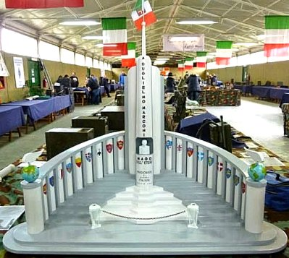
National Archives FO 939/142 61 Working Camp, Wynols Hill Camp – used above.

Forest of Dean Mapping Project - Fiona Small and Cathy Stoertz – 2006 – English Heritage

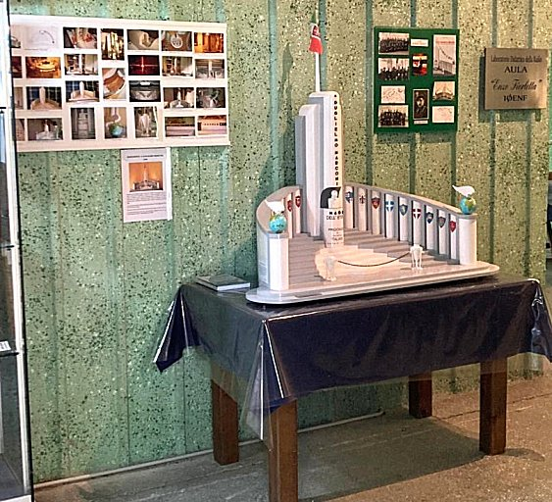
Book - ‘Da El Alamein a Marconi - mio padre e il Monumento dei POW al Campo 61 di Wynols Hill’ - ‘From El Alamein to Marconi - my father and the POW Monument at Camp 61 on Wynols Hill' by Laura Porciani. Publisher: Libri Sandit, 2011

* Laura, the daughter of Bruno Porciani, interned from October 1942 to March 16, 1946, contacted me. Her father designed and directed the work of the monument dedicated Marconi. Laura’s husband made a 1/10 scale replica model of the monument for the 70th anniversary of that event. The model, in memory and honour of the Italian POWs, was later donated by Laura for the 80th anniversary to: Piana delle Orme-Latina Museum, and is on display in the pavilion of "Quelli Della Radio.” Laura’s husband, Pino Canese (who passed away in 2023), also made a 3D video of Camp 61.

Link to museum - https://pianadelleorme.it/
A lot more information and pictures of items, see Laura’s Facebook group: https://www.facebook.com/groups/coleford.campo61/

Superb video of the camp: https://drive.google.com/file/d/1w_PagtRZSbZhvVipgpQk6Dy9lTrug14c/view?fbclid=IwAR3FHRCmrFqU6DfoU_9Sa0d27zS1ICLUdKEhpSivpEdDvLyHt-E343Qj9fw

Information about the pows who built the monument; https://radiomarconi1895-altervistaorg.translate.goog/marconi/prigionieri.html?_x_tr_sl=it&_x_tr_tl=en&_x_tr_hl=en&_x_tr_pto=sc –

https://www.sungreen.co.uk/ - various photos of Italian pows and artefacts / photo of the chapel - https://www.sungreen.co.uk/Broadwell/Chiesetta.htm

Hostels

Churcham, Gloucestershire. SO 769 182.  Attached to a different camp before this entry.  10/1947 – 35 pows being used as an; “anti squatter squad.” Hostel leader – Maat Franz Faltus (B+), had been leader at Llancloudy.  End 1947 – Administration transferred to Leckhampton Camp 263 | 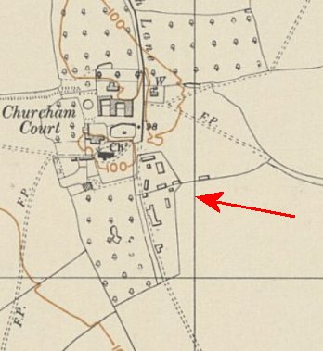
   | 1942 | 1943 | 9/1945 | 5/1946 | 6/1946 | 7/1946 | 11/1946 | 5/1947 | 7/1947 | 8/1947 | 10/1947
  Churcham |  |  |  |  |  |  |  |  |  |  | 35
 | Ordnance Survey 1955

Highnam Court. Huts. SO 794 194. Arrow indicates location shown in aerial photos.  Probably attached to a different camp before these entries. (I can see no evidence of the huts shown in a 1948 photo (see Hollingsbee book below) – in an aerial photo dated April 1946).  5/1947 – Hostel leader; Ogefr Werner Hausweiler (B+), aged 29, metal turner – “Non political but good, pleasant type.”  Some discontent noted as 60 pows had arrived from a camp where they said food and clothing was better. Patched clothing being given out at this hostel.  Weekly discussion group for about 15 pows. A mathematics class had started.  10/1947 – same leader.  End 1947 – Administration transferred to Leckhampton Camp 263 | 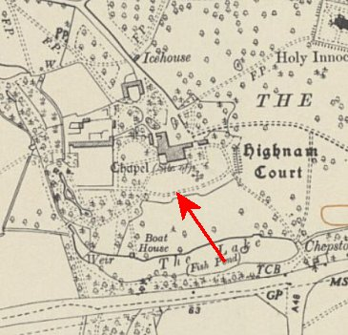
   | 1942 | 1943 | 9/1945 | 5/1946 | 6/1946 | 7/1946 | 11/1946 | 5/1947 | 7/1947 | 8/1947 | 10/1947
  Highnam Court |  |  |  |  |  |  | 292 | 277 | 293 | 260 | 214
 | Ordnance Survey 1955

Llancloudy, Herefordshire. (Also with spelling Llanclowdy) a small village (SO 496 210) – possibly near to Llanlowdy Cottage/Farm. Huts.
1943 - listed as a hostel for Italian pows.

5/1946 – Hostel leader: O/Maat Bruno Zauber (B), aged 46, owner of a flower shop in Berlin. “Somewhat of an opportunist. No personality.” (Despite this comment, he later became camp leader).

Morale was ‘fairly good.’ Nearly half the pows were ‘youth’ (under 25); this was seen as a problem as most had known no other politics than Nazism. It was being considered whether to place all youth pows in one hostel under the leadership of a suitable older pow.

No electricity supply. A battery operated wireless. 3 small English classes, short of books and materials.

Religion – A RC padre held fortnightly services. Mr Reymond, a Benedictine from Belmont Abbey also visited to say Mass. Protestants attended a local church every three weeks. There was a choir of 12 members.

7/1946 – The bus company wanted to make; “extortionate charges” for the delivery of newspapers, even to the British staff – this was turned down.

11/1946 – still no electricity supply. Oil lamps used.

5/1947 – Hostel leader; Maat Franz Faltus (B+), aged 37, forwarding agent, widower – “a disappointed opportunist who is now afraid to adopt any definite political line… Does little in the way of re-education.”

Morale “not so good” as main camp mainly due to isolation.

7/1947 – same leader.

 | 1942 | 1943 | 9/1945 | 5/1946 | 6/1946 | 7/1946 | 11/1946 | 5/1947 | 7/1947 | 8/1947 | 10/1947
Llancloudy |  |  | 70 cap I | 72 G | 67 | 70 | 71 | 62 | 61 | 61

Newent, Gloucestershire. SO 715 257 – marked as Hostel, Ministry of Works  1943 – listed as a hostel for Italian pows.  1945 – administration listed with Kingsfold Camp 46. | 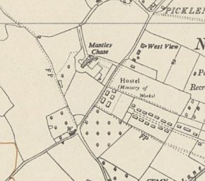
   | 1942 | 1943 | 9/1945 | 5/1946 | 6/1946 | 7/1946 | 11/1946 | 5/1947 | 7/1947 | 8/1947 | 10/1947
  Newent |  |  | With C46
 | Ordnance Survey 1955

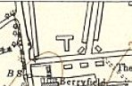
Ross-on-Wye – 1. “Three Crosses.” Local memories place it where Three Crosses Close is now – SO 601 249.

9/1945 – Listed as a hostel for German pows. Original pows were from camps in USA (via Camp 185). It does not state this, but pows from US camps generally had low morale. They had been mis-informed in the US that they were to be returned to Germany, instead they found themselves in working camps in the UK. Many had received no news from home for a long time which had an additional depressing effect.

5/1946 – Hostel leader; Fw Oskar Herkel (B), aged 34, professional soldier, non-political, “Lacks personality.”

No wireless. 1 small English class, short of books and materials.

 | 1942 | 1943 | 9/1945 | 5/1946 | 6/1946 | 7/1946 | 11/1946 | 5/1947 | 7/1947 | 8/1947 | 10/1947
Ross-on-Wye 1 |  |  | 40 cap G | 30 G | 27 | 22

Ross-on-Wye – 2 - ‘Drill Hall’ In 1938 the Drill Hall was located in Hill Street, but then moved to Alton Lane. General area – SO 257 238  5/1946 – Hostel and 130 German pows transferred from The Mount, Camp 197.  5/1947 – Hostel leader; Stfw Wilhelm Guenther (B-), aged 42, ex soldier / post office official. “Poor type, very sloppy in appearance but with typical mentality of a German Sergeant.” Had been replaced once, and was recommended he be replaced again.  “A collection of very poor Ps/W but they have made extensive civilian contacts in the town.”  7/1947 – same leader, despite previous recommendation – it was stated his attitude had improved lately.  Ross Council refused to allow pows to attend meetings and it was noted that there was some strong anti-German feeling in the town. A club held every Saturday afternoon, had been started by the Free Churches with the aim of forming better contacts between the pows and the people of Ross.  A group of 10 pows attended English lessons given by a schoolmaster in Ross.  10/1947 – same hostel leader.  November 1947 - recorded as administered by Ledbury Camp 27. | 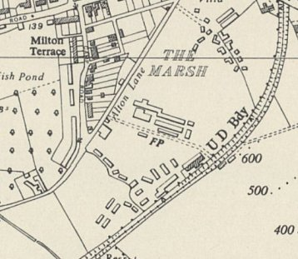
 | Ordnance Survey 1954

 | 1942 | 1943 | 9/1945 | 5/1946 | 6/1946 | 7/1946 | 11/1946 | 5/1947 | 7/1947 | 8/1947 | 10/1947
Ross-on-Wye 2 |  |  | With C197 |  | 164 | 170 | 205 | 186 | 190 | 193 | 200

