Camp 36 - Hartwell Dog Track Camp, Hartwell, Aylesbury, Buckinghamshire

Included in the 1945 ICRC camp list – Labour Camp. 36. Hartwell Dog Track Camp, Aylesbury, Bucks.

1947 Camp List
36(G.W.C.) | Hartwell Dog Track Camp, Aylesbury, Bucks | E. | Priswar, Aylesbury | Stone 297 | Aylesbury | Lt.Col.W.L.Barnard | v/1453/2

Prisoner of War Camps (1939 – 1948) - Project report by Roger J.C. Thomas - English Heritage 2003
OS NGR | Sheet | No. | Name & Location | County | Cond’n | Type 1945 | Comments
SP 807 121 | 165 | 36 | Hartwell Dog Track Camp, Hartwell, Aylesbury | Buckinghamshire | 4 | German Working Camp

Location: The camp, still seen on the map was at NGR SP 797 121. It was alongside the A418. 1947 aerial photo - View map: Ordnance Survey, OS Air Photo, 6 inch to the mile (1:10,560), Sheet 42/71 S.E. - Ordnance Survey Air Photo Mosaics, 1944-1950  Before the camp: Farmland, then site of Hartwell Greyhound Racing Track. The land was being used for dog racing by the Bugle Horn Hotel, (shown on map) from 1933 to 1940. In June 1940, a renewal of the track licence was refused, and the stadium was demolished in 1941.  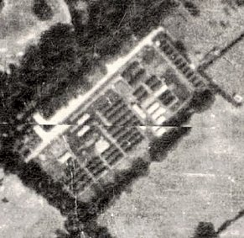  Pow camp: Italian then German pows.  December 1941 - Italian pows, some of whom were formed as a construction crew to build Shalstone Camp 55.  1943 – Hostels listed for Italians; Great Haseley / High Wycombe / Quainton / Pioneer Company, Taplow.  5 May 1944 - Hostels listed for Italian pows, (WO 32/10737); Burnham Beeches, Bucks / Great Haseley, Great Milton, Oxon / High Wycombe, Bucks / Quainton, Aylesbury, Bucks  The camp was listed as an Italian Labour Battalion under the Eastern Command area in May 1944 and as an Italian POW Working Camp in November 1944, (WO 32/10737). The Italians were recorded as being non-co-operators.  “The prisoners were contained in the central area in Nissen huts. They were well provided for, cookhouse, entertainment centre, medical centre and sick bay and a doctor. The main entrance and guard room was about 100 yards down Sedrup Lane on the left. There were four sentry boxes mounted quite high up round the perimeter and there were always guards on duty with searchlights. The soldiers’ quarters were on the outer aspect, bordering onto Sedrup Lane and the Oxford Road. | 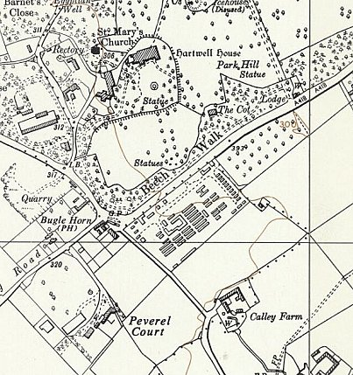
 | Ordnance Survey 1960

Where the Meadoway sign now is, was the dining hall, canteen and entertainment hall where dances were often held and well attended by local people, and the transport area, with a large pit where vehicles were serviced. On the left, bordering onto the orchard, was the Sergeants’ Mess and Quarters; further on were more Nissen huts where the soldiers lived.

The Sergeants’ Mess frequently held dances towards the end of the war and the music was provided by the German Prisoners’ Band, which was very good. We local residents were invited to attend.

There were several other large buildings backing onto the Oxford Road, Administrative Offices and General Stores. The soldiers stationed there were often older men and seemed to stay, not often being moved on and they integrated quite well into village life.

The Italian prisoners of war were often seen going off to work on local farms, transported in lorries. They were always singing and waving to passers by. When Italy capitulated in 1943, they were repatriated to Italy, [this was after the end of WW2] although some chose to remain in the area and their descendants still live here. The Italian POWs made shopping baskets from local willow, which they plaited and made into various shapes. The baskets were well made and lasted for several years. Many of the locals purchased them, which not only occupied the prisoners, but also gave them a little pocket money. They also made rings and bangles from old materials such as colourful toothbrushes and any old metal scraps they could find.

The German POWs were very good with wood carving and they also had their own small garden within the compound. The German prisoners of war were much more reserved and aloof in manner.

When POWs had committed a misdemeanour, they were sent down to Hartwell House cellars for punishment. The Italians marched up the road carrying their loaves of bread and singing loudly. The Germans on the other hand marched with dignity and remained silent. A few days later they would be seen returning to the POW camp. After the end of the war, before they were repatriated, they were free to move around and mix with the local people. Not all chose to return to Germany, particularly those whose homes were in the Russian Zone and many chose to stay, and lived and worked in Aylesbury and surrounding area.

Before the camp closed, the prisoners gave a concert at the Drill Hall in Aylesbury to local residents who had shown them kindness during their stay. It was an excellent and very memorable evening, which we all enjoyed and I recall very well. My parents befriended several of these men, who remained here, married and lived locally for many years.” (From memoirs of the 1930s and ‘40s by Jean McClane. Published in Parish News: Stone, Dinton & Hartwell – April, 2011).

1 August 1945 - an urgent memorandum was sent to this camp, and others, about maintaining records of Italians who were classed as ‘co-operators’. At this point many, sometimes all, of the Italian pows were in hostels / billets.

31 October 1945 - An International Red Cross visit to 4 hostels attached to Camp 36 was carried out. The hostels were :

1. Braddenham - opened 18 August 1945, 10 tents x 10 men + 1 large marquee tent, 100 German prisoners.
2. Attached to POW camp (Wexham Road?), opened 13 August 1945, 10 tents x 10 men, 100 men
3. Coleshill Amersham, opened 13 August 1945, 100 men in tents
4. Northchurch hostel, opened 13 August 1945, large hut, 50 men.

Oversight and development of re-education activities and English teaching for German pows was carried out by PID (Political Intelligence Department of the Foreign Office) / COGA (Control Office for Germany and Austria – UK). Visits and reports were made. The standard of the reports varied greatly. The visitors took little interest, if any, in activities other than re-education. They rarely mentioned welfare, sports, games, pastimes, crafts, etc of the pows. If there were still Italian pows in hostels, they were usually ignored by PID.

9/11 March 1946 – English Inspector’s report without numbers of pows. Interpreter; Staff Sergeant Russell.

The main camp still held Italian pows and there were also unnamed Italian hostels. There were 4 German hostels.

Strict discipline was noted – e.g. pows not allowed to speak to English overseers when out working, other than for the performance of their work.

20/22 March 1946 – Capt P N Bartlett visited after a request to carry out political screening and investigate Nazi influence at Northchurch hostel. Strength – 420 Other Ranks.

No pows were recorded for the main camp, presumably they were still Italians which PID ignored – figures for the German hostels were rounded – see chart later.

Political screening: | A+ | A | B+ | B | B- | C
 | 1 | 8 | 33 | 89 | 74 | 206

This was a very high number of category C (‘black’) pows. Many pows retained their belief in Nazism. A visiting lecturer (Dr Hering) in April 1946 commented that some persisted in stating that the films and news of concentration camps were faked.

Commandant: Lt Col Barnard / Interpreter : S/Sgt Russel

There was an overall camp leader for all the hostels; Kohlbrei (B-), a former school teacher. He had replaced a German who had appointed himself as leader and was subsequently removed.

Morale was regarded as improving, except at Slough hostel. Positive aspects were seen as; some re-education activities, (books, lectures, radio); arrival of mail, except from the American zone; and a general feeling that an interest was being taken in them.

Rescreening of pows placed many on ‘better’ categories – this was often the case. Northchurch in particular, one of the main purposes for this visit, had 50% of category C pows upgraded to B-.

The standard list of re-education activities was given, with a note that the distances to the hostels made it difficult to share / develop activities in them;

Newspapers – Some German newspapers received. No mention of British papers which were usually also received.

Library – PID had sent a selection of books.

Lectures – had started.

Discussion Groups – started in all hostels.

Films – none

Wireless – at all hostels.

Camp magazine – none

Press reviews – items (?) sent out each day from the main camp.

English Instruction – see report earlier this month.

Other activities –

Religion – A protestant padre. “Local arrangements” for Catholics.

Education – little due to lack of teachers.

Theatre – none.

Music – each hostel had a choir and 2 had small orchestras.

May 1946 – many new pows arrived from the USA where they had been incorrectly told they were to be returned to Germany. Morale amongst these pows was consequently low on their arrival in the UK. Other pows were newly arrived from camps in Germany and Belgium where conditions had been very poor. Many od the new arrivals were ex-Waffen SS.

The German pow developing re-education work, (not named in the March report) was a young pow who had attended the special training course at Wilton Park. It was questioned by a visiting lecturer whether he had the required abilities.

2 July 1946 – English Inspector’s Report. German Working Camp, (with 5 German and 1 Italian hostels). Total strength 1526, (NOT including the Italian hostel at Stokechurch).

Commandant; Lt Col Barnard. Lagersprecher; Mittmann.

4 classes with 87 pupils ranging from beginners to advanced, taking place in the dining hall. A shortage of teaching materials noted.

“…military discipline being rigidly enforced” – 18 pows were tried on this day for failing to have their paliasses in the correct position on their beds – their pay was docked.

8 July 1946 – Visiting lecturer, K P Pringsheim, repeated the same comments as above – “The commandant at the Main Hostel and some of his officers seem to be much more concerned with military discipline and the right way of making beds than with re-education.” The S/sgt interpreter was regarded as very good, but soon to leave.

19-22 July 1946 – Further comments on the British staff were made by another visiting lecturer, Hans Gottfurcht. He added an additional section to his report concerning the Commandant in particular, including comments; “Feeling in the camp is very bitter indeed. The most convinced democrats amongst the Ps emphasize that democratic and anti-militaristic re-education is an impossibility as the Commandant is insisting on tiny ‘spit and polish’ matters… A towel put in the wrong place for drying or a boot incidentally falling down from a board and found so at an inspection might mean a deduction of wages for one or more days.”

Further examples – pows not allowed to keep pets, (many camps had adopted stray cats or dogs) – insistence that pows were properly dressed even on free Sunday afternoons.

The circumstances are curious as the report stated; “I have not been asked by a single Ps to deal with these matters, and I am of course unable to judge how far they are justifiable grievances.” However, the visitor thought that some events were “extraordinary” and that the camp could be so much better in spirit.

27/28 July 1946 – Disturbing comments were made by a visiting lecturer (Dr G Liedholz) about Nazism in one of the hostels, (Great Haseley, identified in a later report). Not only were there still many who held the views that films of concentration camps were faked, there was open hostility to the lecturer, and death threats had been made to anti-Nazis. The usual doubts surfaced that the photographs of Belsen had in fact been taken at Katyn, (scene of mass executions of Polish officers by Russians), or that they were of German citizens killed by allied bombing. It was recorded that this only occurred at the one hostel, not the main or satellite camps.

This and the issues over the commandant’s militarism were referred to a Colonel Frazer in PID, but there are no records of any follow-up.

28 August 1946 – Lecturer reported that pows were coming back from work on the harvest between 8 and 9 o’ clock – which was not suitable to then give a lecture.

11 October 1946 – English Inspector’s Report. Total strength 1757.

Commandant; Lt Col Barnard. Lagersprecher; Weber.

Decline in numbers studying English – 3 classes with just 38 pupils. Some pows studied privately.

The Inspector stated that; “The re-educational programme is being zealously carried out” – in contrast to previous reports.

31 December 1946 – Visit for Re-education and screening in hostels. Strength – 1 officer (the M.O.), 1794 OR. Recorded as Germans – but some were “Roumanians”.

Commandant: Lt Col W L Barnard Camp Leader: Fw Karl Kremerskethen (B+) – “promising”.
Interpreter: S/Sgt J B Federl Deputy CL: OGefr Stephan Gut (B+)
German MO: Dr Rothzeil (B+)

This was the fifth camp leader in 9 months; very unusual, in most camps they lasted a lot longer – could be just coincidence with repatriations.

Only partial screening was carried out. There were 169 appeals pending against gradings – the better the grade, the earlier the repatriation. 120 pows had been repatriated from October to December.

Morale varied according to work – most were working at farms with good morale – road workers, “satisfied with their lot” – workers at Woburn Green Paper Mill, “very well treated.” The relaxation of fraternisation rules improved general morale and good contacts with locals were developing. There was a steadily growing interest in new (political) ideas, especially amongst those who had contacts with the local populations.

40% were ‘Youth’ pows (under-25). No special provision had been arranged for them.

The standard list of re-education activities was given and improvements noted;

Wochenpost and Ausblick – 300 / 180 respectively.

Newspapers – a wide range of English papers bought from the camp welfare fund. Some German papers sent by COGA. A few Swiss papers also received.

Library – 670 books; more needed.

Lectures – Very popular.

Discussion groups – in all sites, weekly meetings usually about news items.

Films – Main, Peterley and Haseley regular. Mill Lane wanted to join in as they now had electricity.

Wireless – at all sites. No mention of loudspeakers, and difficulty accommodating all who wanted to listen.

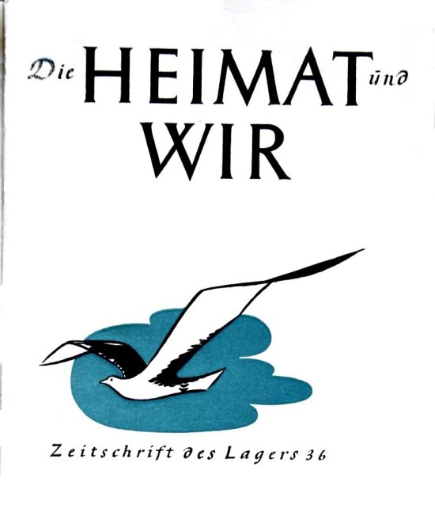 | Camp magazine - Die Heimat und Wir: Zeitschrift des Lagers 36 (‘Home and Us’ Journal of Camp 36). 300 copies of 48 pages produced fortnightly. Paper shortage prevented the magazine from growing larger.  Press review – in association with discussion groups.  Information room – exhibitions of printed materials touring main and hostels. At this time the subject was; “Political Caricature.”  Other activities –  Religion - Protestant parson; Bamberger (A) – “is doing good work.” Catholic chaplain; Bauer (A) – he also visited Camp 268.  Education – only at some sites; maths, French, German, stenography.  Entertainment – A small orchestra at the main camp + choir, theatre, musical group.  A Camp Council to discuss internal matters had been newly established consisting of elected representatives on the basis of 1 for every 20 pows. The s/sgt interpreter also attended.  15 January 1947 – Segregation Section Report. Strength – 1 officer; 1626 OR. Figures for camp and hostel numbers were incomplete.  Same senior staff. The camp leader was briefly described – “no Party membership. The man is still young… he is very capable and keen on his job…. He also organises political discussion groups together with the Organiser of Studies which are very well attended. He is a good man in the right job, and is well liked in the camp.”

Simplified political screening was used: | A | B | C | Not known
 | 121 | 1231 | 261 | 14

The visitor’s assessment of the British staff: “The Officers’ attitude is one of complete indifference, and although not actively antagonistic, they make it clear that they have no time for us, as they are only interested in running the Camp on a militaristic basis…” This is the only report that gives this opinion about ‘indifference’ to re-education – however, the militaristic aspect is recorded in other reports. It was noted that the S/Sgt was very co-operative and worked to develop re-education.

There is no mention of any disruption at the camp, or complaints from the pows, and the list of re-education activities was well developed – few camps managed to develop a democratically elected Camp Council. Although it is clear that the Commandant insisted on strict military discipline, and probably went over the top at times, it should be remembered that this camp had far more than its fair share of category C Nazis. It is also interesting to note that all complaints about him being overly strict and petty-minded were made in just one month; July 1946. No other PID report, or the many lecturer’s reports, repeat these allegations.

Notes on some of the German staff:

The organiser of studies – Matr.Gefr Ludwig Heelein, aged 40, former party member since 1939; “A strict Catholic, who only became a party member through fear of losing his job, being an engineer.” Democratic outlook, intelligent, doing an excellent job of work in the camp and hostels.

Medical Officer – Stabsartz Dr Gerhard Rottsahl (previously spelled ‘Rothzeil’) – party member and SA since 1933. “Now that he has been informed of the trials at Nuremberg with regard to the Concentration Camp Doctors, he is thoroughly disgusted with his German Medical colleagues and also deeply shocked.” Believes in democracy – “honest and straightforward character and is popular in camp.”

Protestant padre – Uffz Otto Bamberger, aged 41, no party affiliations, anti-Nazi. Held services for pows every Sunday at the local church in Stone. A good influence.

The Catholic chaplain was not mentioned.

Overall, the camp was considered to be politically “grey (B) tending towards black” (C). The black element was largely due to an intake of younger pows from Belgium where they had expected to be returned to Germany. The older pows and “Volks Germans” were generally more stable.

February 1947 – Camp magazine; Die Heimat und Wir : Zeitschrift des Lagers 36 - The Wiener Holocaust Library

Includes an obituary. “Far from home, our comrade Herbert Kutzborski passed away suddenly and unexpectedly in an accident. We will cherish his memory forever. Camp Leaders and Comrades of POW Camp 36.” Herbert Kutzborski was killed on 17 February 1947. He was later reinterred at the Cannock Chase German Military Cemetery.

2,3,14 June 1947 – Re-education survey. Total strength 1 officer; 1915 OR.

Commandant: Lt Col Hall-Dare Camp Leader: Gefr Dr Fuchs (B+) – “doing well.”
Interpreter: S/Sgt J B Federn Deputy CL: Not listed
German MO: Dr Retzeit (B+) [another spelling variation].

The new commandant was considered to be; “very well disposed towards re-education.”

The standard list of re-education activities was given with very little change from the previous report.

“Sport, education and entertainment keep Ps.W alive in main camp.”

Visits and contacts – 1 group attended Aylesbury district council. Aylesbury museum could be visited. Local contacts were regarded as positive.

There seems to be one or two reports missing from the file – 2 further reports were made on the satellite camp, these would normally have been conducted at the same time as visits to the main camp.

30 October 1947 – English Inspector’s Report. Total strength 1093.

Commandant recorded as Lt Col ‘Holiday’ – I think this was a mis-spelling of Hall-Dare! Lagersprecher: Ahlbrecht.

0 classes – 2 expected to start in November. A pointless report which head office was clearly not impressed with – the final rambling sentence received the comment; “What does this mean?”

14 November 1947 - Camp number included in an ‘Urgent Memorandum’ (FO 939/270) regarding inspection of food parcels.

There are no further reports – I believe the camp would have closed shorty after this, probably at the end of the year along with many others.

Known Camp Commandants;

1946 – 1947: Lieutenant Colonel W L Barnard. Initially with the Oxford and Bucks Light Infantry, then from 1942 with the Pioneer Corps. Retired July 1947.
1947: Lt Col Hall-Dare }
1947: Lt Col Holiday???? }
Camp and hostels + number of pows where known:

 | Not open |  | Unknown |  | Open |  | With another camp

 | 1941 | 1943 | 1944 | 10/45 | 3/46 | 7/46 * | 10/46 Ger | 12/46 Ger | 6/47 Ger | 10/47
Main | It | It | It | It | ? | 836 Ger | 625 | 567 | 748 | 530
Great Haseley |  | It | It |  |  | 67 Ger | 57 | 52
High Wycombe |  | It | It
Quainton |  | It | It | ? | 75 | With C 238
Taplow |  | It
Burnham Beeches |  |  | It
Bradenham |  |  |  | 100 Ger
Coleshill |  |  |  | 100 ? | 100 | 97 Ger | 103 | 84 | 96 | 80
Northchurch |  |  |  | 50 ? | 50
Slough |  |  |  | 100 | 100 | 99 Ger | 113 | 90 | 106 | 93
Little Marlow |  |  |  |  | 100 | 106 Ger | 110 | 88
Peterley |  |  |  |  |  | 201 Ger | 530 | 434 | 666 | 340
Stokechurch |  |  |  |  |  | ? It
Mill Lane |  |  |  |  |  |  | 51 | 46 | 51 | 50
Billets |  |  |  |  |  | 120 | 164 | *** | 249 | ?
Total | ? | ? | ? | ? | ? ** | 1526 +? | 1757 | 1795 | 1916

*+ 1 Italian hostel not listed. ** See note on entry of report above. ***If main and hostel numbers are deducted from the total this leaves 434, but this is far too high for the number of billetees.

After the camp: Some reports say the site was left abandoned. It is now a small residential estate.

Further information:

National Archives –
FO 939/118 36 Working Camp, Hartwell Dog Track Camp, Aylesbury, Buckinghamshire. Dated 1946/47. And, FO 939/298 same as above. Dated 1947. Used above.

The Buckingham County Council website has two aerial pictures of the camp taken in 1946.

The Imperial War Museum has copies of the magazine dated May and Christmas 1947.

Satellite Camp

Peterley (Manor) (Prestwood / Great Missenden). 10 miles from the main camp. Huts. Site visible on map just to the SW of the Manor; NGR SU 880 995. Site used as army base until D-Day. Possible memories of Italian pows would date the camp to before May 1946.  May 1946 – many new pows arrived from camps in Germany and Belgium where conditions had been very poor. A high number of these men were ex-Waffen-SS. (Reported by visiting lecturer).  October 1946 – Listed as a satellite camp rather than a hostel.  December 1946 – Commanding Officer; Captain Phipps. Satellite camp leader; Klaus Müller (A) – “a well educated fellow, whose brain is getting rusty, but he is the right sort.”  January 1947 – Camp leader, Klaus Müller, aged 31, no party affiliations, would like to remain in the UK. He was a student of economics. “Has got things well organised and is excellent at his job.” Large number of youth pows recently arrived from Belgium.  6 June 1947 – The size and nature of this satellite camp warranted a separate visit to survey re-education. Strength - 669 OR. | 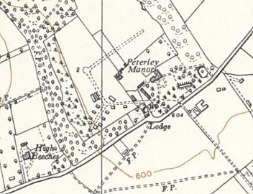
 | Ordnance Survey 1961

Officer commanding – Capt Philipps – “always been helpful.” Camp speaker – Ogefr. Heinz Nonnenbruch (B+) [previously hostel leader at Little Marlow].

Screening – A 6 / B 662 / Unscreened 1. 29 appeals pending.

Overall good morale. 200 recent arrivals, “a good lot,” had been transferred from M.U. Bicester [Maintenance Unit associated with Old Windmills Camp (see camp 33).

Newspapers – good newspapers in adequate supply.

Wochenpost and Ausblick – more requested.

Library – a fair ration received from the main camp.

Discussion group – reduced with summer weather.

Press reading – Dr Sasser (re-education leader) prepared material and delivered this.

Films – YMCA and English films received (Travelling Films Ltd).

Wireless – Not able to receive foreign stations – action being taken.

Camp magazine – from main camp.

English instruction – class of 20 beginners and another with 18 advanced.

Information room – waiting for display materials to be sent by main camp.

Other activities –

Orchestra and theatre group – strengthened by pows from Bicester who brought their own instruments.

Religion – Visits from clergy in main camp. Pows visited Prestwood and Gt Missenden.

15 August 1947 – Re-education survey. Strength 620 – 532 in camp; 88 in billets. 250 pows repatriated to date.

O.C.: Capt Le Mesurier - “co-operative.” Camp leader: Gefr Nonnenbruch (as before) – “very suitable.”
Interpreter: S/Sgt Federn (as main camp) Deputy C/L: Uffz Carl Menckel (B)
Morale raised by repatriations and ex-pows writing back to state they had found jobs.

30% of pows were ‘youth’. A group had been sent to the special youth training camp 180 (Radwinter).

The standard list of re-education activities was very similar to the last report – wireless had slightly improved, they were able to receive broadcasts from Leipzig / the Information Room had still not received exhibition materials.

30 October 1947 – a further re-education survey. Strength 310.

The OC was listed as Lt Col Hall Dare, the main camp commandant.

There was little change to the previous report on any aspect – it seems pointless. Many of the pows had established individual contacts, but there were no official organised outside contacts.

 | 1941 | 1943 | 1944 | 10/45 | 3/46 | 7/46 * | 10/46 Ger | 12/46 Ger | 6/47 Ger | 10/47
Peterley |  |  |  |  |  | 201 Ger | 530 | 434 | 666 | 340

https://heritageportal.buckinghamshire.gov.uk/Monument/MBC32758 - has 4 aerial photos.

Hostels

Bradenham

31 October 1945 - International Red Cross visit. Opened 18 August 1945, 10 tents x 10 men + 1 large marquee tent, 100 German prisoners.

 | 1941 | 1943 | 1944 | 10/45 | 3/46 | 7/46 * | 10/46 Ger | 12/46 Ger | 6/47 Ger | 10/47
Braddenham |  |  |  | 100 Ger

Burnham Beeches, Bucks. In May 1942, Burnham Beeches was taken over by the War Department to become a depot where vehicles were repaired and stored. Barbed wire was erected around the area and the public were excluded from entry. The camp also included a prisoner of war camp which housed Italian POWs.

5 May 1944 - Hostel listed for Italian pows, (WO 32/10737).

 | 1941 | 1943 | 1944 | 10/45 | 3/46 | 7/46 * | 10/46 Ger | 12/46 Ger | 6/47 Ger | 10/47
Burnham Beeches |  |  | It

Coleshill (Amersham). Believed to be to the right of the drive leading from the main road to Brentford Grange (SU 962 948) and Farm. 15 miles from the main camp.

31 October 1945 - International Red Cross visit. Opened 13 August 1945, 100 men in tents.

March 1946 – Hostel recorded as politically grey/black. Hostel leader; Kanngiesser (B-).

July 1946 – Tents still in use.

October 1946 – Accommodation recorded in huts, but oil lamps still in use.

December 1946 – Hostel leader; Behrend (B) – “has done a good job.” 50% of pows invited to Christmas meals by locals.

June 1947 – same leader – spelling Behnen (B). Excellent relations with ‘outside world.’

Two photographs are recorded as being taken here in 1947:
https://digit-wdr-de.translate.goog/entries/43676?index=0&q=eyJ7OH0iOlsiY29sZXNoaWxsIl19&qt=search&_x_tr_sl=de&_x_tr_tl=en&_x_tr_hl=en&_x_tr_pto=sc
https://digit-wdr-de.translate.goog/entries/43439?index=1&q=eyJ7OH0iOlsiY29sZXNoaWxsIl19&qt=search&_x_tr_sl=de&_x_tr_tl=en&_x_tr_hl=en&_x_tr_pto=sc

 | 1941 | 1943 | 1944 | 10/45 | 3/46 | 7/46 * | 10/46 Ger | 12/46 Ger | 6/47 Ger | 10/47
Coleshill |  |  |  | 100 ? | 100 | 97 Ger | 103 | 84 | 96 | 80

Great Haseley – (Great Milton, Oxon). 9 miles from the main camp. Huts.

1943 - Listed as a hostel with Italian pows.

5 May 1944 - Hostel listed for Italian pows, (WO 32/10737).

May 1946 – Many pows were newly arrived from camps in Germany and Belgium where conditions had been very poor. Visiting lecturers recorded that of the 68 pows – 50 were ex members of the Waffen-SS.

October 1946 – Oil lamps still in use.

November 1946 – A visiting lecturer commented that some of the pows had been punished for heckling a previous lecturer – no further details.

December 1946 – Hostel leader; BTSM Willi Probst

January 1947 – Same leader, aged 25, no party affiliations, gave weekly lectures. – “Has rather a difficult job as this hostel consists of the blacker elements. He is however, tackling his job well.”

 | 1941 | 1943 | 1944 | 10/45 | 3/46 | 7/46 * | 10/46 Ger | 12/46 Ger | 6/47 Ger | 10/47
Great Haseley |  | It | It |  |  | 67 Ger | 57 | 52

High Wycombe – (Bucks). NGR SU 848 925. (Aerial photo 1947).  1943 - Listed as a hostel with Italian pows.  5 May 1944 - Hostel listed for Italian pows, (WO 32/10737).  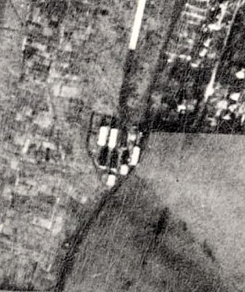  Information from ‘The High Wycombe Society, Newsletter, No 180, Summer 2016.’  The pow camp… “in High Wycombe was at the „top‟ of Chairborough Road, at that time a dead end… The Italian Prisoner of War camp was erected in 1941-2 just beyond the ending of the road. Several buildings with pre-fabricated walls were assembled on substantial concrete bases. They were not Nissen huts, but more like army barrack buildings. The whole camp was surrounded by a high wire fence topped with barbed wire.  The prisoners always seemed quite friendly to us children who would often wander up there to see what was going on. One evening we were entertained by a group just inside the fence singing in Italian, accompanied by guitar and mouth organ. We sat there enchanted but well back from the fence. The guards always moved us back.”  After the Italian Armistice… “In Wycombe, the regular sight of prisoners being marched down Chairborough Road in groups with a guard ceased, as they were allowed to stroll down unguarded to work in different parts of the town. Many of them worked in the Royal Electrical and Mechanical Engineers (R.E.M.E.) depots… where army vehicles were being serviced, one at the bottom of Chairborough Road, (Schneiders) another at the corner of Copyground Lane and Desborough Park Road, (Bristow and | 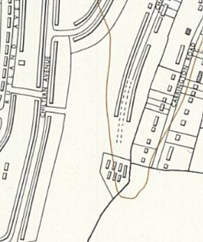
 | Ordnance Survey 1960
Townsend). Some worked in local firms or surrounding farms. They all wore brown overalls with a big yellow circle patch on the back, so you could always identify them wherever they were. After the Italian surrender the prisoners had more freedom but they were still living at the prison camp…”

“By the August summer school holidays in 1945 the buildings, presumably still Ministry property, were deserted, windows and doors left unsecured. The camp was then neglected and started to become derelict, with the youngsters from the surrounding areas using the buildings as a playground. Windows were broken, and many of the internal fittings and fixtures were ripped out, all being items that were in very short supply at the time. Nearly a year later in its 24th May 1946 edition, under a heading „P.O.W. Camp Smashed‟ the Bucks Free Press carried the news that the camp had been rendered uninhabitable. The council was shocked at the vandalism, which had allegedly occurred within days of the camp being „vacated‟. It had hoped to use the huts to accommodate returning soldiers and their families.”

A camp at High Wycombe with 50 pows was listed attached to Kings Cliffe Camp 702 towards the end of 1946 – not certain if this was the same place as most hostels for 702 were linked to RAF bases.

 | 1941 | 1943 | 1944 | 10/45 | 3/46 | 7/46 * | 10/46 Ger | 12/46 Ger | 6/47 Ger | 10/47
High Wycombe |  | It | It

After the camp – squatters moved on to the site and with Council assistance it was refurbished and made habitable. Later demolished and now a residential area.

Little Marlow. 15 miles from the main camp. Huts. 15/20 miles from the main camp.  Site visible on map just north of Westhorpe House, NGR SU 866 874  March 1946 – Recorded as politically grey. Hostel leader; Muller (B)  December 1946 – Hostel leader; Fritz Nonnenbruch (B+) – “a business man, of not purely German descent, who runs his hostel very successfully.”  Local Quakers working with this hostel | 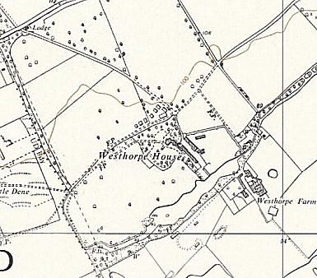
   | 1941 | 1943 | 1944 | 10/45 | 3/46 | 7/46 * | 10/46 Ger | 12/46 Ger | 6/47 Ger | 10/47
  Little Marlow |  |  |  |  | 100 | 106 Ger | 110 | 88
 | Ordnance Survey 1960
Mill Lane (Gerrards Cross). Huts. 20 miles from main camp. (Note there was also a Mill Lane camp in Essex, number 116)

October 1946 – New hostel for this camp. No electric lighting, oil lamps used, and cramped accommodation.

November 1946 – a visiting lecturer commented on poor conditions at the hostel – for example, no hot baths or showers.

December 1946 – Hostel leader; Georg Wilken (B+) – “a vet, is a useful and co-operative type and takes an interest in his men.”

June 1947 – same leader, spelling as ‘Wolken.’ Excellent relations with ‘outside world.’

 | 1941 | 1943 | 1944 | 10/45 | 3/46 | 7/46 * | 10/46 Ger | 12/46 Ger | 6/47 Ger | 10/47
Mill Lane |  |  |  |  |  |  | 51 | 46 | 51 | 50

Northchurch –

May 1945 – Recorded as a hostel for Batford Camp 95.

31 October 1945 - International Red Cross visit. Taken over 13 August 1945, large hut, 50 men. 14 miles from the main camp.

March 1946 – Recorded as politically grey/white. Hostel leader; Beck (A). 4 C category pows had recently been removed, it does not say where they were sent.

June 1946 – In a report about a lecture it was reported that this hostel was to be transferred to a different camp, (unnamed).

 | 1941 | 1943 | 1944 | 10/45 | 3/46 | 7/46 * | 10/46 Ger | 12/46 Ger | 6/47 Ger | 10/47
Northchurch |  |  |  | 50 ? | 50

Quainton – (Aylesbury, Bucks). NGR SP 751 204. 5 miles from the main camp.  1943 - Listed as a hostel with Italian pows. Local history states the pow hostel was opened in 1942 for Italians.  5 May 1944 - Hostel listed for Italian pows, (WO 32/10737).  March 1946 – Recorded as politically grey. Hostel leader; Griese (B-). This was described as a new hostel – i.e. new for German pows. The 75 pows had been transferred from Norduck Farm Camp 268 – 40% were category C.  Summer 1946 – Administration transferred to Norduck Camp 268.  Summer 1947 – Closed as a pow hostel. Accommodated European Voluntary Workers up to 1948. | 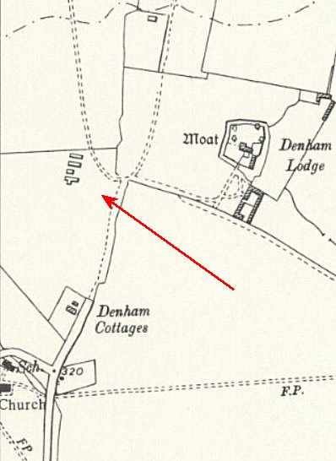
   | 1941 | 1943 | 1944 | 10/45 | 3/46 | 7/46 * | 10/46 | 12/46 | 6/47 | 10/47
  Quainton |  | It | It | ? | 75 | With C 268
 | Ordnance Survey 1958
Slough. 20/30 miles from the main camp.

31 October 1945 - International Red Cross visit. Attached to POW camp (Wexham Road?), opened 13 August 1945, 10 tents x 10 men, 100 men

March 1946 – Recorded as politically black – 85% category C. Hostel leader; Bindel (B-). Poor conditions – tented and with no electric lighting. Low morale noted.

July 1946 – Still tented accommodation.

October 1946 – Accommodation recorded as being huts, but oil lamps still being used.

December 1946 – Hostel leader; Bootsmaat Horst Schneegaas (B+) – “a live wire and is democratically minded.” 70% of pows invited to Christmas meals by locals.

January 1947 – Same leader, aged 30, no party record, a merchant. “His father was a member of the Free Masons before Hitler came to power.” Wanted to remain in the UK. Had spent 7 months in USA, 1937/8. Democratic outlook, gave weekly political lectures. Spoke good English and gave English lessons. “The hostel is very well run by him, and he is popular with it’s inmates.”

June 1947 – Hostel leader Fw Krause (B). Excellent relations with ‘outside world.’ Links with Westham Road Community Centre. A protest letter in the Slough Observer was believed to have resulted in more good than harm as there were many contrary opinions.

 | 1941 | 1943 | 1944 | 10/45 | 3/46 | 7/46 * | 10/46 Ger | 12/46 Ger | 6/47 Ger | 10/47
Slough |  |  |  | 100 | 100 | 99 Ger | 113 | 90 | 106 | 93

Taplow (Pioneer Company). Possibly at The Gore, Burnham, alongside Taplow.

1943 - Listed as hostel with Italian pows.

 | 1941 | 1943 | 1944 | 10/45 | 3/46 | 7/46 * | 10/46 Ger | 12/46 Ger | 6/47 Ger | 10/47
Taplow |  | It

