Camp 275 Topsite Camp, Thames Ditton, Surrey

Prisoner of War Camps (1939 – 1948) - Project report by Roger J.C. Thomas - English Heritage 2003
OS NGR | Sheet | No. | Name & Location | County | Cond’n | Type 1945 | Comments
TQ 15 67 | 176 | 275 | Topsite Camp, Thames Ditton | Surrey | 5 | German Working Camp | Precise location not identified, NGR given for Thames Ditton.

Location: Close to Camp 193 Hampton Park. I cannot find a place called ‘Topsite’ in Thames Ditton. The address used on camp correspondence was; Topsite Camp, Claygate Lane, Thames Ditton, Surbiton, Surrey, (possibly Greenwood Road / Claygate Lane – NGR TQ 163 659). An alternate name used later was; ‘Hinchley Wood’ which is just a little further S of the area shown on the map.  Before the camp:  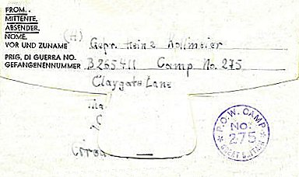  Pow Camp: Administered by the Pioneer Corps.  No records of Italian pows – probably opened 1945? Accommodation was in tents. No record of any hostels.  21 January 1946 – Commandant; Major T Toomey (Pioneer Corps). In a letter about a recent lecturer, he stated that there were 499 pows in the camp. Recreation/dining huts had recently been built.  <<< Pow letter-sheet from 1946.  6 April 1946 – A visiting lecturer noted that many of the pows were depressed due to receiving very little news from home – especially those with families in the Russian Zone. | 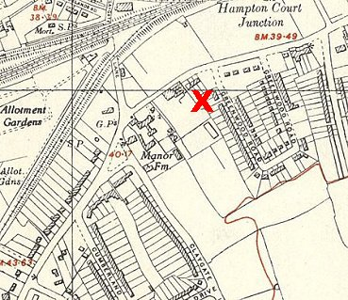
 | Ordnance Survey 1948

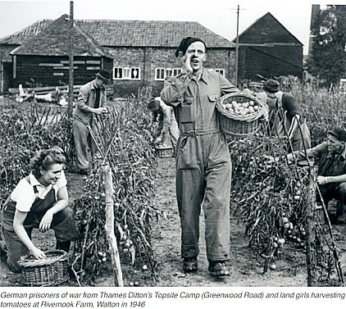 | 7 May 1946 – Dr. W Milch, a visiting lecturer, gave a report that was more informative than others – “Tented camp; moral standard; good: intelligence level; average: about 200 p/ws still unscreened….. Camp leader good and efficient… Very good work done by the (obviously German born) S/Sgt. [K Stanley, he was the interpreter].  Main trouble: no teachers in the camp… no men suitable to do the job… Even no English class last month owing to lack of experienced teachers!”  May 1946 – Camp magazine Number 1: Die Neue Zeit : Lagerzeitug PWW. Camp No. 239 - The Wiener Holocaust Library. Note that the magazine is for Topsite Camp 275, not Weston Acres 239. On the same website they have edition Number 3 from July 1946 when the Topsite location had become a hostel for Camp 239.  June 1946 – In early June, 20 pows and the Commandant, Major Toomey, were sent from this site to establish a new Camp 275 in Friockheim, Scotland.  The Topsite location became a hostel for Weston Acres Camp 239 and was called ‘Hinchley Wood.’  Further Information:  Picture: https://residents-association.com/images/thamesdittontoday/spring2020.pdf Residents Association Magazine Spring 2020.  National Archive FO 939/303 – has documents related to visiting lecturers at the camp from February 1946 to May 1946 – used above. (Filed with the title - “275 Working Camp, Kinnell Camp, Friockheim, Angus”).

