Camp 275 Kinnell Camp, Friockheim, Arbroath, Angus

Prisoner of War Camps (1939 – 1948) - Project report by Roger J.C. Thomas - English Heritage 2003
OS NGR | Sheet | No. | Name & Location | County | Cond’n | Type 1945 | Comments
 |  | 275 /275a | Kinnell Camp, Friockheim, Arbroath | Angus |  | German Working Camp | Scotland

Location: The EH record above records that Camp 275/275a was a German Working Camp in 1945. This is incorrect. Reports (FO 939/303) show that in 1945/46, Camp 275 was based at Topsite, Thames Ditton - and did not move to Scotland until June 1946. A camp number with a suffix letter (275a) usually refers to an associated pow hostel.

Visitors described the site as; “a dispersed hutted camp permitting more freedom of movement than most camps” and “housed in spacious RAF buildings and has no barbed wire at all.”

The main Kinnell Camp 275 was based around Kinnell Airfield just on the NE edge of Friockheim. The airfield closed in 1945 and was used for storage and maintenance as a satellite site for RAF 260 Maintenance Unit, (MU260). MU260 used pow labour – and was located at several sites – another was alongside Errol Airfield Pow Camp 274.

There were three accommodation areas for the airfield: 1. a small group of Nissen huts set out in an L-shape at NO 616 523; 2. a larger group of huts within a square enclosure at NO 617 519; 3. the largest, a combined three hut building and a detached hut at NO 613 522.

I believe that site 275a was a hostel for Italian, and then German pows. Initially, in 1943 it was administered by Balhary Camp (No.3/63) and would have taken that camp’s number until its administration was taken over by Camp 275. The reports (FO 939/144) for Balhary gave details of this hostel. NGR according to Canmore was NO 5992 4959.

POW Camp 275:

June 1946 – National Archive file FO 939/303 shows that a new Camp 275 was opened using the address ‘Kinnell, Friockheim, Angus’, (the telephone number was ‘Friockheim 261). This was a German Working Camp. Descriptions of the location are mentioned above.

Oversight and development of re-education activities and English teaching for German pows was carried out by PID (Political Intelligence Department of the Foreign Office) / COGA (Control Office for Germany and Austria – UK). Visits and reports were made. The standard of the reports varied greatly. The visitors took little interest, if any, in activities other than re-education. They rarely mentioned welfare, sports, games, pastimes, crafts, etc of the pows. If there were still Italian pows in hostels, they were usually ignored by PID.

27/28 July 1946 – Visit to Organise re-education / Ascertain screening position. Strength: 0 officers; 381 O.R. It was recorded that this was the first visit to the camp from COGA.

Commandant: Major T Toomey Camp Leader: Hptfw Ritscher (B)
Interpreter: S/Sgt R Williams Deputy C/L: Obwm Ehrentrant (est.B)
German m O: None

The Commandant and the deputy Camp Leader had been transferred from the Topsite Camp to form this new camp in Scotland.

The Camp Leader came from Cowden Camp 242.

The abilities of the interpreter S/Sgt to influence re-education was doubted.

The current pows were made up from:

Early June 1946 – 20 pows from 275 Camp (Topsite). (Topsite was called ‘Hinckley Wood’, a district next to the site of the camp).
July - 38 pows from 242 Camp (Cowden, Perthshire).
July - 323 pows from Camp 21 (from camps in Belgium then via Comrie, Perthshire).

The first 20 pows were picked by the Commandant when he was at Topsite to form the nucleus of the pow staff.
Only 38 pows had been politically screened – the visitor estimated the camp to be politically Grey / Black (Black = Nazi).

Overall, the pows were satisfied with conditions in the camp and a generally low morale was improving. Pows from Belgium had previously been badly treated in camps and were described as being cynical and unfriendly to the pow staff. Not all of the pows had been allocated work.

A high proportion of the camp were Youth pows, (under-25). Many of these had known no other political ideology other than Nazism, but it was hoped they could be guided by others. 2 youth and 2 older pows had been recommended to attend the special training courses held at Wilton Park (Beaconsfield).

The standard list of re-education activities was given, but very little had started:

Wochenpost: 70-100 copies received

Ausblick: No copies so far.

Newspapers: Copies of the Times Weekly and Manchester Guardian Weekly were received. Others were on order. 6 German papers were received fortnightly.

Library: None

Lectures: None

Films: None

Wireless: 1 in recreation room with a loudspeaker in the dining hut. It seems to have been very limited as only BBC programmes are mentioned.

Camp magazine: hoped to start soon.

Press review: being considered.

English Instruction: 2 teachers hoping to start soon, but teaching materials were lacking.

Other activities –

Religion – no activity yet.

Education – none.

Entertainment – There was a hall to seat 400, but no theatre group. No musical instruments were available. There was a football field, but no sports gear.
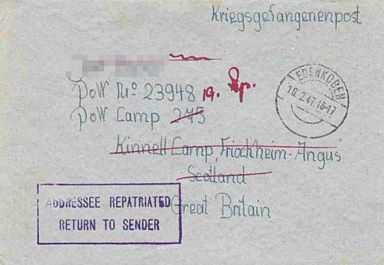
13 September 1946 – Paul Senft gave a lecture at the camp when 300 out of 375 pows attended.

He reported on the mood of two groups of pows in particular. Those who had been transferred from Belgium still showed resentment and bitterness after their experience, but their morale was improving. A second group had been transferred from camps in the USA where they had been incorrectly informed that they would be returned to Germany – instead they found themselves in working camps in the UK. There were “strong antagonistic currents” in some pows. These observations were repeated by other lecturers over the next few months.

31 January 1947 – Camp 275 disbanded as a unit and the site became a satellite camp attached to North Hill Camp 75 at Laurencekirk.

February 1947 cover to Kinnell / Friockheim >
Further Information:

National Archives FO 939/303 – 275 Working Camp, Kinnell Camp, Friockheim, Angus. 1946-1947. Used above.

FO 1120/240 – Re-educational survey visit reports for camps 266 to 276. Dated 1 January 1946 – 31 December 1948. Duplicate of report in file above.
Canmore - http://canmore.org.uk/site/272560

Vertical air photographs - 106G Scot/UK 6, 3244-3245, flown 14 April 1946.

Friockheim Hostel. Previously administered by Balhary Camp 3/63.

Location: NGR NO 5992 4959. Area shown as recreation ground on the 1959 OS map below. This site confirmed by local memories and aerial photographs.

Canmore records that this was a small camp with aerial photographs in April 1946 showing at least four large and two smaller huts + a small rectangular area with paths can be seen situated centrally between the huts. This matches a hostel description as being a site with 6 huts.

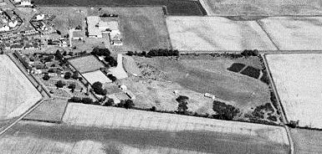 | 1943 to November 1946 - listed as a hostel for Balhary Camp with Italian pows.  November 1946 – 66 pows. Hostel leader; Obermaat Heinz Berger (C). “Very backward hostel. 50% US intake. The Nazi atmosphere already reported by Capt Drucker has not improved since the former Nazi Hostel Speaker Grimm has been replaced by another Nazi.” 21 out of 66 pows were graded ‘C’.  No further record of this site as a hostel for Balhary after November 1946. | 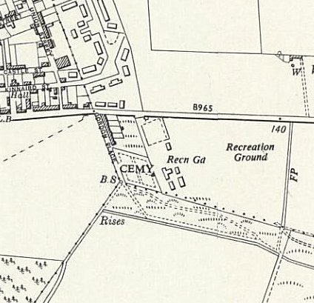
 |  | Ordnance Survey 1959

