Camp 273 Flixton Airfield, Flixton, Suffolk

Prisoner of War Camps (1939 – 1948) - Project report by Roger J.C. Thomas - English Heritage 2003
OS NGR | Sheet | No. | Name & Location | County | Cond’n | Type 1945 | Comments
TM 3057 8591 | 156 | 273 | Flixton Airfield, Flixton, Bungay | Suffolk | 5 | German  Working Camp | Former RAF Bungay (Station 125). Precise location not identified, NGR given for approx centre of the numerous dispersed accommodation sites.

Location: The NGR above is located at ‘X.’ However, the English Heritage ‘Pastscapes’ website listed the camp at TM 325 866; ‘Y’. Aerial photographs show many hutted areas – several of which may have been used. About 4 km S of Bungay. Flixton Airfield was also known as Bungay Airfield.  Before the camp: Used by USAAF from 1942 to June/July 1945.  Pow Camp:  Spring/Summer 1945 – listed as opened with capacity of 600. (Progress report 152 – FO 939/383).  3 March 1946 – Camp magazine; No. 15; Der Lager Spiegel : POW-Zeitung des Camps 273 - The Wiener Holocaust Library. I believe this is from Flixton Camp 273, rather than Debach Camp 273 which had a magazine with the same name. In an article about, ‘The relations between England and Germany’ it begins:  “Colonel Baker, already known to many comrades from Flixton, gave a very interesting lecture on Anglo-German relations on the 15th of this month.” | 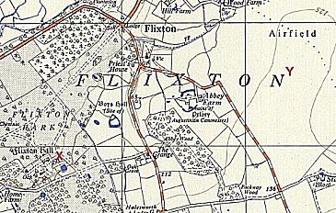
 | Ordnance Survey 1956
Spring 1946 - Believed to have closed (or transferred to a different camp as a hostel) when the Camp number 273 was transferred to Debach Camp.

After the camp:

Further Information:

