Camp 273 Debach Airfield, Debach, Suffolk

1947 Camp List
273(G.W.C.) | Debach Airfield, Woodbridge, Suffolk | E. | Priswar, Woodbridge | Woodbridge 235 | Woodbridge | Lt.Col.F.A.Levis | v/1453/2

Prisoner of War Camps (1939 – 1948) - Project report by Roger J.C. Thomas - English Heritage 2003
OS NGR | Sheet | No. | Name & Location | County | Cond’n | Type 1945 | Comments
TM 2287 5404 | 156 | 273 /273a | Debach Airfield, Debach, Woodbridge | Suffolk | 5 | German Working Camp | Former RAF Debach (Station 152). Precise location not identified, NGR given for approx centre of the numerous dispersed accommodation sites.

Location: Various sites around the airfield.  Before the camp: Farmland requisitioned at the start of the war. Airfield built in 1942/1943. Used by USAAF from 1944 to 1945.  Pow Camp: Used as a pow camp from 1945/6. Mainly Nissen huts. Number 273 previously used by Flixton Camp.  1946 – Additional intake of 800 pows from camps in the USA. Most had very low morale as they had been misinformed in the US that they were being repatriated. Instead, they found themselves in working camps in the UK.  27 November 1946 - As part of the re-education programme administered by COGA, Paul Bondy, a German-speaking refugee gave lectures at the camp on. He recorded a camp complement of 2,000.  22/28 November 1946 – Screening visit by PID. Strength; 1 officer (the M.O.), 2284 Other Ranks, (including 149 billetees). | 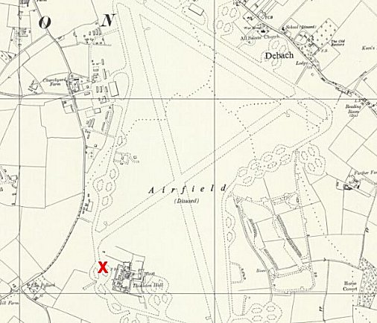
  Oversight and development of re-education activities and English teaching for German pows was carried out by PID (Political Intelligence Department of the Foreign Office) / COGA (Control Office for Germany and Austria – UK). Visits and reports were made. The standard of the reports varied greatly. The visitors took little interest, if any, in activities other than re-education. They rarely mentioned welfare, sports, games, pastimes, crafts, etc of the pows.
 | Ordnance Survey 1958
“The camp is sited on an airfield, rather dispersed, no barbed wire and excellent accommodation.” At this time 2 main ‘sites’ and some smaller.

Commandant: Lt Col F A Levis Camp Leader: Ofw R Edelmann (A)
Interpreter: Lt W Broekere Deputy C/L: Uffz W Wagner (A)
German M.O.: Ost.Arzt Dr Wittenbecher

The Commandant had been at this camp for 1 month, he had served as Commandant in other camps.

Lt Broekere had been posted as the Admin Officer to the camp, but also served as I.O. He was Polish and had worked in pow camps in East Africa. A S/Sgt interpreter from Botesdale Camp 56 assisted for a short time.

Simplified political screening figures were given; A 154 / B 1867 / C 178 / Unscreened 86. There was no sign of any political extremism, and C grade Nazis were not active.

Morale was recorded as excellent – with the usual desire for repatriation.

1/2 May 1947 – Re-educational Survey. This was the 3rd visit, but the 2nd report is not in the file. Strength; 1 officer, 1765 OR, (125 in billets).

The camp recorded as ‘3 sites.’ 69 pows were attached to 680 company (Shaftesbury Camp), no details given.

Commandant: Lt Col F A Levis Camp Leader: Ofhr Hans Schrievers (B)
Interpreter: Lt W Broekere Deputy C/L: Wm Fritz Vogt (B)
German M.O.: Ost.Arzt Dr Wittenbecher (B-); dentist: St.Ogefr Karl Karger (B).

Hans Schrievers had been camp leader for 4 months, aged 36, a municipal inspector, described as; “a rather weak vacillator type with a Nazi record.”

Political screening: | A | B+ | B | B- | C | Unknown
 | 17 | 235 | 1154 | 253 | 40 | 67

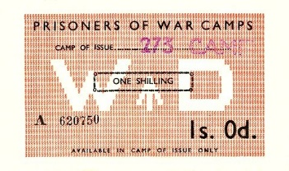
313 pows were appealing against their political grades – the better the grade, the sooner repatriated, in theory. 397 pows repatriated since 1 January 1947.

The deputy leader was aged 31, a school teacher, thought to be a better organiser than the leader.

The M.O. aged 40, was considered to be a good doctor, he had little political influence.

< Camp token money. Could only be used in the camp of issue.

Morale was good overall; length of captivity was always the main negative factor.

40% of the pows were ‘youth’ (under-25). There were no special provisions for them.

The standard list of re-education activities was given:

Wochenpost and Ausblick – 400/170 respectively.

Newspapers – Sufficient range of British papers. 3 German and 1 Austrian newspapers received.

Library – 900 books and 350 text books.

Lectures – Regular; attendance depended on the subject.

Discussion groups – Held weekly with about 40/50 pows attending – occasionally much higher.

Films – YMCA and Gaumont British supplied on alternate weeks.

Wireless – 9 sets, but 5 were battery operated. They were spread throughout the camp, the medical centre (CRS), and detention barracks. Loudspeakers were installed in the theatre and cookhouse.

Camp magazine – Der Lagerspiegel, 250 copies issued fortnightly. A separate publication was issued for the billetees; “Der Farmbote.”

Press review – Given in a meeting held on Sundays.

English instruction – 116 pupils in 3 grades with 5 pow and 1 civilian teachers. Others studied on their own. The civilian was a teacher from Felixstowe. There was also an ‘English Club’ of 24 meeting on Sunday mornings.

Information room – displayed general information and text and pictures on a theme, currently “The UNO.”

Other camp activities –

Religion – Daily services were held in the camp chapel. Evangelical padre, San O/Maat Johannes Huelsen (B), aged 50; was not popular with the British staff or pows. RC priest Uffz Thomas Woerl (A), aged 35; had been in a monastery in Bavaria; “a quiet, self-disciplined personage,” he also worked in Camps 171 and 258. Pows were able to attend local church services. There were 3 religious youth groups.

Education – Classes for French (20 pupils), Italian (6), Russian (25), Latin (5), German grammar (14), arithmetic (16), mensuration (geometry 16), agriculture (17), horticulture (12), bookkeeping (14), shorthand (21), chemistry (5), mathematics (11) and calculus (8).

Entertainment – 22 pows formed a theatre group and there was a 13 member orchestra; they often combined to give variety shows. A choir of 30. Football, handball, table-tennis, boxing and chess were popular.

7 – 12 July 1947 – Progress report. Strength; 1 officer, 1965 OR, including 130 in billets. The camp now recorded as being ‘4 sites.’

Commandant: Lt Col D J Stewart Camp Leader: Ofhr Hans Schrievers (B)
Interpreter: Lt J B Richards Deputy C/L: Wm Fritz Vogt (B)
Adjutant: Capt Williams German M.O.: Ost.Arzt Dr Wittenbecher (B-)

The new Commandant was supportive of re-education, he had “a most sympathetic approach to all P/W problems.”

The new Interpreter did NOT speak German.

Site leaders: 1 Fw Emil Kochems (B-) 4 Stgefr Helmut Rueckelt 5 Uffz Heinrich Sammet 7 O/Faehnr Albert Mueller (B-)

No explanation given for this numbering of the sites.

Political screening: | A | B+ | B | B-
 | 4 | 290 | 1388 | 284

308 appeals outstanding against political grades. 842 pows repatriated to date.

Morale was recorded as “reasonably good” – the main negative factors being further delays to repatriation and bad news from home.

Most camp activities had reduced due to the good weather and pows being given greater freedoms to leave the camp. Very few changes were noted:

Films – Travelling Films Ltd had replaced Gaumont British, pows complained of the high price they charged (6d, while YMCA only charged 3d).

Wireless – loudspeaker systems at all sites.

Religion – same padre and priest. There had been an attempt to set up a 3rd religious group of “Baptist-Methodist.” Members of the group tried to persuade others against attending camp services and used slogans such as; “Follow the (Catholic and Protestant) Priest into Hell.” This group was “nipped in the bud” by the Commandant who stated that Baptist pows could attend services in an individual capacity, but no organised 3rd camp group would be tolerated.

Education – A large number of classes continued. A group of pows visited Cambridge University.

Entertainment – Weekly concerts were given by the camp orchestra led by a professional musician. The theatre group was led by a “Variety Artiste.”

1 – 4 October 1947 – Progress report and “Investigation of article in Camp Magazine.” Strength; 1 officer, 1258 OR, including 81 in billets. The camp was recorded as being ‘2 sites’ with the other 2 closed down.

There was a new Interpreter; Lt D Alyar, and a new deputy camp leader; Uffz Mueller (B+)
Site leaders: 5 Uffz Heinrich Sammelt (B+) 7 Uffz Wolfgang Schulter-Stemmerk (B)

Simplified screening figures were given – A 4 / B 1255. No further appeals recorded. 1042 pows repatriated to date.

There were very few, and only minor, changes to activities. No further trouble had occurred from the “dissident” religious group.

No comment was made in this report about the article in the camp magazine, a review was probably raised as a separate appendix.

In his conclusions, the visitor recorded that this was, “a very happy camp.”

30 December – 2 January 1948 – Re-educational visit. Strength; 1 officer, 939 OR.:

HQ; 2 sites | Harwich Hostel – 35 miles away | Detached at Colchester Barracks | Billetees
671 | 211 | 1 | 57

Commandant: Lt Col D J Stewart Camp Leader: Ofhr Hans Schrievers (B+)
Interpreter: S/Sgt J P Harris Deputy C/L: Ofhr Albert Moeller (B+)
Adjutant: Capt Williams German M.O.: Ost.Arzt Dr Wittenbecher (B-)
Assistant C/O: Major Dix.

Another new interpreter; he did not impress the visitor.

Assistant Commandant Dix took an interest in the general welfare of pows and, along with the Commandant, had a positive influence in the camp.

Screening figures: A 1 / B 939. 1627 pows repatriated to date. 60/70 pows were requesting “Civilianisation” in order to stay in the UK, this included the Deputy leader.

25-30% of the pows were ‘youth.’ An idea of forming a youth group had been raised, but not developed further.

Many pows developed friendly relationships with local families. Because of its isolation it was difficult to form formal links, but some cultural links had been established with groups in Ipswich; Ipswich Industrial Co-operative Society (for music concerts and talks), Salvation Army, Peace Pledge Union, and the YMCA. There were slight contacts with Woodbridge Town Council and English speaking pows were able to attend meetings. Football matches were held with local teams.

Camp activities continued much the same as before, but were affected by repatriations and transfers of pows.

The RC Priest was particularly active in education and welfare of pows.

There were no further reports – the camp is likely to have closed soon after.

Known Commandants:
1946 Lt Col F A Levis, had been Commandant at Sandbeds Camp 53.
1947 Lt Col D J Stewart, from the Yorks and Lancaster Regiment.

After the camp: Used for a short time to accommodate displaced persons. Mixed use

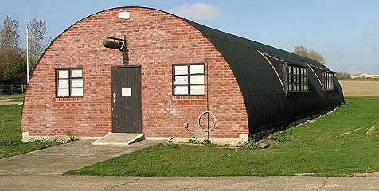
Further Information:

The 493rd Bomb Group Museum has information and displays about the pow camp – well worth a visit. Their website has some photos of pows at the camp; https://493bgdebach.co.uk/pow

National Archives FO 1120/240 – Re-educational survey visit reports for camps 266 to 276. Dated 1 January 1946 – 31 December 1948. Used above.

FO 939/275 – details of an ‘Exhibition: 273 Camp, Debach Airfield Camp, Woodbridge, Suffolk’. Dated 1946-1948. Exhibitions were usually created by the pows themselves as part of a re-education programme controlled by the Control Office for Germany and Austria (COGA). Political themes such as ‘democracy’ were often the theme for the displays.

Hostel

Harwich

1/1948 – Hostel leader; O/Fw Emil Kochems (B+). He had been a site leader at HQ – “an average, hard working type.” The hostel had recently been taken over and was expected to close.

