Camp 272 Davenport House, Worfield, Shropshire

Prisoner of War Camps (1939 – 1948) - Project report by Roger J.C. Thomas - English Heritage 2003
OS NGR | Sheet | No. | Name & Location | County | Cond’n | Type 1945 | Comments
SO 754 954 | 138 | 272 / 272a | Davenport House, Worfield, Bridgnorth | Shropshire | 4 | German Working Camp | STANDARD type.

Location: There is mention of the camp being at ‘Hallon’ which is at the NE of the estate.  Before the camp: A camp for 2,500 troops was built in the grounds November 1943 to March 1944. A pumping station was built to supply the camp and Worfield and Bradney villages. US troops were stationed here.  Pow Camp:  A suffix letter (‘a’ in the English Heritage list) usually donated a hostel.  Memories – “When the Americans no longer needed Camp Davenport it was used by prisoners of war, Italians and Germans. They were taken out daily by the WARAG to work on farms and there were different uniforms for Italians and Germans. In their spare time they made craft items such as slippers and entertained themselves by singing. Bob Adams described how you could hear them singing in the evenings and they were as good as any male voice choir.  The Worfield people welcomed the newcomers into their midst and local businesses presumably felt the benefit of the extra trade. When the Americans had left Davenport the prisoners of war brought labour which must have been a great boon to the farmers.” From an article entitled; ‘Worfield During and After the War,’ compiled from memories provided by Bob Adams and a book by Adrian and Neil Turley.  Spring/Summer 1945 – listed as opened with capacity of 500. (Progress report 152 – FO 939/383).  1946 – pows previously held in camps in Canada were sent here, (probably also from US Camps).  March 1946 – Camp magazine; Der Lagerspiegel aus Worfield : Camp 272 - The Wiener Holocaust Library  28 June 1946 – Taken over as a satellite camp with 689 pows by Coven Lawn Camp 151; “ has a flourishing re-educational programme.” 2nd i/c Captain Wonack took over as CO. Called Worfield Camp. | 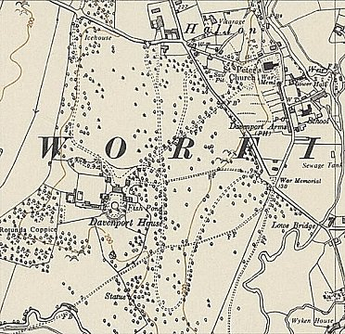
 | Ordnance Survey 1954

Later taken over with Coven Lawn by Teddesley Hall Camp 194.

Further Information:

Hostels. These three hostels were transferred to Coven Lawn Camp 151 in June 1946.

Drakelow

Moor Lane. (Witton, Birmingham – possibly SP 077 926 – not confirmed). Previously with Hampton Lovett Camp 54.

Marsh and Baxter. The Marsh and Baxter Factory was located in Brierley Hill, SO 918 870.

