Camp 267 Mereworth Castle Camp, Mereworth, Kent

Prisoner of War Camps (1939 – 1948) - Project report by Roger J.C. Thomas - English Heritage 2003
OS NGR | Sheet | No. | Name & Location | County | Cond’n | Type 1945 | Comments
TQ 669 532 | 188 | 267 | Mereworth Castle, Mereworth, Waterinbury | Kent | 5 | German Working Camp | Precise location not identified, NGR given for Mereworth Castle.

Location:  Before the camp: Large country house and estate.  Pow Camp: A heritage statement for a development at the site (2020) stated that the location of the camp is not known. A local memory stated; “The Mereworth camp was in the woods near the castle.” ??? also Mereworth Woods Hostel.  Spring/Summer 1945 – listed as opened with capacity of 500. (Progress report 152 – FO 939/383).  March 1946 – Camp Magazine; Chronik von Mereworth : PoW Camp Nr 267 - The Wiener Holocaust Library  1 June 1946 – became a satellite camp for Somerhill Camp 40.  March 1948 – recorded as a hostel for Walderslade Camp 117.  After the camp:  Further Information: The house is privately owned. | 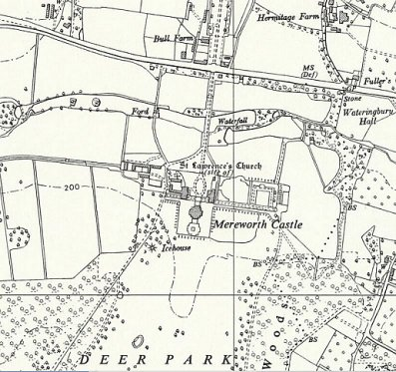
 | Ordnance Survey 1959

