Camp 266 Hutted Camp, Langdon Hills, Essex

1947 Camp List
266(G.W.C.) | Hutted Camp, Langdon Hills, Laindon, Essex | E. | Priswar, Laindon | Laindon 3334/5 | Laindon | Lt.Col.J.B.Constable | v/1453/2

Prisoner of War Camps (1939 – 1948) - Project report by Roger J.C. Thomas - English Heritage 2003
OS NGR | Sheet | No. | Name & Location | County | Cond’n | Type 1945 | Comments
TQ 668 864 | 177 | 266 | Hutted Camp, Bentley Farm, Old Church Hill, Langdon Hills | Essex | 4 | German Working Camp

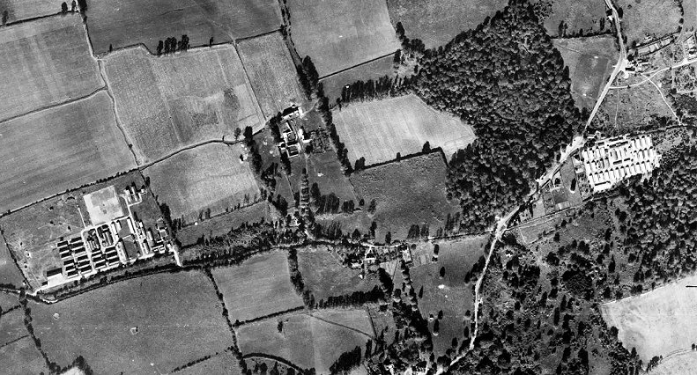 | 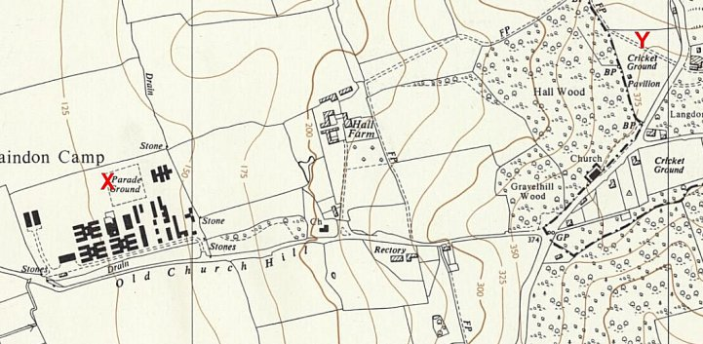
1946 - Aerial Photo | Historic England | Ordnance Survey 1960

Location: The NGR above places the camp inside the Parade Ground area (X) on the 1957 map. Bentley Farm is across the road from this site. This was a British troop camp and the site may have been used as a postal address. The pow camp was at (Y), at the end of Dry Lane, where the cricket ground was built later and shown on the aerial photo. Commandants had use of a large house opposite the entrance to the camp – though it is not known if any lived there.

Before the camp:

Pow Camp: Spring/Summer 1945 – opened April; capacity stated to be 800 (FO 939/383). Throughout its history, the camp had a regular flow of pows in and out.

There were 4 International Red Cross (ICRC) reports on the camp; 3/9/1945; 18/3/1947; 5/11/1947 and 22/3/1948. They are referred to in the book listed below.

3 September 1945 – ICRC Report recorded 660 pows. Commandant Major F W Lynch; Camp Leader Feldw Oswald Fullner; Deputy C/L Wachm Erich Mueller.

1946 – Additional intake of many pows from camps in the USA and Canada. Most had very low morale as they had been misinformed in the US that they were being repatriated. Instead, they found themselves in working camps in the UK. Pows from Canada often retained their Nazi ideology as they had been captured early in the war.

3 March 1946 – Camp magazine, No.7; Aufwartz : Halbmonatsschrift des POW-Camp 266 : Fuer Politische Selbsterzichung und Neuorientierung - The Wiener Holocaust Library

April 1946 - A group of pows managed to hoist a swastika flag on Hitler’s birthday – however, they were not generally supported by the rest of the pows.

August 1946 – An investigation was carried out at the camp by a member of PID that led to the transfer of a number of “trouble-makers” resulting in an improvement of “both discipline and political atmosphere.” No further details appear in a later report.
Oversight and development of re-education activities & English teaching for German pows was carried out by PID (Political Intelligence Department of the Foreign Office) / COGA (Control Office for Germany and Austria – UK). Visits and reports were made. The standard of the reports varied greatly. The visitors took little interest, if any, in activities other than re-education. They rarely mentioned welfare, sports, games, pastimes, crafts, etc of the pows. If there were still Italian pows in hostels, they were usually ignored by PID.

14 – 19 September 1946 – Report by the ‘Segregation Section’ mainly concerning political screening. Strength: 2 officers (the M.O.s), 2549 Other Ranks in HQ, 8 hostels, billets + ‘others.’ Increased size resulted in Commandant having rank of Lt Col, the previous Commandant had been a Major.

Commandant: Lt Col J H Constable Camp leader: Obfw Fritz Kindervater (A).
Interpreter: S/Sgt Sinclair Deputy C/L: Hptwm Josef, Bergheim (A).

Political screening: | A+ | A | A- | B+ | B | B- | C | C+ | Unknown
 | 4 | 290 | - | 669 | 1263 | 256 | 59 | 2 | 8
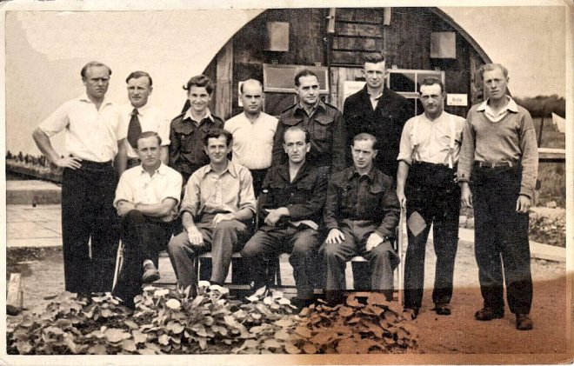
There had been at least two PID visits to the camp before this, but the reports are not in the National Archive file.

The Interpreter was aged 20 and found to be “outstandingly helpful.” It was suggested he should be allowed to carry out further screenings.

Camp leader Kindervater; “extremely good type with sound political ideas… liked by the British staff and his compatriots.”

Deputy leader; “well chosen.”

Although morale was improving, most pows were politically apathetic. Many pows were from Poland and Czechoslovakia and had not received any mail. Many would soon find their citizenship under question having been members of the German army.

< Picture postcard sent 1946; pows and Nissen hut behind.

26/29 November 1946 – Progress report. Strength; 3 officers, 2193 OR.

Commandant: Lt Col J H Constable Camp leader: Uffz Horst Berg (B+)
Interpreter: S/Sgt Sinclair Deputy C/L: Gefr H Hoyer (B+)
German M.O.: O/St.Arzt Trutschler (B)

Other than the Interpreter, there was no interest from the Commandant or other British staff in re-education. In a later report it was stated that the Commandant was popular with the pows.

The new camp leader was aged 21, “proving a success.”

Political screening: | A | B+ | B | B- | C | Unscreened
 | 46 | 606 | 1243 | 228 | 64 | 9

Morale was stated to be better at HQ than in the hostels – but poor at Tillingham. The main reason for good morale was the start of repatriations. The visitor raised a number of questions to be resolved regarding finances and communications with other pows in other camps.

About 40% of the pows were ‘youth,’ (under 25); they were not seen as a problem.

The standard list of re-education activities was given:

Wochenpost and Ausblick – 400 / 0 respectively, “sufficient.”

Newspapers – All sites received English newspapers. 7 German newspapers per week were sent to HQ.
Library – 900 books of all sorts. More required.

Lectures – Infrequent, but popular. Complaints that some were too short at just 30 minutes.

Films – Fortnightly YMCA supplied films costing 6d, thought to be too expensive. [This may be incorrect, most other sites stated 3d for YMCA and 6d for commercial supplied films]. Occasional COGA information films.

Wireless – A set at all sites.

Camp magazine – Popular, though limited number of contributors.

Press reviews – held at all sites.

Discussion groups – no details.

English instruction – separate appendix.

Other camp activities –

Religion – Protestant padre, O/Lt Salewsky. Pows able to attend services arranged at local churches.

Theatre – groups active at HQ and 2 (unnamed) hostels, preparing for Christmas.

Orchestra – Small bands at HQ and large hostels.

10 November 1946 - death of Obegfr Richard Schulze from TB. He was later reinterred at Cannock Chase German Military Cemetery.

Spring 1947 – Unsuccessful escape attempt with very few details. See book below.

21 March 1947 - As part of the re-education programme administered by the Control Office for Germany and Austria (COGA), Paul Bondy, a German-speaking refugee gave lectures at the main camp and 1 hostel. He recorded a camp complement of 2,000.

8 – 12 May 1947 – Progress report. Strength; 3 officers, 2136 OR.

No changes to senior personnel. The German M.O.s were listed; O/St.Arzt Trutschler (B), O/Arzt R Gruenwald (B), and O/Leut G Saleski (A).

Political screening: | A | B+ | B | B-
 | 38 | 556 | 1268 | 277

170 pows were appealing against their political grades; the better the grade, the sooner repatriated, in theory. 74 appeals had been heard, but no details of success rate; in most camps, most appeals were upheld. 805 pows repatriated to date.

Morale was the same as the last report. 50-60% were ‘youth’ who were not seen as a problem except for some at Tillingham.

Despite losses of many leaders due to repatriations, re-education activities continued. Changes noted –

Wochenpost and Ausblick – 200 copies of each.

Library – 1000 books at HQ, still insufficient. A lending system for other sites was in operation.

Lectures – regular at one site. Complaint raised by Tillingham that there had been a gap of three months.

Discussion groups – held at all sites.

Films – supplied by Travelling Films Ltd and YMCA.

Religion – A RC padre from Camp 286 visited fortnightly.

Education – 25% of pows attended various classes; English, French, ‘Craftsmanship Calculation,’ and book-keeping.

Entertainment – All sites except Hylands Hall had its own theatre group and orchestra / band. Concerts were organised between the sites.

22 July 1947 – the HQ band played with the Laindon Festival Orchestra at Memorial Hall.

23 May 1947 - death of Gerf Guenther Willi Meise, aged just 21, from TB/Meningitis. He was later reinterred at Cannock Chase German Military Cemetery.

4 – 13 September 1947 – Progress report. Strength; 3 officers, 1812 OR.

Commandant: Lt Col H S Hobby M.C. Camp leader: Fw Rolf Zimmermann (B-)
Interpreter: S/Sgt P H Sinclair Deputy C/L: Uffz Heinz Froebel (B)
German M.O.: O/St.Arzt Wm Trutschler (B)

The new Commandant was cooperative, but did not promote re-education. He was described as, “an ‘old soldier’ type, and although scrupulously fair, is not very popular with the rank and file.”

The new Camp leader made a very favourable impression.

Political screening: | A | B+ | B | B-
 | 4 | 593 | 942 | 276

No appeals pending. 1005 pows repatriated to date.

Morale generally ‘fair,’ but poor at Hylands Hall and Tillingham.

The % of ‘youth’ pows had fallen – 40% at HQ and the satellite, 25-30% at most hostels, only 10% at Great Wakering.

Greater freedoms to leave the camp in free time and long working hours for the harvest, greatly reduced participation in re-education activities. Changes –

Library – 2500 books; additions mainly from disbanded Camp 634.

Religion – regular services for RC and Protestants (under resident padre O/Leut Salewski). Padre Jacobs from Camp 286 visited. Some pows attended local services.

Education – only classes for English.

Information rooms – displayed exhibitions of text and pictures on a theme.

Outside contacts – small groups visited the local magistrates court and fortnightly meetings of the Society of Friends at Chelmsford.

26/28/30/31 January 1948 – Progress report and “Civilianisation Board.” Strength 3 officers, 1114 OR.

Commandant: Lt Col F Cronin Camp leader: Fw Rolf Zimmermann (B-)
Interpreter: S/Sgt Goldberg Deputy C/L: Uffz Heinz Froebel (B)
German M.O.: Ass Arzt Dr Hildebrandt (B)

The new Commandant was interested (not active) in re-education; he was, “extremely fair in his administration and is well liked.”

The new Interpreter was not as supportive of re-education as his predecessor, and not as popular.

Simplified screening figures were given: A 1 / B 1116. 1350 pows repatriated to date. Morale was recorded as fair and pows were mainly politically apathetic.

The Commandant allowed fortnightly dances to be held at Laindon Village Hall – invitation only, with pows allowed to bring their own partners. The small band from HQ provided the music. The dances were regarded as a tremendous success – I wonder if local young males thought the same?

Outside contacts had been developed with Chelmsford Magistrates Court, Billericay Council meetings, and the Salvation Army. It was difficult to maintain activities due to repatriations and attractions outside of camp.

The Civilianisation Board met at Hylands Hall hostel on 26 January and considered 70/80 applications – a separate report was issued.

8-10 March 1948 – Re-educational Assessment. Arrange further Cultural Contacts. Strength; 2 officers, 2025 OR.

1 change to senior personnel; German M.O.: O/Starzt Jobst Schaefer (B).
A survey was conducted in camps still open at this time concerning pow attitudes to the British, (following a PID circular dated 25.2.1948). It was pointless, carried out far too late and in totally random ways. Some visitors simply gathered whoever was around and asked them to give a show of hands to the questions, some only asked a ‘selected’ group – most did not state how the data was gathered or the numbers involved. The visitor at Langdon stated; “Straightforward answers to direct questions were not forthcoming.” He did not give figures for the survey questions, instead a list of criticisms, mainly based on length of time in captivity and conditions in Germany, were raised.

Outside contacts were well developed in comparison to many other camps. Most pows developed their own informal contacts with local families. HQ received over 100 Christmas invitations. Civilians were invited to pow entertainments. Visits to London theatres were arranged for parties of 10 to 35 pows. There were links with local religious groups, local institutions and associations.

13-17 April 1948 – Re-educational assessment. Strength; 2 officers, 1449 OR.

Commandant: Lt Col F Cronin Camp leader: R Nehss
Interpreter: S/Sgt R Goldberg Deputy C/L: -
German M.O.: O/S Arzt P Schemann

It was stated that the Commandant; “does not believe in the possibility of re-educating Germans. He is a strict disciplinarian who, however, treats the Ps/W very liberally.” (?!)

The Interpreter was dismissed in the report as of; “no significance.”

A very much more negative opinion of the pows was expressed. The former leader, awaiting repatriation was; “in my opinion an arrogant Nazi-minded anti-British individual and the Ps/W employed in his office are similarly tainted.” Many of the pows were regarded as anti-British and past grievances such as watches being stolen and photos destroyed at Kempton Park were raised. All activities were winding down or ceased.

Lecturers had visited the camp – far too late for most – to discuss issues about resettlement.

The camp closed shortly after this report.

Known Camp Commandants:
Major F W Lynch, later Commandant at Co-ed Bel Camp 237.
Lt Col J B (or H) Constable
Lt Col H S Hobby M.C. from the East Yorks Reg. Previously Commandant at Wollaton Park Camp 166.
Lt Col F Cronin

After the camp: Used for a while by Shell to house workers.

Further Information:

National Archives -
FO 1120/240 – Re-educational survey visit reports for camps 266 to 276. Dated 1 January 1946 – 31 December 1948. Used above.

IWM has copies of 7 news-sheets produced in Camp 266 between November 1945 to December 1947 as part of the re-education programme in the camp. They also have 2 copies of the magazine Zum Geleit, dated October/November 1947, Ref LBY E.J. 452.

The German Federal Archives have a copy of the camp magazine.

‘German POW Camp 266 Langdon Hills’ – K Porter and S Wynn – 2012 – Affinity Self Publishing. This book was written without reference to the PID reports detailed above and consequently there are errors. However, the book contains memories, especially of social events, and pictures. It also refers to the ICRC reports.

https://www.laindonhistory.org.uk/content/through-the-decades/the_war_years/ww_ii/hutted_camp_266

Camp numbers

 | Open |  |  | With other camps |  |  | Unknown |  |  | Not listed / not open

 | 1945 | 9/1946 | 11/1946 | 5/1947 | 9/1947 | 1/1948 | 3/1948 | 4/1948
HQ | 800 cap. | 383 | 377 | 425 | 308 | 236 | 249 | 204
Chelmer Road |  | 321 | 267 | 302 | 282 | 284
Great Wakering |  | 256 | 197 | 228 | 190
Horndon |  | 165 | 150
Hylands Hall | ? | 460 | 409 | 362 | 305 | 194 | 302 | 282
Rawreth |  | 270 | 226 | 107 | 69
South Church |  | 61 | 5
Tillingham I | ? | 149 | 427 | 209 | 373 | 310 | 322 | 146
Tillingham II | ? | 366 | 427 | 410 | 151 | 310 | 322 | 146
Purfleet | Was Camp 286 |  |  |  |  |  | 365 | 207
Harold Wood |  |  |  |  |  |  | 332 | 52
Hill Hall | With C 116 |  |  |  |  |  | 381 | 272
Thoby Priory | With C 116 / 286 |  |  |  |  |  | 68
Other | - | 8 (1) | 46 (2) | - | - | - | - | -
Billetees |  | 102 | 92 (3) | 96 | 137 | 93 | 332 | 288
Total |  | 2551 | 2196 | 2139 | 1815 | 1117 | 2027 | 1451

- 8 “attached to Hylands Hall.” (2) at Roxwell Bomb Disposal Unit. (3) listed as “billetees and cooks.”

Hostels:

Chelmer Road, Chelmsford. Possibly linked to Chelmsford Prison Detention Barracks, OR, at TL 722 076 by sports ground and site later recorded as a Ministry of Labour hostel.

9/1946 – No electric light, mainly tented. Hostel leader; Rudolf Krummlinde (B), only in post for 5 days. 11/1946 – Now a hutted camp, but still no electric supply. Same leader.

5/1947 – Hostel leader; Wachm K Krafft (B). Pows able to have film shows by hiring Springfield village hall. Wireless battery set with limited range. 9/1947 – same leader, he settled in the UK on release.

1/1948 – Hostel leader Wachm Willi Baer [or Baehr] (B+), had been leader at Rawreth. Still no electric supply.

 | 1945 | 9/1946 | 11/1946 | 5/1947 | 9/1947 | 1/1948 | 3/1948 | 4/1948
Chelmer Road |  | 321 | 267 | 302 | 282 | 284

Great Wakering  Previously an AA site. At least 43 Nissen type huts at NGR TQ 953 879. “The camp saw use as a Prisoner of War camp immediately following wartime, before being used as temporary housing…. The battery camp initially consisted of around 43 huts. Nissan huts with curved corrugated roofs going round in a circular formation. There was a function-type hall hut immediately west of the entrance road surviving today that connects the camp area to Wakering Common – this was used for dances and Christmas functions etc.” https://beyondthepoint.co.uk/wakering-camp/  5/1946 – stated as opening during this month.  9/1946 – no hostel leader listed.  11/1946 – Hostel leader; O/Maat Hohberg (B), “fairly efficient.” A theatre group and chess circle were active. 5/1947 – same leader.  9/1947 – Hostel leader; O/Gefr Karl Matthei (B+) | 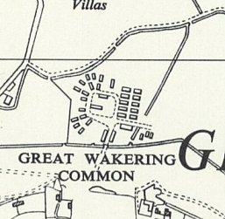
   | 1945 | 9/1946 | 11/1946 | 5/1947 | 9/1947 | 1/1948 | 3/1948 | 4/1948
  Great Wakering |  | 256 | 197 | 228 | 190
 | Ordnance Survey 1961

Harold Wood

3/1948 – Hostel leader; Uffz Horst Gehnech (B). 4/1948 – same leader.

 | 1945 | 9/1946 | 11/1946 | 5/1947 | 9/1947 | 1/1948 | 3/1948 | 4/1948
Harold Wood |  |  |  |  |  |  | 332 | 52

Hill Hall

3/1948 – Hostel leader; Hfw Alfred Koelner (B). 4/1948 – same leader.

 | 1945 | 9/1946 | 11/1946 | 5/1947 | 9/1947 | 1/1948 | 3/1948 | 4/1948
Hill Hall | With C 116 |  |  |  |  |  | 381 | 272

Horndon

6/1946 – stated as opening during this month.

9/1946 – Hostel leader; Uffz Theodor Eller (A), aged 34, “well educated… has started classes in brick-laying and carpentry.”

11/1946 – Hostel leader; Fw Streng (B+), “doing his job well.”

 | 1945 | 9/1946 | 11/1946 | 5/1947 | 9/1947 | 1/1948 | 3/1948 | 4/1948
Horndon |  | 165 | 150

Hylands Hall. Previously country estate, military hospital, base for troops including the SAS. Camp located in the parkland.

Record of Italian pows before Germans – so the site would have been under the administration of a different HQ at that time.

9/1946 – Hostel leader; Feldwebel Kurt Pfeiffer (A); “keen type.” 11/1946 – same leader.

5/1947 – Hostel leader; Uffz K Volkmann (B+)

9/1947 – Hostel leader; O/Wachm Bruno Buettner (B+); “completely colourless,” his removal was recommended.

1/1948 – Hostel leader; Uffz Joergen Fischer (B). 4/1948 – same leader.

POWs created an illustrated album, chronicling their time at the camp and the characters they met – held by the Essex record office.

 | 1945 | 9/1946 | 11/1946 | 5/1947 | 9/1947 | 1/1948 | 3/1948 | 4/1948
Hylands Hall | ? | 460 | 409 | 362 | 305 | 194 | 302 | 282

Purfleet

2/1948 – Camp taken over by Langdon.

14 February 1948 – A supplementary report was issued for this hostel. Strength; 649 OR.

Officer i/c: Capt Bassett Camp leader; Gefr Helmuth Klenk (B)

The camp leader had deferred his repatriation. “A law student… quiet and sincere but inclined to be slow in his reactions…. Quite popular.”

Morale ‘fair.’ The camp was still in the process of re-organising after being taken over. There was a small discussion group, Information room, and English classes. The camp magazine had merged with the HQ magazine. 4/1948 – same leader.

 | 1945 | 9/1946 | 11/1946 | 5/1947 | 9/1947 | 1/1948 | 3/1948 | 4/1948
Purfleet | Was Camp 286 |  |  |  |  |  | 365 | 207

Rawreth. (Near Southend). Location NGR TQ 796 922.  Some notes from Rawreth Parish newsletter – Aug/Sept 2013; Previously an AA site. Italian pows remembered so it would have been attached to a different HQ at that time. Both Italians and Germans made small ‘presents’ from wood and metal which they sold – an example is held by the Museum in Rayleigh Windmill.  9/1946 – Excellent accommodation noted. Hostel leader; Uffz Hermann Hillebrand (A); “capable and understanding.” Many pows were from Poland and had received no mail from home.  11/1946 – Hostel leader; Wm Willi Baehr (B). 9/1947 – same leader. | 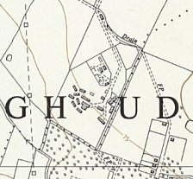
   | 1945 | 9/1946 | 11/1946 | 5/1947 | 9/1947 | 1/1948 | 3/1948 | 4/1948
  Rawreth |  | 270 | 226 | 107 | 69
 | Ordnance Survey 1960

South Church

9/1946 – Hostel leader; Oberfeldw Franz Weilandt (A); “good type, sensible.”

11/1946 – expected to close.

 | 1945 | 9/1946 | 11/1946 | 5/1947 | 9/1947 | 1/1948 | 3/1948 | 4/1948
South Church |  | 61 | 5

Thoby Priory

3/1948 – Hostel leader; Uffz Robert Exner (B)

 | 1945 | 9/1946 | 11/1946 | 5/1947 | 9/1947 | 1/1948 | 3/1948 | 4/1948
Thoby Priory | With C 116 / 286 |  |  |  |  |  | 68

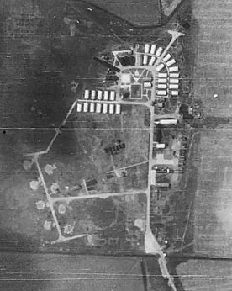
Tillingham

Location; 1 site was just S of Marsh House Farm, NGR TM 017 033 – ex-Anti-Aircraft site, shown in 1945 aerial photo; Aerial Photo | Historic England . The 2nd site is NOT confirmed, possibly at Lower Barn Farm. Both sites were bleak! Alongside Tillingham marshes.

Believed to have opened in 1944, at that time it would have been administered by a different HQ.

11/1947 – ICRC report; Tillingham 1 with 125 pows; and Tillingham 2 with 293.

9/1946 – Hostel leader; Feldwebel Eugen Gerber (A); “good democratic background, and is very capable and popular.”

11/1946 – The 2 hostels were combined. “One of the worst hostels ever visited.” Hostel leader; O/Fw Eismann (B+), “extremely dull, sullen and inefficient, who blames everything on the lack of electric light.” No heated or lighted recreation room, wireless was in the leader’s office. “The prisoners look apathetic and sullen…” Removal of the leader was recommended.

5/1947 – Listed as a satellite camp (due to increased numbers), with two sites working together. Officer i/c: Capt Atkinson; “a typical regular soldier and has very little time for the ‘cultural’ life of Ps/W.” Film shows were given by Travelling Films Ltd who had generators installed in mobile vans. Wireless battery set had a limited range.

Tillingham 1 – camp leader; Fw C Streng (B+)
Tillingham 2 – camp leader; Fw O Eismann (B+); had been leader in the last report, again recommended he be replaced.

Low morale recorded due to;
1; Isolation of the camp. 2; ‘Military’ atmosphere. 3; Colourless leader at site 2. 4; An intake of ex-SS men from Camp 1016.

An additional reason, given later, was antagonism of local civilians… “the area had been a ‘Killer Zone’ for rocket projectiles, and had suffered rather severely as a result.”

9/1947 – Tillingham 1 – camp leader; Fw C Streng (B+), as before.
Tillingham 2 – camp leader; Fw Karl Sachse (B+), new; an “improvement on his predecessor… but lacks the dynamic personality.”

1/1948 – 1 leader; Fw Karl Sachse (B+). Still no electric supply. 4/1948 – same leader.

 | 1945 | 9/1946 | 11/1946 | 5/1947 | 9/1947 | 1/1948 | 3/1948 | 4/1948
Tillingham I | ? | 149 | 427 | 209 | 373 | 310 | 322 | 146
Tillingham II | ? | 366 | 427 | 410 | 151 | 310 | 322 | 146

