Camp 265 Park Farm, Thorney, Northamptonshire (aka Thorney)

Prisoner of War Camps (1939 – 1948) - Project report by Roger J.C. Thomas - English Heritage 2003
OS NGR | Sheet | No. | Name & Location | County | Cond’n | Type 1945 | Comments
TF 2925 0361 | 142 | 265 | Park Farm, Thorney, Peterborough | Northamptonshire | 4 | German Working Camp

Location: TF 289 039 where hostel located in 1958. Note there was also a Thorney Hostel in Lincolnshire – see Camps 52 / 138.  Before the camp: Farmland  Pow Camp:  Spring/Summer 1945 – listed as opened with capacity of 860. (Progress report 152 – FO 939/383). Described as a tented camp – Nissen huts built later.  Commandant – Major Hobbs. Actively and successfully promoted re-education activities.  March 1946 – Camp Magazine No.1; Von Drinnen und Draussen : Park Farm Camp : Zeitung des 90 G.P.W.W. satellite Camp - The Wiener Holocaust Library  Camp leader listed as W Krause.  Summer 1946 – became a satellite camp for Friday Bridge camp 90.  After the camp: Used for a while to house European Voluntary Workers. Park Farm is used as both a working farm and an exhibition and visitor centre. Exhibition halls included information on the WWII PoW Camp. Camp site is a residential area.  Further Information:  IWM has a copy of the camp newspaper (as Camp 90) dated December, 1946. Catalogue LBY E.J. 431 | 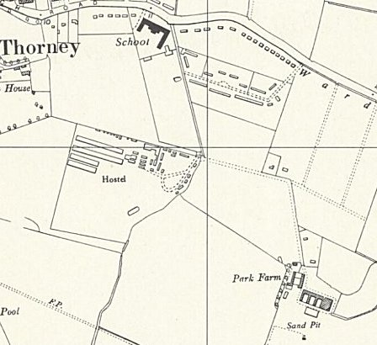
 | Ordnance Survey 1958

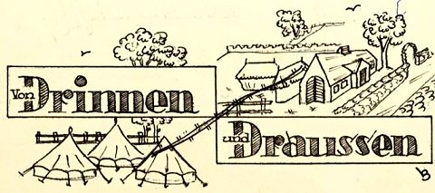 | 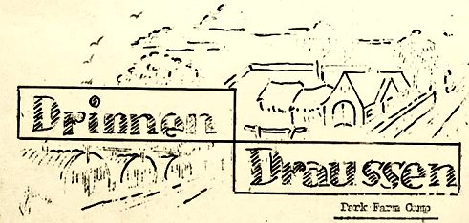
From tents to huts; shown in the title pictures for the camp magazine – March 1946 and November 1946

