Camp 6 (& 578, 580, 685) - Long Marston Camp, Warwickshire

Included in the 1945 ICRC Camp list – Labour Camp. 578. No 9 Camp, E.S.C.D. Long Marston, Stratford-on-Avon, Warwicks.
Included in the 1945 ICRC Camp list – Labour Camp. 580. No 5 Camp, E.S.C.D. Long Marston, Stratford-on-Avon, Warwicks.

Prisoner of War Camps (1939 – 1948) - Project report by Roger J.C. Thomas - English Heritage 2003
OS NGR | Sheet | No. | Name & Location | County | Cond’n | Type 1945 | Comments
SP 15 48 | 151 | 6 | Long Marston Camp | Warwickshire | 5 |  | Ordnance Depot
SP 160 470 | 151 | 685 | No.3 Camp, ESCD, Long Marston | Warwickshire | 5 | German  Working Camp | Precise location not identified. NGR for centre of complex. Central Engineering Park.

1947 Camp List
685(G.W.Coy) | N | No.3 Camp E.S.C.D., Long Marston, Stratford-on-Avon | Stratford-on-Avon 3249 | 25(W.O.) | V/1270/4

Location: Based around the railyards and depot at Long Marston. A location for Camp 6 shown on the map (NGR SP 150 480) and a probable Camp 685 also shown – but these may have been the same camp. No information where Camps 578 and 580 were.  The site was a very large railway loop, with sidings, storage sheds and warehouses.  E.S.C.D. – The Royal Engineers Supply Depot was based at this site – C may be ‘Central’, but the exact definition of ‘ESCD’ is uncertain.  Previous Use: Farming land. The Ministry Of Defence purchased the site in 1940.  POW Camp: Italian pows up to March 1946.  22 March 1946 – The camp became a German Working Camp with 776 pows; “2/3 arrived from Belgium, the remainder from USA and Canada.”  Many pows transferred from camps in Belgium had experienced extremely poor conditions. The August report noted that; “the physical condition of the men from Belgium made every political or educational activity during the first 3 months impossible.”  Most pows arriving from the USA had very low morale as they had been misinformed in the US that they were being repatriated. Instead, they found themselves in working camps in the UK. | 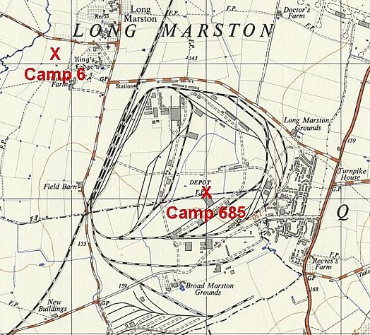
  Oversight and development of re-education activities and English teaching for German pows was carried out by PID (Political Intelligence Department of the Foreign Office) / COGA (Control Office for Germany and Austria – UK). Visits and reports were made. The standard of the reports varied greatly. The visitors took little interest, if any, in activities other than re-education. They rarely mentioned welfare, sports, games, pastimes, crafts, etc of the pows. If there were still Italian pows in hostels, they were usually ignored by PID.
 | Ordnance Survey 1958

Pows from Canada were often C grade; they had been captured early in the war and retained their Nazi ideology.

7/9 August 1946 – The report gave the location as: “No. 685 G.P.W.W. Coy.
No. 6 E.S.C.D.”
1st PID visit to report on Re-education and carry out political screening.

Strength; 0 officers, 776 Other Ranks – “of which 111 are attached from camp 689…. but will be transferred to 685 within a few days.” (689 = Blackmore Camp, Worcester).

Commandant: Major Collier M.C. Camp leader: Fldw Deile (B+)
Interpreter: None Deputy C/L: Faehnr z See J Daedlow (B-)
German interpreter: O/Gefr Reckert (B)

As was the case in many camps, the Commandant had no interest in re-education. Commandants were not required to promote re-education, which was developed by the Foreign Office – the camps were under the control of the War Office. The purpose of the camps was to hold pows and to set them to work when possible. Many Commandants preferred to concern themselves with welfare and other activities rather than re-education – though some did not do that either. If the camp was working and kept under control that was sufficient as far as many Commandants (and the War Office) were concerned. It was stated that Major Collier, “professes to be an opponent of democracy. He is a disciplinarian who regards the PW’s as soldiers and he treats them well….” but he, “discourages or even forbids political discussions of any kind.” It is to be hoped he was opposed to democracy within the camp, and not in general.

The Camp leader was, “suitable.”

Deputy C/L Daedlow had been graded ‘C,’ he was investigated during this visit and upgraded to B-. “A frank youngster who makes a good impression, former HJ (Hitler Youth) leader who is today honestly on the road to realizing the true character of Nazism.”

Political screening: | A | B+ | B | B- | C | Unscreened
 | 31 | 64 | 342 | 141 | 65 | 133

Morale was recorded as “very low.” The main reasons for this were slow repatriation, and 80% coming from the Russian or Polish Zones. Other negative aspects were; news from home; lack of education facilities; and the cut in cigarette rations. Pows from Belgium criticised an article in Wochenpost, “for whitewashing the conditions in the PW camps in Belgium.”

20% of the pows were ‘youth’ (under 25) considered to be in particular need of re-education.

Re-education activities had barely started – the situation was far worse than in most camps. The standard list was given:

Wochenpost and Ausblick: 100 / 0 copies respectively. More requested.

Newspapers – None, and not available locally.

Library – None.

Lectures – 1st lecture just given and met with great interest.

Discussion groups – hoped to start, but “The attitude of the Commandant makes such meetings very difficult.”

Films – YMCA shows only.

Wireless – 2 sets available, but 1 was battery operated.

Camp magazine – being planned. Paper and stencils needed.

Press review – None.

English instruction – 70 pupils, 3 teachers, 2 grades, 50 text books.

Other camp activities –

Religion – Protestant padre, Gefr Wolff (C) and RC priest, San.Gefr Bauer (A), held services on Sundays and weekly Bible classes. Wolff had been a Nazi Party member and had been a prison chaplain – “The unpleasant way in which he now excuses his previous activities make him unsuitable” – he was considered to be otherwise “harmless.”

Education – Classes for German grammar, French, Spanish and technical subjects.

Theatre – a group of 12 pows gave monthly variety shows. Playscripts requested.

Orchestra – 6 players led by a professional musician gave joint performances with the theatre group. Instruments and sheet music needed.

October 1946 – Camp Magazine; Der Gong : 685 G.P.P.W Coy. - The Wiener Holocaust Library. “Publisher: ‘Gong’ press group. For the editor Johannes W Grohsmann. Internal Organ of Camp 6, 685 (G.) PWW Coy (E.S.C.D.) Long Marston.”

Faehnr z See J Daedlow recorded as Camp leader, previously deputy. Chess matches recorded with South Littleton Camp 665 and Springhill Lodge Camp 185.

Herausgeber: Pressegruppe des ‘Gong’. Fuer die Schriftleitung Johannes W Grohsmann. Internes Organ des Camp 6, 685 (G.) PWW Coy (E.S.C.D.) Long Marston.

9 May 1947 – 685 Working Company; Re-education survey. Strength; 1 officer (the M.O.), 1018 OR.

Commandant: Major Hitchcock Camp leader: Faehnr z See J Daedlow (B+)
Interpreter: None Deputy C/L: Uffz Partsch (B)
German M.O.: Ass.Arzt Wamsgans (B)
The camp leader had been upgraded from B- to B+.

Political screening: | A | B | C (or B-) (obscured text).
 | 4 | 906 | 109

400 pows were appealing against their political grades, (the better the grade, the sooner repatriated, in theory). 198 pows repatriated to date.

Morale was recorded as “good.” 200 ‘youth’ pows were no longer considered to be a problem.

Re-education activities had improved, despite no interest from the British staff. Newspapers and library were described as “adequate.” Pows were able to visit garrison film shows. The wireless had extension speakers in all huts. 105 pows were studying English.

The C grade padre was still in place, but no comment made. The RC priest had left, a padre from Ettington Park Camp 31 visited weekly.

Education – classes for maths, sign-writing, French and physics.

Entertainment – the theatre group had grown to 22 performers, they composed their own plays. The orchestra had reduced to 6 players. There was a choir.
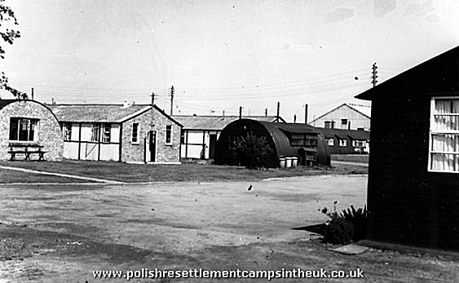
February 1948 - Long Marston was listed as a hostel for Ettington Park Camp 31 with 316 pows.

After the camp: Continued to be used as an army storage depot up to 2004. Polish demobilised soldiers recorded as working here from 1948 to 1968.

Many of the accommodation buildings around the depot were used as Polish Resettlement Camps.

Mixed accommodation buildings at Long Marston depot. These were used for Polish Resettlement – further pictures at: https://www.polishresettlementcampsintheuk.co.uk/longmarston.htm >>>

Further Information:

The Imperial War Museum has a copy of the magazine dated Christmas 1946. Ref LBY E.J. 364

National Archives – FO 1120/246. Used above.

