Camp 261 Ampthill, Bedford, Bedfordshire

Prisoner of War Camps (1939 – 1948) - Project report by Roger J.C. Thomas - English Heritage 2003
OS NGR | Sheet | No. | Name & Location | County | Cond’n | Type 1945 | Comments
TL 029 383 | 153 | 261 | W.D. Camp, Ampthill | Bedfordshire | 4 | German Working Camp

Location: Ampthill Park is located to the north-west of Ampthill in Bedfordshire on the edge of the town. Possibly a few huts still shown on the OS map. The nearby Ampthill Camp Memorial Cross does not refer to the POW camp, it is a memorial from the First World War.  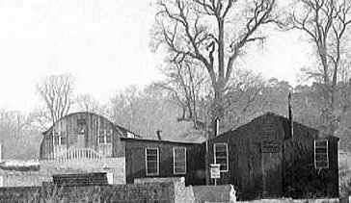  Before the camp: Country Park.  Pow Camp:  1943 - an Italian pow hostel for Ducks Cross Camp 72 was listed at Ampthill.  Spring/Summer 1945 – listed as opened for German pows with capacity of 500. (Progress report 152 – FO 939/383).  Wooden and Nissen type huts.  <The camp in 1949. (County Records Office Bedfordshire).  November 1946 – listed as a satellite camp for Luton Camp 270. Reports – see 270.  After the camp: Parkland. Football pitches and sports are by the site of the camp. | 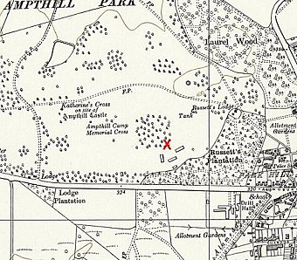
 | Ordnance Survey 1960

Further Information:

