Camp 259 Weekley Camp, New Ground Spinney, Boughton Park, Weekley, Kettering, Northamptonshire

1947 Camp List
259(G.W.C.) | Weekley Camp, Weekley, Kettering, Northants | E. | Priswar, Goddington | Kettering 3893 | Kettering | Lt.Col. C.A.Fowler | v/1453/2

Prisoner of War Camps (1939 – 1948) - Project report by Roger J.C. Thomas - English Heritage 2003
OS NGR | Sheet | No. | Name & Location | County | Cond’n | Type 1945 | Comments
SP 893 818 | 141 | 259 | Weekley Camp, New Ground Spinney, Boughton Park, Weekley, Kettering | Northamptonshire | 4 | German Working Camp | STANDARD type. Restored parkland. See Camp no.35.

Going for a Boughton – 3 of them with similar names:
Camp 35 - SP 749 664 – In Boughton Park by village of Boughton, Northamptonshire.
Camp 259 - SP 893 818 – Weekley camp in Boughton Park by Boughton House, Northamptonshire.
Camp 633 - SK 6835 679 – New Ollerton, Nottinghamshire (aka Proteus camp).

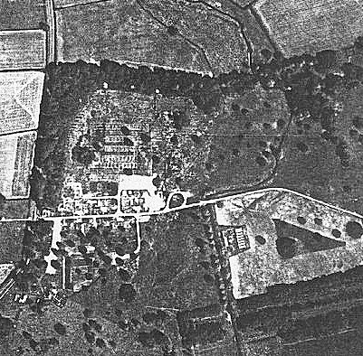  Location: New Ground Spinney is marked on the map, the NGR shown at X.  Before the camp: Part of the estate for Boughton House.  Pow Camp: “Built among beautiful old trees.”  Most pows at this working camp were employed on local farms and in brick works.  Spring/Summer 1945 – listed as opened with capacity of 1240. (Progress report 152 – FO 939/383).  13 August 1945 - 300 German pows arrived, followed on 23 / 27 August by a further 950. Mainly tented accommodation.  March 1946 – Camp magazine:  Die Brucke : Monatsschrift des PWW Camp 259 - The Wiener Holocaust Library | 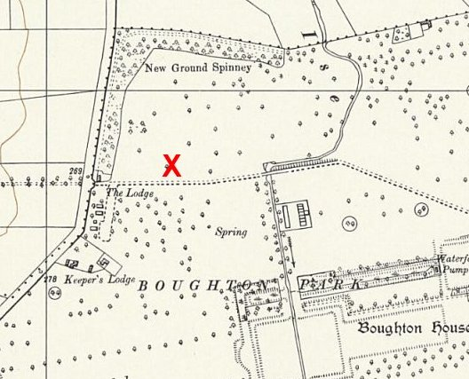
 | Ordnance Survey 1958
9 April 1946 – A visiting German lecturer, Mr P F Doring, gave a very enthusiastic report about the camp: “Weekley Camp is the happiest Camp I have seen so far. Although the prisoners are housed in tents there is a feeling of quiet happiness in the Camp and every single man the present writer has spoken to is full of praise and gratitude.” He stated that the previous Commandant, Major Williams, was adored – and the present Commandant, Major Collins, and Captain Smith were admired and loved. “It is really blessed work these gentlemen are doing.”

Early April 1946 – approximately 200 pows arrived from Canada and the USA. They were not, at first, seen as a particular problem.

30 April 1946 – A further 301 pows arrived from USA and Canada. The pows from the USA were particularly discontented as they had been mis-informed in the States that they were returning to Germany, when in fact their UK destination had been known. Amongst these pows were 208 Category C/C+ pows – regarded as potential troublemakers.
4 May 1946 – the next lecturer, Richard Broh, also commented on the popularity of the Commandant. The nature of the pows overall had changed in part due to the arrival of pows from Canada and the U.S. Many of the pows from Canada had been held for several years, and some still held the Nazi ideology that had been strong in the early years of the war.
29 May 1946 – another lecturer reported that about 400 pows had been transferred from this camp, leaving a complement of c.1500. From the comments in the next report, it would seem this group included many of the Nazi pows who had recently been returned from Canada.

Oversight and development of re-education activities and English teaching for German pows was carried out by PID (Political Intelligence Department of the Foreign Office) / COGA (Control Office for Germany and Austria – UK). Visits and reports were made. The standard of the reports varied greatly. The visitors took little interest, if any, in activities other than re-education. They rarely mentioned welfare, sports, games, pastimes, crafts, etc of the pows. If there were still Italian pows in hostels, they were usually ignored by PID.

1 – 2 June 1946 – General Survey. Strength 1 officer (the M.O.); 1777 O.R.

Political screening: | A+ | A | A- | B+ | B | B- | C | C+ | Unscreened
 | 9 | 107 | 53 | 87 | 528 | 69 | 694 | 41 | 173

Commandant: Lt Col Fowler Camp Leader: Josef Einsfelder (A) [Spelling ? Insfelder in a later report]
Interpreter: S/Sgt Kahn Deputy C/L: Heinz Foil (A)
German M.O.: Ass.Arzt Hoelkemann (A-, est B+)

The Commandant was a new appointment, he had previously been Commandant at Ledbury Camp 27.

Living accommodation was still in tents – some huts had been built and used as communal facilities – cooking, dining, ablutions…. Electric lights were to be installed in the huts – but in a 1948 report there was still a shortage of electric lighting in the camp. The theatre held at least 280 people.

Morale was fairly high – but low for pows who were not working. Pows from Polish zones were not receiving news from home and that created a lot of worries.

Standard re-education activities were starting up:

Wochenpost – 140 received.

Newspapers – English newspapers received in large numbers; only 5 or 6 copies of German papers now and then.

Library – very small

Lectures – 1 or 2 a month.

Discussion group – every 3 weeks, good attendance.

Films – from YMCA.

Wireless – 5 loudspeakers controlled by the British staff, but soon put under German control when electricity was available.

Camp Magazine – started.

News reviews – daily extracts from newspapers were posted on notice boards.

English Instruction – 200 pupils with 4 pow teachers.

Other activities:

Religion – both denominations were amply catered for. Protestant padre von Feilitzsch lived in the camp; RC Priest visited from Boughton Park Camp 35.

Theatre – light entertainment.

Orchestra – good, light and classical music.
15 June 1946 – Lecturer, Paul Senft, reported that he had received mixed reactions from pows – including Nazi and anti-Nazi views. However, the more extreme Nazi group from Canada had been moved from this camp; “A group of strongly Nazi-minded POWs, who came from Canada and centred round a university-lecturer and kept up all their army-habits, are no longer there; they were reported to have been opposed and derided by most older POWs in this camp.”  7 – 8 July 1946 – English Inspector’s Report. Strength – 2083.  1300 of the 1355 pows at the main camp were still accommodated in tents. A new satellite camp had been added at Little Addington, previously Camp 98; and a hostel at Corby.  There were 3 classes for English.  15 July 1946 – Lecturer, K P Pringsheim, commented on how frequently this camp received lecturers. He stated that there were major differences in the political attitudes between the sites. Weekley main and the hostel were regarded as mainly white (A grade) and often anti-Nazi. The Satellite Camp was led by a pow who was against any attempt at political discussion, and the lecturer wondered about the negative effect of SS-men at that camp. He recommended that the leader and the SS were removed. | 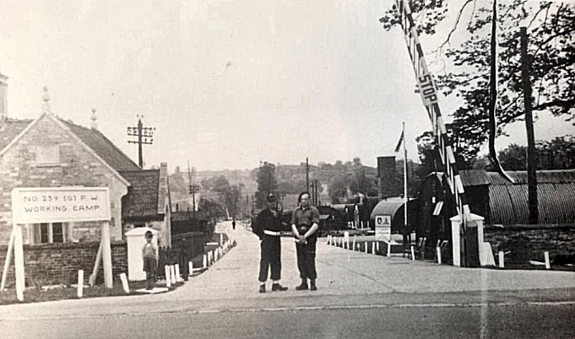

28 July 1946 – Another lecturer, B Borkon, was not impressed by the camp. He found the British management to be extremely lax and disorganised. He commented that, “Not one of them was in uniform. The commandant was away, and the adjutant in charge passed his time in accompanying his wife and baby and dog in and out of the British side of the camp. Though they were all very charming people individually.” His visit lasted over a weekend, so I am not sure if that may have had some part to play as other lecturers did not mention poor management.

10 November 1946 – a lecturer mentioned that a suicide occurred in the camp on the previous day. Likely to have been Karl Gottstein, the only German death recorded by the CWC on that day – he was later reburied at Cannock Chase German Military Cemetery.

15th November 1946 - Incidental information from a German theatre group journal held by the Deutsches Historisches Museum. The group toured pow camps around England during 1946. It recorded its visit to Weekley Camp, 259 on 10th – 15th (5 performances).

27-28 November 1946 – English Inspection Report. Strength 2095 in main camp, 1 satellite and 1 hostel.

Camp Leader / Lagersprecher was recorded as ‘Becker.’

31 December 1946 – there was a visit from the Segregation Section to review political screening. Figures similar to next report.

6 January 1947 – a visit was made to inspect Re-education. Strength 2 officers and 2023 O.R. 174 pows had been repatriated to date.

Political screening: | A+ | A | A- | B+ | B | B- | C | C+
 | 4 | 175 | 2 | 299 | 1147 | 296 | 95 | 7

Commandant: Lt Col G A Fowler Camp Leader: Becker Otto (B+) now “C”
Interpreter: S/Sgt Wagner (Main Camp) Deputy C/L: Demaker Franz (A)
“ Rabel (Little Addington) German M.O.: Hoelkemann Dr. Ob.Lt. (A)

This report was largely negative which was unusual in comparison to others. Although the British staff were “co-operative and meticulous in all their obligations to the P.W.,” little interest was shown in re-education, except by the Officer in command at Little Addington, Captain Creed. It was recommended that the Interpreter at Little Addington be replaced as he was obstructive to re-education.

The camp leader had been ‘elected.’ Aged 33. He ran the camp on military lines and had been a Nazi party member. The visitor recommended he be replaced and was downgraded to category C. However, it was noted that although, “the military authorities are aware of our difficulties. They are reluctant to change him for he runs the camp with good discipline and the C.O. likes him.” It was not recommended that the deputy should replace him, as he was due to be repatriated.

Morale was considered to be low, mainly due to news from Germany and the slow rate of repatriation. ‘Political Progress’ in the camp was regarded as poor, mainly due to the lack of re-education activities. Nazis did not have a strong influence in the camp, but many pows were forming into cliques and there was little regard for democratic ideals.

30% of the pows were ‘youth’ (under-25). They were regarded as a problem as many were cynical and showed disrespect, apathy and negativism. It was recommended that a group be sent for training at the Training Centre, (Wilton Park Camp 300).

Re-education activities were listed as ‘poor’ – and yet the standard list of activities was given and seems fairly active:

Newspapers – British, Swiss, Austrian and German papers were received (except from Russian zones).

Library – adequate, but a need for circulation to the satellite and hostel.

Lectures – only 3 lectures in the previous 3 months.

Discussion groups – held weekly, but were ‘slackening off.’

Films – one a week from Gaumont British and YMCA.

Wireless – adequate.

Camp magazine - Die Brűcke (The Bridge) – 225 copies of 6-10 pages each month.

English Instruction – running very well.

Information room – organised but pows not very enthusiastic.

Other activities:

Religion – 30% of pows interested. A visiting priest from another camp visited once a month for Roman Catholics. Weekly visits by an English priest from Kettering.

Education – courses were held for English, French, physics, chemistry, mathematics and commerce.

Entertainments – 19 members formed a theatre group producing mainly comedies and cabarets. “Fairly good” orchestra of 10 men. Choir of 40 pows.

Though this report stated that there was little interest in re-education shown by the commandant and British staff, a visiting lecturer shortly after stated the opposite and praised the work being carried out. The next report supported the lecturer’s views.

9 – 15 June 1947 – Re-education Survey and to look at “Establishing outside contacts”. Strength – 1 officer, 2018 O.R.

Political screening: | A+ | A | A- | B+ | B | B- | C | C+
 | 2 | 14 | 1 | 333 | 1228 | 352 | 89 | 0

Commandant: Lt Col G A Fowler Camp Leader: Kahle, Gerd (N0.37344) (B+)
Interpreter: none Deputy C/L: Puerner, Albert (N0. 342929) (B)
German M.O.: Dr Hoelkmann, Bernhard (No. 1146) (A)
609 pows had been repatriated to date.

“Lt Col G A Fowler is an important influence in re-education, he knows what COGA is doing and does every thing possible to augment our efforts by establishing and maintaining outside contacts.”

The camp leader had been in position for about 2 months – “Most outstanding personality of the camp. 38 years old, no party history, scientist, (Botany and Foresting) by profession and free lance explorer. Seven and a half years a PW in Canada and England and has deferred repatriation in the hope of being allowed to return to Canada.”

Morale was; “Good throughout the camp. This is due to a just and fair administration, a good environment, a first class camp speaker, well organised activities in all departments, re-education, sport, theatricals, outside visits and a steady flow of repatriations.”

Political progress was seen to be good with only a few Nazi elements left, and a developing “democratic spirit.”

30% of the camp were Youth Pows (under-25). Previously seen as a problem, but this report was far more positive due to; “The spirit of friendly help from the older PsW.”

Re-education was well organised. Outside contacts had developed with civilians at Kettering. Four huts were used for re-education.

Wochenpost and Ausblick – separate appendix.

Newspapers – Adequate British papers, but foreign newspapers were rare. One newspaper ‘Das Andere Deutschland’ printed in South America was sent to the camp by the SPD in London [Social Democratic Party]. It was described as being left-wing and had previously been referred to the Foreign Office as potentially subversive.

Library – 1500 mixed books. At the Satellite camp the pows subscribed 1d per week to buy new books.

Lectures – regular.

Discussion Groups – once a week with a “good critical spirit.”

Films – weekly

Wireless – adequate.

Camp Magazine – 200 copies of 12 pages each month.

Press review – weekly and circulated to Information Room and hostels.

English Instruction – separate appendix.

Information Room – popular, but request made for exhibitions to be sent.

Other activities –

Religion – 10% active. Adequate arrangements with a pow pastor and a priest visting from Kettering. “Many of the Youths tainted by the SS oath and outlook are ashamed to go to church and prefer to sneak in a side door lest they be seen by their comrades.”

Education – well organised and a range of subjects.

Entertainments – good theatre group, orchestra and choir, variety shows given monthly. Sport was popular, there was a football ground where matches were played against other camps and civilian teams.

Visits – groups of pows had, (or were about to), visited Kettering local council, Oundle School, and a local music festival.

June 1947 - the satellite camp at Little Addington was closed.

August 1947 – Three hostels previously attached to Stamford Camp 106 were re-assigned to Weekley – Blatherwycke, Wansford and Colleyweston

9 – 12 September 1947 – E E M Rolfe visited the camp to survey Re-education. Strength 2 officers, 2803 O.R.

Commandant: Lt Col G A Fowler Camp Leader: Uscha. Blanck, Siegfried (B+)
Interpreter: S/Sgt Burstyn Deputy C/L: Owm. Puerner, Albert (N0. 342929) (B+)
German M.O.: St.Arzt Dr. Wurtz, Hans (B+) / St.Arzt Dr. Schultze-Jena, Bernhard (B-)

Political screening: | A+ | A | A- | B+ | B | B- | C | C+
 | 1 | 17 | 1 | 552 | 1774 | 460 | 0 | 0

833 pows had been repatriated to date.

The visitor commented that the Commandant was; “socially cultivated.” The British staff had little involvement in re-education. “The young interpreter at HQ (S/Sgt Burstyn, an Austrian Jew) is used by the Commandant for office purposes…” “S/Sgt Buchler at Collyweston… will be demobilised in 2 weeks time, and then there will be very little political supervision in the whole of No.259 Camp.”

Camp leader; “Specially seconded to this position by the W.O. A weak young man. He means well and will make no difficulties.”

Study leader (Fw Hans Waldmann) “45 years old, law student, ex Party member, convinced Catholic, anti-communist. The leading personality in the camp…. A good influence, but not a political inspiration.”

German M.O. (Wurtz) “A very amiable man. Ex ‘C’ (screened in Ireland); ex P.G., joined S.A. in 1945. Nonchalant laissez-faire attitude…”

Morale at the main camp was “moderately high”, but many pows showed political passivity and apathy. A passing remark was made that; “PsW are not carried on the bus service to Kettering.” – however good relationships were forming in the town with various groups. The refusal of the bus service to carry pows was reported on again later.

Youth pows were pleased with new freedoms that had been granted and that part of their pay was given in English money rather than camp tokens.

Re-education activities continued much as before, though some were being affected by repatriations.

September 1947 – K Bloch visited the camps to give lectures about; “The Jewish Question.” The camps were politically stable for him to hold q/a sessions afterwards without any animosity being shown.

4-6 October 1947 – English Inspector’s Report. Total strength 2382 in main, 2 satellites and 2 hostels.

Autumn 1947 - Boughton Park Camp 35, became a satellite to Weekley. Harrington Hostel was transferred from Byfield Camp 87.

13 - 16 November 1947 – Re-education survey. Strength 3 officers, 3267 OR.

Simplified screening fugures were given – A : 9 / B : 3261. 1302 pows had been repatriated to date.

No change in British / German senior personnel since the last report.

Blatherwycke and Corby Hostels were due to close.

Morale was regarded as having deteriorated due to length of captivity, delays and issues for mail from home. Another suicide was recorded, this for a pow who was middle aged with 4 children who was due to be repatriated to the Russian Zone.

Re-education activities were similar to previous reports. Good relationships were recorded with the people of Kettering. The local bus company (United Counties Omnibus Co). were prepared to carry pows, but the local union committee declined to do so – this still occured in April 1948. (Also at other local camps – eg. Byfield Camp 87).

20 – 22 December 1947 – Mr Rolfe returned for another re-education survey. Strength 3 Officers and 2898 O.R.

Screening figures: A – 9 / B – 2892. 1722 pows repatriated to date.

Another interpreter had been added to the staff: S/Sgt J Zajac, though both were due to be demobilised. The German M.O. was listed as St.Arzt Dr. Rutz, Hermann (B-).
Re-education activities were similar to previous reports. Though there were some difficulties with outside people, outside contacts for the pows were increasing, and a number of pows had attended the special training camp at Wilton Park.

28 January – 1 February 1948 – English Inspector’s Report. Total strength 2468 in main, 2 hostels and 3 satellite camps.

13 – 16 April 1948 – Re-education survey and Outlook. Strength – 2 officers, 1228 O.R.

Commandant: Lt Col G A Fowler Camp Leader: O/Wm Puerner, Albert (B+)
Interpreter: None Deputy C/L: Sauke, Ernst (B)
German M.O.: St.Arzt Rottshal (B+) [At Weekley] / O.Arzt Schultze-Jena (B-) [At Wansford]

The previous camp leader, Siegfried Blanck – “ex-Polizei Div. Panzer Regt., C/L at HQ since Sept ’47…. Was a very poor selection. Completely woolly minded, he lacks positive outlook, with however, strong anti-British bias. I arranged for his immediate transfer to 186 camp, and for his replacement by O/Wm Puerner (B+/29), Deputy C/L since February 1947. The Commandant had already suggested this solution of his C/L problem.” [Camp 186 – Fornham Park]. It was very unusual for such immediate action to take place, recommendations for removal often took months, if affected at all.

A survey was conducted in camps still open at this time concerning pow attitudes to the British, (following a PID circular dated 25.2.1948). It was pointless, carried out far too late and in totally random ways. Some visitors simply gathered whoever was around and asked them to give a show of hands to the questions, some only asked a ‘selected’ group – most did not state how the data was gathered or the numbers involved. The results for Weekley are of little, if any, value.

Attitudes to British: | Hate | Dislike | Distrust | Indifference | Benefit of doubt | Liking
 | 2% | 30% |  | 30% | 20% | 18%

Negative reasons given:

- the western powers were weak when dealing with Russia.
- a general feeling that there were improved conditions in the Russian controlled zone.
- length of captivity, “We condemned the Nazis for organised forced labour, and yet we have retained up to half a million slave workers in Britain”;
- maltreatment at the immediate end of the war
- bad conditions in Germany being blamed on the occupying powers.
- conditions in the camp; lack of electric lights; strict discipline; harsh treatment by employers; the Kettering busmen.

Outside contacts - Visits to Kettering Council meetings had ceased. Harrington had particular problems as Kettering was 10 miles away, and Northampton 12 miles. There were well attended meetings with the Anglo-German Fellowship. The visitor hoped that more visits would be made, and a possible trip to London.

Other activities were gradually being ended due to the repatriation of many of the organisers.

There were no further reports in the Foreign Office files.

The camp closed soon after this report.

Known Camp Commandants:

c.1945 – 1946 Major Williams
1946 – ? Major Collins
May/June 1946 - 1948 Lieutenant Colonel G A Fowler, previously with Sandbeds C53 and Ledbury C27.

After the camp: Reverted to parkland.

Camp numbers

 | Open |  |  | With other camps |  |  | Unknown |  |  | Not listed / not open

 | 8/45 | 6/46 |  | 7/7/46 | 7/46 | 11/46 | 1/47 | 6/47 | 9/47 | 10/47 | 11/47 | 12/47 | 2/48 | 4/48
Weekley | c.1250 | 1778 |  | 1247 | 1250 | 1252 | 1335 | 1358 | 1406 | 1156 | 1312 | 1300 | 990 | 850
Little Addington | Camp 98 |  |  | c.650 | 620 | 619 | 617 | 412
Corby |  |  |  | c.80 | c.75 | 74 | 73 | 79 | 82 | 47 | 43
Colleyweston | Hostel for Camp 10/106 |  |  |  |  |  |  |  | 538 | 491 | 523 | 432 | 10
Wansford | Hostel for Camp 10/106 |  |  |  |  |  |  |  | 713 | 628 | 606 | 521 | 418 | 242
Blatherwycke | Hostel for camp 10/106 |  |  |  |  |  |  |  | 66 | 63 | 61 | 34 | 35
Boughton Park Sat. | Camp 35 |  |  |  |  |  |  |  |  |  | 411 | 364 | 458
Harrington | With C 54/49 |  | Satellite / Hostel for Camp 87 |  |  |  |  |  |  |  | 314 | 250 | 162 | 138
Billetees | 0 | 0 |  | 108 | ? | c.150 | 0? | 170 | ? | ? | ? | ? | 274 | ?
Total |  | 1778 |  | 2083 | ? | 2095 | 2025 | 2019 | 2805 | 2382 | 3270 | 2901 | 2468 | 1230

The number of billettees was often confused in the reports, eg 108 in the English Inspector’s report of July 1946 / 0 in the survey carried out in the same month. It seems that pows in billets were often included in the main camp total. Several of the totals do NOT add up from the figures above.

Further Information:

National Archives:
FO 939/182 – 259 Working camp, Boughton House Camp, Weekley, Northamptonshire. Dated 1945 – 1948. Used above - a lot of this file is duplicated from file below.
FO 939/314 – 259 Working camp, Boughton House Camp, Weekley, Northamptonshire. Dated 1945 – 1948. Used above.
FO 1120/238 – Re-educational survey visit reports for camps 257 to 259. Dated 1 January 1946 – 31 December 1948. Duplicates of reports in files above.

IWM have a copy of the camp magazine from January 1948. Catalogue LBY E.78946-5

Satellite and Hostels
Little Addington – formerly Camp 98.

July 1946 – c.650 pows all accommodated in huts. Lagersprecher H Schuermann Zu Berghof.

January 1947 – Camp leader, ob. F/W Meyer, Kurt (A)

June 1947 – Camp leader, Illg, Alfred (No.103293) (B+) – “former school teacher, 34 years old, four months in this job, no party history, quite suitable and co-operative in re-education.”

 | 8/45 | 6/46 | 7/7/46 | 7/46 | 11/46 | 1/47 | 6/47 | 9/47 | 10/47 | 11/47 | 12/47 | 2/48 | 4/48
Little Addington | Camp 98 |  | c.650 | 620 | 619 | 617 | 412

Blatherwycke, Bulwich, Northamptonshire

September 1947 - Camp leader Ogefr. Tiedemann, Walter (B+); “…utterly reasonable, sound to the core, an excellent moderating and humanising influence…” Same C/L 12/47.

 | 8/45 | 6/46 | 7/7/46 | 7/46 | 11/46 | 1/47 | 6/47 | 9/47 | 10/47 | 11/47 | 12/47 | 2/48 | 4/48
Blatherwycke | Hostel for Stamford camp 106 (10) |  |  |  |  |  |  | 66 | 63 | 61 | 34 | 35

Boughton Satellite – formerly Camp 35.

November 1947 - Camp Leader - Stock, Werner (B-) and 12/47.

December 1947 – the camp had many contacts with local people and groups.

 | 8/45 | 6/46 | 7/7/46 | 7/46 | 11/46 | 1/47 | 6/47 | 9/47 | 10/47 | 11/47 | 12/47 | 2/48 | 4/48
Boughton Park Sat. | Camp 35 |  |  |  |  |  |  |  |  | 411 | 364 | 458

Collyweston. Previously a hostel for Stamford Camp 106. Opened August 1946.  August 1947 – Three hostels attached to Stamford Camp 106 were re-assigned to Weekley Camp 259 – Blatherwycke, Wansford and Collyweston.  September 1947 – Camp leader Gefr. Koormann, Paul (A). Morale was low with; “long hours of work in the brick factories near Peterborough (19 miles away) mean that for five days in the week most of the men here spend almost 12 hours a day away from camp.” The commandant was trying to close this camp down, but it lasted until 1948.  A pow had recently committed suicide “He had been transferred from a hostel and was cut off from his English girlfriend. It appears from his diary that this preyed on his mind, and completed the overthrow of a not very firmly-grounded personality.”  October 1947 – British officer i/c Captain Farrop. | 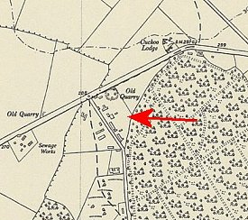 | 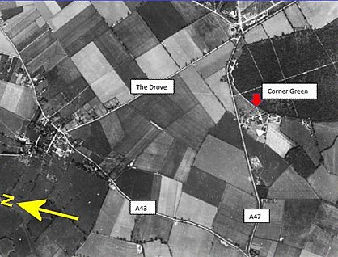
 | OS 1952 – NGR TF 0005 0142 | Aerial photograph of site alongside the A147

November 1947 – Camp Leader Koehler, Willi (B) and 12/47

December 1947 – reported that pow relationships with the foremen in the brickworks at Peterborough were not good.

Mid January 1948 – due to close, not included in the April 1948 report.  After the camp:  Site used as emergency housing.  With thanks to Sandra Johnson, Researcher for the: www.collywestonhistoricalsociety.org.uk for helping me find the location and supplying the photograph of the hut. | 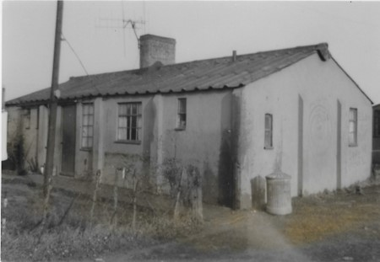
   | 8/45 | 6/46 | 7/7/46 | 7/46 | 11/46 | 1/47 | 6/47 | 9/47 | 10/47 | 11/47 | 12/47 | 2/48 | 4/48
  Colleyweston | Hostel for Camp 106 |  |  |  |  |  |  | 538 | 491 | 523 | 432 | 10
Corby Hostel (there were a few large camps near to Corby – but the number of pows at this Corby hostel is very low and probably only a few huts in use).

1943 – Corby listed as a hostel for Italian pows with Farndon Road Camp 49.

Many pows worked at the Corby steel works.

July 1946 - c.80 pows all accommodated in huts.

January 1947 – Camp leader, F/W Kolster, Wilhelm (C). Described by the Segregation team in December as; “almost a C+ but seems too muddleheaded to be dangerous. His removal has been recommended to the Adjutant.”

June 1947 – Camp leader, despite the previous recommendation in January, no change – “Not an ideal type, and there is hope that he will soon be changed.”

September 1947 – same as above, but now regraded as (B) – same 11/47.

 | 8/45 | 6/46 | 7/7/46 | 7/46 | 11/46 | 1/47 | 6/47 | 9/47 | 10/47 | 11/47 | 12/47 | 2/48 | 4/48
Corby |  |  | c.80 | c.75 | 74 | 73 | 79 | 82 | 47 | 43

Harrington Hostel - Remotely situated, 7½ miles from Kettering. Further details – see Camp 54.

November 1947 – Camp Leader Uffz. Leuschner, Adolf (B) and 12/47 – “a young man of considerable intelligence. He was in the SS, but it is obvious that he has thought things out for himself since then.”

April 1948 – Camp Leader, Nickel (B)

 | 8/45 | 6/46 | 7/7/46 | 7/46 | 11/46 | 1/47 | 6/47 | 9/47 | 10/47 | 11/47 | 12/47 | 2/48 | 4/48
Harrington | With C54/49 | Satellite / Hostel for Camp 87 |  |  |  |  |  |  |  | 314 | 250 | 162 | 138

Wansford

September 1947 – Camp leader Fw Schreiber, Adolf (B+); same 4/48.

December 1947 – “great resentment is caused by the action of military police in Peterborough, Ps/W are continually being charged with being improperly dressed, and at present 14 men are serving sentences of C.B. (7 days or 14 days).” The camp visitor hoped that the Steel Works at Corby would not require pows to work late on Christmas Eve. 50% of the pows were ‘youth’ (under-25).

 | 8/45 | 6/46 | 7/7/46 | 7/46 | 11/46 | 1/47 | 6/47 | 9/47 | 10/47 | 11/47 | 12/47 | 2/48 | 4/48
Wansford | Hostel for Stamford Camp 106 (10) |  |  |  |  |  |  | 713 | 628 | 606 | 521 | 418 | 242

