Camp 22 (& 157) - Bourton Camp, Bourton-on-the-Hill, Gloucestershire

1947 Camp List
157(B.C.) | Bourton Camp, Bourton-on-the-Hill, Moreton-in-Marsh, Glos. | S. | Priswar, Bourton-on-the-Hill | Blockley 297 | Moreton-in-Marsh (G.W.R.) | Lt.Col.A.F.B.Powell | v/202/4 (over 1500PW)

Prisoner of War Camps (1939 – 1948) - Project report by Roger J.C. Thomas - English Heritage 2003
OS NGR | Sheet | No. | Name & Location | County | Cond’n | Type 1945 | Comments
SP 160 321 | 151 | 157 | Bourton Camp, Bourton-on-the-Hill | Gloucestershire | 4 | Base Camp | LARGE STANDARD. Large complex comprising six prisoner compounds. Each compound enclosed by a double wire perimeter and guarded by watchtowers. Site presently under forestry.

Location SP 160 321 Large camp shown on OS map – smaller camp to north is listed as ‘Hostel – Gloucester County Agricultural Board’. Road running alongside is the A424.  Before the camp: Fields  POW Camp: Italian, then German POWs.  Late 1942 – Camp 22; about 500 Italian pows recorded.  1944 / 45 - Listed as American Transit Camp No. 1 located in the UK united states pow theatre of operations enclosure no 1.  6 June 1945 – Camp 157; Commandant Lt Col Hanbury.  1 August 1945 – 1,284 pows = 1205 German; 60 Austrian; 6 Polish; 13 Czechs held in 2 compounds. Further details see *  September 1945 - Appendix to HQ Southern Command War Diary – Bourton On The Hill – Base camp – capacity 4000.  17 September 1945 – ICRC Inspection by Major Frédérick Bieri. Commandant Lt.Col. A F B Powell *.  14 November 1945 – ICRC Inspection by Rodolphe Haccius. 3,187 pows in 4 compounds. Same commandant. Camp leader Hpt Hans Sceibelein *.  DER NEUE WEG  DER NEUE WEG  DER NEUE WEG  DER NEUE WEG | 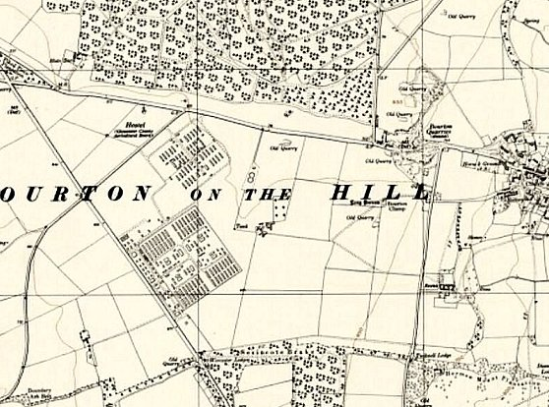
 | Ordnance Survey 1955

February 1946 - A question was raised in the House of Commons about the repatriation of pows held here: “Mr. Edelman asked the Secretary of State for War whether he will now consult with the Chancellor of the Duchy of Lancaster in order to expedite the repatriation and release of anti-Nazi German prisoners of war, formerly at Camp 7, Ascot, and now mainly at Camp 157, Bourton-on-Hill, who gave useful political information and service to the prisoners-of-war programme of the B.B.C. and who could play a valuable part in the reconstruction of a democratic Germany.

Mr. Lawson - 316 anti-Nazi prisoners of war from Camp 157, who were formerly at Camp 7, Ascot, were repatriated on 7th February. A further small number of prisoners of war who were at Camp 7 will be concentrated for repatriation in the near future. Others who are at present actively employed at this camp will be repatriated as soon
as replacements can be found.” (House of Commons, Written answers, 12 February 1946, Volume 419).

January 1947 – 2 pows died from heart failure; Willhelm Schwarz (ex-German Merchant Navy - 15th) and Wilhelm Dettmann (listed as a German civilian - 21st). Both were reinterred at Cannock Chase German Military Cemetery.  June 1947 – Camp magazine; Der Neue Weg : P.O.W. Camp 157 - The Wiener Holocaust Library  October/November 1947 – Reported by Camp 92 that their excellent Interpreter Officer, Lt Grenville was transferred to this camp.  11 November 1947 – ICRC Inspection by Edmond Aeberhard. 401 pows (including 107 pow staff) *.  14 November 1947 - Camp number included in an ‘Urgent Memorandum’ (FO 939/270) regarding inspection of food parcels.  Known commandants:  1945 - Lt Col Hanbury.  1945 - ? Lt.Col. A F B Powell – from the Royal Artillery. Previously Commandant of North Burton Camp 158.  Further information:  The Imperial War Museum has two copies of the camp magazine ‘Der Neue Weg’ (The New Way) for camp 157. Dated February and Jun 1947. Catalogue number LBY E.J. 398  * Inside the Wire – Chapter 6 – Ian M C Hollingsbee – 2014 – The History Press.  Archived photos of the camp - https://www.chippingcampdenhistory.org.uk/content/catalogue_item/pow-camp-photos-bourton-on-the-hill-2009  Hostel  Elkstone –  August 1946 - Listed as being transferred to Leckhampton Camp 263 from Camp 157. | 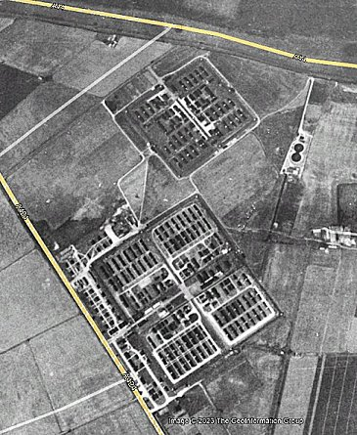
 | Google Earth Pro images. 1945

