Camp 166 - Wollaton Park Camp, Nottingham, Nottinghamshire

1947 Camp List
166(G.W.C.) | Wollaton Park Camp, Nottingham | N. | Priswar, Nottingham | Nottingham 73025 | Nottingham | Lt.Col.H.S.Hobby | v/1453/2

Prisoner of War Camps (1939 – 1948) - Project report by Roger J.C. Thomas - English Heritage 2003
OS NGR | Sheet | No. | Name & Location | County | Cond’n | Type 1945 | Comments
SK 529 393 | 129 | 166 | Wollaton Park Camp, Wollaton Hall, Nottingham | Nottinghamshire | 4 | Base Camp | Parkland

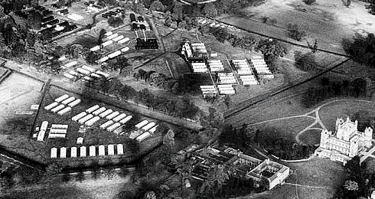 | 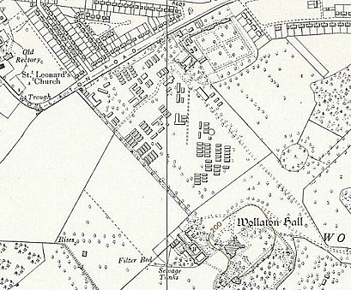
 | Ordnance Survey 1958
Location: Just to the W of Nottingham. Picture above - https://www.britainfromabove.org.uk/en/image/EAW012060

Before the camp: Large estate. American troops of the 508th Parachute Infantry regiment based here.

Pow Camp: Italian and then German pows. Believed that the first batch of Italians converted the troop camp for pow use.

1945 - Pow camp opened, announced in local press.

1945 – Edition 3 of the Camp magazine, 12 pages: Neues Leben : Lagerzeitung 166 - The Wiener Holocaust Library. Camp Leader – Benner.

1946 - Families from across the Nottingham district were sent invitations by the military authorities at Wollaton Park following an article in a newspaper. A map was included in the article illustrating a five-mile radius around the camp.

During 1946 - German pows were shipped back from America, they expected to be returned to Germany. One pow, Paul Seufert, recalled; “We could hardly sleep for thinking what home would be like…” but after they docked at Liverpool the message was soon spread that they; “had been handed over to the Tommies. Suddenly only British officers and soldiers with fixed bayonets were to be seen; the Americans had disappeared. Next day at Woolaton Park we were put into fresh units, filed in the usual way, medically inspected and interrogated. Each of us got a new number. It was like being made prisoner a second time.” (Thresholds of Peace, p170, M B Sullivan, 1979, Hamish Hamilton). No record of disturbances arising from this situation in this camp, but morale was low.

26 September 1946 – Death of pow, Helmut Kumpat, from Wollaton Camp at the General Hospital. Cause Subacute Bacterial Endocarditis. Later reinterred at the Cannock Chase German Military Cemetery.

Oversight and development of re-education activities and English teaching for German pows was carried out by PID (Political Intelligence Department of the Foreign Office) / COGA (Control Office for Germany and Austria – UK). Visits and reports were made. The standard of the reports varied greatly. The visitors took little interest, if any, in activities other than re-education. They rarely mentioned welfare, sports, games, pastimes, crafts, etc of the pows. If there were still Italian pows in hostels, they were usually ignored by PID.

March 1947 – An oil painting depicting a single cross on a mountain peak with trees and mountains was presented by the pows in appreciation of the Christian fellowship to Mansfield Road Baptist Church.

21 March 1947 – Re-education survey. Strength; 3 officers, 1536 Other Ranks. This was the 3rd visit by PID, but the only report held in the National Archive file listed below.

Main Camp | Greenwood Hostel | Billetees | Detached
1490 | 14 | 28 | 7

Commandant: Lt Col Hobby Camp leader; Fw G Rogge (B)
Interpreter: S/Sgt Wilchfort Deputy C/L: None
German M.O.: Dr Henkel and Hessbrűcker.

The Commandant was supportive of re-education activities, but not actively involved. He was regarded as liberally minded; “highly respected by all the Germans for his fairness and just treatment in his duties.”

The Interpreter had only been at the camp for 3 weeks with no experience of working with pows. Like the rest of the British staff, he was not active with re-education activities.

Camp leader Rogge, had recently been elected to this position. “He is quite a sound man, an Antinazi and a very good disciplinarian.”

Political screening: | A | B | C | C+ | Unscreened
 | 118 | 1320 | 93 | 5 | 3

99 pows were appealing against their grade – the better the grade, the sooner repatriated, in theory. 358 pows repatriated to date + 79 due to leave in next few weeks.

Morale had been regarded as low, but had risen to ‘fair’ as repatriations were underway.

40% were ‘youth’ (under-25) – they were not considered to be a problem and there was no special provision for them. Many were ‘pessimistic’ and needed further stimulus to replace Nazi ideas.

The standard list of re-education activities took place:

Newspapers – “adequate supply of both English and Foreign newspapers.”

Library – 1500 books, but more political books requested.

Lectures – separate report.

Discussion groups – Started in February, held weekly.

Films – “adequate.”

Wireless - “adequate.”

Camp magazine – ‘Neues Leben;’ 350 copies with 15 pages, monthly.

Press review – Circulated daily.

Information room – exhibitions on a theme with text and pictures, some made in camp, some sent by PID. “It is one of the best Information Rooms I have visited.”

Other camp activities –

Religion – only 10% interested. Services are “adequate.” Influence of padres was good.

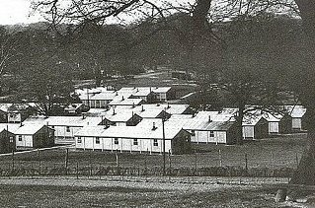
Education – Good range, but repatriations of ‘A’s’ would have a serious effect.

Entertainments – The theatre could hold 200. One show a month was produced. An excellent orchestra of 20 members. The Commandant was requesting permission for the orchestra to give a public performance in aid of the ‘Nottinghamshire Flood Victims.’

April 1947 - An escape attempt was made– “After bloodhounds had been used by Nottingham police, three German prisoners of war who escaped from Wollaton Park camp on Tuesday were found yesterday in a disused farm shed at Heanor, 18 miles away.” (Gloucester Citizen).

The camp seems to have had good relations with the neighbourhood - “German POWS Thanks - Nottm. People ‘Gave us Hope.’ Tribute to the tolerance, generosity and hospitality of Nottingham citizens was paid by Lagersprecher (camp spokesman) Feldw. Hans Rogge of the Wollaton Park German POW Camp at a farewell concert held in the Salvation Army Hall, Nottingham, last night….’Thank you for giving us hope for the future.’… Appreciation of the understanding shown by Col. H.S. Hobby, Commandant of the camp, was also expressed.” (Extracts from article sent to me – from 1947, but without the name of the newspaper).

< Huts in the camp. 1 was kept and converted for use as a café.
(www.flickr.com/photos/45904802@N08/5442836277 )

1947 - The 2 M.O.’s, Dr Henkel and Hessbrűcker, and many pows were transferred to Langar Camp 262.

March 1948 – recorded as a hostel for Langar Camp 262.

Known Camp Commandants:
1947 Lt Col H S Hobby (I think he was from the East Yorkshire Regiment and had been awarded a MC).

After the camp: Reverted to parkland.

Further Information:

National Archives FO 1120/230 – Re-educational survey visit reports for camps 165 to 175. Dated 1 Jan 1946 to 31 Dec 1948. Just 1 report, used above.

IWM have a copy of the camp newspaper dated 1 Mai. Ref LBY E.J. 402. The German Federal Archives also have a copy – date unknown.

Aerial photo - raf_541_113_rp_3074 - Aerial Photo | Historic England

Hostel

Greenwood. NGR SK 602 402. Alongside Greenwood Road.

“Originally we believe this camp site was an army barracks, housing personnel who manned anti-aircraft emplacements that were to protect the ordinance depot in the Meadows area.” https://woods2012.wordpress.com/history/prisoner-of-war-camp/

11/1947 to March 1948 – administered by Langar Camp 262.

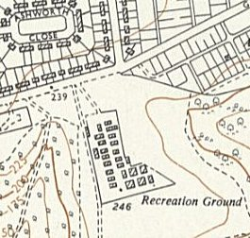 | 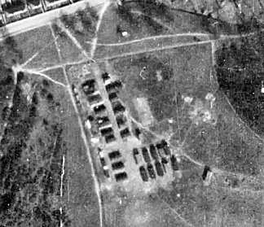 | 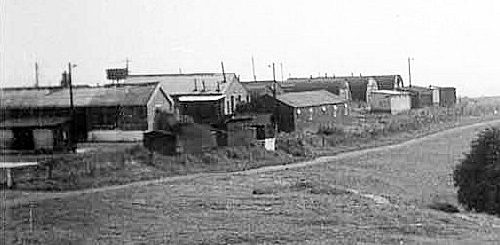
Ordnance Survey 1955 | raf_3g_tud_uk_117_rvp1_6003 - Aerial Photo | Historic England | The camp taken from Greenwood Road.

