Camp 142 - Brockworth Court, Brockworth, Gloucester, Gloucestershire

Included in the 1945 ICRC camp list – Labour Camp. 142. Brockworth Court, Brockworth, Gloucester.

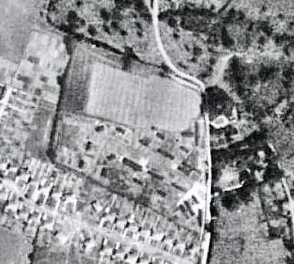  Location: NGR for Brockworth Court is SO 891 171 – camp at SO 891 167. Another camp 554 Woodfield Farm was just 2.5 km N of here.  Before the camp: Country estate and lands.  Pow Camp: Italian collaborator Pows listed from 1944 until at least September 1945, then a German Working Camp.  1943 – camp opened.  November 1944 - The camp was listed as an Italian Labour Battalion, (WO 32/10737).  1 August 1945 - an urgent memorandum was sent to this camp, and others, about maintaining records of Italians who were classed as ‘co-operators’. At this point many, sometimes all, of the Italian pows were in hostels / billets.  15 September 1945 - Hostel listed for pows from this camp , (WO 32/10737): Northleach, Cheltenham, Gloucestershire. Link to map  September 1945 - Appendix to HQ Southern Command War Diary–  Brockworth Court Camp – Italian labour battalion – capacity 100 – 92/339379. | 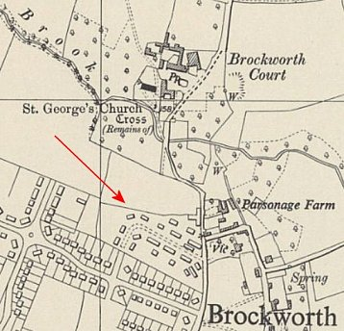
 | Ordnance Survey 1952
Italian hostels – Northleach, Newtown, Shurdington, Bentham House, Sezincote, Winchcombe, Woodchester, Quedgeley – total cap 900

24 June 1946 – Brockworth Italian Labour Camp was amalgamated with Leckhampton Camp 263. It was still open as a hostel in March 1948.

Postal items: Seen Pow mail to Italy dated June 1943

After the camp: 2019 residential area.

Further Information:

Inside the Wire – Ian M C Hollingsbee – The History Press – 2014. A chapter on Brockworth and Quedgeley hostel.

Hostels

Bentham House, just outside Little Shurdington. NGR SO 911 175.  Very close to Hunt Court which was listed as a pow hostel for Leckhampton Camp 263.  September 1945 – Listed as a hostel for Italian pows. | 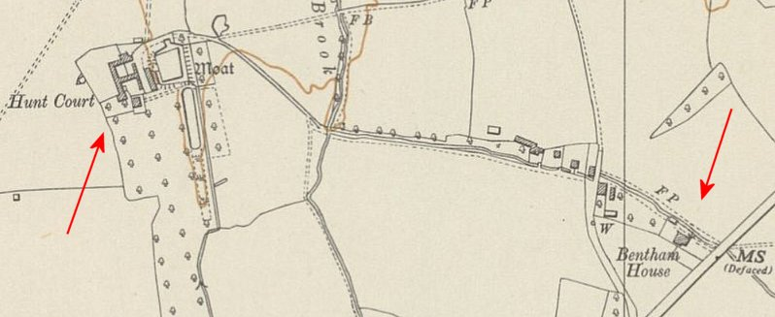
 | Ordnance Survey 1954
Elmbridge

19 November 1945 – hostel taken over by Leckhampton Camp 263.

Newtown. Huts. Where the Canterbury Pub is on Ashchurch Road, GL20 8BT.

September 1945 – Listed as a hostel for Italian pows.

June 1946 - Transferred to Sudeley Camp 37.

Nothleach, Cheltenham, Gloucestershire. “A few pows were housed in the old prison” [at Northleach] - Leckhampton Local History Society.

1942 - listed as a hostel for Italian pows with Sudeley Camp 37.

September 1945 – Listed as a hostel for Italian pows with Brockworth.

24 June 1946 – administration transferred to Leckhampton Camp 263.

Quedgeley. Hostel at Quedgeley Court - NGR SO 816 152. A large, late Victorian brick house, now demolished.

September 1945 – Listed as a hostel for Italian pows.

24 June 1946 – administration transferred to Leckhampton Camp 263.

Sezincote

September 1945 – Listed as a hostel for Italian pows.

June 1946 - Transferred to Sudeley Camp 37

Shurdington. SO 921 186. Shurdington Social Centre – “built during WW2 to house women’s land army volunteers. It was subsequently used for POW’s and, during the fifties, as hospital rehabilitation.”

“The part wooden / part brick structure was equipped with dormitories, washrooms, kitchen, dining room and recreation area, and halls.” http://www.shurdington.org/socctrold.htm

September 1945 – Listed as a hostel for Italian pows.

24 June 1946 – administration transferred to Leckhampton Camp 263.

Stanton. Possibly located near to Stanton Court – SP 067 343

June 1946 - Transferred to Sudeley Camp 37, (and later with Springhill Camp 185).

Winchcombe

September 1945 – Listed as a hostel for Italian pows.

February 1948 – Listed with Leckhampton Camp 263.

Woodchester,

September 1945 – Listed as a hostel for Italian pows.

24 June 1946 – administration transferred to Leckhampton Camp 263.

