Camp 124 - Bedminster Camp, (Ashton Gate Camp), Ashton Gate, Bristol, Gloucestershire

Included in the 1945 ICRC camp list – Labour Camp. 124. Bedminster Camp, Ashton Gate, Bristol.

1947 Camp list
124(G.W.C.) | Bedminster Camp, Ashton Gate, Bristol 3. | S. | Priswar, Bristol | Bristol 64700 and 64471 | Bristol | Lt.Col.A.J.Uden | v/1453/2

Prisoner of War Camps (1939 – 1948) - Project report by Roger J.C. Thomas - English Heritage 2003
OS NGR | Sheet | No. | Name & Location | County | Cond’n | Type 1945 | Comments
ST 58 71 | 172 | 124 /a | Ashtongate Camp / Bedminster Camp, Ashton Gate, Bristol | Gloucestershire (Avon) | 5 | German Working Camp

Location: NGR above is a general location. NGR ST 565 713 – not confirmed.  Before the camp: Ashton Vale Works.  Pow Camp: There were close working links between this camp and nearby Ashton Court Camp 6.  Memories from Kathleen Woodward on http://brisray.com/:  “I lived in Bower Road, Ashton from 1937 until 1956 and well remember the number of POW and Polish camps in the district. The Polish camp was near Ashton Drive - my friend and I used to walk by it on the way to Pit Ponds where we fished for tadpoles. The Germans were often seen in the neighbourhood walking around in their distinctive POW uniforms. Some of the neighbours befriended them which caused a lot of bad feeling, as they were encouraged to try and sell small wooden toys they had made in the camp. I remember one time two of them leaned on our front gate looking at my little sister playing and my mother rushed out and took her into the house. | 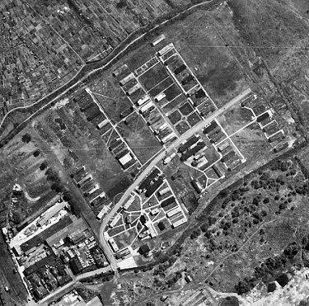 | 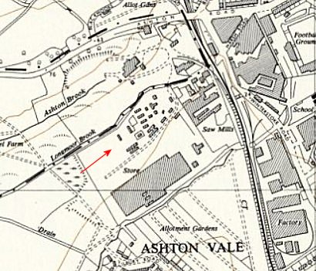
 | 1947 - raf_cpe_uk_2223_v_5239 - Aerial Photo | Historic England | Ordnance Survey 1955

I recall towards the end of the war the German speakers in my class at school were taken to a hall in Bedminster to entertain German prisoners by singing German carols and taking around refreshments. I still remember being surprised while we were singing "O Tannenbaum" a group of them joined hands and started singing rather loudly what I later realised was the Red Flag.
Americans had been stationed in the Bond Houses in Winterstoke Road, Ashton Gate, and when they had gone back the buildings were used to house POWs.”

I have not yet found any official reports, but the camp magazine, No.2 (‘translated as CM2’ - see below) contained a lot of useful information.

November 1945 – CM2 “…we arrived here at Bedminster Camp from another British camp* command as the first of 300 comrades. The camp, formerly used as an American camp for German POWs, had stood empty for several months and now served as accommodation and a temporary home for us and our comrades who were gradually arriving. Here we arrived in a camp that had nothing but the huts and hut furnishings. Everything that would enable and facilitate coexistence in a camp had to be created first...

First, the bare minimum was done: the huts, washrooms, and toilets were brought into proper condition, the shower rooms were provided with hot water every day of the week, and a kitchen and dining room were set up to feed and provide basic meals for 1,000 men. Then, other equally important things, such as sports, entertainment, and spiritual care, were addressed.” * Failand Camp – mentioned later
The article mentioned - soccer and handball games - a theatre group - a band equipped with homemade instruments – monthly film screenings - Skat tournaments - a recreation room - German and English newspapers and magazines - a good radio receiver - ten different study groups - and a library

1946 – new pows arrived after being held in camps in the USA.

Interpreter officer – Lt Brent, he wrote articles for the camp magazine.

Pows from this camp were used for building pre-fab houses in Airport Road, Knowle. Inscriptions were left in the concrete bases, including ‘L.H.Erbalt Deutschen POW’.

14 March 1946 – death of a pow, Hermann Kuhles, aged 41. No details of cause. He was buried at Bristol (Greenbank) Cemetery.

8-11 April 1947 - As part of the re-education programme administered by the Control Office for Germany and Austria (COGA), Paul Bondy, a German-speaking refugee gave lectures at the main camp and 3 hostels. He recorded a camp complement of 1,000.

15 April 1946 - Camp Magazine – also sent to Camp 6. Wir Schaffen Mit : Monats-Zeitschrift des PoW-Camp 124 - The Wiener Holocaust Library

14 November 1947 - Camp number included in an ‘Urgent Memorandum’ (FO 939/270) regarding inspection of food parcels.

December 1947 – Noted in a Leckhampton Camp 263 report that 2 hostels, Siddington and Woodchester, had been transferred to Camp 124.

1 January 1948 - Comment for Ashton Court Camp 6 in a Re-education report – “Kraus from Camp 124 looks after evangelicals and Father Kreis from Camp 44 visits the Catholics”.
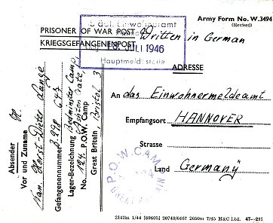
Known camp Commandants:
Lt Col R C G Joy later at Goathurst Camp 44.
1947 Lt Col A J Uden, from the Royal Regiment of Artillery.

< Postcard July 1946 to Germany.

After the camp:

Further Information:

Hostels

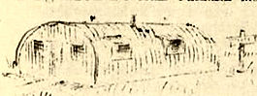
Failand. 2 close locations possible -

1. Bristol and Clifton Golf Club, Beggar Bush Lane, Failand; history – “The Club had lost one field, requisitioned as a POW camp…”

2. “We had a German prisoner of war camp at Sixty Acres, Failand and somehow three of them got to know that my father was ill in bed. They came to see if they could sit with him and one of them came regularly. He was a barber and he used to cut Father's hair and shave him and would sit at his bedside until it was time to go back to camp. Three of them were at Father's funeral. They were not all bad, but had to fight the same as our own men did whether they wanted to or not.” http://www.ndlhs.org.uk/pennant/Pennant-4.pdf

April 1946 – CM2; “Just a few miles from Bedminster lies another of the main camp's protégés – Failand. We spent our involuntary stay in England amidst a very beautiful landscape. Our camp is currently not large, barely 60 men go about their daily work here.” Small illustration probably shows the type of huts in use.

Siddington

November 1947 – transferred from Leckhampton Camp 263.

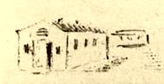
Sunnyside.

Previously administered by Wapley Camp 124 (see for location).

April 1946 – CM2; “Near the village of Yate, directly on the edge of the river, lies the 'Sunnyside' camp. Its just a small hostel. The six barracks are arranged around a sports field, where there's lively sports action every Sunday. The 77 of us living here behind the barbed wire have absolutely no intention of settling down and resting in our confined space.” Small illustration probably shows the type of huts in use.

Tortworth. Probably in the grounds of Tortworth Court.

CM2 – “When the Americans came to England during the war to take part in the fighting against fascism, they built a large hospital camp in the castle grounds. A large tent city was also built near this camp, which has since disappeared. Only a few living and kitchen barracks remain. This was then enclosed with a barbed wire fence, and 25 German POWs were stationed inside. No one will ever be able to answer why this ugly wire was built, because the camp inmates were working freely in the farmers' fields every day…”

Woodchester

November 1947 – transferred from Leckhampton Camp 263.

