Camp 258 RAF Camp, Seething, Brooke, Norfolk

Location: Seething is a small village about 9​¹⁄₂ miles south east of Norwich. RAF Seething was located S of the village. The centre of the airfield was at TM 315 955.  Before the camp: The airfield was built 1942-43 as a USAAF bomber base. It was used by the 448th Bomb Group flying B-24’s until July 1945 when it was handed over to the RAF. There were three runways and two hangars – barracks in fields to the south of the airfield.  Pow Camp: Roger Thomas (English Heritage - 2005) reported that a number of huts were hidden in nearby woodland.  Summer 1945 – listed as opened with capacity of 600. (Progress report 152 – FO 939/383).  1946 – Additional intake of many pows from camps in the USA. Most had very low morale as they had been misinformed in the US that they were being repatriated. Instead, they found themselves in working camps in the UK.  11 July 1946 – Re-education report. Strength; 1 officer (the M.O.), 1297 Other Ranks at HQ + 3 hostels. (Possibly also billets, but these were not listed).  The 4th PID report, but the first 3 are not in the National Archive file. | 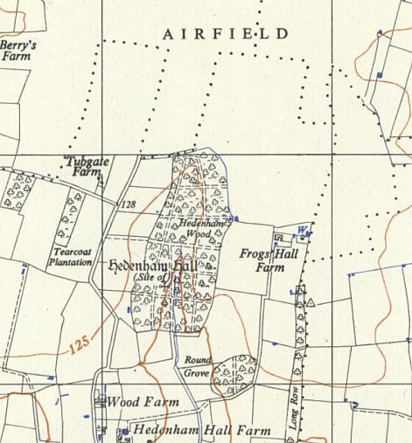
  Oversight and development of re-education activities and English teaching for German pows was carried out by PID (Political Intelligence Department of the Foreign Office) / COGA (Control Office for Germany and Austria – UK). Visits and reports were made. The standard of the reports varied greatly. The visitors took little interest, if any, in activities other than re-education. They rarely mentioned welfare, sports, games, pastimes, crafts, etc of the pows. If there were still Italian pows in hostels, they were usually ignored by PID.
 | Ordnance Survey 1956

HQ | Mettingham | Brooke | Bungay
867 | 200 | 150 | 80

Political screening: | A | B | C | Unscreened
 | 159 | 276 | 246 | 517

This was a far higher number of both As and Cs than in most camps.

Commandant: Lt Col Ashton Camp leader: O.Wm Hagedorn (A)
Deputy i/c: Major Spence Deputy c/l: Fw Goettlich (est A)
Interpreter: S/Sgt Auslander German M.O.: A/Arzt Adelkamp (A)

Lt Col Ashton was interested in re-education.

Major Spence had been Commandant before the camp grew in size. He was respected and liked.

The Interpreter was an, “over-worked, worried man.” He was due for demobilisation.

Morale in the camp was low, mainly due to lack of any information about repatriation. Mail was slow to get through.

‘Youth’ pows (under-25) were described as a problem as they were not inclined to join in with re-education activities after working long hours during the day.

The standard list of re-education activities was given:

Wochenpost and Ausblick – separate appendix.

Newspapers – “Adequate” British papers. Some Swiss and German papers were received.

Library – more books required.

Lectures – Regular and popular.

Discussion group – Good.

Films – YMCA and PID films shown at HQ only.

Camp magazine – Improving.

Press review – None.

English instruction – separate appendix.

Other camp activities -

Religion – “fairly dull in this camp.”

Education – Classes (named in previous report) were well attended.

Theatre – Very good theatre group, but needed play scripts.

Orchestra – reviewed in last report.

30 August 1946 – Camp Magazine; Der Brennpunkt : POW Camp 258 - The Wiener Holocaust Library

9-12 October 1946 – A visit by the Segregation Section of PID to review screening. Strength; 3 officers (2 MOs and 1 dentist), 1735 OR.

Commandant: Lt Col J F Ashton Camp leader: Fw Horst Goettlich (A)
Interpreter: S/Sgt K M Rawack Deputy c/l: Owm Bruno Rehbock (A)

The Commandant wished to ensure that pows returning to Germany had the highest opinion of British democracy.

The new Interpreter was a German refugee from Vienna, a Dr of medicine, recently naturalised and supportive of re-education.

Camp leader Goettlich had been deputy leader. Aged 25, “A charming young man… has the confidence of everybody in spite of his youth.”

The Deputy leader had been hostel leader at Bungay. Aged 35, a wine merchant; “A very sound fellow of liberal outlook.”

Ass.Arzt Dr Alfons Adelkamp (A), aged 31; a strong Catholic, received high praise for being an active democratic influence.

Ass.Arzt Dr Hans Nachtwey (A), aged 35; had been associated with the Nazi Party, but it was believed he was now anti-Nazi and “sincerely democratic.”

O/Lt Dr Werner Wetzel, dentist, (A), aged 40; had been a member of the SA in 1933, but left in 1935 “for reasons of conscience.” Believed to be anti-Nazi.

Political screening: | A+ | A | A- | B+ | B | B- | C | C+ | Unknown
 | - | 94 | 1 | 109 | 459 | 94 | 134 | - | 847

Religion – Evangelical padre, Gefr Hans Roeth (A), aged 35. Had been a member of the SA 1933 to 1937. Moved to Holland and was interned by the Germans after the invasion. He was soon released and was called up in 1942. He gave; “an impression of nobility of character amongst prisoners and British staff.” Catholic padre – not seen.

Late 1946 / Early 1947 – Seething became a pow hostel administered by Ellough Camp, which then took the number 258. Brooke hostel was also transferred. The Commandant, Interpreter and 1 doctor were transferred to Ellough.

Known Commandants:
1946 Major Spence
1946 Lt Col John Forbes Ashton, from the Border Regiment. He moved in 1947 to Ellough Camp 258. Later to Berechurch Camp 186 and then to Fornham Camp 186 (the last camp to close).

After the camp: The site was sold in 1959 and mostly returned to farming land. The wartime Control Tower is a museum for the 448th Bomb group.

Further Information:

National Archives FO 1120/238 – Re-educational survey visit reports for camps 257 to 259. Dated 1 January 1946 – 31 December 1948. Used above.

Seething Tower museum - https://448bombgroup.co.uk/ - has some German relics donated to the museum.

Hostels. * Were the 2 names below recorded in error?

Brooke. In the grounds of Brooke Hall NGR TM 288 989.

“In 1938, Brooke Hall was on the point of sale again when the property was requisitioned by the War Office and occupied by the military, then POWs. A sentry box stood near the back lodge, huts and tents were placed in the park and the house and gardens neglected.” Norfolk Gardens Trust magazine, article by Marion Folkes, Spring 2024, p3.

7/1946 – Hostel leader; Fw Hoenmann *

Administration transferred to Ellough Camp 258.

Bungay NGR TM 346 893

Previously attached to Botesdale Camp 56, then Uplands Camp 131.

7/1946 – Hostel leader; Fw Rehbock.

Mettingham

7/1946 – Hostel leader; Fw Honmann *

